TECHNICAL GUIDE

Purbalingga birth outcomes
  - Data flow, identity matching and production operations

PBG-01 through PBG-10 • BigQuery • Asia/Jakarta
Logic reviewed from the Purbalingga production SQL bundle and the September 2026 validation results.

Version 1.1 | 8 September 2026

Simple summary
The Purbalingga pipeline turns repeated pregnancy and delivery records from several health-information systems into two linked analytical entities: one canonical pregnancy and one canonical delivery. It preserves source lineage, applies explicit conflict guards, and produces operational monitoring and reporting views for Looker Studio.
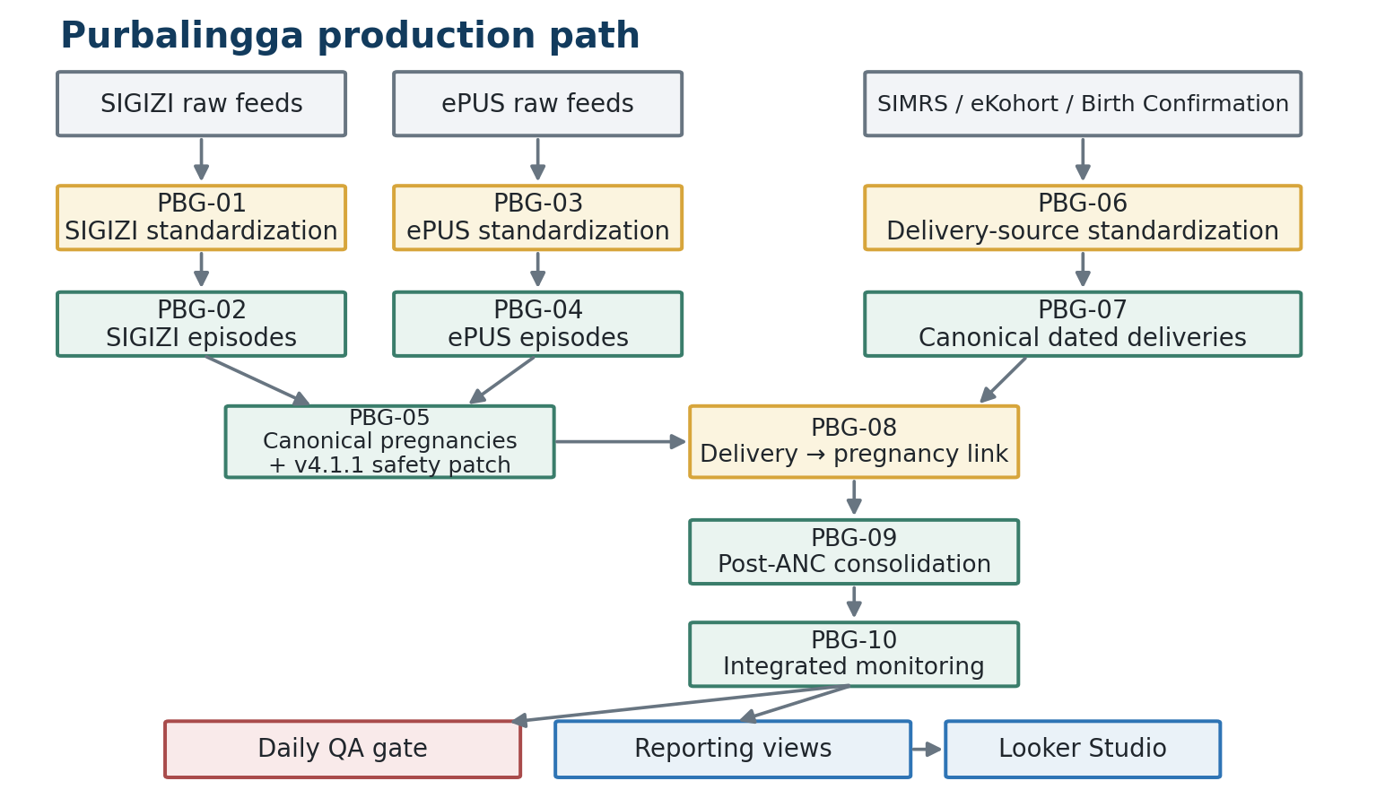
Amber = processing stage; green = stored analytical table; blue = reporting layer; grey = raw inputs; red = QA or safety control.
Essential distinction PBG-05 resolves pregnancy identity. PBG-07 resolves delivery identity. PBG-08 links those two entities. These are different questions and must remain separate.

What each source contributes
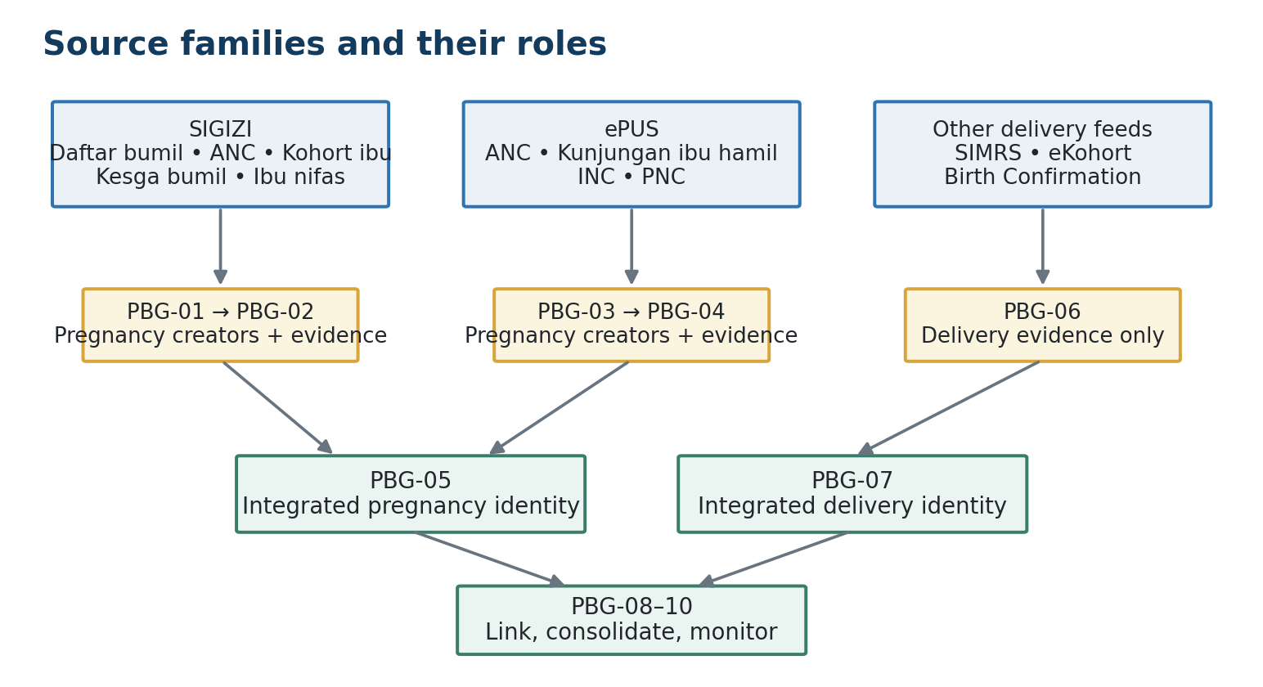
SIGIZI and ePUS can create pregnancy episodes from designated pregnancy-source records. Other feeds contribute delivery or outcome evidence only.
The pipeline deliberately prevents outcome-only rows from inflating the pregnancy denominator. SIGIZI IBU_NIFAS and ePUS INC/PNC remain useful evidence, but they do not independently create a new pregnancy episode.

Where the pregnancy identity is decided
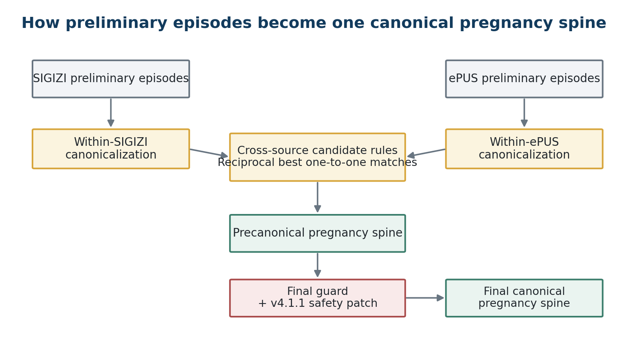
PBG-05 first canonicalizes within each source, then matches across sources, then applies a conservative final guard.
A canonical pregnancy is not merely the newest row. It is a stable analytical identity supported by source episodes, normalized identifiers, pregnancy dates and controlled fallback evidence. Unmatched episodes remain in the final spine rather than being discarded.

Where delivery records are linked
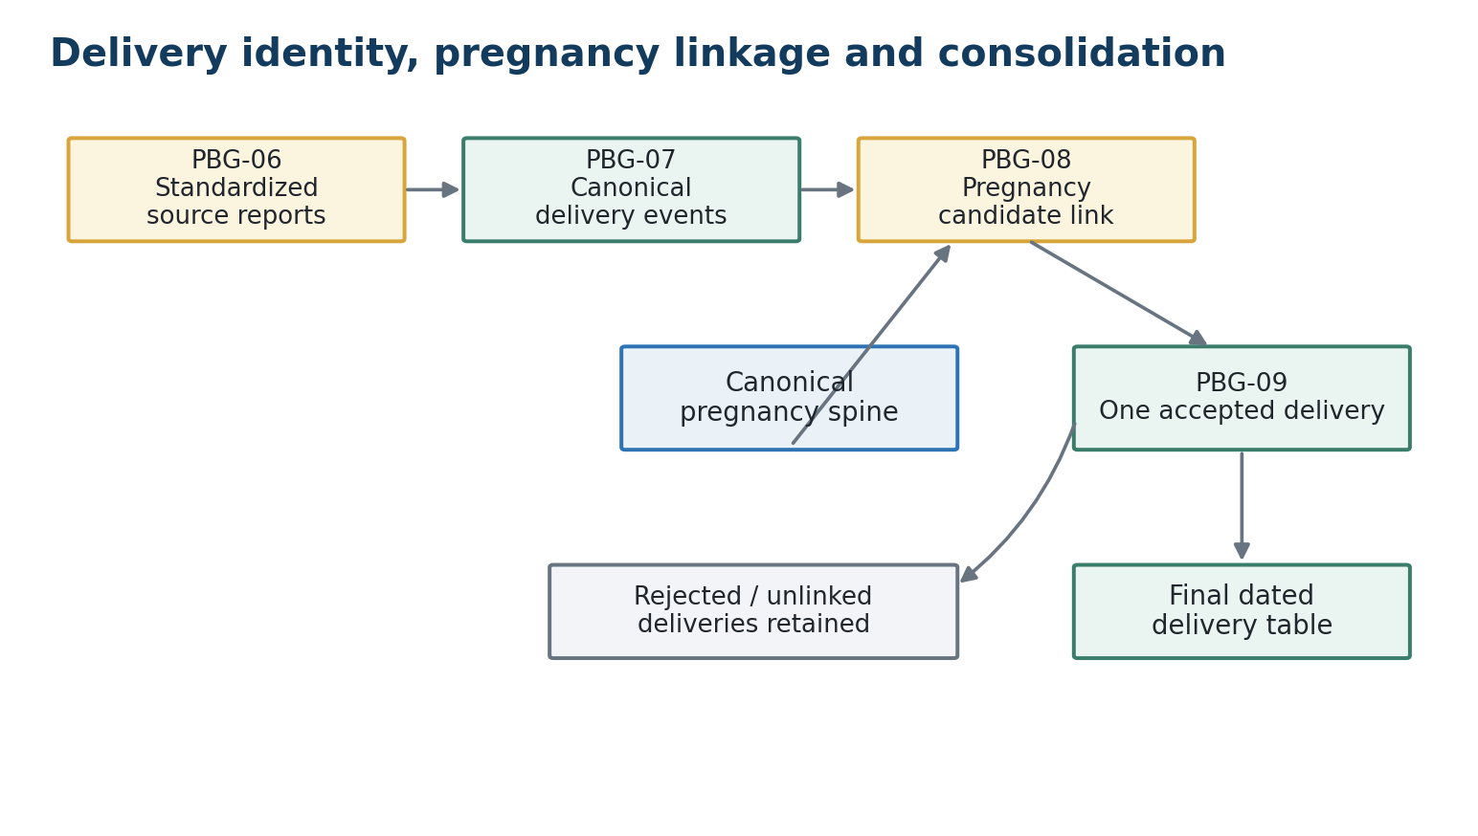
PBG-09 enforces at most one accepted dated delivery per pregnancy while retaining rejected or unlinked known deliveries.
The delivery path first groups source reports believed to describe the same birth. Only after that does it ask which pregnancy the delivery belongs to. Multiple delivery clusters linked to one pregnancy are reconciled in PBG-09.

Where the final products appear
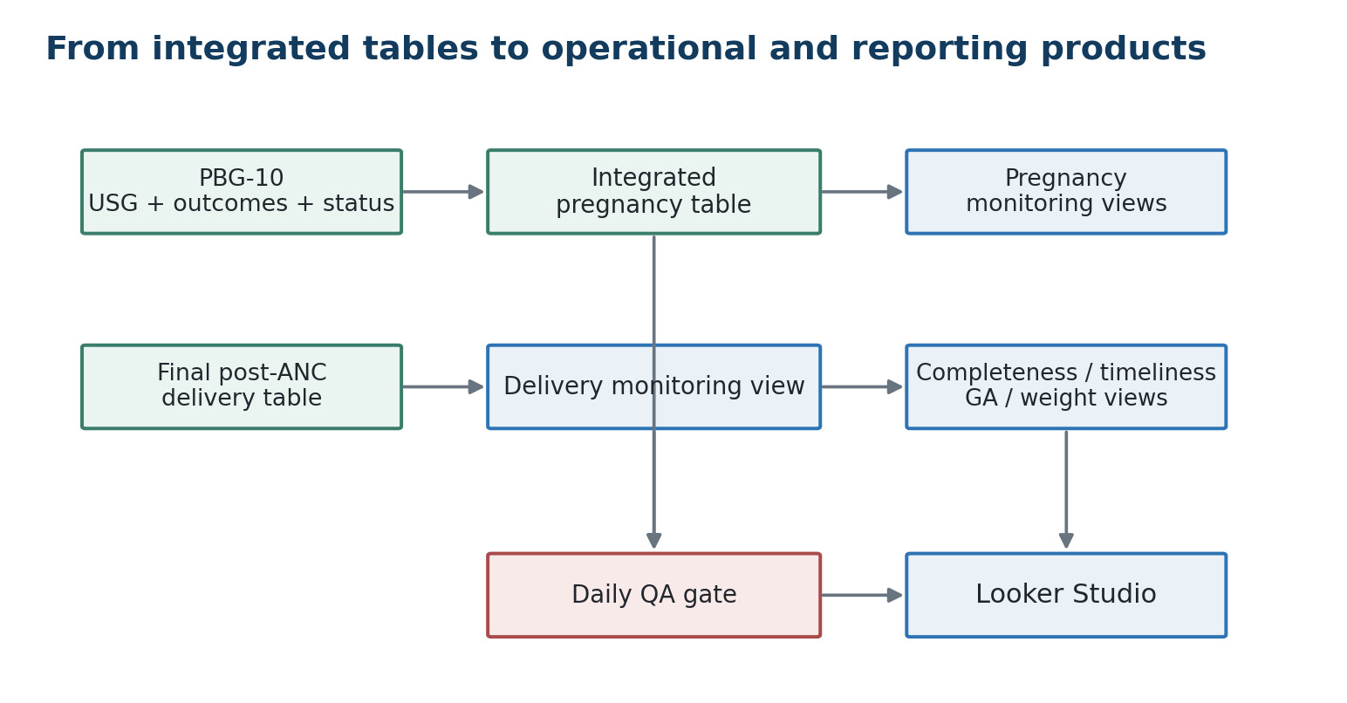
PBG-10 must run daily because ACTIVE_PREGNANCY and MISSING_BIRTH depend on the current date.
Reporting views are deployed once and automatically reflect refreshed tables. Their SQL should be rerun only when the view logic changes; they do not need a daily schedule.

A simple story: follow Siti Aminah through the pipeline
Siti Aminah is a fictional mother used only to explain the data model. NIK-A, P-A and D-A are teaching labels, not real identifiers or production hashes.
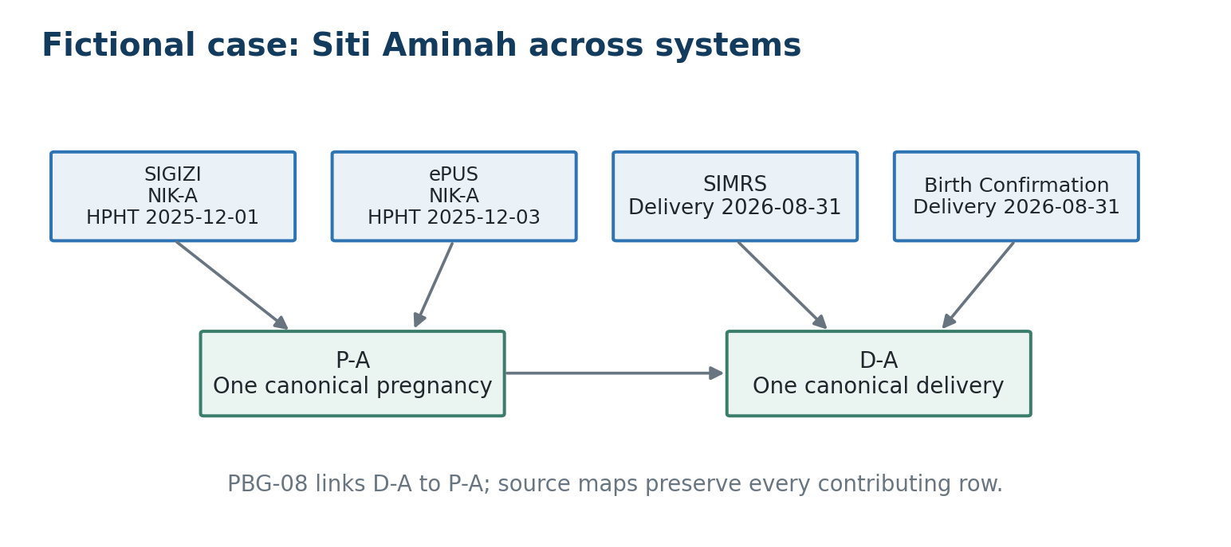
Several source rows can correctly reduce to one pregnancy and one delivery while remaining traceable through canonical and member maps.
What the source records say | What the pipeline decides
SIGIZI and ePUS contain compatible identity and pregnancy dates. | PBG-05 creates one canonical pregnancy P-A.
SIMRS and Birth Confirmation report the same delivery date. | PBG-07 creates one canonical delivery D-A.
D-A occurs within the plausible pregnancy window for P-A. | PBG-08 links D-A to P-A; PBG-09 retains it as the accepted delivery.

Detailed logic

1. Cleaning and source standardization
PBG-01, PBG-03 and PBG-06 normalize source-specific schemas before any cross-record comparison. Cleaning makes values comparable; it does not certify that a filled field is true. Raw JSON, source table, source record identifiers, file information and QA flags remain available for traceability.
Field family | Standard treatment
Names | Normalize Unicode, case, spacing and punctuation; build core and compact comparison variants where needed.
NIK | Extract digits; accept ordinary 16-digit values; classify placeholders and rounded values as untrusted or suspect.
Phone | Normalize digits and Indonesian prefixes; use only sufficiently complete values for matching.
Dates | Parse common year-first and day-first source formats; apply lower bounds, current-date limits and future-HPL allowance.
Geography | Normalize generic Puskesmas prefixes and comparable village/Posyandu text without importing Lombok-specific aliases.
Provenance | Retain source system, table, source key, physical-row fingerprint and original serialized row.

2. Pregnancy creators versus evidence-only rows
Source | Creates a preliminary pregnancy? | Other role
SIGIZI DAFTAR_BUMIL | Yes | Registration and pregnancy dating.
SIGIZI KESGA_BUMIL_ANC | Yes | ANC and pregnancy dating.
SIGIZI KOHORT_IBU | Yes | Pregnancy, delivery and outcome evidence.
SIGIZI KESGA_BUMIL | Yes | Pregnancy evidence.
SIGIZI IBU_NIFAS | No | Outcome and delivery matching evidence only.
ePUS ANC | Yes | ANC, pregnancy dating and USG source.
ePUS KUNJUNGAN_IBU_HAMIL | Yes | Pregnancy and visit evidence.
ePUS INC | No | Conservative delivery enrichment and outcome evidence.
ePUS PNC | No | Outcome-supporting evidence.

Why this matters A postpartum or delivery record can confirm an outcome, but it must not manufacture an additional pregnancy denominator row.

3. Building preliminary pregnancy episodes
Both SIGIZI and ePUS derive a pregnancy anchor from HPHT, otherwise from HPL minus 280 days. Records are ordered within the resolved maternal identity. A gap greater than 120 days between consecutive anchors begins a new preliminary episode. Records before 1 January 2018 are outside the analytical pregnancy floor.
Branch | Maternal identity hierarchy before episode split
SIGIZI | Own NIK; unique pregnancy signature mapped to NIK; name core + DOB + Puskesmas; name core + DOB + village; name core + DOB; unique signature mapped to DOB; weak pregnancy signature; otherwise source-specific row.
ePUS | Trusted NIK; name core + DOB + Puskesmas; name core + DOB; otherwise retain weak rows separately.

PBG-04 may attach ePUS INC delivery evidence to an existing ePUS pregnancy. The NIK route allows an anchor gap up to 120 days; weaker identity evidence uses a 60-day anchor tolerance. INC still cannot create the pregnancy itself.

4. Within-source pregnancy canonicalization
PBG-05 compares preliminary episodes within SIGIZI and within ePUS. Candidate pairs are classified by the strongest qualifying rule, ranked, and converted into canonical maps. An episode that is not merged maps to itself.
Rule family | Required evidence
NIK + anchor | Same trusted NIK and pregnancy anchors within 30 days.
Strong name + DOB + HPHT | Exact compact name, exact DOB, HPHT within 14 days and at least one corroborator.
Strong name + DOB + HPL | Exact compact name, exact DOB, HPL within 14 days and at least one corroborator.
Exact pregnancy fallback | Exact compact name and DOB with exact HPHT, HPHT within 7 days, or HPL within 7 days; trusted-NIK conflict blocks weak variants.
Name + facility + exact HPHT | Exact compact name, same Puskesmas and exact HPHT, with no trusted-NIK conflict.

Corroborators are supporting agreement in location, phone or close delivery evidence. They strengthen a rule but are not interpreted as independent statistical variables.

5. SIGIZI-to-ePUS pregnancy matching
Canonical episodes from the two source families are compared across sources. Candidate pairs are ranked by rule priority and date distance. Reciprocal best matches are assigned one-to-one; matched episodes leave later rounds, while unmatched episodes remain available as source-only pregnancies.
Priority family | Cross-source requirement
NIK + anchor | Same trusted NIK and anchors within 90 days.
Strong name + DOB + HPHT | Exact compact name, exact DOB, HPHT within 14 days and at least one corroborator.
Phone + DOB + anchor | Same valid phone and DOB, with anchor difference within 30 days.
Strong pregnancy fingerprint | Exact compact name, exact HPHT and HPL, plus at least two corroborators; subject to final safety review.
Name/DOB/date fallbacks | Exact compact name and DOB with exact/near HPHT or HPL, blocked by trusted-NIK conflict where specified.

Trusted NIK “Trusted” is a pipeline data-quality class: a normal 16-digit value that is not a placeholder or rounded suspect value. It is not external verification against a civil-registration database.

6. Final pregnancy guard and v4.1.1 safety patch
After the first cross-source spine is formed, residual rows are compared again. The final guard permits controlled rescue rules for imperfect data while recording the merge method, conflicts, edit distance and corroborators in the final canonical map.
Final rule | Safeguards
FINAL_NIK+ANCHOR_30D | Same trusted NIK and anchor within 30 days.
FINAL_STRONG_NAME+DOB+HPHT_14D+CORROBORATOR | Exact compact name and DOB, HPHT within 14 days, at least one corroborator.
FINAL_FUZZY_NAME+DOB+HPHT_14D+2_CORROBORATORS | Edit distance ≤1 for shorter eligible names or ≤2 for longer names; exact DOB; HPHT within 14 days; at least two corroborators; no trusted-NIK conflict.
FINAL_PHONE+DOB+HPHT_HPL | Same usable phone and DOB, with close HPHT or HPL.
FINAL_NAME+DOB_MISSING+EXACT_PREGNANCY+2_LOCATION | Exact compact name; DOB absent on one side without a DOB conflict; exact HPHT/HPL; at least two agreeing location components; no trusted-NIK conflict.
Fingerprint overrides | Exact pregnancy fingerprint or unique pair, but the v4.1.1 patch blocks automatic merging when trusted NIK and DOB both disagree.

v4.1.1 production protection NIK conflict alone may be a source typo and DOB conflict alone may be a source error. When both trusted NIK and DOB disagree, the two strong fingerprint override rules must keep the records separate.

7. What the final pregnancy tables mean
Object | Row grain and purpose
t_sigizi_episode_canonical_map_v3_3 | One row per preliminary SIGIZI episode, mapping it to the chosen within-source canonical episode.
t_epus_episode_canonical_map_v3_3 | One row per preliminary ePUS episode, with the equivalent within-source mapping.
t_pregnancy_cross_source_matches_v3_3 | Accepted one-to-one SIGIZI↔ePUS episode pairs.
t_pregnancy_final_canonical_map_v3_3 | One row per precanonical pregnancy, pointing to the final pregnancy and recording the final merge rule and QA.
t_pregnancy_episode_spine_v3_3 | One row per final canonical pregnancy; the downstream identity spine.

8. Delivery-source standardization (PBG-06)
PBG-06 builds one standardized record for each eligible source delivery or outcome report. The clinical event date comes only from delivery or abortion evidence; a report or ingestion date is never substituted for the clinical delivery date. Exact physical duplicates are removed by the full-row fingerprint, while reused business keys with different content are preserved.
Source system / table | Priority | Role
SIMRS / SIMRS_API_INC | 1 | Hospital delivery and outcome evidence.
ePUS / EPUS_INC | 2 | Delivery evidence derived from the standardized ePUS source table.
eKohort / EKOHORT_PERSALINAN | 3 | Delivery evidence; tgl_persalinan is the primary clinical date.
eKohort / EKOHORT_PELAYANAN_IBU_BERSALIN_FIXED | 4 | Additional delivery evidence.
SIGIZI / KOHORT_IBU | 5 | Delivery evidence from the standardized SIGIZI table.
SIGIZI / IBU_NIFAS | 6 | Postpartum outcome/matching evidence.
Birth Confirmation / APP | 7 | Non-deleted confirmation-app records.
Birth Confirmation / LEGACY | 8 | Legacy confirmation records.

eKohort timeliness correction For both eKohort tables, report_timestamp_raw is now NULL. file_date and ingestion_timestamp behave as snapshot-period metadata and can precede the clinical delivery. eKohort records still count toward completeness, but eKohort timeliness is unavailable until a trustworthy report-entry timestamp exists.

9. Deduplicating dated delivery reports (PBG-07)
PBG-07 includes dated DELIVERY rows only. ABORTION, CONFLICT_DELIVERY_ABORTION and DELIVERY_DATE_UNKNOWN remain for later outcome integration. The algorithm establishes trusted-NIK delivery clusters first, then conservatively attaches untrusted records, and finally groups residual records by composite evidence.
Deduplication route | Evidence
Trusted-NIK date chain | Same trusted NIK; consecutive delivery dates with gaps of at most 3 days.
Attach untrusted row to trusted cluster | Close delivery date plus name+DOB, name+phone, name+HPHT, name+HPL, or same name/date/Puskesmas evidence.
Residual name + DOB | Comparable name, exact DOB and delivery dates within 3 days.
Residual name + phone | Comparable name, same phone and delivery dates within 3 days.
Residual pregnancy-date route | Comparable name with HPHT/HPL within 14 days and delivery dates within 3 days.
Residual location route | Comparable name, exact delivery date and same Puskesmas.

The canonical event date is selected by the number of supporting source systems, then supporting source records, then source priority, followed by a deterministic date tie-break. Conflicting identity, gestational-age and outcome values remain visible as QA flags.

10. Linking a delivery to a pregnancy (PBG-08)
PBG-08 starts from one canonical delivery and one canonical pregnancy. Candidate pairs are blocked by NIK, compact name or phone, then tested for biological plausibility. The ordinary pregnancy window is 126–322 days after the pregnancy anchor (approximately 18–46 weeks).
Candidate method | Condition
NIK+PREGNANCY_WINDOW | Exact trusted NIK, plausible pregnancy timing, and not both an explicit name and DOB disagreement.
NAME+DOB+PREGNANCY_WINDOW | Comparable name and exact DOB, plausible timing, no trusted-NIK conflict.
NAME+HPHT_14D+PREGNANCY_WINDOW | Comparable name, HPHT within 14 days, plausible timing, no trusted-NIK conflict.
NAME+HPL_14D+PREGNANCY_WINDOW | Comparable name, HPL within 14 days, plausible timing, no trusted-NIK conflict.
PHONE+DOB+PREGNANCY_WINDOW | Same usable phone and exact DOB, plausible timing, no trusted-NIK conflict.
NAME+PKM+CLOSE_EDD | Restrictive fallback: same name and Puskesmas, delivery within 14 days of linking EDD.

A unique best candidate becomes the accepted pregnancy link. Equally ranked pregnancies produce AMBIGUOUS_ANC_MATCH. If the same trusted NIK exists but dates are impossible, the status is ANC_LINK_DATE_IMPLAUSIBLE rather than NO_ANC_MATCH.

11. Post-ANC consolidation (PBG-09)
Several canonical delivery events may independently link to the same pregnancy. PBG-09 chooses the strongest delivery as the pregnancy winner, based on linkage method, closeness to EDD, corroborators, source-system support, source-record support, known outcome and a deterministic tie-break.
Distance from winner | Action
Same date to 42 days | Consolidate into the pregnancy winner.
More than 42 days | Do not merge; reject that pregnancy linkage and retain the delivery as a standalone known delivery.
No accepted pregnancy match | Retain as unlinked delivery.
Ambiguous or date-implausible match | Retain with its diagnostic status.

Critical invariant After PBG-09, a pregnancy may have at most one accepted final dated delivery. A known delivery is never discarded merely because its pregnancy link was rejected.

12. USG dating and outcome evidence (PBG-10)
PBG-10 builds ePUS ultrasound dating, validates non-dated outcome evidence, attaches it to pregnancies, and produces one final monitoring row per canonical pregnancy. USG records match by trusted NIK or by compact name+DOB within a visit window from 30 days before to 300 days after the pregnancy anchor. Conflicting trusted NIKs block the fallback.
Expected delivery date priority | Source
1 | Recorded HPL from ePUS
2 | Recorded HPL from SIGIZI
3 | Canonical recorded HPL
4 | EDD derived from early USG GA at 4–14 weeks
5 | ePUS HPHT + 280 days
6 | SIGIZI HPHT + 280 days
7 | Canonical HPHT + 280 days
8 | Fallback HPHT + 280 days

For SIGIZI IBU_NIFAS, tgl_abortus alone does not confirm an abortion. The status must explicitly indicate abortion, miscarriage or keguguran. A date-only signal remains in the evidence table as unconfirmed QA and is excluded from pregnancy-outcome determination.

13. Final monitoring statuses
Precedence | Status | Meaning
1 | DELIVERED | An accepted dated delivery is linked.
2 | ABORTUS | Confirmed abortion evidence is linked.
3 | DELIVERED_DATE_UNKNOWN | Delivery is confirmed but a usable delivery date is absent.
4 | DATE_UNKNOWN | Pregnancy dating is insufficient for active/overdue classification.
5 | MISSING_BIRTH | Expected delivery date is before the analysis date and no resolved outcome is present.
6 | ACTIVE_PREGNANCY | Expected delivery is today or in the future, with no resolved outcome.

HPL today is not overdue The overdue test is expected_delivery_date < CURRENT_DATE("Asia/Jakarta"), not ≤. This is why PBG-10 must run every day even when no source file changes.

Reporting and operations

14. Reporting views
View | Grain and purpose
v_birth_reporting_source_long | One final dated delivery × one source system. Supplies completeness and record-level timeliness fields.
v_birth_reporting_daily_trend | One date × one source. Supplies daily, rolling 7-day and rolling 30-day reporting measures.
v_delivery_gestational_age | One final delivery. Uses valid recorded GA first, then HPHT-derived GA within 18–46 weeks.
v_delivery_birth_weight | One final delivery. Chooses the best-supported delivery-level weight and exposes conflict and category fields.

These four objects are ordinary views. Deploy them once or recreate them when the SQL logic changes. They do not require daily Scheduled Queries.

15. Completeness and timeliness definitions
Measure | Definition
Completeness | Reported deliveries ÷ all final canonical dated deliveries for the source grid.
Timeliness H+1 | Captured deliveries reported on H+0 or H+1 ÷ captured deliveries with a valid non-negative report-date delay.
Average delay | Sum of valid non-negative delay days ÷ valid timeliness denominator.
Negative delay | Report date before clinical delivery date. Classified invalid and excluded from the timeliness denominator.
Report date unavailable | Captured record with no trustworthy report date. Included in completeness, excluded from timeliness.

Timeliness must be filtered to reported_in_source_count = 1 when calculated from the long view. Otherwise the chart mixes “was the birth captured?” with “was a captured birth reported on time?”
Current eKohort interpretation After the timestamp correction, eKohort completeness remains meaningful. Its timeliness numerator and denominator should be zero/NULL until a reliable entry timestamp is supplied.

16. Production schedule
Order | Stage | Depends on | Main output
1 | PBG-01 | SIGIZI raw ingestion | t_sigizi_source_records
2 | PBG-02 | PBG-01 | t_sigizi_pregnancy_episode_v3_3
3 | PBG-03 | ePUS raw ingestion | t_epus_source_records
4 | PBG-04 | PBG-03 | t_epus_pregnancy_episode_adapter_v3_3
5 | PBG-05 | PBG-02 + PBG-04 | t_pregnancy_episode_spine_v3_3
6 | PBG-06 | PBG-01 + PBG-03 + other delivery feeds | t_delivery_source_records_v3_3
7 | PBG-07 | PBG-06 | t_delivery_event_canonical_v3_3
8 | PBG-08 | PBG-05 + PBG-07 | t_delivery_pregnancy_link_v3_3
9 | PBG-09 | PBG-08 | t_delivery_event_canonical_post_anc_v3_3
10 | PBG-10 | PBG-09 | t_pregnancy_monitoring_integrated_v3_3
11 | QA | PBG-10 | QA result sets

If one stage fails, every dependent stage should be considered stale. Correct the failure and rerun from that stage forward. Separate Scheduled Queries require enough spacing to prevent overlap; a dependency-aware orchestrator is safer when available.

17. Daily QA gate
Check | Passing condition
Pregnancy uniqueness | Row count equals distinct pregnancy_episode_id count.
Delivery uniqueness | Row count equals distinct final delivery_event_id count.
One accepted delivery per pregnancy | The exception query returns no rows.
Operational due reconciliation | Expected due = birth found due + missing birth due.
Delivery linkage reconciliation | Final deliveries = linked + unlinked.
Source-long uniqueness | One row per delivery_event_id × source_system.
Timeliness arithmetic | H+0 + exact H+1 = reported by H+1; negative delays are reviewed by source.

Validation snapshot — 7 September 2026
The following values are a dated validation snapshot, not permanent expectations. They will change as raw data and the current date change.
Validation item | Observed result | Status
Canonical pregnancies | 26,832 rows; 26,832 distinct IDs | Pass
Final canonical deliveries | 18,579 rows; 18,579 distinct IDs | Pass
Accepted final deliveries per pregnancy | No exception rows | Pass
Operational due reconciliation | 16,045 = 11,898 found + 4,147 missing | Pass
Delivery linkage reconciliation | 18,579 = 13,371 linked + 5,208 unlinked | Pass
Delivery × source grid | 92,895 rows; 92,895 distinct pairs | Pass

Important post-snapshot change The snapshot exposed 3,528 negative eKohort delays. Investigation showed file/snapshot dates were being treated as reporting dates. The corrected PBG-06 intentionally nulls eKohort report timestamps; rerun PBG-06 through PBG-10 and QA before treating later timeliness results as final.

Worked examples
All records below are fictional and demonstrate logic only. Names, dates and short IDs are teaching devices, not dashboard totals or source extracts.

Worked case A — repeated records become one pregnancy
Source episode | Identity | Pregnancy evidence
SG-A | NIK-A; SITI AMINAH | HPHT 2025-12-01
EP-A | NIK-A; SITI AMINAH | HPHT 2025-12-03

The trusted NIK agrees and the anchors differ by two days, so the cross-source NIK+ANCHOR rule can propose a match. If each episode ranks the other first, PBG-05 combines them into one pregnancy P-A and retains both source episode IDs in lineage fields.

Worked case B — two identity conflicts must remain separate
Field | Episode 1 | Episode 2
Compact name | SITIAMINAH | SITIAMINAH
HPHT / HPL | Exact match | Exact match
Trusted NIK | NIK-A | NIK-B
Maternal DOB | 1997-04-15 | 1995-08-20

The pregnancy fingerprint is strong, but both trusted NIK and DOB disagree. The v4.1.1 patch blocks FINAL_STRONG_PREGNANCY_FINGERPRINT_OVERRIDE and FINAL_HIGH_CONFLICT_UNIQUE_FINGERPRINT. The records stay as separate pregnancies for review.

Worked case C — several reports become one delivery
Report | Identity / date | Deduplication effect
SIMRS-A | NIK-A; 2026-08-31 | Creates or joins trusted-NIK date cluster.
EPUS-A | NIK-A; 2026-08-31 | Joins the same trusted-NIK cluster.
BC-A | NIK absent; same name+DOB; 2026-09-01 | Can attach to the trusted cluster because the date is within 3 days and identity supports it.

PBG-07 selects one canonical event date using cross-source support. PBG-08 then links the event to P-A if the pregnancy window and candidate ranking pass.

Worked case D — eKohort completeness without false timeliness
Field | Value | Interpretation
Clinical delivery date | 2024-06-24 | Valid delivery evidence.
file_date / ingestion timestamp | 2024-06-01 | Snapshot metadata occurs before delivery; not a valid report-entry date.
PBG-06 output | report_timestamp_raw = NULL | Delivery remains captured in eKohort; timeliness is unavailable.
Reporting view | reported_in_source_count = 1 | Counts toward eKohort completeness.
Reporting delay | NULL | Excluded from timeliness denominator; no negative-delay artefact.

Worked case E — one pregnancy, competing delivery clusters
Delivery event | Date / evidence | PBG-09 decision
D-A | 2026-08-31; strong NIK link; multiple sources | Pregnancy winner.
D-B | 2026-09-02; weaker link; same pregnancy | Within 42 days: consolidate to D-A.
D-C | 2027-03-01; implausibly distant | Do not merge; reject pregnancy link and retain as standalone known delivery.

Appendix

A. Builder-to-output registry
Builder | Reads | Main persistent output
PBG-01 | Five SIGIZI raw feeds | t_sigizi_source_records
PBG-02 | t_sigizi_source_records | t_sigizi_pregnancy_episode_v3_3
PBG-03 | Four ePUS raw feeds | t_epus_source_records
PBG-04 | t_epus_source_records | t_epus_pregnancy_episode_adapter_v3_3
PBG-05 | PBG-02 + PBG-04 outputs | Within-source maps, cross-source matches, final map and t_pregnancy_episode_spine_v3_3
PBG-06 | SIGIZI/ePUS standardized tables + SIMRS/eKohort/Birth Confirmation | t_delivery_source_records_v3_3
PBG-07 | t_delivery_source_records_v3_3 | Delivery helper maps and t_delivery_event_canonical_v3_3
PBG-08 | Canonical pregnancies + canonical deliveries | t_delivery_pregnancy_link_candidates_v3_3; t_delivery_pregnancy_link_v3_3
PBG-09 | PBG-07 + PBG-08 | t_delivery_post_anc_map_v3_3; t_delivery_event_canonical_post_anc_v3_3
PBG-10 | Pregnancy spine, delivery evidence, final deliveries, raw ePUS ANC | USG, outcome evidence/linkage and t_pregnancy_monitoring_integrated_v3_3

B. Raw source registry
Source family | Raw object
SIGIZI | raw_data.sigizi_daftar_bumil
SIGIZI | raw_data.sigizi_kesga_bumil_anc
SIGIZI | raw_data.sigizi_kohort_ibu
SIGIZI | raw_data.sigizi_kesga_bumil
SIGIZI | raw_data.sigizi_ibu_nifas
ePUS | raw_data.epus_anc
ePUS | raw_data.epus_kunjungan_ibu_hamil
ePUS | raw_data.epus_inc
ePUS | raw_data.epus_pnc
SIMRS | raw_data.simrs_api_inc
eKohort | raw_data.ekohort_persalinan
eKohort | raw_data.ekohort_pelayanan_ibu_bersalin_fixed
Birth Confirmation | raw_data.birth_confirmation_app
Birth Confirmation | raw_data.birth_confirmation

C. Important intermediate objects
Stage | Object family | Why it exists
PBG-05 | *_episode_quality / *_pair_features / *_candidates | Comparison-ready pregnancy evidence and accepted candidate rules.
PBG-05 | *_canonical_map | Lineage from preliminary episode to canonical pregnancy.
PBG-05 | t_pregnancy_episode_spine_precanonical_v3_3 | Initial SIGIZI/ePUS integration before final guard.
PBG-05 | t_pregnancy_final_* | Final residual matching, chain resolution, selection and QA.
PBG-07 | t_delivery_trusted_nik_* | Trusted-NIK date chains and cluster summaries.
PBG-07 | t_delivery_nontrusted_to_nik_* | Conservative attachment of untrusted rows to trusted delivery events.
PBG-07 | t_delivery_residual_* | Composite grouping for records without a trusted anchor.
PBG-07 | t_delivery_event_member_map_v3_3 | Source-report lineage into the canonical delivery event.
PBG-08 | t_delivery_pregnancy_link_candidates_v3_3 | All accepted candidate pairs and ranking evidence.
PBG-09 | t_delivery_post_anc_map_v3_3 | Winner, consolidated, rejected and retained delivery actions.
PBG-10 | t_outcome_evidence_* | Validated non-dated outcomes and their pregnancy linkage.

D. Operational glossary
Term | Meaning
Canonical pregnancy | The final integrated pregnancy identity used downstream; source-only pregnancies are retained.
Canonical delivery | A group of source delivery reports judged to describe one dated birth event.
Pregnancy anchor | HPHT where available, otherwise a supported HPL-derived start estimate.
Canonical map | Crosswalk from a preliminary identity to the selected canonical identity.
Member map | Lineage showing which source reports contribute to a delivery event.
Corroborator | An additional agreeing field such as geography, phone or close delivery date.
Trusted NIK conflict | Two non-null trusted NIK values disagree.
Source priority | Deterministic preference used after evidence strength; not a claim that one system is always correct.
Timeliness denominator | Captured source records with a trustworthy, non-negative reporting delay.

E. Scope and maintenance notes
- Project: stellar-orb-451904-d9; dataset: kohort_bumil_v2; operational timezone: Asia/Jakarta.
- The guide documents PBG-01 through PBG-10 and the four deploy-once reporting views in the Purbalingga repository package.
- Counts are snapshots; matching rules and object grains are the durable parts of the documentation.
- The corrected eKohort timeliness treatment is newer than the repository snapshot originally reviewed and should be synchronized back to GitHub.
- When source schemas or matching tolerances change, update the SQL, QA expectations and this guide together.

Pregnancy First-Seen and New-Pregnancy Extension
New pregnancy, in plain language
A pregnancy is new on the date when its final canonical pregnancy episode first becomes observable in any retained pregnancy-creating source file. It does not need to be K1. If the first retained appearance is K3, the pregnancy is counted as new on the upload date of that K3-containing file.
Later visits, repeated exports, and later appearances in another system enrich the existing canonical pregnancy and do not count it again. A later pregnancy belonging to the same woman remains a separate episode and can have its own first-seen date.

Simple raw-source-to-first-seen flow
Layer | Purbalingga objects | Function
1. Retained raw history | SIGIZI and ePUS pregnancy-creating files | Preserve file name and ingestion history.
2. Standardized records | PBG-01 and PBG-03 | Clean identifiers, source table, file date, and timestamps.
3. Source episodes | PBG-02 and PBG-04 | Group contributing records into preliminary pregnancy episodes.
4. Canonical pregnancy | PBG-05 | Resolve within-source and cross-source pregnancy identity.
5. First-seen lineage | PBG-05C lineage table | Trace each final pregnancy back to every creating source record.
6. Summary and reporting | PBG-05C summary + registry/metrics views | Select first appearance and publish daily/rolling counts.

Source scope
Pregnancy membership in this architecture is created by SIGIZI and ePUS. The included creator tables are SIGIZI DAFTAR_BUMIL, KESGA_BUMIL_ANC, KOHORT_IBU and KESGA_BUMIL, plus ePUS EPUS_ANC and EPUS_KUNJUNGAN_IBU_HAMIL.
SIGIZI IBU_NIFAS, ePUS INC/PNC, eKohort, SIMRS and Birth Confirmation are delivery/outcome evidence. They are deliberately excluded from establishing or backdating a pregnancy first appearance.

Lineage and timestamp selection
- Start at t_pregnancy_episode_spine_v3_3 and expand canonical SIGIZI/ePUS episode IDs.
- Expand the pregnancy-creating member-record arrays and join them to cleaned source records.
- Match source system + source table + stable record ID to the earliest retained raw history.
- Collapse repeated raw versions into one pregnancy × contributing-source-record lineage row while retaining first/last upload and ingestion evidence.
- At pregnancy level, choose the earliest upload timestamp anywhere in the lineage. Use ingestion only when no upload exists anywhere; use cleaned file date only as a final auditable fallback.
- Derive first-seen date in Asia/Jakarta and preserve resolution, fallback, collision and unresolved flags.

Worked example: first observed at K3
Date/time (WIB) | Observation | Counting consequence
10 Mar 2026 08:15 | SIGIZI K3-containing file first shows pregnancy P-A. | P-A is new once on 10 March; first-seen source is SIGIZI.
14 Mar 2026 09:00 | The same record is present in a repeated export. | No new count; retained as later lineage evidence.
20 Mar 2026 13:10 | An ePUS record matches P-A. | No new count; final source combination may become SIGIZI + EPUS.

Objects and grains
Object | Grain | Primary function
t_pregnancy_source_upload_lineage_v3_3 | One pregnancy × one contributing source record | Raw/cleaned lineage, first/last timestamps and audit resolution.
t_pregnancy_upload_summary_v3_3 | One final canonical pregnancy | Pregnancy-level first/last seen and source-specific counts.
v_pregnancy_registry_v3_3 | One final canonical pregnancy | Identity, status, dating, outcome, geography and first-seen flags.
v_new_pregnancy_metrics_daily_v3_3 | One date × first-seen source scope | Daily and rolling 7-/30-day distinct pregnancy metrics.

Selected field dictionary
Field | Meaning
pregnancy_first_upload_timestamp | Earliest retained upload timestamp in the pregnancy lineage.
pregnancy_first_ingestion_timestamp | Earliest warehouse ingestion timestamp in the lineage.
pregnancy_first_seen_timestamp/date | Upload-first selected timestamp and its Asia/Jakarta calendar date.
pregnancy_first_seen_source_system/table | System and table of the selected first observable source record.
pregnancy_first_seen_resolution_method | Exact raw-history or fallback timestamp path.
pregnancy_first_seen_fallback_flag | True when the selected record has no upload timestamp.
pregnancy_last_seen_timestamp/date | Latest retained observation in the pregnancy lineage.
contributing_source_record_count | Distinct pregnancy-creating source records connected to the episode.
first_seen_today / rolling flags | Whether first-seen date is today, within 7 dates, or within 30 dates.
first_seen_source_scope | Source of first appearance; not the final source combination.

Metrics
- Daily: distinct pregnancy episodes first seen on the metric date.
- Rolling seven days: metric date and the preceding six dates, inclusive.
- Rolling thirty days: metric date and the preceding twenty-nine dates, inclusive.
- ALL: unduplicated distinct pregnancy_episode_id across sources.
- Source-specific: system where the pregnancy first appeared, not its final source combination.

Scheduling and deployment
- Schedule 05C_PBG-05C_pregnancy_first_seen.sql after PBG-05 succeeds. It can run in parallel with the delivery branch.
- The PBG-05C script creates the two materialized tables together and contains temporary parsing UDFs.
- Deploy views_deploy_once/15_v_pregnancy_first_seen.sql in a separate BigQuery job.
- Do not schedule the view script daily. Re-run it only when its definitions change.
- Run utilities/12_validate_pregnancy_first_seen.sql after initial deployment and material logic changes.

Validation and operational review
- Confirm one row per pregnancy in both upload summary and registry.
- Confirm each final pregnancy has resolved lineage or an explicit unresolved classification.
- Review upload/ingestion coverage by source system and table, plus all fallback and collision rows.
- Confirm repeated exports and later appearances in another source do not recount a pregnancy.
- Confirm later pregnancies for the same woman remain separate episode IDs.
- Confirm ALL, daily and rolling values use distinct pregnancy_episode_id and pregnancy_first_seen_date.

Limitations
First seen means first observable in retained data history, not necessarily the original clinical registration or first ANC date. Deleted or pre-retention files cannot be reconstructed. File-name time is operational upload/export evidence rather than a clinical-event time. Whole-row fingerprint identifiers may change when export content changes; these records remain auditable through cleaned-row fallback flags.

Version 1.1 update
Added PBG-05C pregnancy first-seen lineage, upload summary, registry, daily new-pregnancy metrics, deployment rules, QA checks, field definitions and retained-history limitations.

