MATLAB Project #1

Audio Equalizer

Swapnil Acharya

ECE 471

04/03/2019

**Objective:**

The object of this project is to research time-domain and frequency domain characteristic of audio/music signal, then design a 5-band equalizer system using Simulink and Matlab.

**Background:**

An audio signal is a representation of sound, typically using a level of electrical voltage for analog signals, and a series of binary numbers for digital signals. Audio signals have frequencies in the audio frequency range of roughly 20 to 20,000 Hz, which corresponds to the upper and lower limits of human hearing (Audio Signal). The process of adjusting the balance between frequency components within an electronic signal is known as equalizing (Equalization). Equalization is heavily used in Sound Recording. In sound recording and reproduction, equalization is the process commonly used to alter the frequency response of an audio system linear filters (Equalization).

**Design Specifications:**

A 5-band equalizer is to be designed using Simulink and Matlab. Linear Filters must be used for audio filtering.  
  
Band 1: < 250 Hz (Bass)  
A lowpass filter is to be designed to pass audio signal with center frequency of 250 Hz.  
In this band drum, bass, piano, acoustic instruments, vocals lie.

Band 2: 250 Hz to 1 kHz (Lower Midrange)  
A bandpass filter is to be designed to pass audio signal with center frequencies between 250 Hz to 1 kHz. In this band phone effect, less aggressive vocals, … lie.

Band 3: 1 kHz to 4 kHz (Upper Midrange)  
A bandpass filter is to be designed to pass audio signal with center frequencies between 1 kHz to 4 kHz. In this band background instruments and vocals lie.

Band 4: 4 kHz to 8 kHz (Presence)  
A bandpass filter is to be designed to pass audio signal with center frequencies between 4 kHz to 8 kHz. In this band presence and clarity of acoustic instruments and solo vocals lie.

Band 5: 8 kHz to 19 kHz (Brilliance)  
A bandpass filter is to be designed to pass audio signal with center frequencies between 8 kHz to 19 kHz. In this band phone ambience lies.

**Procedure:**

To achieve the design specifications, Fir filters are used because of their linear phase and stability.  
Specified Parameters:

|  |  |  |  |  |  |  |  |  |
| --- | --- | --- | --- | --- | --- | --- | --- | --- |
| Filter # | Band | Response Type | Design Method | Order | Center Frequency (Fc) Hz | Attenuation at Fc (dB) | Phase | Stability |
| 1 | < 250 Hz | Lowpass | Window: Kaiser | 1000 | 250 | 6dB | Linear | Stable |
| 2 | 250 Hz – 1k Hz | Bandpass | Window: Kaiser | 1000 | Fc1 = 250  Fc2 = 1000 | 6dB | Linear | Stable |
| 3 | 1kHz – 4kHz | Bandpass | Window: Kaiser | 1000 | Fc1 = 1000  Fc2 = 4000 | 6dB | Linear | Stable |
| 4 | 4kHz – 8kHz | Bandpass | Window: Kaiser | 1000 | Fc1 = 4000  Fc2 = 8000 | 6dB | Linear | Stable |
| 5 | 8 kHz –  20 kHz | Bandpass | Window: Kaiser | 1000 | Fc1 = 8000  Fc2 = 20000 | 6dB | Linear | Stable |

Table 1: Filter Design Specs Summarized

**Results:**

**Filter #1:**  
To only allow frequencies less than 250 Hz to pass, a Lowpass Filter is designed.

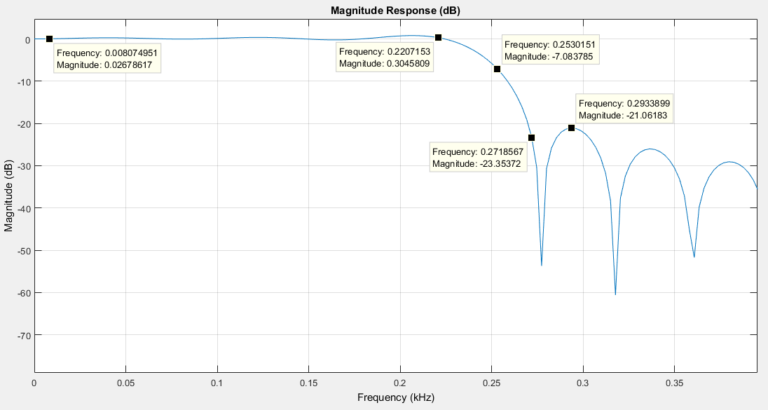Figure 1: Filter #1, Lowpass Filter Magnitude Response

Figure 1 shows that this filter has passband edge frequency at 250 Hz with 6dB attenuation and stopband edge frequency at ~270 Hz with ~23dB attenuation.

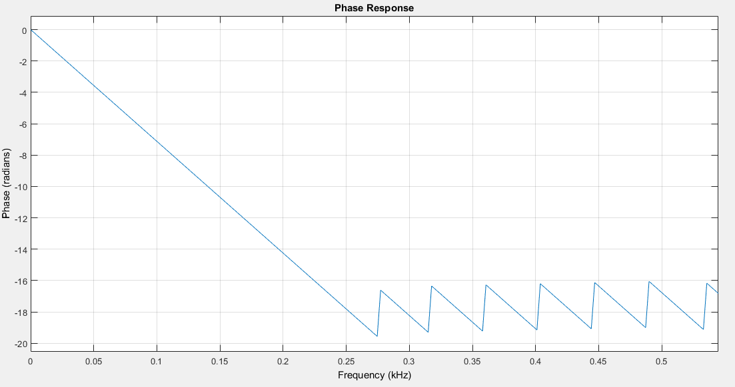Figure 2: Filter #1, Lowpass filter Phase Response

Figure 2 shows that Filter #1, has a linear phase.

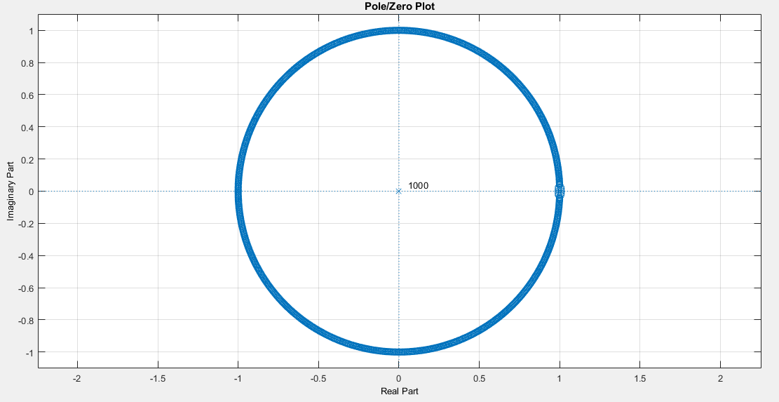Figure 3: Filter #1, Lowpass filter pole zero plot

Figure 3 shows that Filter #1 is stable as all the poles lie inside the unit circle.

**Filter #2:**  
To only allow frequencies between than 250 Hz and 1kHz, a Bandpass Filter is designed.

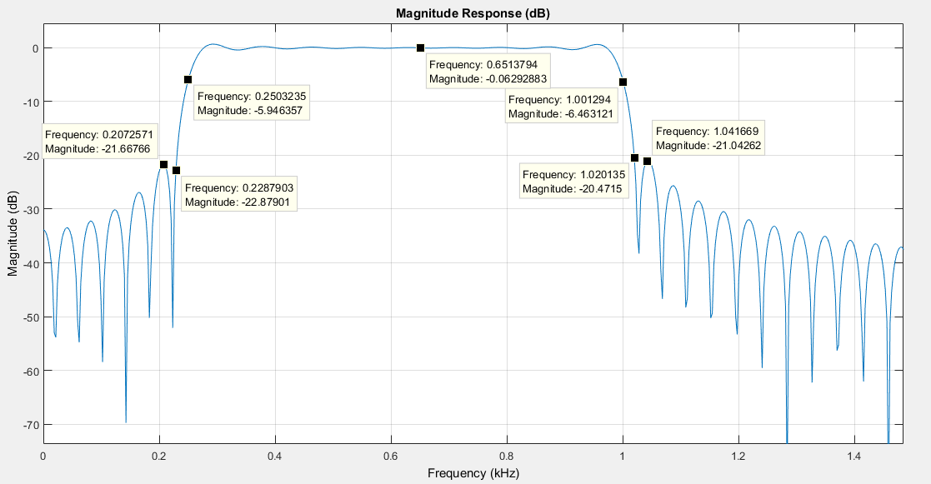Figure 4: Filter #2, bandpass filter Magnitude Response

Figure 4 shows that Filter #2 has,   
Fstop1: ~228 Hz, Attenuation: ~22dB  
Fpass1: ~250 Hz, Attenuation: 6dB  
Fstop2: ~1.2 kHz, Attenuation: ~20dB  
Fpass2: ~1 kHz, Attenuation: 6dB

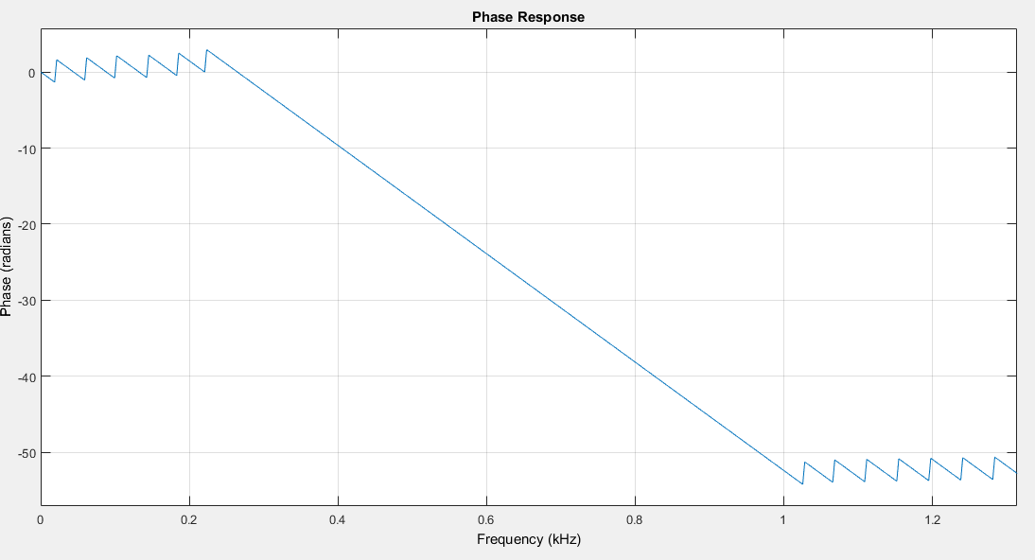Figure 5: Filter #2, bandpass filter phase response

Figure 5 shows that Filter #2 has linear phase.

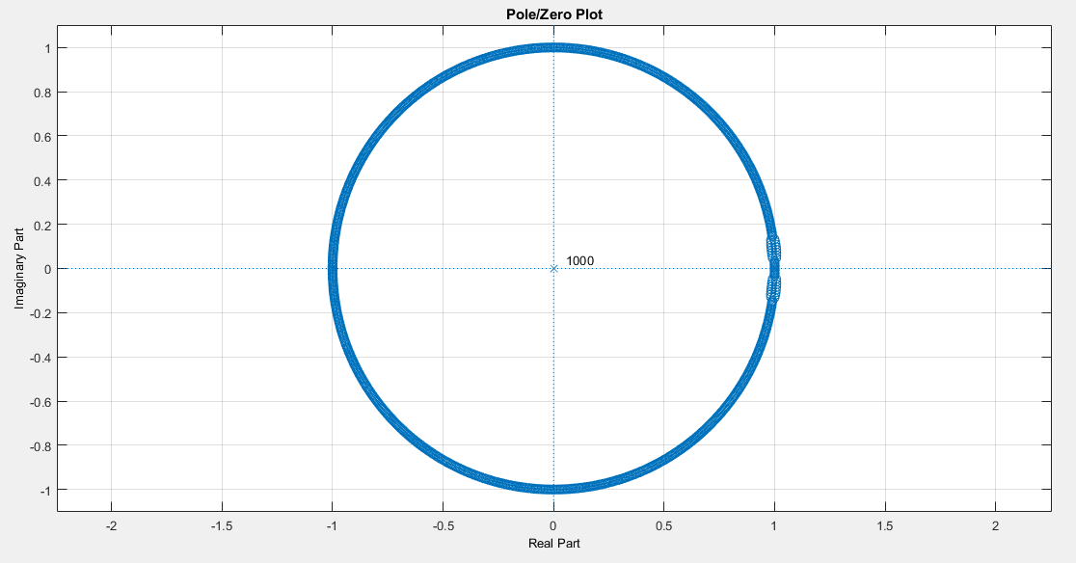Figure 6: Filter #2, bandpass filter pole zero plot

Figure 6 shows that Filter #2 is stable because all the poles lie inside unit circle.

**Filter #3:**  
To only allow frequencies between than 1 kHz and 4kHz, a Bandpass Filter is designed.

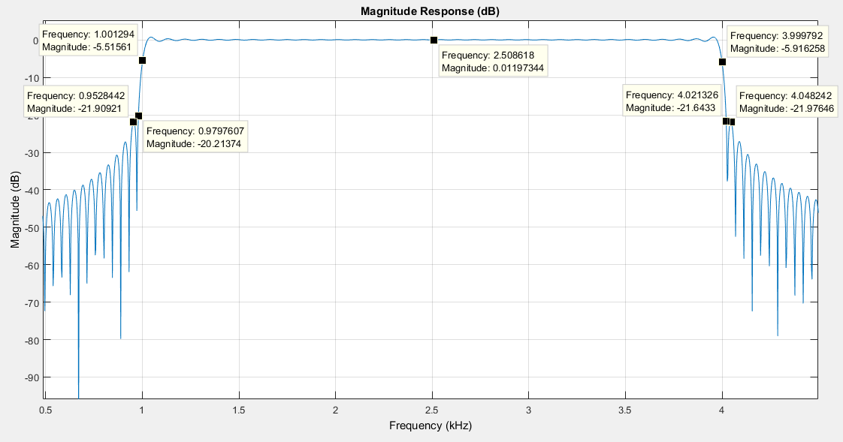Figure 7: Filter #3, bandpass filter Magnitude Response

Figure 7 shows that Filter #3 has,   
Fstop1: ~ 980Hz, Attenuation: ~20dB  
Fpass1: ~1 kHz, Attenuation: 6dB  
Fstop2: ~4.02 kHz, Attenuation: ~21B  
Fpass2: ~4.0 kHz, Attenuation: ~6dB

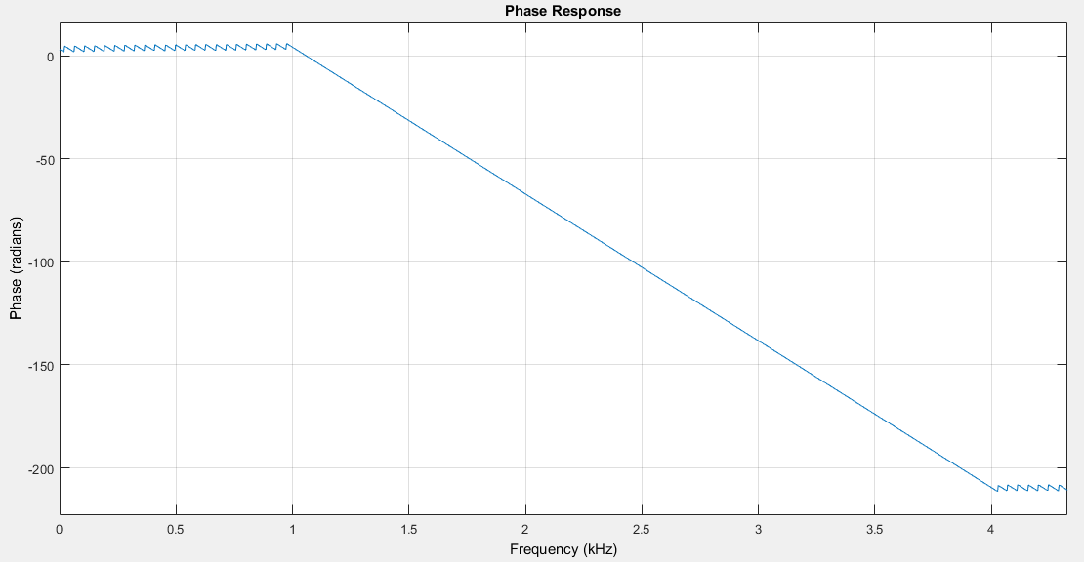Figure 8: Filter #3, bandpass filter phase response

Figure 8 shows that Filter #3 has linear phase.

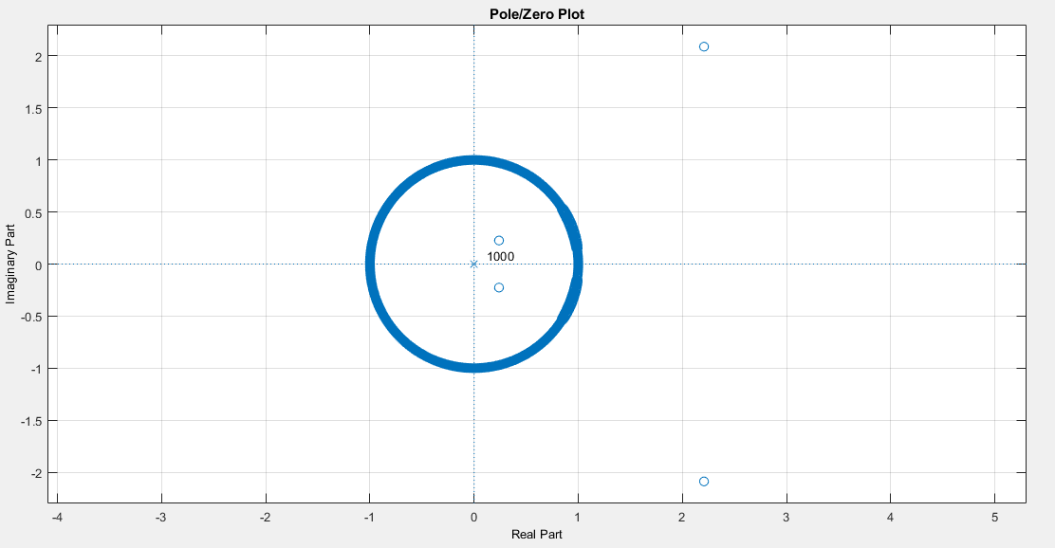

Figure 9: Filter #3, bandpass filter pole zero plot

Figure 9 shows that Filter #3 is stable because all the poles lie inside unit circle.

**Filter #4:**  
To only allow frequencies between than 4 kHz and 8kHz, a Bandpass Filter is designed.

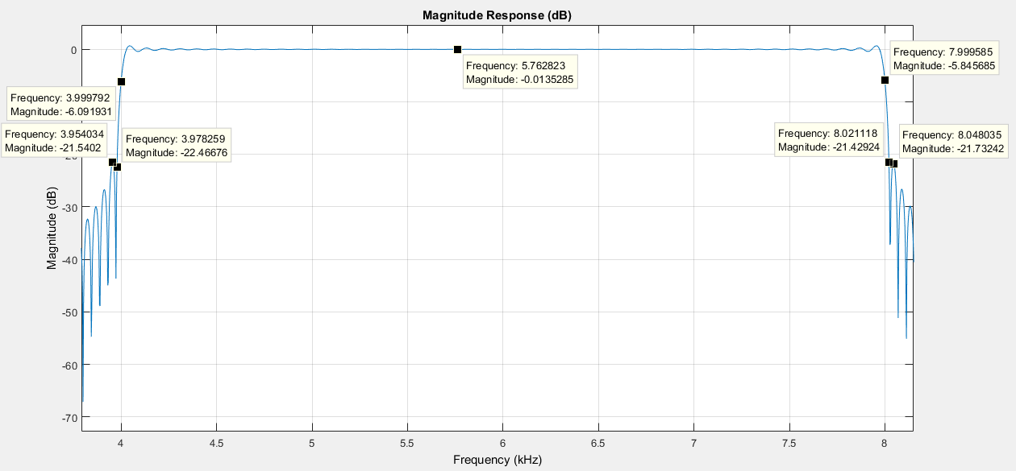Figure 10: Filter #4, bandpass filter Magnitude Response

Figure 10 shows that Filter #4 has,   
Fstop1: ~ 3.97 kHz, Attenuation: ~22dB  
Fpass1: ~4 kHz, Attenuation: 6dB  
Fstop2: ~8.02 kHz, Attenuation: ~21 dB  
Fpass2: ~8.0 kHz, Attenuation: ~6dB

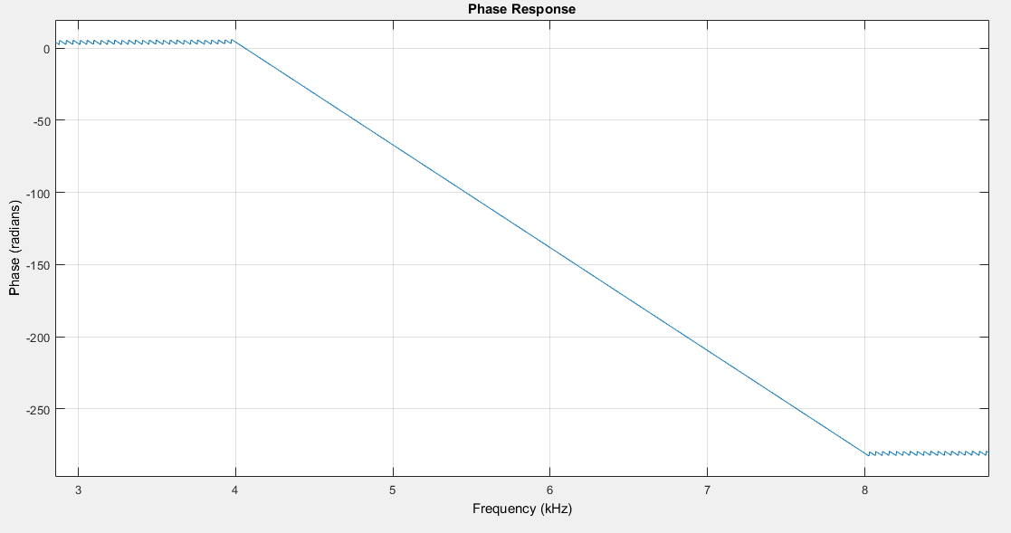Figure 11: Filter #4, bandpass filter phase response

Figure 11 shows that Filter #4 has linear phase.

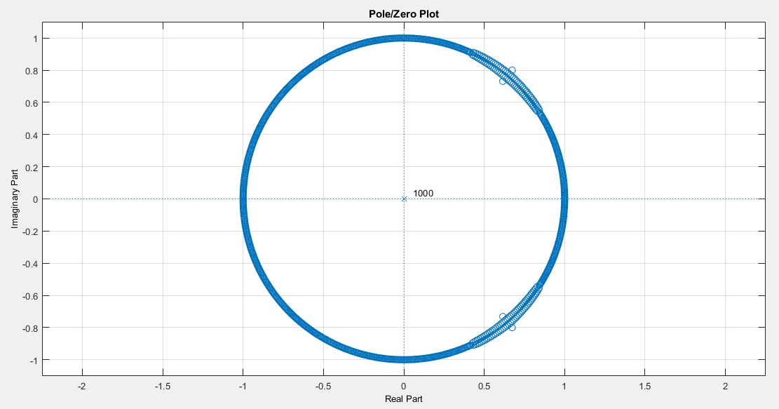Figure 12: Filter #4, bandpass filter pole zero plot

Figure 12 shows that Filter #4 is stable because all the poles lie inside unit circle.

**Filter #5:**  
To only allow frequencies between than 8 kHz and 20kHz, a Bandpass Filter is designed.

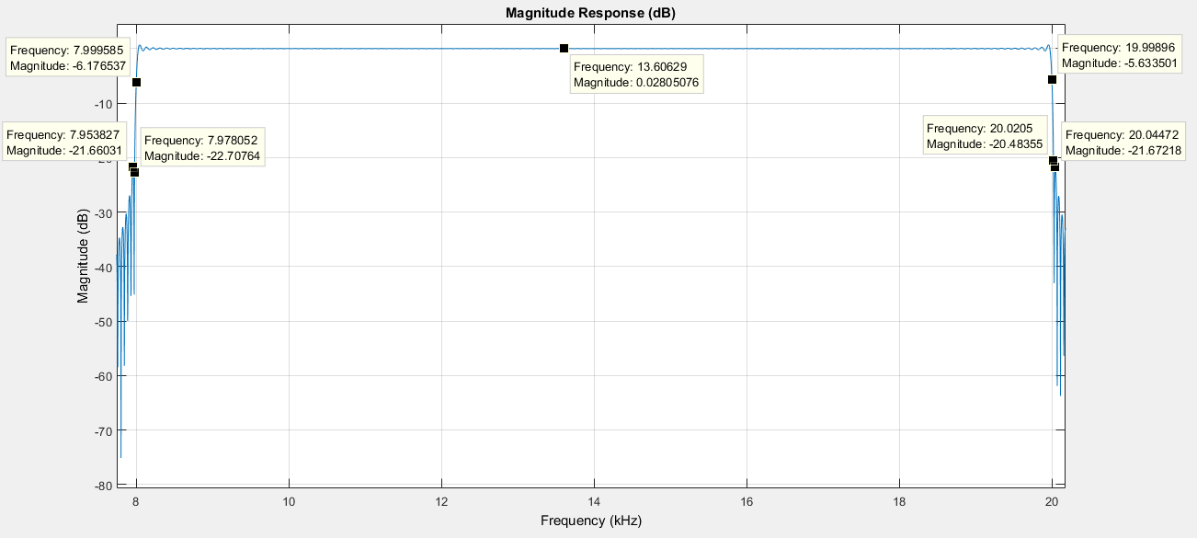Figure 13: Filter #5 bandpass filter Magnitude Response

Figure 13 shows that Filter #5 has,  
Fstop1: ~ 7.97 kHz, Attenuation: ~22dB  
Fpass1: ~8 kHz, Attenuation: 6dB  
Fstop2: ~20.02 kHz, Attenuation: ~21 dB  
Fpass2: ~20.0 kHz, Attenuation: ~6dB

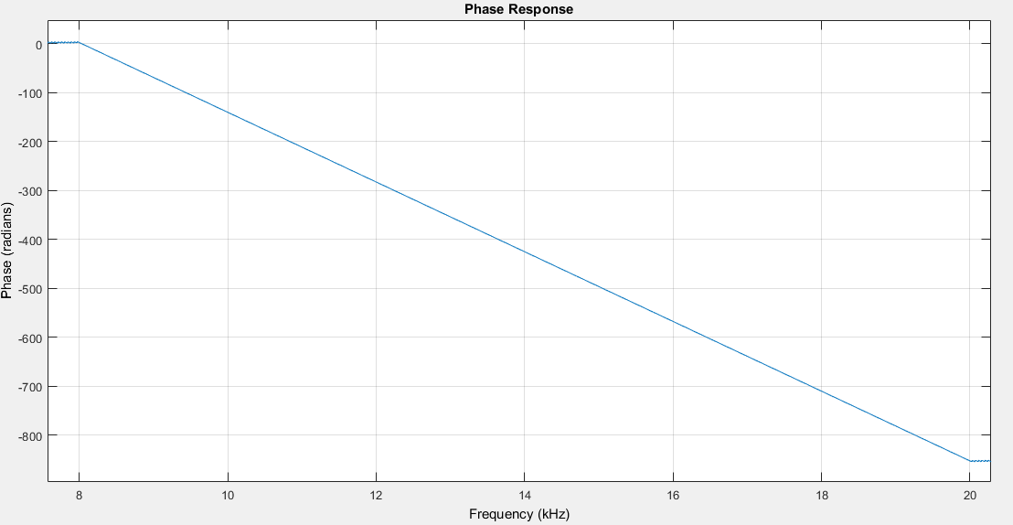Figure 14: Filter #5, bandpass filter phase response

Figure 14 shows that Filter #5 has linear phase.

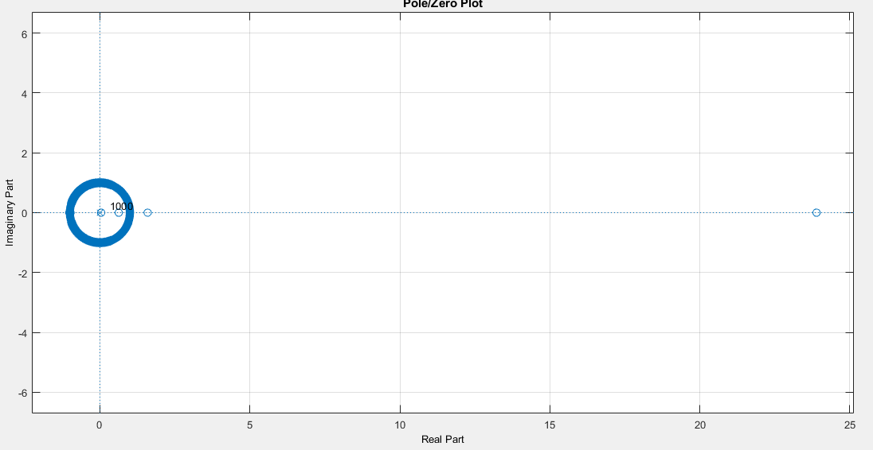Figure 15: Filter #5, bandpass filter pole zero plot

Figure 15 shows that Filter #5 is stable because all the poles lie inside unit circle.

|  |  |  |  |  |  |  |  |  |  |  |
| --- | --- | --- | --- | --- | --- | --- | --- | --- | --- | --- |
| Filter # | Response Type | Design Method | Fstop1  (Hz) | Fpass1  (Hz) | Fpass2  (Hz) | Fstop2  (Hz) | Fstop1 Attenuation (db) | Fpass1 Attenuation (dB) | Fpass2 Attenuation (dB) | Fstop2 Attenuation (dB) |
| 1 | Lowpass | Window Kaiser | 270 | 250 | NA | NA | ~23 | 6 | NA | NA |
| 2 | Bandpass | Window Kaiser | 228 | 250 | ~1k | ~1.2k | -22 | 6 | 6 | ~20 |
| 3 | Bandpass | Window Kaiser | ~980 | ~1k | ~4k | ~4.02k | ~20 | 6 | 6 | ~21 |
| 4 | Bandpass | Window Kaiser | ~3.97k | ~4k | ~8k | ~8.02k | ~22 | 6 | 6 | ~21 |
| 5 | Bandpass | Window Kaiser | ~7.91k | ~8k | ~20k | ~20.02k | ~22 | 6 | 6 | ~21 |

**Audio Spectrum Results:**

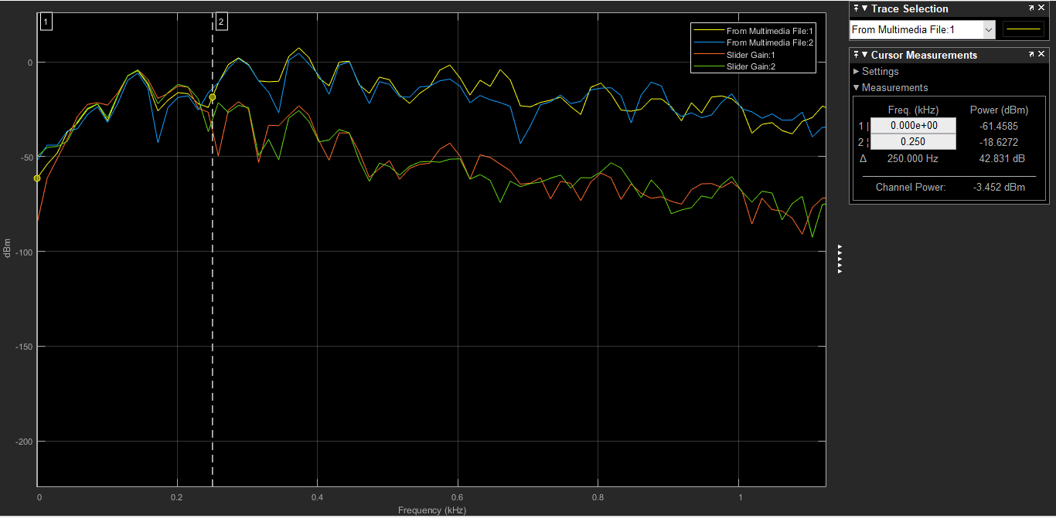Figure 16: Filter #1, Input signal through Lowpass Filter (passband < 250 Hz)

Figure 16 shows the input signal spectrum (Yellow and Blue lines) and the spectrum of input signal when it passes though low pass filter (Red and Green Lines). The input signal with frequencies less than 250 Hz are not attenuated by the lowpass filter because these frequencies lie on the passband of this filter, whereas frequencies greater than 250 Hz get stopped(attenuated) by the lowpass filter because they lie on the stop band of this filter.

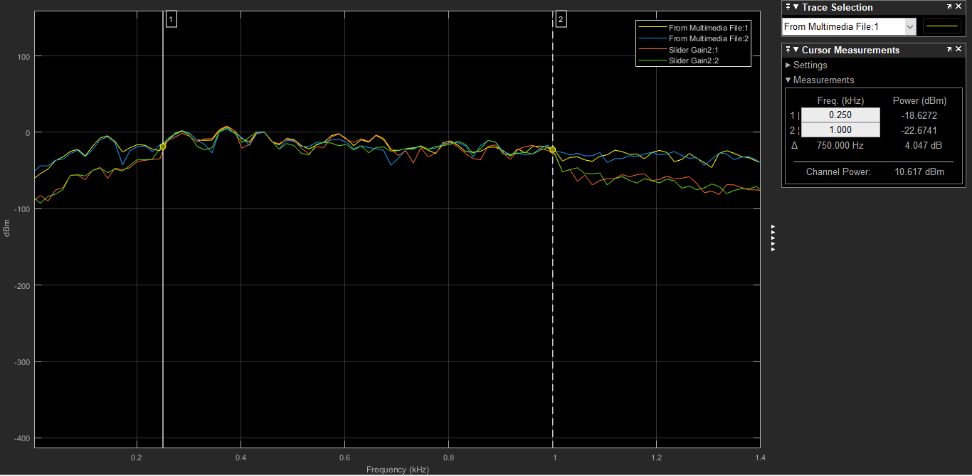Figure 17: Filter #2, Input signal through Bandpass Filter (passband 250Hz – 1kHz)

Figure 17 shows the input signal spectrum (Yellow and Blue lines) and the spectrum of input signal when it passes Bandpass filter (Red and Green Lines). The passband of this bandpass filter is between 250 Hz to 1kHz. Therefore, as shown in figure 17, input signal with frequencies that lie on passband are not attenuated by this filter however frequencies less than 250 Hz and greater than 1kHz get attenuated by this filter.

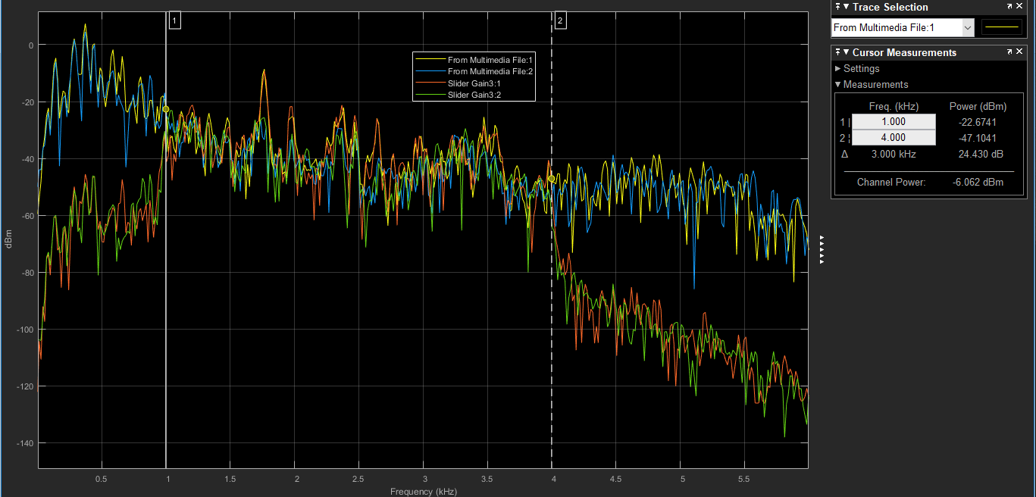Figure 18: Filter #3, Input signal through Bandpass Filter (passband 1 kHz – 4kHz)

Figure 18 shows the input signal spectrum (Yellow and Blue lines) and the spectrum of input signal when it passes Bandpass filter (Red and Green Lines). The passband of this bandpass filter is between 1kHz to 4kHz. Therefore, as shown in figure 17, input signal with frequencies that lie on passband are not attenuated by this filter however frequencies less than 1 kHz and greater than 4kHz get attenuated by this filter.

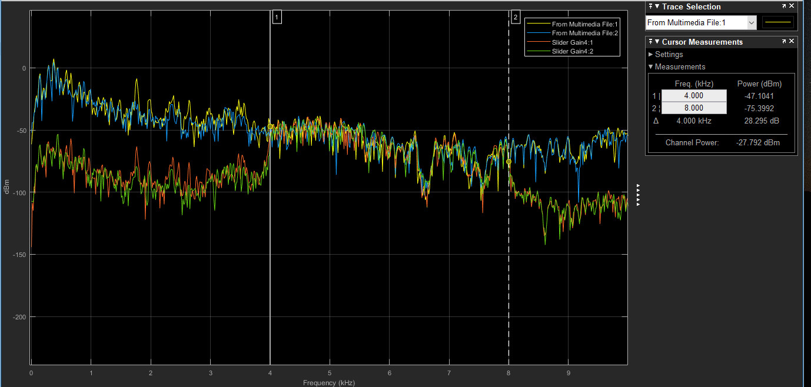Figure 19: Filter #5, Input signal through Bandpass Filter (passband 4 kHz – 8 kHz)

Figure 19 shows the input signal spectrum (Yellow and Blue lines) and the spectrum of input signal when it passes Bandpass filter (Red and Green Lines). The passband of this bandpass filter is between 4 kHz to 8 kHz. Therefore, as shown in figure 19, input signal with frequencies that lie on passband are not attenuated by this filter however frequencies less than 4 kHz and greater than 8 kHz get attenuated by this filter.

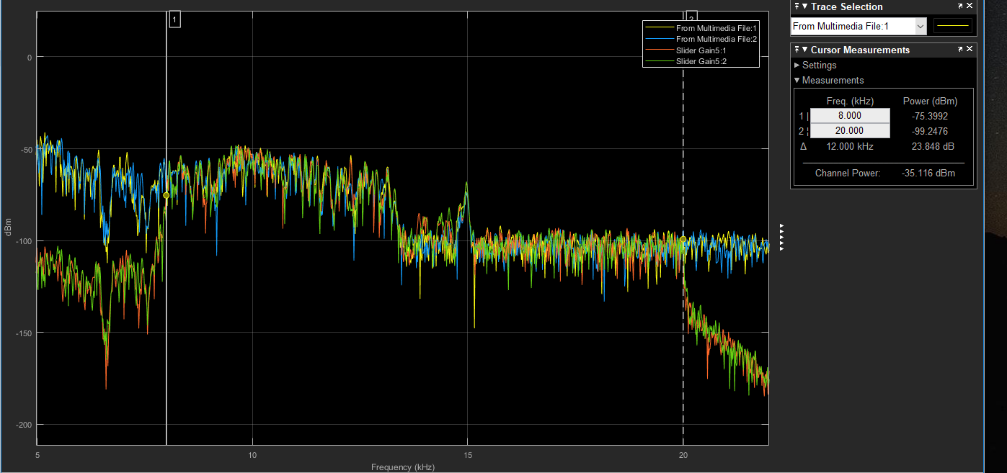Figure 20: Filter #6, Input signal through Bandpass Filter (passband 8 kHz – 20 kHz)

Figure 20 shows the input signal spectrum (Yellow and Blue lines) and the spectrum of input signal when it passes Bandpass filter (Red and Green Lines). The passband of this bandpass filter is between 8 kHz to 20 kHz. Therefore, as shown in figure 19, input signal with frequencies that lie on passband are not attenuated by this filter however frequencies less than 8 kHz and greater than 20 kHz get attenuated by this filter.

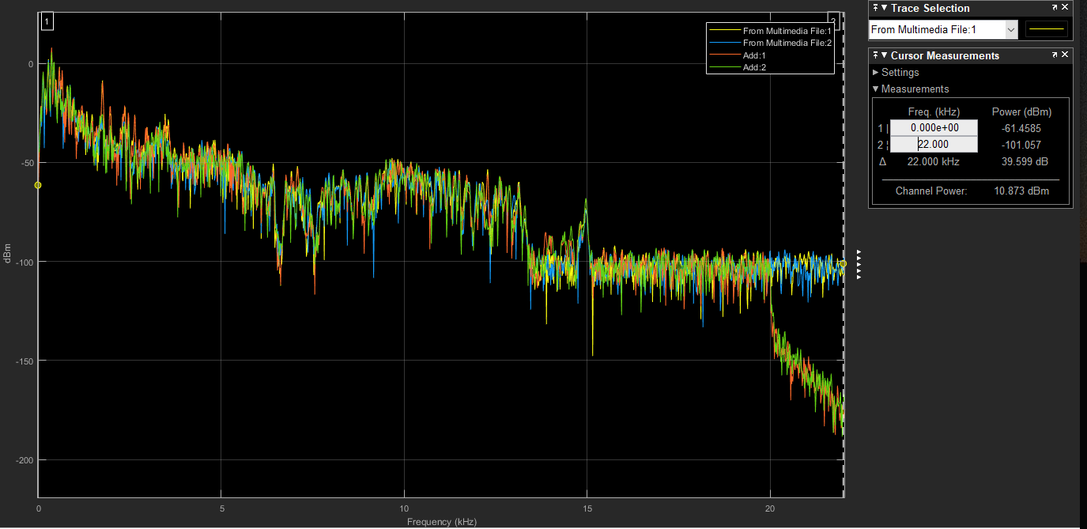Figure 21: Spectrum of Sum of Input signal through All the Filters

Figure 21 shows the original input signal (blue and yellow lines) and the sum of input signal though filters (read and green). For the band (0 Hz – 20 kHz), the output signal from filters are like input signal.

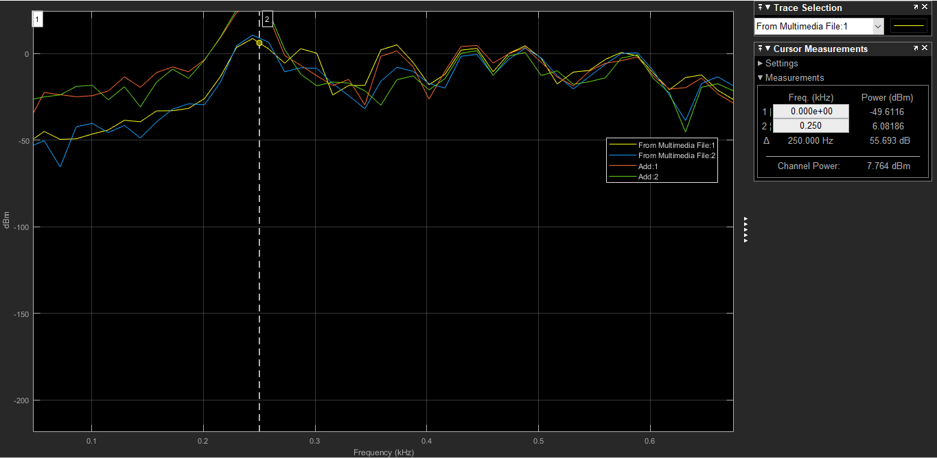Figure 22: Bass Amplified

Figure 22 shows the original signal (blue and green) and the input signal through filter (red and green). The gain of input signal through filter has been increased to 15. When this configuration was run, louder bass could be heard.

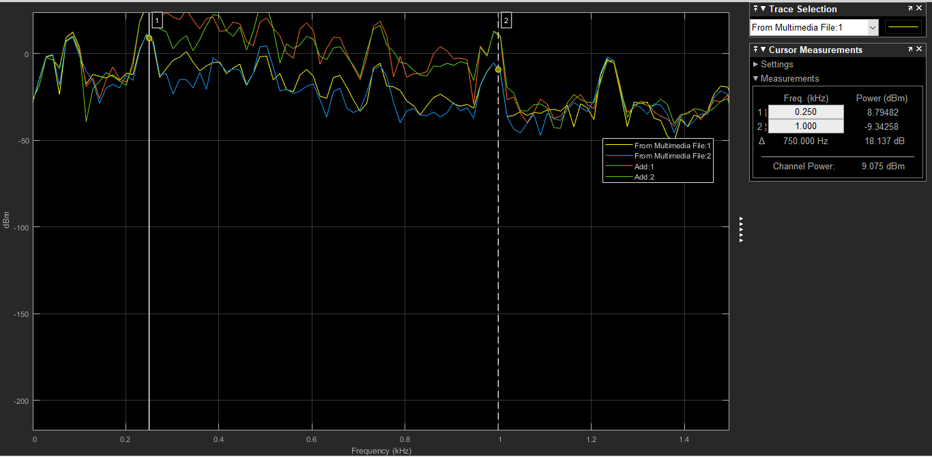Figure 23: Lower Midrange Amplified

Figure 23 shows the original signal (blue and green) and the input signal through filter (red and green). The gain of input signal through filter has been increased to 15. When this configuration was run, louder lower midrange sound could be heard.

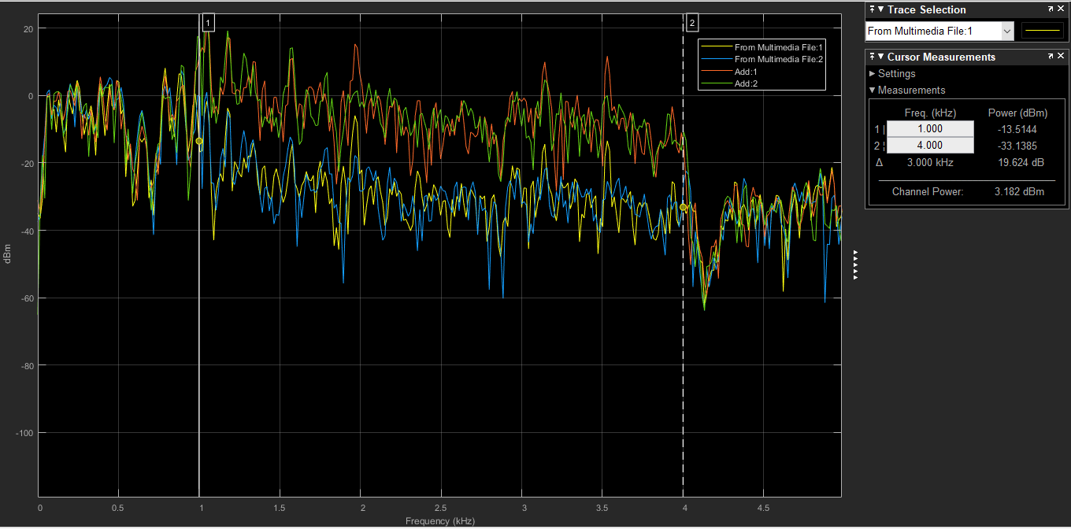Figure 24: Upper Midrange Amplified

Figure 24 shows the original signal (blue and green) and the input signal through filter (red and green). The gain of input signal through filter has been increased to 15. When this configuration was run, louder upper midrange sound could be heard.

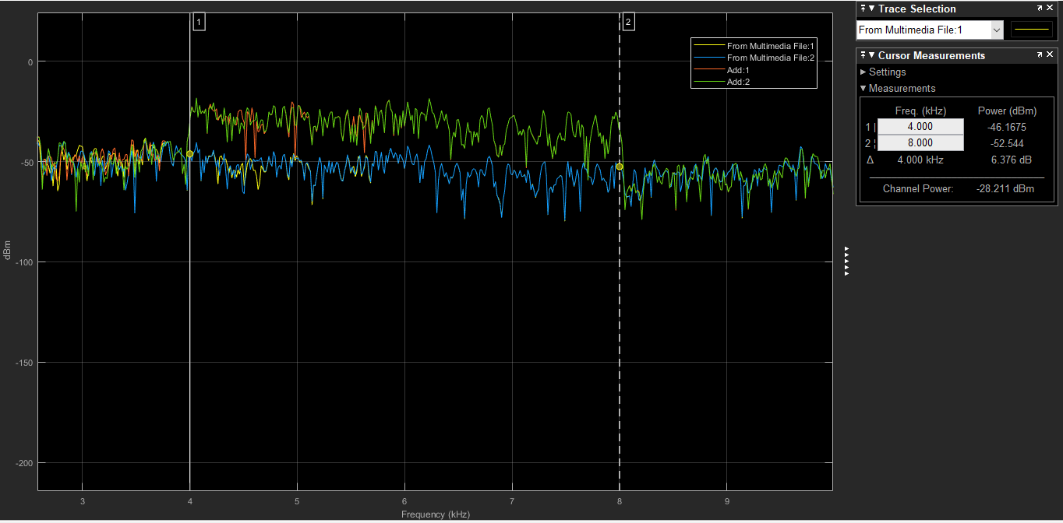Figure 25: Presence Amplified

Figure 25 shows the original signal (blue and green) and the input signal through filter (red and green). The gain of input signal through filter has been increased to 15. When this configuration was run, louder Presence could be heard.

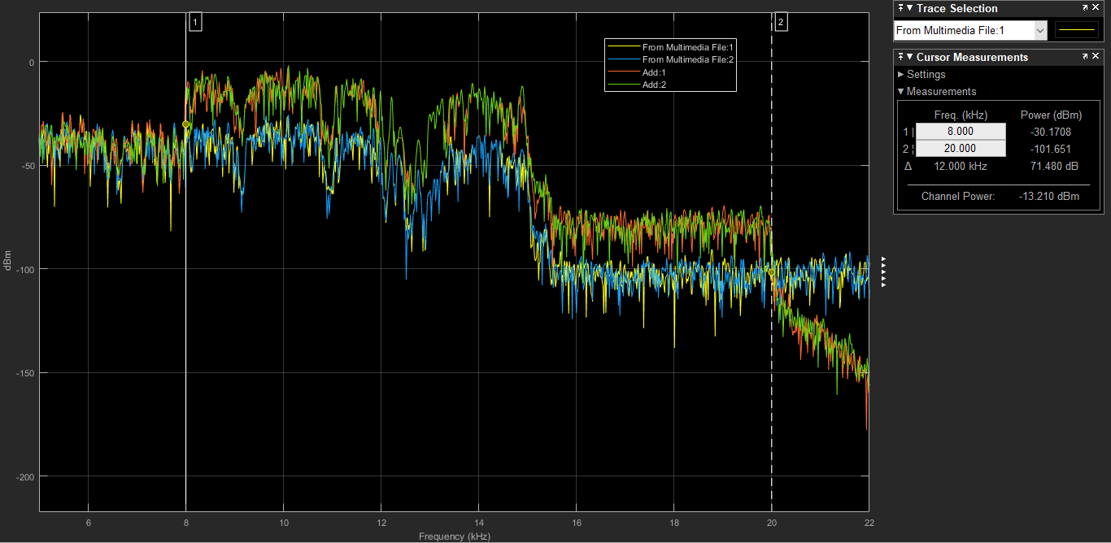

Figure 26: Brilliance Amplified

Figure 26 shows the original signal (blue and green) and the input signal through filter (red and green). The gain of input signal through filter has been increased to 15. When this configuration was run, louder Brilliance sound could be heard.

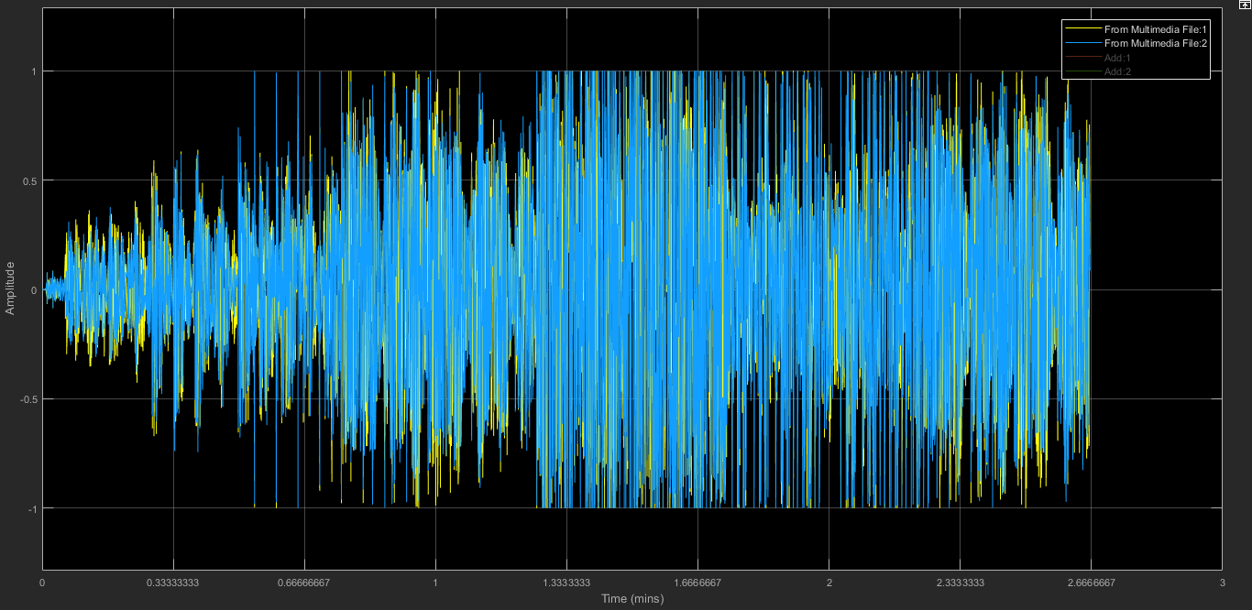Figure 27: Input Audio Signal in Time Domain

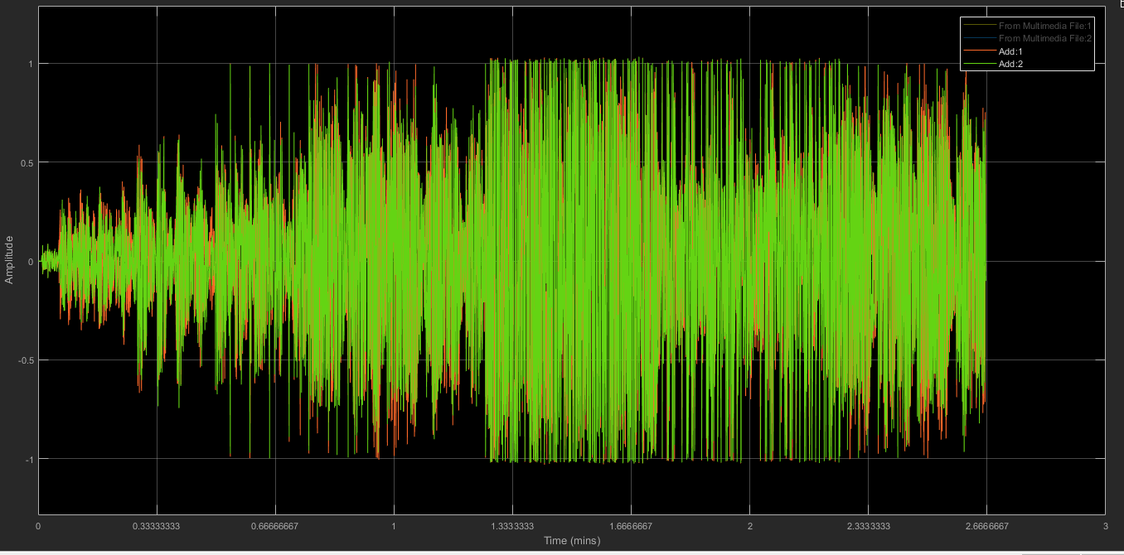Figure 28: Input Audio Signal when put though filters in Time Domain

**Verification of the Equalizer**

To verify the sum of filters resulted in a continuous spectrum, the coefficients of all the filter’s used in this equalizer were exported then these coefficients were used to get a combine frequency response of digital filter. Then magnitude response of this digital filter is shown below:

Matlab Code:

%project File

[y,Fs] = audioread('BE_OE.mp3');

Ts = 1/Fs;

%sound(y,Fs);

Hd = (1 * H1)+ (1 * H2) + (1 * H3) + (1 * H4) + (1 * H5);

[h,w] = freqz(Hd,1);

hFinal = abs(h);

mag_dB = 20.*log10(hFinal);

subplot(2,1,1);

plot(w, mag_dB);

grid on;

title('Magnitude Response of the Eqalizer with gain of 1');

xlabel('Angular Frequency (kHz)');

ylabel('Magnitude (dB)');

Hd = (5 * H1)+ (4 * H2) + (3 * H3) + (2 * H4) + (1 * H5);

[h,w] = freqz(Hd,1);

hFinal = abs(h);

mag_dB = 20.*log10(hFinal);

subplot(2,1,2);

plot(w, mag_dB);

grid on;

title('Magnitude Response of the Eqalizer with varied gain');

xlabel('Angular Frequency (kHz)');

ylabel('Magnitude (dB)');

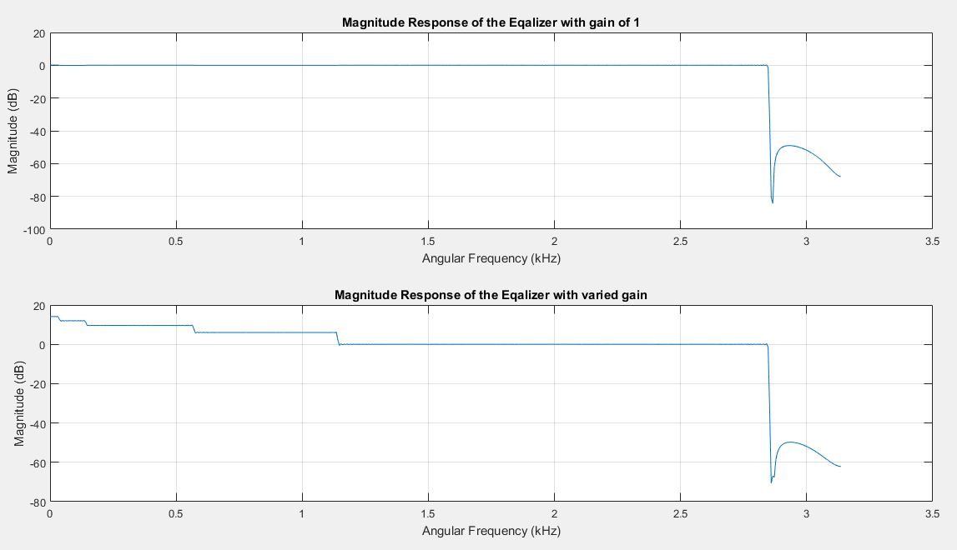Figure 29: Magnitude Response of the Equalizer

Figure 29: Plot 1, shows the Magnitude Response of equalizer with a gain of 1. The flat line for majority shows that the frequency bands line up correctly. The presence of flat line shows that the cutoff frequencies from all the filters match with adjacent bands. Plot 2 shows the magnitude response with different gain. This also verifies that this design can be used as an audio equalizer.

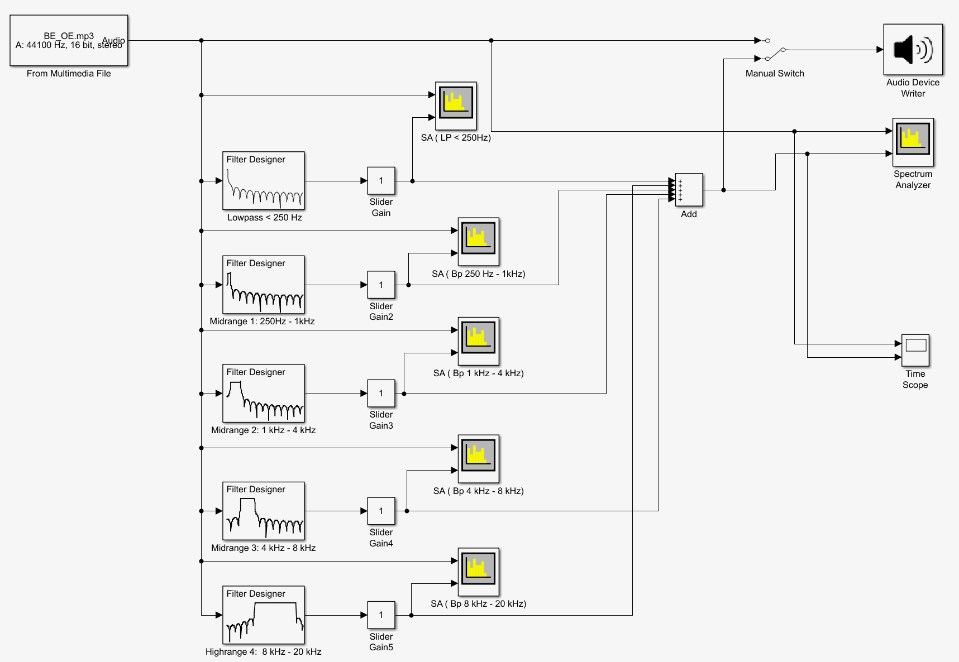

**Conclusion**

A 5-band equalizer was designed using Simulink. Amplitude of frequency band was increased to see the effect of gain of the audio. Fir Filter were used for Filter design methods because fir filters are stable and do not have feedback. High order filters were used for this project, however, lower filter order could be used to reduce any delay present in output signal of filters. This equalizer was then verified in MATLAB by plotting its magnitude response. The magnitude response showed the band lined up correctly for the combination of all 5 filters.

**References**

Dr. Ling Hou, Class Notes

“Audio Signal.” *Wikipedia*, Wikimedia Foundation, 8 Mar. 2019, en.wikipedia.org/wiki/Audio_signal.

“Equalization (Audio).” *Wikipedia*, Wikimedia Foundation, 15 Mar. 2019, en.wikipedia.org/wiki/Equalization_(audio).