

Course: Erasmus — BI and Data Analytics
Level: 2LIG

Smart Supply Chains:
Unlocking Performance Insights
with Power BI

Presented by :  Oueslati Malek | professer :  Dr.Hamdi Hassen  Dr. Ayari Ahlem

Année Universitaire : 2025–2026

Introduction

Business Intelligence & Supply Chain
In today's data-driven economy, companies generate vast amounts of transactional data across their supply chain operations — from order placement to final delivery. Without the right tools to analyze this data, critical performance issues remain hidden and decisions are made on intuition rather than facts.
Business Intelligence addresses this challenge by transforming raw data into meaningful visual insights. Through dashboards, KPIs, and interactive reports, BI enables decision-makers to monitor performance in real time, identify bottlenecks, and take corrective action before problems escalate.

Project Overview
This project applies BI concepts to the analysis of a real-world e-commerce supply chain dataset. Using Microsoft Power BI as the analytics platform and the DataCo Smart Supply Chain dataset from Kaggle (180,519 transactions, 2015–2018), we built a 5-page interactive dashboard covering delivery performance, order fulfillment, shipping mode analysis, and cost & profit optimization.

Dataset
- Source: DataCo Smart Supply Chain — Kaggle (CC0 Public Domain)
- Size: 180,519 orders across 53 columns
- Period: January 2015 — January 2018
- Scope: Global e-commerce — 164 countries, multiple regions and product categories

Key Performance Indicators Tracked
- On-Time Delivery Rate (OTDR) — target: ≥ 95% | actual: 45.2%
- Average Lead Time — target: ≤ 4 days | actual: 3.5 days
- Order Fulfillment Rate — target: ≥ 90% | actual: 33%
- Late Delivery Risk Rate — target: ≤ 10% | actual: 54.82%
- Average Profit per Order — actual: $21.11
- Total Orders: 66,000 | Late Orders: 36,000

Power BI Dashboard

— Overview
The Overview page provides an immediate summary of all key supply chain KPIs through Card visuals, a Donut chart showing delivery status breakdown, and a Bar chart of orders by shipping mode. Three interactive slicers (Date, Region, Shipping Mode) allow dynamic filtering across all visuals.
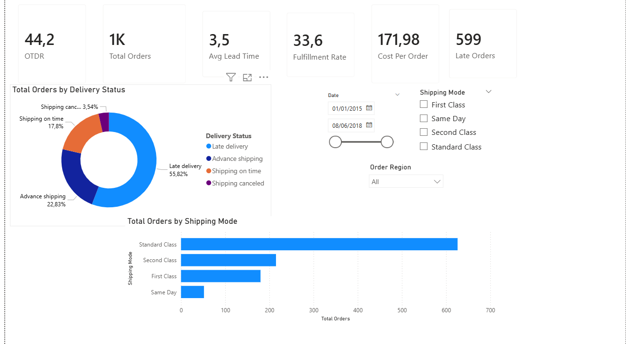

— Delivery Performance
This page focuses on the OTDR metric over time. A line chart displays the monthly OTDR trend with a green reference line at the 95% target, making the performance gap immediately visible. A 3-month forecast using Power BI's built-in ETS algorithm projects that the OTDR will remain flat without intervention. A clustered column chart compares Total Orders vs Late Orders by month.
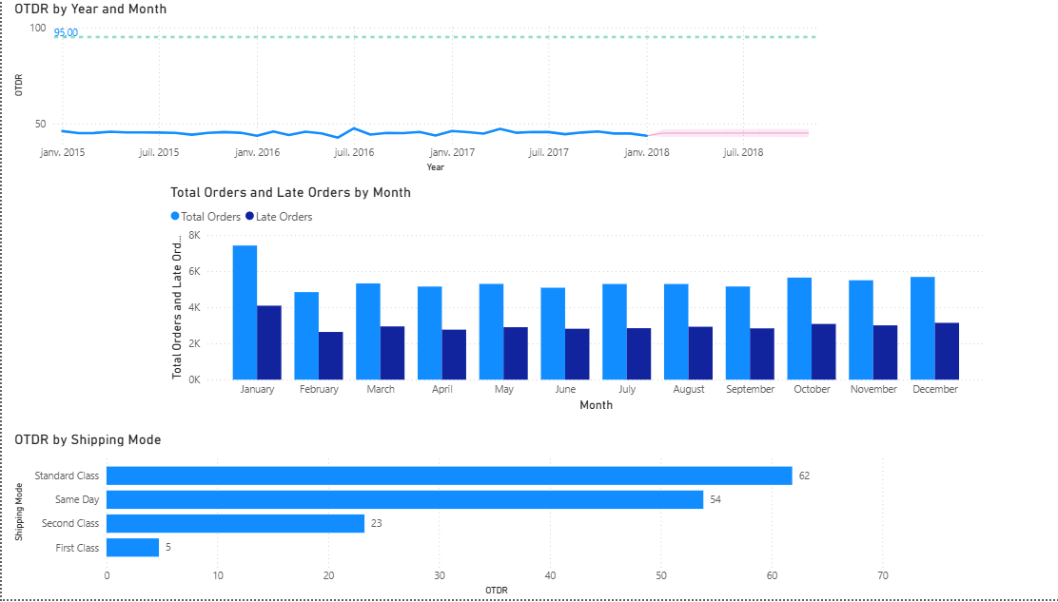
— Order Fulfillment & Risk
This page analyzes order status distribution and late delivery risk by region. With a fulfillment rate of only 33% and 54.82% of orders flagged as high delivery risk, this page identifies the most problematic regions and order statuses.
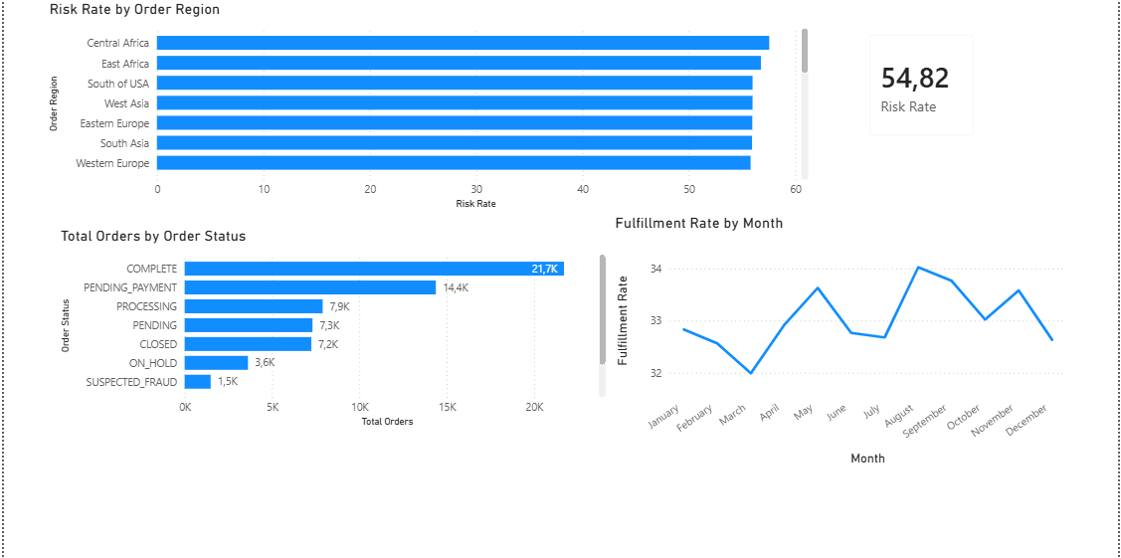— Shipping Mode Analysis
A detailed comparison of the four shipping modes (Standard Class, First Class, Second Class, Same Day) reveals a striking paradox: First Class, despite having the shortest lead time (2 days), achieves the worst OTDR of only 5%, while Standard Class leads with 62% OTDR and $8M in sales.
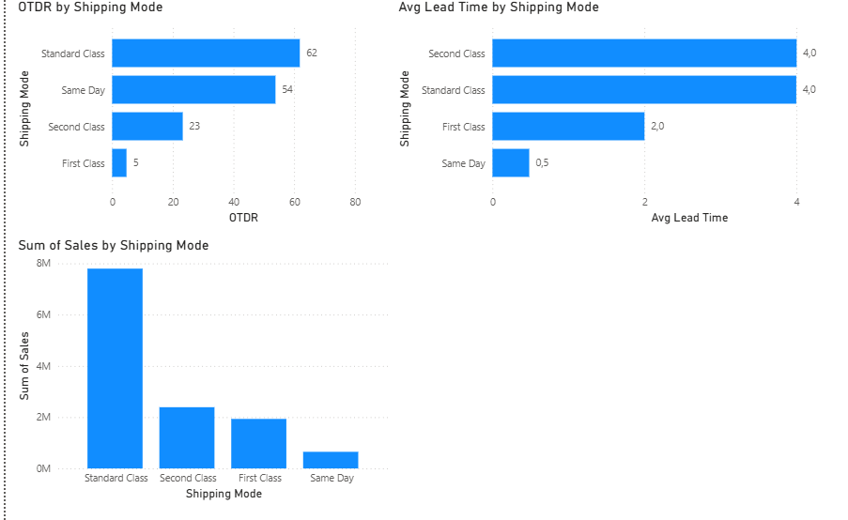

— Cost & Profit Analysis + What-If
The final page analyzes revenue and profitability by region and product category, and includes an interactive What-If simulator. Using a slider parameter (0–30% cost reduction), users can simulate the annual savings generated by reducing shipping costs — a 15% reduction yields approximately $1.9M in annual savings across 66,000 orders.
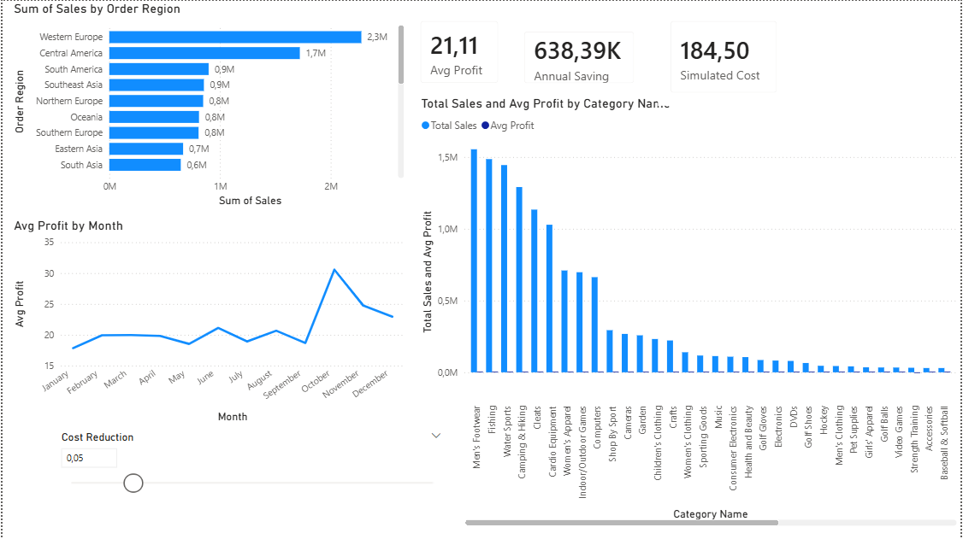

Conclusion

This project demonstrated how Power BI can transform 180,519 raw supply chain transactions into clear, actionable insights across 5 interactive dashboard pages.

Key Findings
- OTDR of 45.2% — 36,000 out of 66,000 orders arrive late, far below the 95% target
- First Class shipping achieves only 5% OTDR despite a 2-day lead time — delivery promises are unachievable
- Standard Class is the most reliable (62% OTDR) and most profitable ($8M in sales) shipping mode
- Only 33% of orders reach COMPLETE status — a major processing backlog needs urgent attention
- 1,500 SUSPECTED_FRAUD orders represent unmonitored revenue risk
- Western Europe leads in sales ($2.3M); Q4 shows a clear seasonal profit peak
- Power BI Forecast confirms: OTDR will NOT improve without structural intervention
- What-If Analysis: a 15% shipping cost reduction generates ~$1.9M in annual savings

Recommendations
- Renegotiate or suspend First Class SLAs — the service is consistently failing
- Reduce PROCESSING backlog — streamline order management workflows
- Promote Same Day shipping for high-value orders — best lead time at 0.5 days
- Pre-position inventory ahead of Q4 seasonal demand peak
- Implement automated fraud detection to recover 1,500 at-risk orders
- Target 15% shipping cost reduction to unlock $1.9M annual savings

Expected Impact After Recommendations
OTDR: 45.2% → 60–65% | Fulfillment Rate: 33% → 55%+
Late Orders: 36K → 24K (–33%) | Annual Saving: ~$1.9M
Avg Profit/Order: $21 → $25+ | Fraud Risk: –80% with detection

