TP3-HTML

- Create the following folder structure
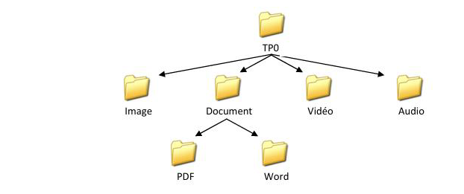
- Place at least one corresponding file in each subfolder (image, video, audio, PDF, and Word).
- Open your text editor (Visual Studio Code) and write the basic structure of an HTML file.
- Save this file as Index.html inside the TP03 folder (this is your homepage or main website page).
- Add an HTML title to your index.html page: Homepage.
- Add the following first-level title to the content of the page:

**COURSES TAUGHT IN COMPUTER SCIENCE ENGINEER **
- Add the following second-level titles to the content:
  - 1nd Year Computer Science
  - 2rd Year Computer Science
- Under each second-level title, add the following third-level titles:
1st Semester 2nd Semester
- Save the changes and open the HTML file in your browser to view the results. Refresh the page after each change.
- Set the background color of your webpage to light blue (`#ADD8E6`).
- Add a horizontal separator before each second-level title.
- Insert the following paragraphs under each third-level title, setting the font size to 5:
  - List of modules taught in the first semester Computer science for the 1st year: ALG1, ASD1, AM2, ISE1, WE.
  - List of modules taught in the second semester Computer science for the 1st year: ALG2, ASD2,
ProbSt, ISE2, LOG, AM2, TEO.
  - List of modules taught in the first semester Computer science for the 2rd year: SFSD, POO1, AM3, ADO2, ENTP, Alg3, AC, ProbStat2.
  - List of modules taught in the second semester Computer science for the 2rd year: POO2, ANG, ISI, IRI, TG ,TL, IBD

- Add the following summary table:
Level |  | Courses in Computer Science License
1st Year | 1st Semester | ALG1 | ASD1 | AM2 | ISE1 | WE |  |  | /
1st Year | 2nd Semester | ALG2 | ASD2 | ProbSt | ISE2 | LOG | TEO | AM2 | /
2rd Year | 1st Semester | SFSD | POO1 | AM3 | ADO2 | ENTP | Alg3 | ProbStat2 | AC
2rd Year | 2nd Semester | POO2 | ANG | ISI | IRI | TG | TL | IBD

- Create two new HTML files in the TP03 folder called Year1.html and Year2.html.
- Make the second-level titles "1st Year Computer engineer " and "2rd Year Computer Science engineer " (which you added in question 7 to the index.html page) hyperlinks to access the pages Year1.html and Year2.html respectively.
- In Year1.html and Year2.html, create nested bulleted lists:

1st Year Computer Science engineer
- 1st Semester:
- ALG1
- ASD1
- AM2
- ISE1
- WE
- 2nd Semester:
- ALG2
- ASD2
- Probst
- LOG
- TEO
2nd Year Computer Science engineer 1st Semester:
  - SFSD
  - POO1
  - AM3
  - ADO2
  - ENTP
  - Alg3
  - ProbStat2
  - AC
2nd Semester
- POO2
- ANG
- ISI
- IRI
- TG
- TL
- IBD

- Add a "Back to Homepage" link at the end of Year1.html and Year2.html, linking back to
Index.html.
- Each item in the numbered lists should link to an HTML page appropriate (ISE1.html, ASD1.html.).
- In ISE1.html, create five links to corresponding files (image, PDF, Word, video, and audio).
- Display the image file from the Image folder in its original dimensions.
- Copy the following system images to the Image folder: Image1.jpg, Image2.jpg, Image3.jpg, Image4.jpg.
- Display a 2-row, 2-column table in ASD1.html, with each cell containing one of these images (resized to 512x384 pixels).
- Modify the table so that each image is a hyperlink leading to image1.html, image2.html, image3.html, and image3.html.
- Add an anchor link at the bottom of ASD1.html to return to the top of the page.

- Create a registration form in a new file called Inscription.html.
- Add a hyperlink in Index.html titled "Register for Computer Science engineer" that links to
Inscription.html.
- In Inscription.html, add a second-level title: "Registration Form for Computer Science engineer ".
- Insert a form inside Inscription.html.
- Add a 12-row, 2-column table inside the form.
- Set the background color of Inscription.html to light green (`#90EE90`) and the table color to light yellow (`#F3F781`) with border size = 0.
- Add the following form fields (one per row):
- Input field for Full Name.
- Two radio buttons for Gender Selection.
- Input field for Age.
- Input field for Address.
- Dropdown menu for Selecting the Wilaya (Region).
- File upload button for Profile Photo.
- Five checkboxes for Sports Activities.
- Input field for Password.
- Input field for Confirm Password.
- Two radio buttons for Study Year Selection.
- Cancel button to Clear Form Data.
- Submit button to Send Data.
- Ensure the form fields have appropriate default values.
