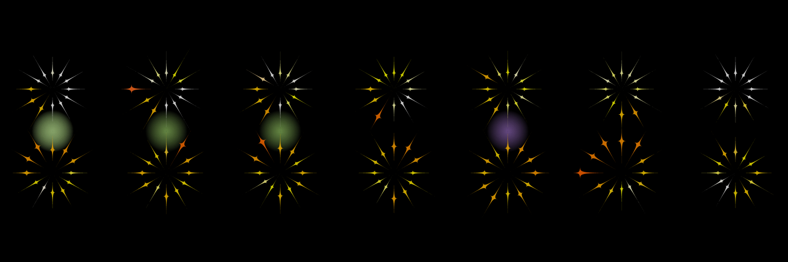

# Question:

How much activity do I get over the week, and how does this compare to my energy intake?

# Justification:

## Activity Tracking

I mapped the “***Mean Activity (g)***” data for each *hour* of *my own data* to the *length* of each star in the image. When I had more activity, the star was further away from the centre of each circle.

I mapped the “***Steps (average per min)***” data for each *hour* of *my own data* to the *colour* of each of the start. A greater number of average steps per minute makes the star turn red; a smaller number makes them more yellow. I used the map function to alter the amount of green displayed: mapping a high number of steps to a low amount of green to achieve this effect.

Both the colour and position of each star combine to give an overview of the activity I got while wearing the tracker.

I also mapped the proportion of time that the wristband thought I was “**Asleep (proportion)**” to the amount of blue colour in each star. This made the sleeping hours appear white, as the red, green and blue values were all near 255.

## Energy Intake

I mapped the “**Energy (kJ)(kJ)**” intake for each day of *my own nutrition* to a glowing dot between each day. More energy intake is represented as a greener dot, while a more purple dot represents lower energy intake.

## Day and Time

Each circle of stars represents 12 hours of my activity, with each star representing one hour. The top of each pair of circles is the AM hours, the bottom of each pair of circles are the PM hours.