**Concepts Lecture 1 - Homeostasis**

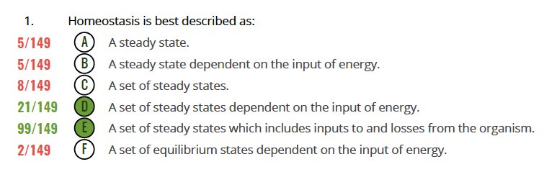

All of these answers are more or less correct – except F – but some answers are definitely better than others. E is probably *the* best answer (and most people went for this) but D is also fine. You’ll never get a formal MCQ that slices the salami this finely! This was just to get you thinking.

A useful, but more qualitative, definition is used in the HomeostasisBloodSugarCircuitry Video from Silverthorn: “Homeostasis is the body’s tendency to maintain relatively constant internal conditions.”

Now to F: Firstly, homeostasis is mostly about reactions, circuits, system, etc. which are maintained *away* from equilibrium, not at equilibrium. Energy is required to hold a reaction away from equilibrium opposing its ‘natural’ tendency to drive towards equilibrium. Now think about this in reverse: Does a system at equilibrium require an input of energy? No. Statement F is also contradictory as well as putting its emphasis on equilibrium states.

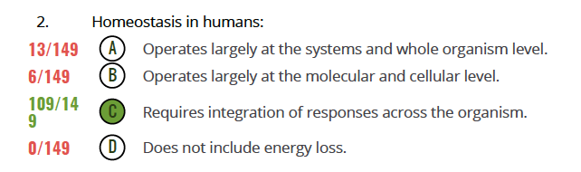

Hard to come to the conclusion (as in A and B) that homeostasis operates largely at certain levels and not others. If you selected either of these answers, what was your rationale? Be really interesting to know!

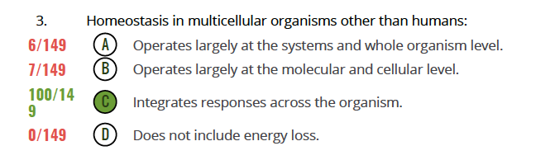

If you answered A or B, ask yourself why multicell organisms other than humans would be any different in general terms from humans.

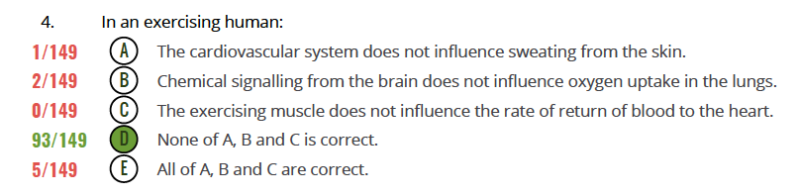

I expected this to be harder and was glad it wasn’t. The key point – that almost all of you seemed to recognise immediately – is that in homeostasis everything is connected. This is like – in fact essentially identical to – the ‘6 degrees of separation’ problem you will all have heard of. What you may not know is the following:

(i) That these degree-of-separation problems contain beautiful but as-yet very poorly understood principles of self-organisation.

(ii) That degree-of-separation problems can be applied to *almost anything*: People who know people, companies that deal with other companies, airports that connect with other airports, organisation of the WWW, molecules interacting with other molecules, and…systems and circuits influencing each other during homeostasis.

(iii) The average degree of separation is most often quite a bit smaller than 6 – often in the range 3-5.

So, think about A, B and C – even if you got the answer correct – and ask yourself what these actual physiological connections might be.