**Tubocurarine reduces single twitch contractile force of cane toad sciatic nerve-gastrocnemius** **muscle under neurogenic stimulation**

**Introduction**

Tubocurarine was historically used as a surgical anaesthetic, as a replacement for barbiturates. This pharmacological antagonist acts on the neuromuscular junction by preventing endogenous acetylcholine (ACh) from binding to nicotinic acetylcholine receptors (nAChR) at the neuromuscular junction (NMJ) (Gray & Halton, 1946; Jenkinson, 1960). Prevention of these post-synaptic ligand-gated sodium ion channels from opening is understood to result in muscle fibres being unable to contract, thus causingmuscle paralysis.

Tubocurarine has experimentally been found to reduce post-synaptic action potential generation by acetylcholine in mammalian acetylcholine receptors (Steinbach & Chen, 1995), as well as a loss in excitability in frog sartorius muscle fibres (Ochs & Mukherjee, 1959). The gastrocnemius muscle similarly contains nAChRs on the endplate of the neuromuscular junction which respond to ACh released from presynaptic lower motor neurons (Castillo & Katz, 1955). It is therefore predicted that the presence of tubocurarine in a cane toadsciaticnerve-gastrocnemius muscle preparation would reduce the force of muscle contraction when stimulated indirectly via an ACh-releasing motor neurone, but not under direct stimulation of the muscle fibres (Blair,1938).

The aim of this study is to observe the effect of tubocurarine on an in-vitro sciaticnerve-gastrocnemius muscle preparation through both myogenic and neurogenic electrostimulation. To determine if tubocurarine affected muscle contractility, the stimulus voltage required for a maximum contractile response was first established and subsequent forces exerted by the muscle at this stimulus voltage were then compared. Thus, the null hypotheses were: the addition of tubocurarine had no effect on maximum neurogenically stimulated contraction at a given voltage for the nerve-gastrocnemius preparation (1) and the tubocurarine had no effect on the maximum contraction at a given voltage for the myogenically stimulated sciaticnerve-gastrocnemius muscle preparation (2).

**Methods**

Experiments were carried out on an isolated cane toad sciatic nerve-gastrocnemius muscle preparation that was dissected approximately 2 hours prior to use. The preparation was placed on top of the electrode wires on a tissue bath, with the proximal end attached to the negative terminal and submerged in Ringer's solution as previously described (University of Sydney, 2016). A length of thread attached at the distal end of the preparation was attached to a 500g capacity force transducer (ADinstruments) via a pulley. A PowerLab device was used to record data on a PC using LabChart software.

To determine the parameters for neurogenic stimulation, single twitch voltages were applied to the nerve starting until contractile force reached a maximum. The corresponding voltage was used for the remainder of the experiment. This was repeated with stimulation applied directly to the muscle to find the experimental parameters for myogenic stimulation.

In the experimental phase, the LabChart software was set to deliver the maximal stimulus voltage for neurogenic stimulation (pulse interval 0.005s, frequency 300Hz). Using a single twitch contraction, the muscle was neurogenically stimulated in Ringer's solution, which was subsequently removed and replaced with tubocurarine solution (10-9 M). This procedure was repeated for increasing concentrations of tubocurarine (from 10-8 M to 10-4 M) with intermittent washes of Ringer's solution. The muscle was then stimulated myogenically at the maximal myogenic stimulus voltage using the same experimental procedure.

**Results**

The parameters of the muscle were determined by increasing the stimulus voltage until the maximal force was exerted. When stimulating the muscle neurogenically, this maximal voltage was 1.75V, and when stimulating the muscle myogenically, this maximal voltage was 2.5V.

**Table 1: Muscle responses (mN) of the nerve-gastrocnemius toad preparation at 1.75V under neurogenic stimulation when increasing concentrations of tubocurarine are added to the tissue bath**

|  |  |  |  |  |  |  |  |
| --- | --- | --- | --- | --- | --- | --- | --- |
|  |  | Concentration of tubocurarine added (M) | | | | | |
|  |  | 0 | 10-9 | 10-8 | 10-7 | 10-6 | 10-4 |
| Force exerted under neurogenic stimulation (mN) | Trial 1 | 66.47 | 56.58 | 58.81 | 44.23 | 43.49 | 37.06 |
| Trial 2 | 66.22 | 63.01 | 63.75 | 49.66 | 42.75 | 37.31 |
| Trial 3 | 69.19 | 63.01 | 63.01 | 50.66 | 41.76 | 36.82 |
| Average (mN) | 67.29 | 60.87 | 61.86 | 48.18 | 42.67 | 37.06 |

Three trials were conducted to determine the muscle response (by the force exerted) under neurogenic stimulation for each concentration of tubocurarine added to the tissue bath. This started with a control of Ringer’s solution (0M tubocurarine), and then increasing concentrations from 10-9 M tubocurarine. These trials were averaged to give the average force (mN) exerted by the muscle at 1.75V, the voltage that gave maximal force under neurogenic stimulation. The average force (mN) can be seen to decrease as the concentration of tubocurarine increases, and also in comparison to the 0 M control with Ringer's solution (Table 1).

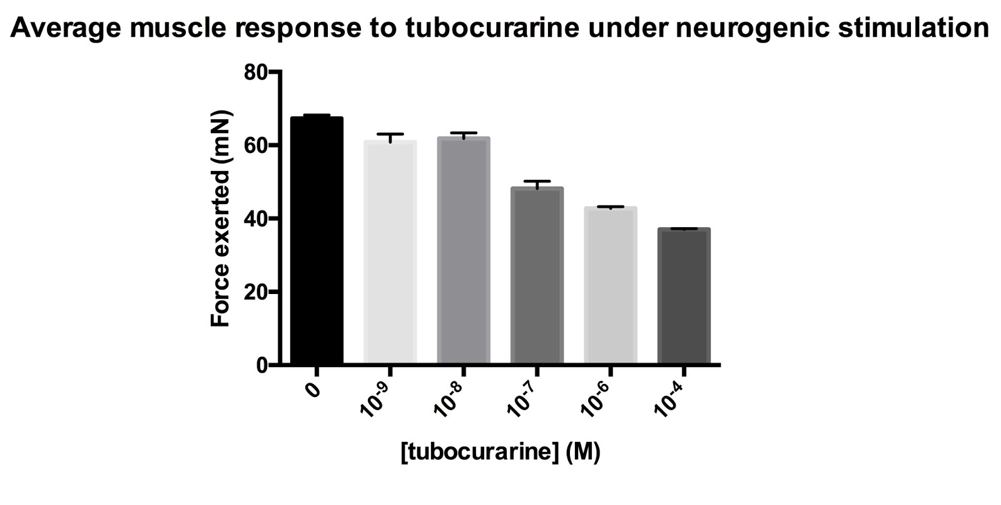

***Figure 1. Average muscle response (mN) with SEM of the gastrocnemius toad preparation at 1.75V under neurogenic stimulation against increasing concentration of tubocurarine in the tissue bath.***

A general trend is observed in Fig 1 that as the concentration of tubocurarine increases, the force exerted by the muscle under neurogenic stimulation at 1.75V decreases. The results have been shown in a column graph, for a scatter XY graph comparing Force exerted to log [tubocurarine] would not have been able to demonstrate the comparison with the control solution of 0M tubocurarine. Error bars with SEM have been included, and are very small, suggesting a small degree of variability across most trials for each concentration tested.

**Table 2: Muscle responses (mN) of the gastrocnemius toad preparation at 2.5V under myogenic stimulation when increasing concentrations of tubocurarine are added to the tissue bath**

|  |  |  |  |  |  |  |
| --- | --- | --- | --- | --- | --- | --- |
|  |  | Concentration of tubocurarine added (M) | | | | |
|  |  | 0 | 10-9 | 10-8 | 10-7 | 10-6 |
| Muscle response under myogenic stimulation (mN) | Trial 1 | 88.92 | 71.69 | 77.35 | 94.74 | 71.91 |
| Trial 2 | 88.47 | 75.08 | 88.24 | 97.46 | 75.31 |
| Trial 3 | 81.44 | 77.81 | 82.57 | 102.91 | 71.69 |
| Average (mN) | 86.28 | 74.86 | 82.72 | 98.37 | 72.97 |

Three trials were conducted to determine the muscle response (by the force exerted) under myogenic stimulation for each concentration of tubocurarine added to the tissue bath. This started with a control of Ringer’s solution (0M tubocurarine), and then increasing concentrations from 10-9 M tubocurarine. These trials were averaged to give the average force (mN) exerted by the muscle at 2.5V, its maximal voltage under myogenic stimulation. The average force (mN) can be seen to fluctuate both above and below in comparison to the force exerted in the control (Table 2), and so no general trend appears.

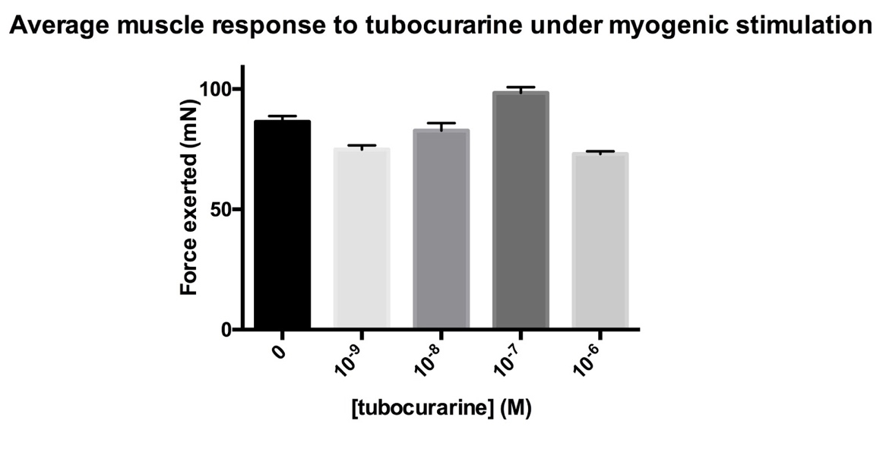

***Figure 2. Average muscle response (mN) with SEM of the gastrocnemius toad preparation at 2.5V under myogenic stimulation against increasing concentration of tubocurarine in the tissue bath.***

No clear general trend can be observed in Fig 2 between the concentration of tubocurarine and the force exerted by the muscle under myogenic stimulation at 2.5V, hence why the results have been expressed through a column graphs rather than a scatter XY graph. A concentration of tubocurarine of 0 (i.e., the control with Ringer’s solution) has an average force of 86.28 mN (Table 2) which is between the maximal and minimal forces exerted by the muscle with tubocurarine solution over the range that was tested, so follows the lack of trend discussed previously. Error bars with SEM have been included, and are relatively small, suggesting a small degree of variability across most trials for each concentration tested.

**Discussion**

The first null hypothesis contended that the addition of tubocurarine had no effect on the force of contraction at the maximum voltage for the nerve-gastrocnemius preparation under neurogenic stimulation (Figure 1). It has been shown that increasing concentrations of tubocurarine leads to a consistent decrease of the muscle response. This result, while expected, cannot be statistically supported as not enough measurements were taken for a useful statistical analysis, with only one muscle preparation tested. However, this trend can be qualitatively observed, and the first null hypothesis has been rejected – thus, tubocurarine indeed has an effect on neurogenically-stimulated contraction.

This observation can be explained by the antagonistic effects of tubocurarine on the end plate nAChRs at the neuromuscular junction. As the same stimulus voltage was applied each time, this would mean the same number of ACh quanta were being released from the presynaptic terminal (Hartzell et al., 1975). However, as tubocurarine competitively binds to the cholinergic receptors (Jenkinson, 1960), less binding will then occur between endogenous acetylcholine and the cholinergic receptors, and thus fewer post-synaptic sodium ion channels will open. This results in a smaller depolarisation of the motor endplate, and thus a twitch contraction of smaller amplitude is produced. This effect is larger as the concentration of tubocurarine increases, as more tubocurarine present results in greater antagonism of the nAChRs (Close & Hoh, 1968).

The second null hypothesis contended that the addition of tubocurarine had no effect on the force of contraction at the maximum voltage for the nerve-gastrocnemius preparation under myogenic stimulation. Whilst changes were detected in contractile force during the experiment (Figure 2), the addition of tubocurarine only appeared to increase contractile force, which has not been documented in the past. This result was not expected, and may be attributed to a lack of experimental reproducibility from the limited number of results. Further repeats of this experiment should be carried out to increase the reliability and reproducibility. Furthermore, multiple sciatic nerve-gastrocnemius muscle preparations could be used to this effect too. This would permit application of statistical tests to confirm that any changes in contractile force due to myogenic stimulation are not significant, and that the changes in contractile force due to neurogenic stimulation are significant. Nevertheless, Figure 2 qualitatively demonstrates no trend in the change of contractile strength between the 10-9 M and 10-6 M tubocurarine, suggesting that the null hypothesis should be retained, and thus tubocurarine indeed has no effect on myogenically-stimulated contraction.

This can be theoretically explained by the lack of activation of AChRs when myogenically stimulating a skeletal muscle (Van Maanen, 1950). Direct electrical stimulation will open voltage-gated ion channels, thus surpassing the need to open ligand-gated ion channels such as nAChRs, to cause depolarisation. Therefore, when the neuromuscular junction preparation is stimulated myogenically, the antagonism of tubocurarine at the nAChRs plays no role in the overall contraction force of the muscle, as Upwadia et al. (1978) have shown. Though previous research has highlighted the blocking effects of tubocurarine on calcium-dependent potassium channels, these channels are not typically found in skeletal muscle (Nohmi & Kuba, 1984) and therefore would have a minimal effect on the contraction of the skeletal muscle preparation present in this experiment.

Another point of limitation is the wash control of Ringer's solution between each successive concentration of tubocurarine. This provided some degree of control, however, taking measurements of these force produced during washes in Ringer's solution would provide a reliable baseline from which to compare results. This would also ensure that the tubocurarine had been completely washed out from the preparation and was no longer bound to the nAChRs. Furthermore, it would provide a mechanism by which to observe whether the muscle parameters vary slightly over time with atmospheric conditions or if the gastrocnemius muscle fatigues.

Furthermore, the length of time that the muscle remained in each concentration of tubocurarine solution before measurements were taken may have affected the results. Of the known cholinergic antagonists, tubocurarine has one of the slowest effects, taking up to 5 minutes to equilibrate with its receptors (Armstrong & Lester, 1979).  Hence, further experimentation should let the muscle preparation equilibrate with the receptor for the same amount of time for each concentration of tubocurarine, before the muscle is stimulated. Alternatively, a time course of the muscle response could be conducted for the same effect.

In conclusion, preliminary findings have shown that tubocurarine decreases the force of muscle contraction from neurogenic stimulation, but not myogenic stimulation, in an isolated cane toad sciatic nerve-gastrocnemius muscle preparation. Future experiments could consider the variables of time taken of the muscle to equilibriate with tubocurarine, and also repeating with multiple preparations, with complete washes of Ringer’s solution as a control measured in between concentrations of tubocurarine.

**References**

Armstrong, D. & Lester, H. (1979). The kinetics of tubocurarine action and restricted diffusion within the synaptic cleft. *The Journal Of Physiology*, *294*(1), 365-386.

Bechter A. M.  (1977). The civilizing of curare: a history of its development and introduction into anesthesiology. *Anesthesia and Analgesia,* 56(2): 305–319.

Blair, H. (1937). The effect of acetylcholine on the excitability of the frog's sartorius muscle. *American Journal Of Physiology,* 124(2), 372-378.

Castillo, J. & Katz, B (1955). On the localisation of acetylcholine receptors. *Journal of Physiology,* 128, 157-181

Close, R. & Hoh, J. (1968). The after-effects of repetitive stimulation on the isometric twitch contraction of rat fast skeletal muscle. *The Journal Of Physiology,* 197(2), 461-477.

Gray, T. & Halton, J. (1946). A Milestone in Anaesthesia?(d-Tubocurarine Chloride). *Proceedings of the Royal Society of Medicine*, 39, 400-408

Hartzell H.C., Kuffler S.W., Yoshikami D. (1975). Post-synaptic potentiation: interaction between quanta of acetylcholine at the skeletal neuromuscular synapse. *Journal of Physiology,* 251(2), 427-63.

Jenkinson D.H. (1960). The antagonism between tubocurarine and substances which depolarise the motor end-plate. *Journal of* *Physiology,* 152, 309-324,

Miledi R. & Potter L.T. (1971).  Acetylcholine receptors in muscle fibres. *Nature*, 233, 599–603.

Nohmi, M. & Kuba, K. (1984). (+)-Tubocurarine blocks the Ca 2+-dependent K+-channel of the bullfrog sympathetic ganglion cell. *Brain research*, 301(1), 146-148.

Ochs, S. & Mukherjee, K. (1959). Action of acetylcholine, choline and D-tubocurarine on the membrane of frog sartorius muscle fibers. *American Journal Of Psychology*, *196*, 1191-1196.

Steinbach, J. & Chen, Q. (1995). Antagonist and Partial Agonist Actions of d-Tubocurarine at Mammalian Muscle Acetylcholine Receptors. *The Journal of Neuroscience,* 15(1), 230-240.

Udwadia, B.P., Gokhale, S.V., Barbhaiya, H.C, Vaishnav, H.S. (1978). The effect of tubocurarine and suxamethonium on directly and indirectly elicited contractions of skeletal muscle in unanaesthetized man using single and train of four impulses. *Journal of Clinical Pharmacology*, 5, 131-134

University of Sydney. Advanced Integrated Physiology Neuromuscular Junction Prac. (2016) pg 1-8 (https://elearning.sydney.edu.au/webapps/blackboard/execute/content/file?cmd=view&mode=designer&content_id=_3595024_1&course_id=_57528_1)

Van Maanen, E. (1950). The antagonism between acetylcholine and the curare alkaloids, d-Tubocurarine, c-Curarine-I, c-Toxiferine-II and erythroidine in the rectus abdominis of the frog. *Journal Of Pharmacology*, *99*, 255-264.