1.Refine By button not working properly.

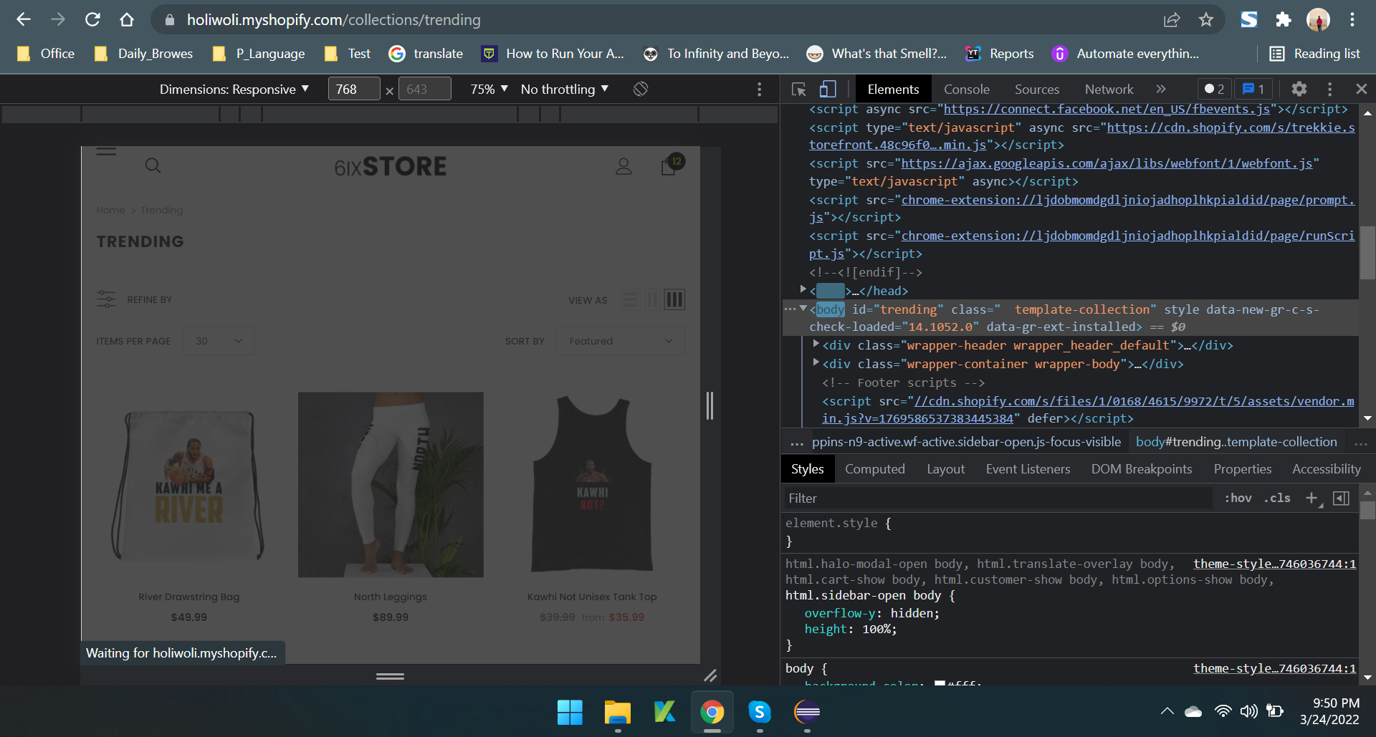

2. Manue Font not showing clearly in the mobile and tablet view.

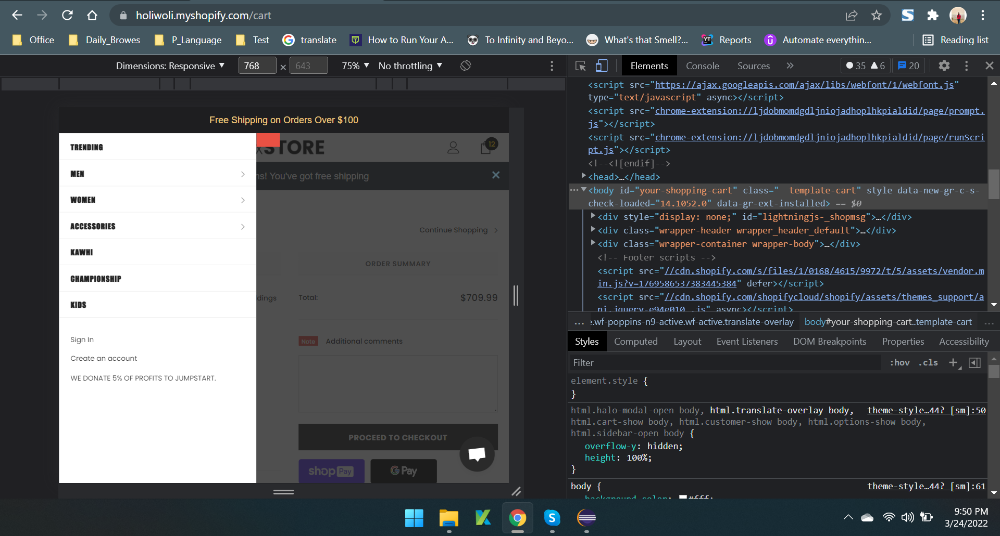

3.New user boucher code not showing properly in Mobile and Tablet.

4.Slide show not showing properly In the mobile and tablet.

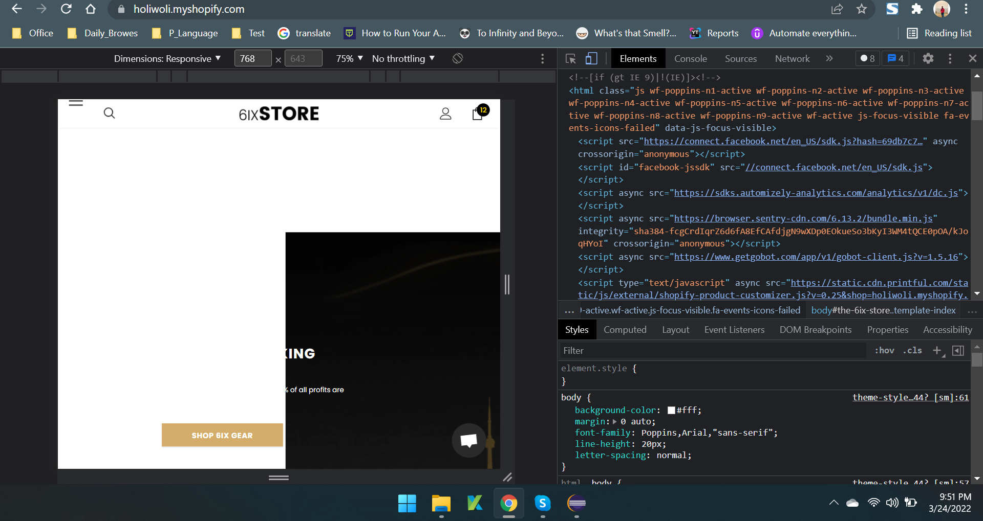

5.Some pages are a. The motto. b.Return Policy c.Terms and condition not showing correct way in mobile and tablet view .

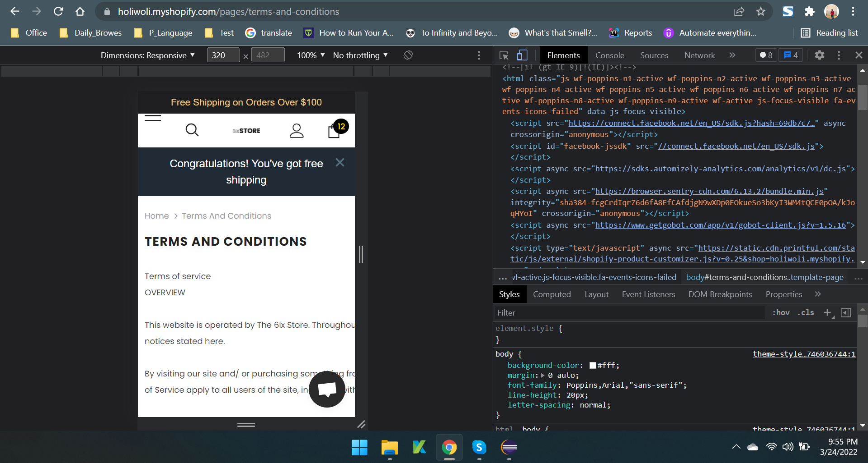

Video Link : https://www.loom.com/share/328ebc25efa943c29b881d080c63a764