Lab - Building a Switch and Router Network

Bugs

* The lefthand side will always be down (red) for some reason
* To fix this problem, go `shutdown` then `no shutdown`

Notes

1. By no means are they correct nor accurate. They are only used as reference & comparison tool.
2. Highly similar to 6.5.1.2 Lab - Building a Switch and Router Network Answers
3. First step: Options > Preferences > Always Show Port Labels in Logical Workspace
4. Exam Notes:
   1. Sometimes, the IP Address is empty in table will be EMPTY. However, the question will tell you how to figure it out.
      1. Eg: go to the subnet, use the third usable address to link and so on.
      2. Not more than 3 columns blank
   2. Don't configure password first, put it at the last.
      1. If you forgot, if you lucky, power cycle the modem, else, you have to reset the entire thing. Extremely time-wasting. Better to complete everything except passwords first and get near max marks.
      2. If question ask router, then router. If question ask router and switch, then router and switch.

Q&A

1. Topology



1. Addressing Table

|  |  |  |  |  |
| --- | --- | --- | --- | --- |
| Device | Interface | IP Address | Subnet Mask | Default Gateway |
| R1 | G0/0 (IPv4) | 192.168.0.1 | 255.255.255.0 | N/A |
| G0/1 (IPv4) | 192.168.1.1 | 255.255.255.0 | N/A |
| G0/1 (IPv6) Link Local | 2001:CAFE:1:1::4 FE80::1 | /64 /64 | N/A N/A |
| S1 | VLAN 1 | 192.168.1.5 | 255.255.255.0 | 192.168.1.1 |
| PC-A | NIC (IPv4) | 192.168.1.3 | 255.255.255.0 | 192.168.1.1 |
| NIC (IPv6) | 2001:CAFE:1:1::5 | /64 |  |
| PC-B | NIC (IPv4) | 192.168.0.3 | 255.255.255.0 | 192.168.0.1 |

* 1. Configure the router.

Note: Things inside [here] are optional. Might have shorter ones but I don’t feel like testing them. **Always cop[**y**] ru[**nning-config**] st[**artup-config**]** after you’re succesful in a step.

* + 1. Console into the router and enable privileged EXEC mode.
       1. Click Router2
       2. Go into CLI tab, type `**en**[able]`
    2. Enter configuration mode.
       1. **Conf**[igure] **t**[erminal]
    3. Assign a device name to the router.
       1. **h**[ost] **Router2**
       2. Honestly, no right or wrong answer, just put whatever you want.
    4. Disable DNS lookup to prevent the router from attempting to translate incorrectly entered commands as though they were host names.
       1. Must be done in `conf t`
       2. `no ip domain-lookup`
       3. If successful: `sh[ow] r[un] | i[nclude] dom[ain-lookup]` should show “no ip domain lookup”
    5. Assign **claS$** as the privileged EXEC encrypted password.
       1. Conf t
       2. Ena[ble] s[ecret] claS$
    6. Assign **CISCO123** as the console password and enable login.
       1. Enable
       2. Configure terminal
       3. Line console 0
       4. Password CISCO123
       5. login
    7. Assign **CISCO123** as the VTY password and enable login.
       1. Enable
       2. Conf term
       3. Line vty 0 4 (get figure from `show running-config`)
       4. Password CISCO123
       5. login
    8. Encrypt the clear text passwords.
       1. Conf[ig] t[erminal]
       2. Se[rvice] p[assword-encryption]
    9. Create a banner that warns anyone accessing the device that unauthorized access is prohibited.
       1. config t
       2. banner motd "This is a secure system. Authorized Access Only!"
          1. (Note: or similar texts)
    10. Configure and activate both interfaces on the router.
        1. Show ip int brief
        2. En[able] (Note: can do before show and after show, doesn’t matter)
        3. Conf t
        4. **For interface GigabitEthernet0/0**
           1. Inter g0/0
           2. Ip ad[dress] 192.168.0.1 255.255.255.0
           3. No sh
           4. Exit
        5. **For interface GigabitEthernet0/1**
           1. Inter g0/1
           2. Ip ad[dress] 192.168.1.1 255.255.255.0
           3. No sh
           4. exit
        6. IF SUCCESS:
           1. Show ip int brief should show gigabitEthernet0/0 and gigabitEthernet0/1 as up up. You should see two wires with green triangles
    11. Configure an interface description for each interface indicating which device is connected to it.
        1. **Gigabit 0/0**
           1. En[able]
           2. Conf[igure] t[erminal]
           3. Int[erface] g[igabitEthernet]0/0
           4. Desc Link Router2 ⬄ PC1 (Note: or whatever description you want, just don’t mislead people)
           5. Exit
        2. **Gigabit0/1**
           1. En[able]
           2. Conf[igure] t[erminal]
           3. Int[erface] g[igabitEthernet]0/0
           4. Desc Link Router2 ⬄ S1 (Note: or whatever description you want, just don’t mislead people)
           5. Exit
        3. **If correct**
           1. You can see with `show int g0/0’ and `show int g0/1’
    12. Save the running configuration to the startup configuration file.
        1. You should be doing this repeatedly, basically `cop ru st`
    13. Set the clock on the router.
        1. En
        2. Clock set hh:mm:ss dd MONTH YYYY
        3. To check: Use `show clock`

**Note**: Use the question mark (**?**) to help with the correct sequence of parameters needed to execute this command.

* + 1. Print screen your results as shown below:

|  |  |
| --- | --- |
| **From PC-B TO:** | **PING SUCCESSFUL ?** |
| PC-B (IPv4) To R1 | yes |
| PC-B (IPv4) To S1 | yes |
| PC-B (IPv4) To PC-A | yes |
| R1 (IPv6) To PC-A | yes |

*\*\* your answer should be all YES. Troubleshoot your configuration commands if any of the answer is “NO”.*

Note: This question is designed to produce NO in a lot of cases. If you didn’t notice, aside from the G0/0 and G0/1, all the IP are NOT properly configured. So, take a breath, and lets get started. Oh and go section-by-section, each section step is “somewhat” dependent on the last section setup. TIP: DO NOT assume that on your first `ping`, if `ping` timed out for first 1-3 packets it will time out ALL.

[PC-B (IPv4) To R1] **Configure PC-B**

**Desktop 🡪 IP Configuration**

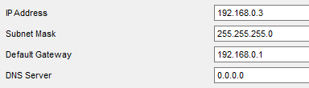

**Desktop 🡪 Command Prompt**

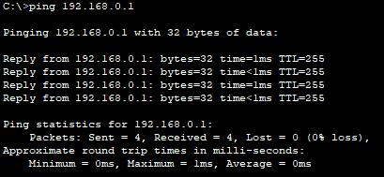

PC-B (IPv4) To S1 **Configure S1**

S1 🡪 CLI

`en`

`conf t`

`ip default-gateway 192.168.1.1`

`inter vlan1`

`ip addr 192.168.1.5 255.255.255.0`

`no sh`

`exi`

`cop ru st`

**[In PC-B] Desktop 🡪 Command Prompt**

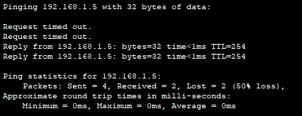

PC-B (IPv4) To PC-A

If you didn’t noticed, the link between PC-B and S1 is still red, head into S1’s CLI, note, switches DO NOT need their IP Addresses configured (in this case) as long as the VLAN is configured correctly

En

Conf t

Inter f0/6

No sh

Configure PC-A IP Address

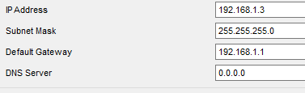

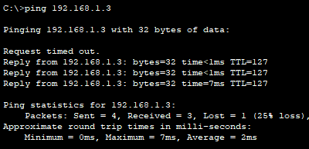

R1 (IPv6) To PC-A

Setup PC-A IPv6

Go into PC-A 🡪 Desktop 🡪 IP Configuration

IPv6 Address: 2001:CAFE:1:1::5/64

Link Local Address: FE80::1

Setup Router IPv6

En

Conf t

Inter g0/1

Ipv6 addr 2001:CAFE:1:1::4/64

Ipv6 addr FE80::1 link-local

exit

cop ru st

Pinging

Go into R1 🡪 CLI

Ping [ipv6] 2001:CAFE:1:1::5

