Research Workshop Attendance, Marketing, and Satisfaction

Claire Curry (STEM Services) and Brianna Narr (Metrics Coordinator)

2023-08-03

# Executive summary

The top three marketing methods that bring in the highest counts of attendees who fill out our post-workshop surveys (hereafter, “attendees” and “attendance”) are emails, word-of-mouth, and the OU Libraries website

The marketing methods with the highest response “intensities” (relative proportion of attendees) were class requirements (making liaison outreach to instructors critical), librarians emailing a departmental listserv directly (we have these permissions for at least two STEM departments to my knowledge), and the OU Libraries website.

Thus, our overall most effective marketing methods are emails, the OU Libraries website, word-of-mouth, and outreach to instructors.

# Absolute effectiveness (counts of attendees) by marketing method

## Overall counts of attendees by marketing method and registration status

These data for people who filled out a post-workshop survey (ie are confirmed to have attended a workshop) and answer the question “How did you hear about this workshop?”. They are grouped by pre-registered or not pre-registered (passerby walk-ins, class workshops where registration wasn’t required). We do not get 100% completion of surveys.

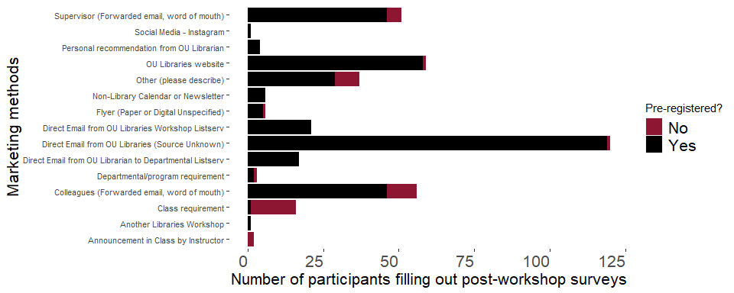

## Marketing methods for selection “Other (please describe)” with at least two words

These words suggest that professors, librarians, and previous workshops were included in methods that reached these attendees. Later data cleaning to incorporate emails/professors/word-of-mouth into the existing categories could be useful.

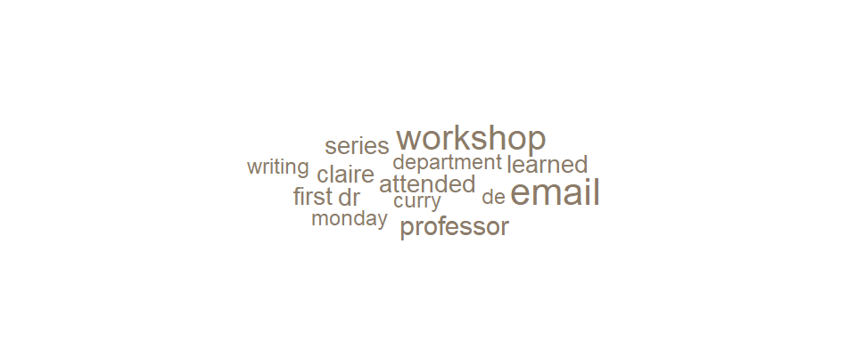

# Marketing sources for people who registered for workshops (attendance yet unknown)

These data are from people who filled out the pre-registration form to attend a workshop. When they filled out this form, we do not know if they will go on to actually attend the workshop. Most of the people in the previous section will have registered, so there is overlap between the datasets, but the post-workshop surveys are anonymous so we cannot connect them directly. The next section shows a broad-level view of the relative effectiveness of methods for people who register vs people who follow through and attend.

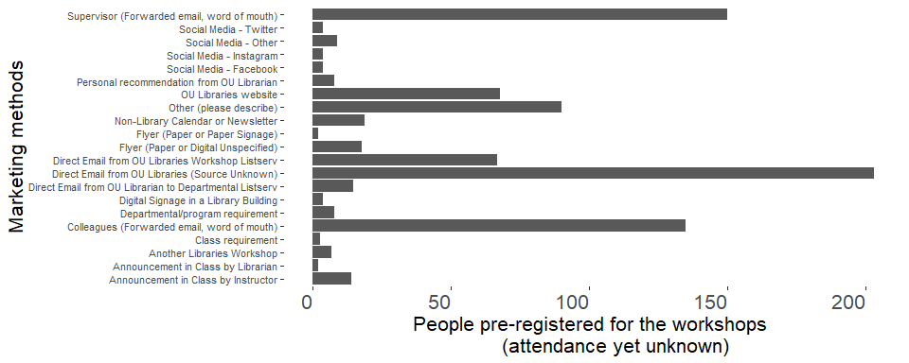

# Relative effectiveness in marketing methods

We do not get 100% survey responses at our workshops. However, I wanted to see to see if some marketing methods are proportionately more effective in getting pre-registrants to actually show up at the workshop. The differences are overall statistically significantly different (Chi-squared = 71.5, df =- 20, p < 0.0001).

Below is a chart that represents this visually as a ratio of attendance to pre-registrant counts. The vertical beige bar shows approximately where about the same proportion (i.e., 0.5 out of 1, or 50/100) of people who pre-registered (red) ended up actually attending and filling out a survey (black).

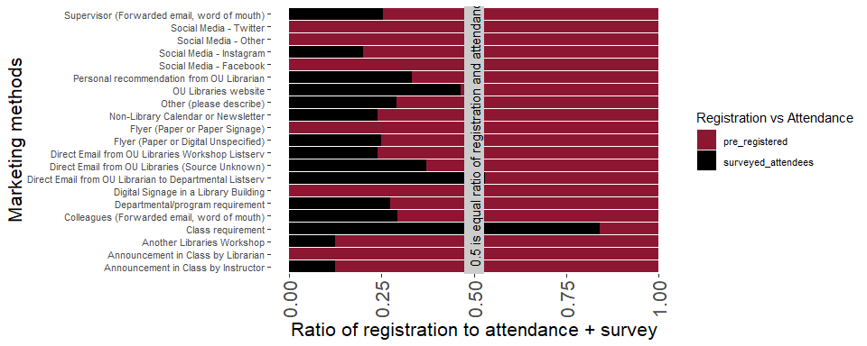

A completely red bar indicates that none of the people who completed the pre-registration survey later completed a post-workshop survey. It is possible some of those attendees showed up but did not complete the offered post-workshop survey. People who pre-registered and heard about the workshop via Twitter, Facebook, Other Social Media Not Specified, Announcement in Class by Librarian, and paper fliers have this result, suggesting those media may not be resulting in attendees or not resulting in attendees willing to provide feedback.

A completely black bar indicates that pre-registration did not occur but people attended anyways (you see these attendees as the red caps to the black bars in the previous section). This occurred more with people who attended a workshop given in a class (“Class Requirement”; that category suggests either we visited the class, which does not involve LibCal registration, or that the instructor asked people to attend a workshop outside of class). With online workshops requiring pre-registration, we don’t necessarily expect any bar to be completely black (all walk-ins). However, in-person workshops can accept passer-by walk-ins who didn’t pre-register or people who saw the event via any other marketing method (again, see the previous section’s chart) and just showed up without pre-registering. Zoom workshops could have other registrants also forward the Zoom link.

Thus, any method with some black has some attendance, and methods with larger amounts of black indicate relatively stronger responses. Thus, the highest response “intensity” are for class requirements, librarians emailing a departmental listserv directly (we have these permissions for at least two STEM departments to my knowledge), and people who find events by examining the OU Libraries website.