Tablet PC
10.1" LCD IPS Panel

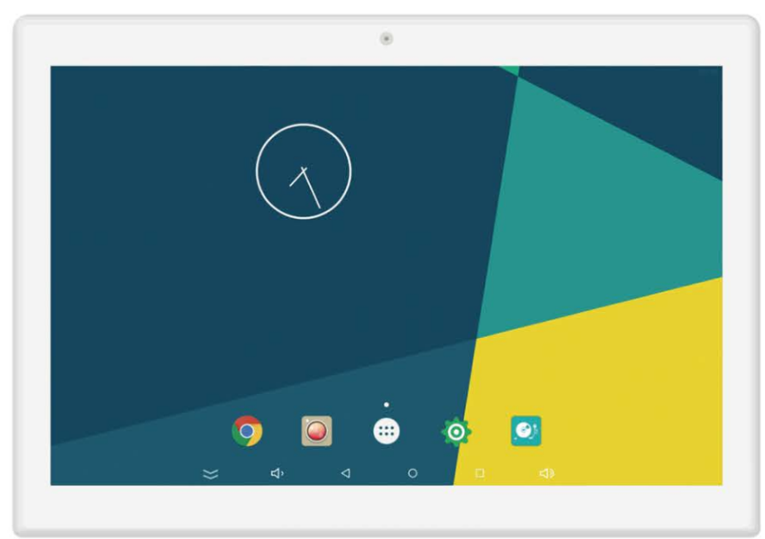

User Manual

Contents

Notes of Importance 2
Features 3
Package Contents 3
Drawing 4
Main Menu 5
Power On/Off 5
Access to The Application 6
Wireless Internet 6
Date Transmission 7
Factory Reset 8

Notes of Importance
1) Please keep the device away from excess temperature (50 C above), too cold (0℃ below) or wet place.
2) Do not grievous hit the device or place something heavy on it.
3) Only use the accessories specified by the manufacturer.
4) Please keep the device away from benzene, diluents or other chemical.
5) Keep the device away from water.
6) The product should be serviced by the professional serviceman, do not try to service it by yourself.
7) Please unplug the power plug of the product when not in use for a long time or during the rainstorm.
8) In order to avoid damaging the touch panel, never place the heavy or sharp objects on the touch panel when use or transport it.
9) Arrange all cables and cords so that people and pets are not likely to trip over or accidentally pull
on them move around or walk through the area. Do not allow children to play with cables and cords.

Features
◆ LCD IPS panel
◆ 10.1"Resolution(1280*800)
◆ Quad core processor
◆ RAM2GB
◆ Internal memory16GB
◆ Android 11
◆ 10-Point capacitive touch
◆ Buletooth 4.0
◆ WiFi802.1b/g/n
◆ 4P-2.0mm,serial port
◆ 4P-2.0mm connect to Rl45 box
◆ HDMI OUT
◆ 2.0USB Host 2.0USB OTG
◆ TF, Support up to 32GB
◆ 2.0M/P, Front camera
◆ Video format:3gp,mpg,wmv,ts,vob,mp4,mov etc.,support up to 1080p
◆ Audio format:aac,amr,ape,flac,m4r,mp2,mp3,wav,wma,ogg etc.
◆ Photo: jpg/png/bmp
◆ 2*2W Speaker
◆ Adapter:12V/2A

Package Contents
Please make sure all of the following are present when you unpack your digital Tablet PC.
1. Tablet PC
2. Power adapter

Drawing

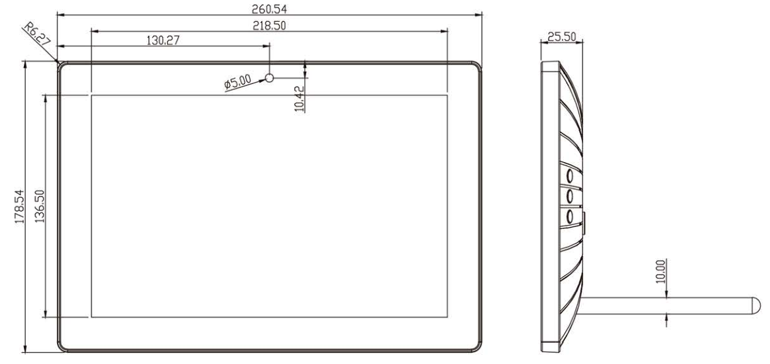

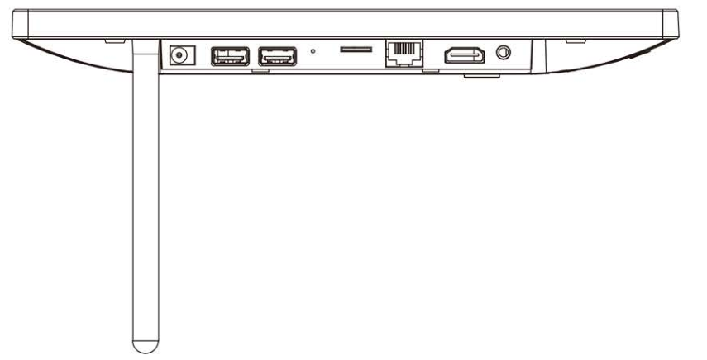

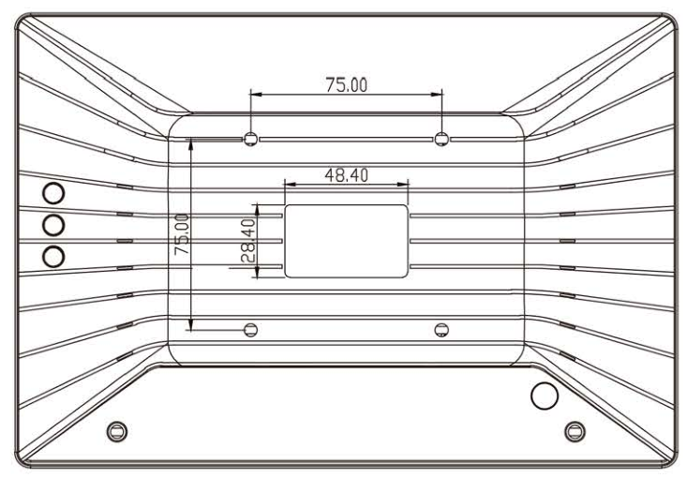

Main Menu
1) Insert the power lead into the DC socket, and then insert the other end into the power socket.
2) Turn on the product by holding the power button for 3 seconds.
3) Screen will show the starting logo.
4) Wait for about 30 seconds and enter into main interface.
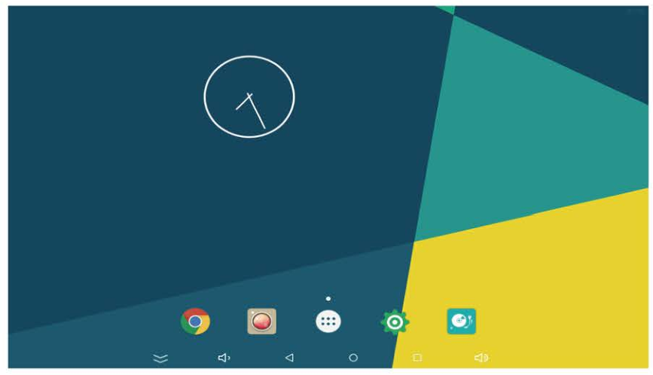

Power On/Off
1) Power on: turn on the device by holding the power button for 3 seconds when the product power off.
2) Power off: holding the power button for 5 seconds and click ok to power off when the product at working status.
3) Short press power button for sleep or awake the product when the product standby.
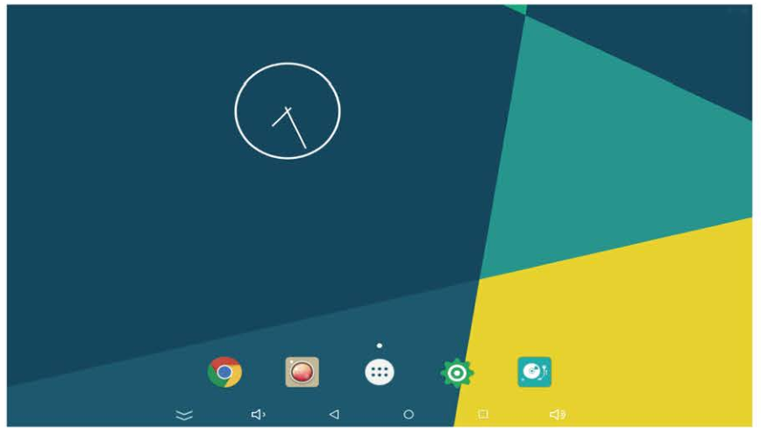

Access to The Application
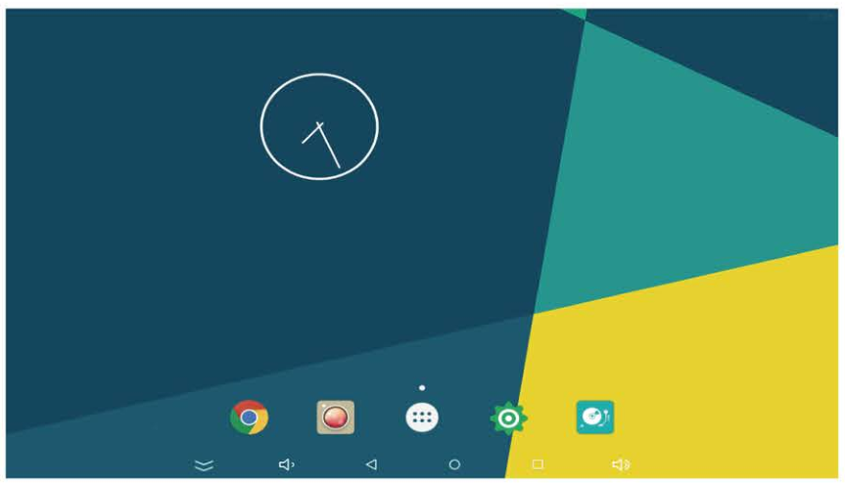
1) In the main menu, click  icon to go to APPS menu screen.
2) Slide the screen leftward/rightward fast, switch to the other menu screen.
3) Click the apps icon to enter into apps click the "RETURN" icon, return to previous page, click the "HOME" icon return to the main menu.
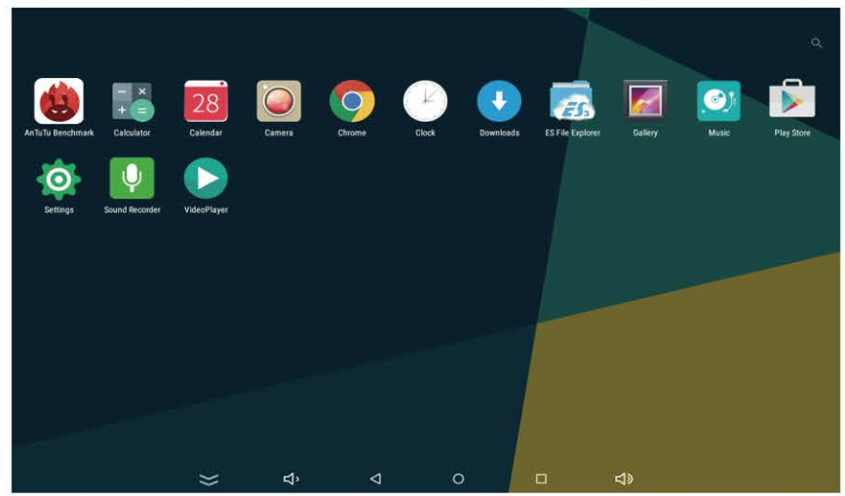

Wireless Internet
1) Enter into the settings and turn on the Wi-Fi, connect to the available networks.
2) Enter into the APPS and click the 'browser', then you will get into the google homepage.
3) You can input the website on the top that you like, or you can search the interesting news and videos by the google search.

Date Transmission
Connecting PC and device by using USB cable, USB icon  will be appeared on the upper left side of status bar, it refers to USB has been connected. As follows:
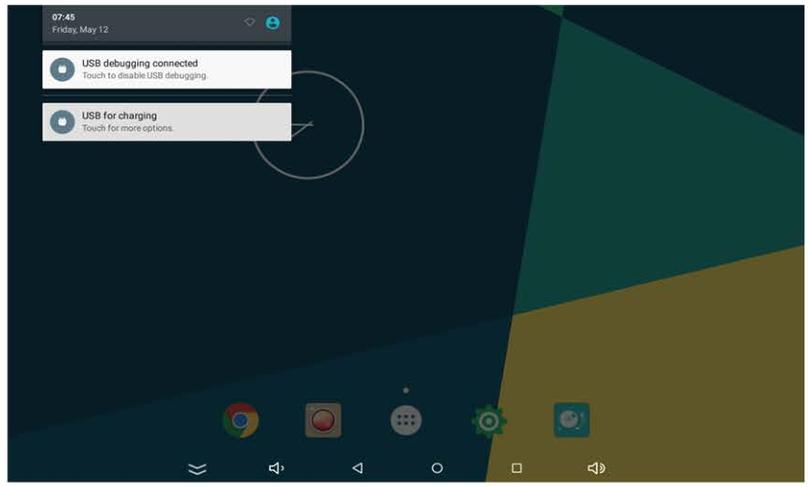
When the operation menu appeared, click "USB connected":
Click "Turn on USB storage" on prompted window:
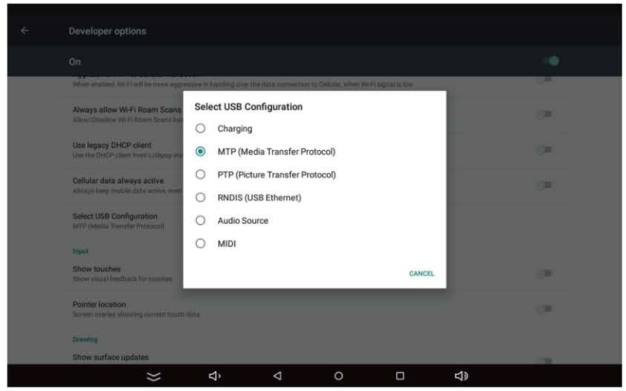
At this time, you can find device storage card and SD card (if the card has been plugged in) in my computer list.
After data transmission, click "Turn off USB storage", and then it will quit the data transmission state.

Factory Reset
If your device has been contracted the virus, or worked unexpectedly by installing third-party applications, then you can erase all data from your device via reset tablet.
Operation: click 'Settings' 'Backup & reset' 'factory data reset', then click the 'reset tablet' and 'erase everything', as the following picture:
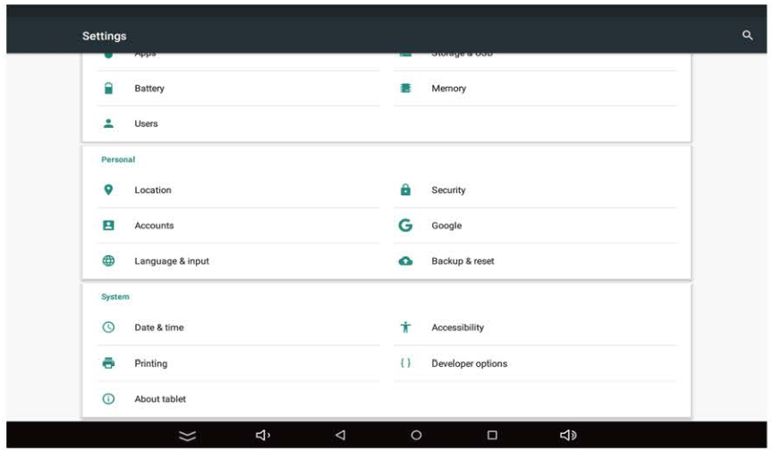
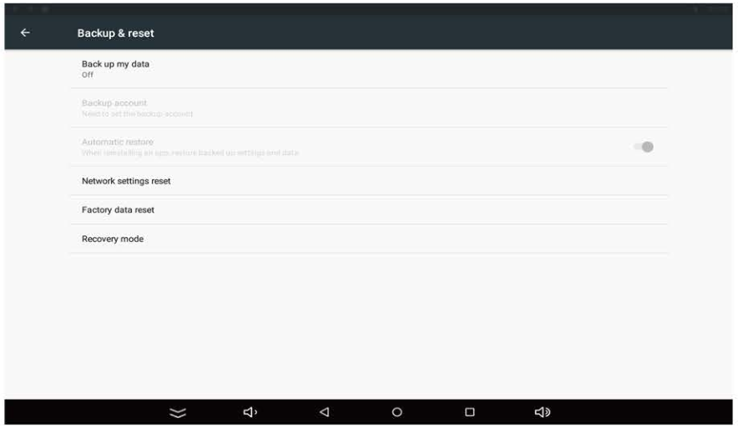

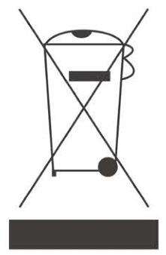

This symbol on the product or in the instructions means that your electrical and electronic equipment
should be disposed of at the end of its life separately from your household waste. There are separate collection systems for recycling in your country. For more information, please contact the local authority or your retailer where you purchased the product.

