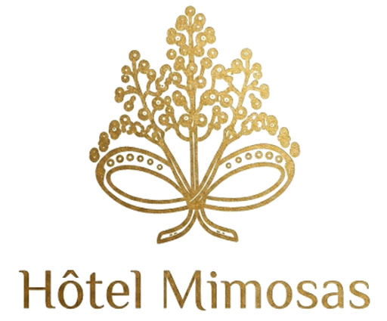
Hotel Mimosas
Investor report, concise business plan and sale pitch
16 Lalla Abla Avenue, 85000 Tiznit | Hotel asset to complete and operate
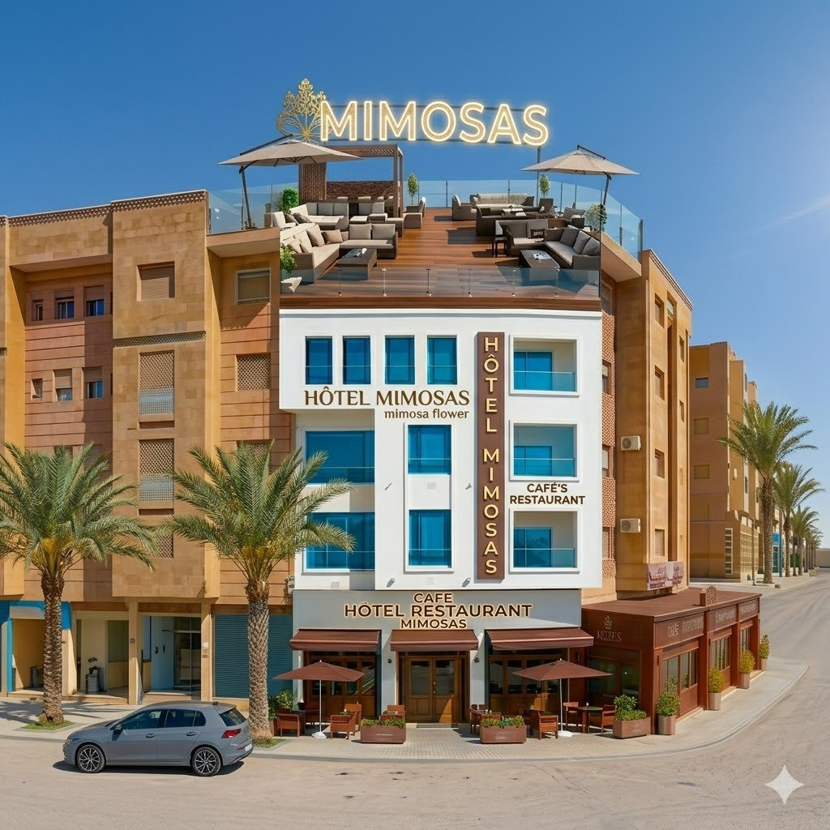
Facade and visual identity of Hotel Mimosas
Address  16 Lalla Abla Avenue, 85000 Tiznit | Positioning  Urban hotel + rooftop + restaurant | Digital  Multilingual website, Leaflet maps, gallery and 360 tour | POI  37 mapped points of interest

1. Executive summary
Investment thesis
Mimosas is a hotel asset in Tiznit whose value is already visible: brand identity, furnished spaces, rooftop, restaurant, 360 tour, photo gallery, multilingual website and an urban location close to the medina flows. The buyer can acquire an advanced project, complete the final finishes and launch an operation focused on stays, restaurant, rooftop and local experience.
This is not positioned as an abstract real-estate promise, but as a hotel operating platform. A buyer should immediately understand the path: finish, classify, commercialize, open, measure and optimize.
2. Asset profile
Criterion | Investor reading
Commercial name | Hotel Mimosas
Address | 16 Lalla Abla Avenue, 85000 Tiznit
GPS coordinates | 29.694128, -9.723413
Concept | Urban hotel with rooftop, food and beverage spaces and short-stay or tourist-stopover potential.
Project status | Advanced potential asset: brand identity, visible spaces, photo content, virtual tour and website already prepared. Works, compliance and classification must be confirmed by technical audit.
360 tour URL | Mimosas/Tour/index.htm
3. Market and destination context
Morocco is benefiting from strong tourism momentum. Public figures from the Ministry of Tourism report 19.8 million visitors in 2025, up 14% versus 2024, and tourism receipts of MAD 138 billion in 2025.
Tiznit offers a distinctive alternative to saturated destinations: medina, ramparts, silver craft, proximity to Aglou, access to Souss Massa landscapes and a calm short-stay positioning.
- The rooftop creates revenue beyond accommodation: cafe, light dining, evenings, private events and local meetups.
4. Mimosas strengths
Strength | Commercial impact | Recommended action
Rooftop | Strong differentiation and revenue beyond rooms. | Create sunset, breakfast, cafe, tapas and private-event offers.
Restaurant / counter | Additional revenue and stronger guest experience. | Define a short, local, profitable and easy-to-run menu.
360 tour | Reduces investor and guest uncertainty. | Use it in the sale process, Google Business, the website and listings.
5. Visual dossier
The visuals show an already legible asset: identity, facade, reception, rooms, rooftop and restaurant.
  Facade | 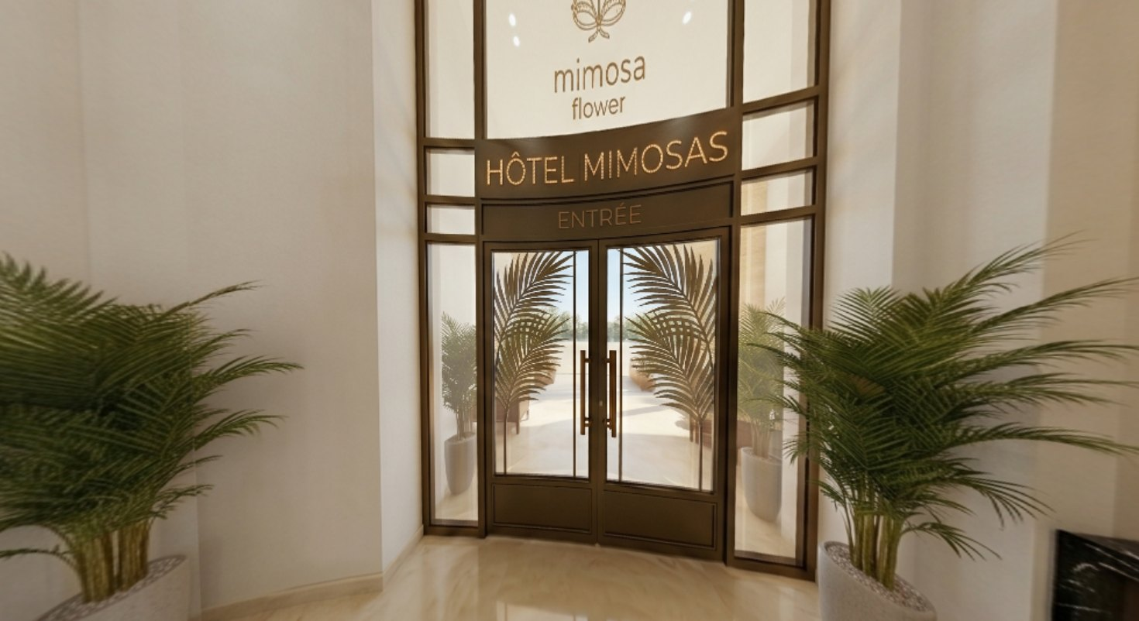  Entrance
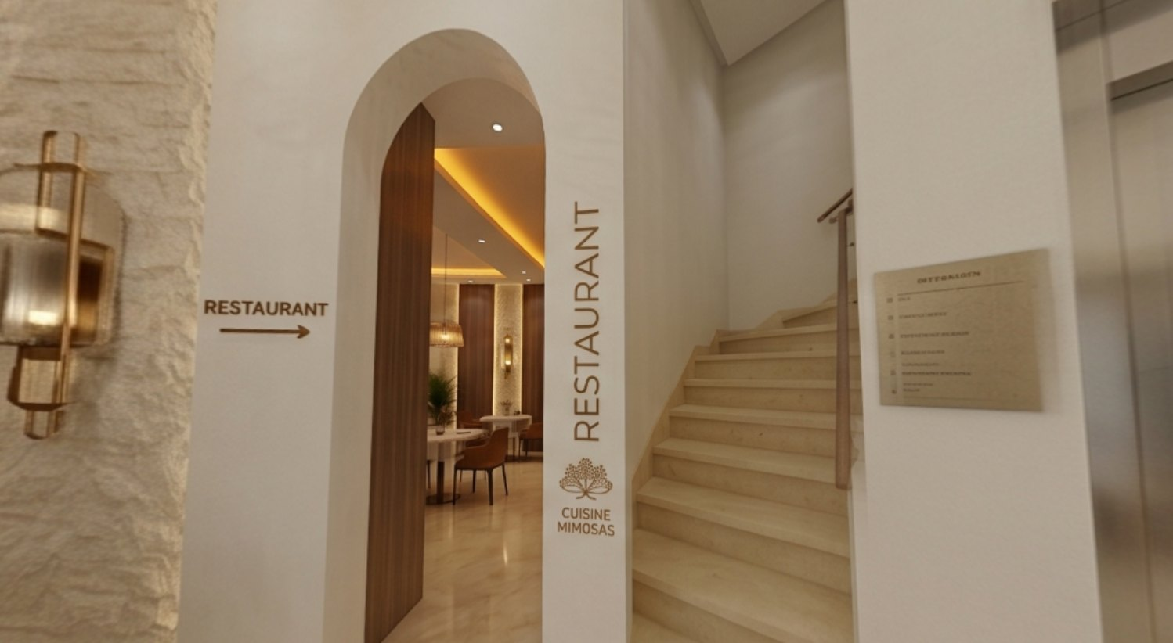  Reception | 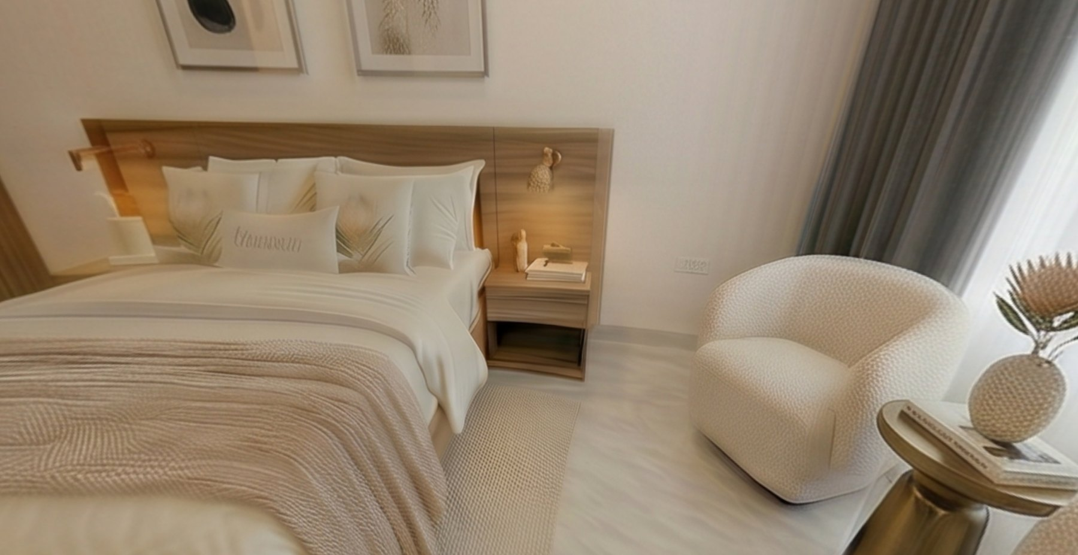  Room
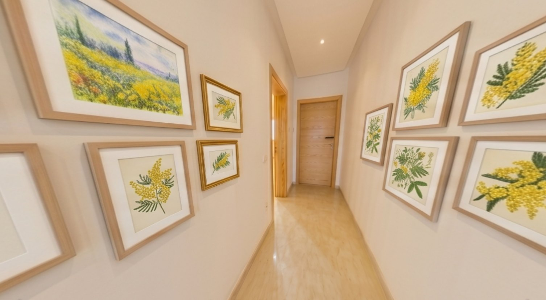  Corridor | 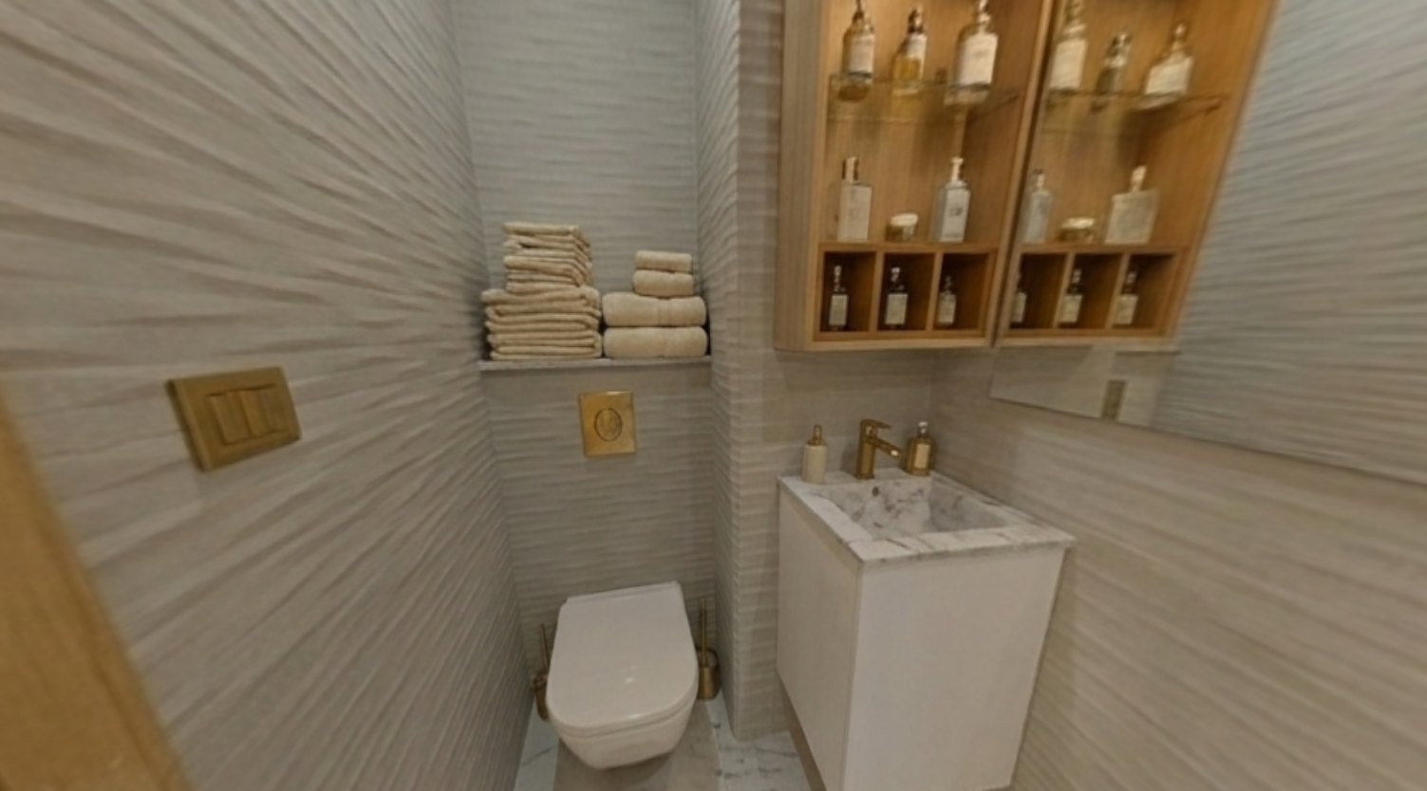  Bathroom
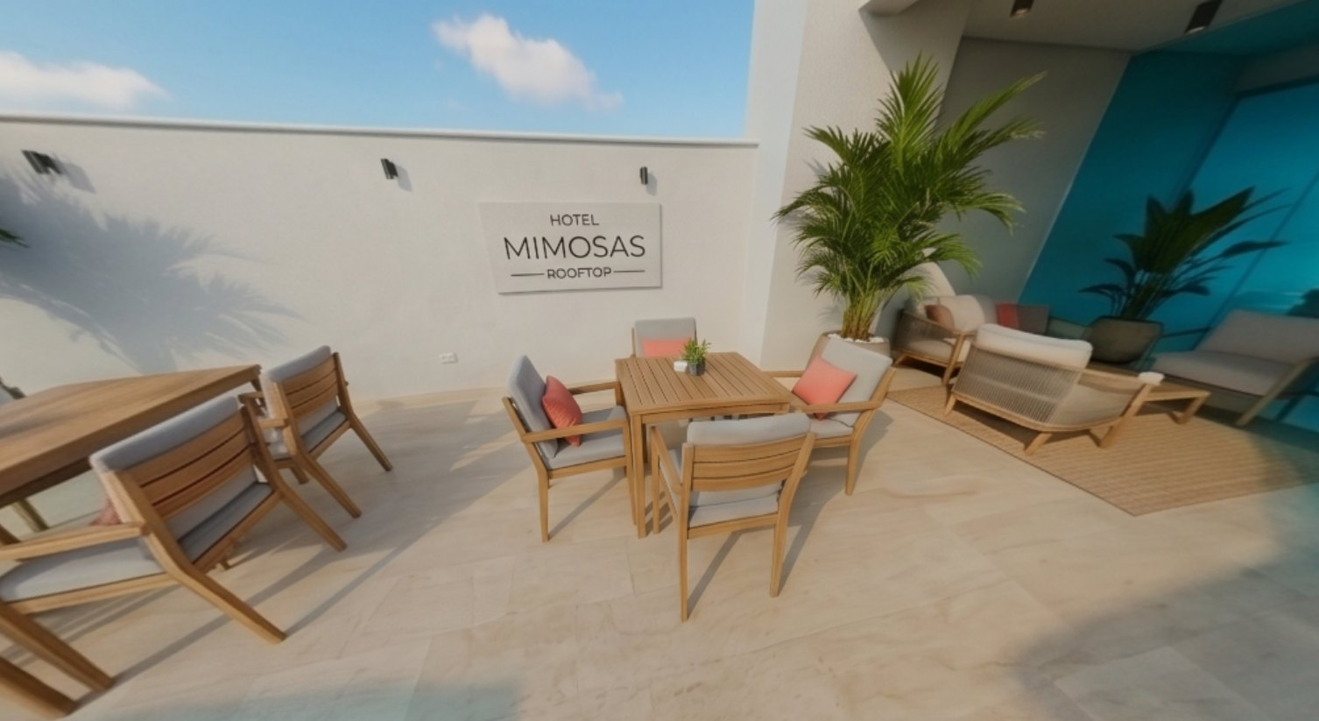  Rooftop | 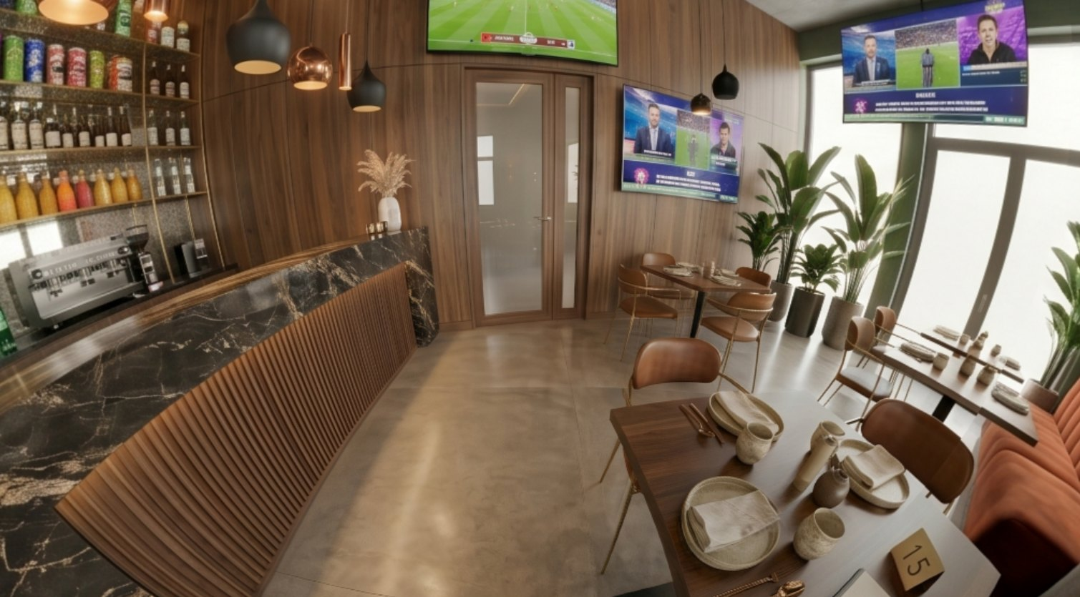  Restaurant
6. Concise business plan
Important
Precise figures must be finalized after audit: price, room count, remaining CAPEX, permits and pricing policy.
Pillar | Operating assumption | KPI
Accommodation | Direct sales + OTAs + local guests, diaspora, stopover travelers. | Occupancy, ADR, RevPAR
Rooftop | Cafe, brunch, sunset, tapas, private events. | Average ticket, covers, margin
Digital | Website, Google Business, WhatsApp, 360 tour, local SEO. | Traffic, enquiries, conversion
7. 90-day takeover plan
Phase | Goal | Actions
Days 1-15 | Audit and secure | Technical, legal, compliance, safety and license audit.
Days 16-45 | Final finishes | Rooms, lighting, plumbing, rooftop, kitchen, reception.
Days 46-90 | Marketing and soft opening | Final photos, OTAs, Google Business, website, reviews.
8. Sale pitch
Pitch
Hotel Mimosas is a takeover opportunity for a high-potential hotel asset in Tiznit: an identifiable project with a rooftop, restaurant spaces, visual identity, multilingual website, 360 virtual tour and destination storytelling. The buyer does not start from zero: they acquire an advanced base, complete the final works, structure the operation and capture the value of an independent hotel in a heritage city between the medina, the Anti-Atlas and Aglou's coastline.
- Tangible asset: photos, spaces and identity are already visible.
- Multiple operating potential: rooms, rooftop, restaurant, events and local experiences.
- Commercial tools are ready: multilingual site, maps, points of interest, gallery and 360 tour.
9. Buyer due diligence points
- Confirm the exact number of operable rooms, surfaces, rooftop capacity and restaurant capacity.
- Cost the remaining CAPEX by trade: safety, plumbing, electricity, furniture, kitchen, signage, accessibility and classification.
- Verify permits, licenses, hotel compliance, insurance, taxation and land/legal status.
10. Conclusion
Mimosas' value lies in converting an advanced project into an operating asset. The ideal buyer is not simply purchasing walls or finishes: they are buying an address, a brand, high-potential spaces, a differentiated rooftop, a digital base and a local tourism story ready to be strengthened.
Sources
- Ministère du Tourisme du Maroc - chiffres clés 2025
- Visit Agadir / Souss Massa - Tiznit et Aglou
- Données internes Mimosas - galerie, site, visite 360, data/projects.json

