GPT Pretraining Exercise
Student: Polex Ouma Otieno
Course: GPT Pretraining — Engineering Department
Date: April 11, 2026

Part A: Download Pretrained GPT-2 Weights
The four pretrained GPT-2 weight files were downloaded using Step04_llm_c.py from the Hugging Face repository. The files downloaded were:

gpt2-small-124M.pth (~622 MB)
gpt2-medium-355M.pth (~1.5 GB)
gpt2-large-774M.pth (~3.0 GB)
gpt2-xl-1558M.pth (~6.2 GB)

The small (124M) and medium (355M) models were used in Parts D and E respectively. These pretrained weights contain the knowledge the model learned from a large corpus of internet text during OpenAI's original GPT-2 training process.

Part B: Training the 124M Model from Scratch
In this part, the GPT-2 small (124M parameter) model was trained from scratch — without any pretrained weights — on the-verdict.txt, a fictional short story. The model was trained for 10 epochs twice: once to establish a baseline, and a second time loading the checkpoint saved from the first run.

First Training Run — Loss Plot
The model was initialized with random weights and trained for 10 epochs on The Verdict.
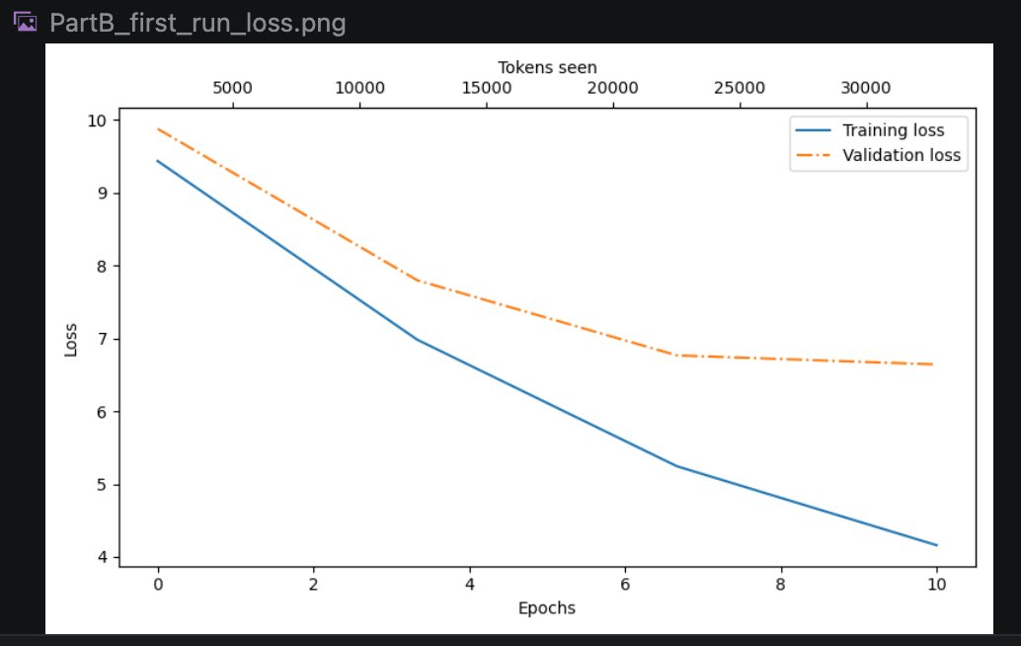

First Training Run — Loss Values
Ep 1 (Step 000000): Train loss 9.437, Val loss 9.880
Ep 3 (Step 000005): Train loss 6.982, Val loss 7.798
Ep 6 (Step 000010): Train loss 5.244, Val loss 6.767
Ep 8 (Step 000015): Train loss 4.160, Val loss 6.643

Analysis — First Training Run
Both the training and validation losses decreased consistently over the 10 epochs, indicating the model was successfully learning patterns from the text. The training loss dropped from 9.437 to approximately 4.160, while the validation loss decreased from 9.880 to 6.643. The gap between training and validation loss widened slightly toward the end, suggesting early signs of overfitting — the model was beginning to memorize the training text rather than generalizing. This is expected given the very small dataset size.

Second Training Run — Loss Plot
The second training run loaded the checkpoint saved from the first run and continued training for another 10 epochs.
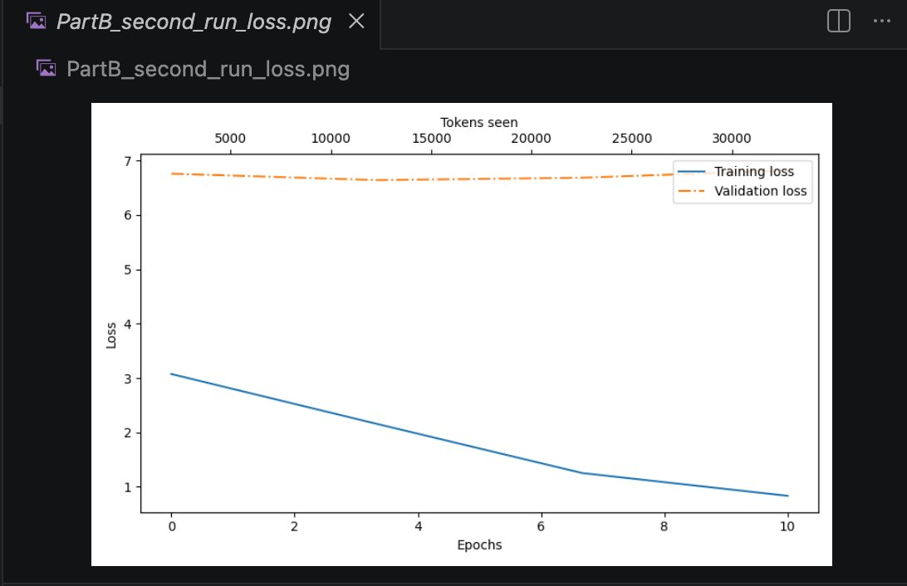

Second Training Run — Loss Values
Ep 1 (Step 000000): Train loss 3.074, Val loss 6.757
Ep 3 (Step 000005): Train loss 2.158, Val loss 6.639
Ep 6 (Step 000010): Train loss 1.254, Val loss 6.682
Ep 8 (Step 000015): Train loss 0.835, Val loss 6.817

Analysis — Second Training Run
The second run shows a clear and severe case of overfitting. The training loss continued to drop dramatically — all the way to 0.835 — while the validation loss remained essentially flat around 6.7 throughout the entire run. This large gap between the two curves is the hallmark of a model that has memorized the training data verbatim rather than learning generalizable language patterns. This is confirmed by the generated text, which by the end of the second run reproduced near-exact sentences from The Verdict: 'Every effort moves you thought Jack Gisburn rather a cheap genius -- though a good fellow enough -- so it was no great surprise to me to hear that, in the height of his glory, he had dropped his painting, married a rich widow, and established himself in...' This is a direct quote from the story, demonstrating complete memorization.

Part C: Text Generation with Scratch-Trained Model
After training the model from scratch, the generate() function was called using 'Every effort moves you' as the starting phrase, with top_k=50 and temperature=1.5, generating 25 new tokens.

Generated Output
Input: 'Every effort moves you'
Output: Every effort moves youement I knew my and established, Lord_ly
down--one Gisburn last The were work; yet_ that this

Analysis
The output from the scratch-trained model is largely incoherent and contains broken words such as 'youement' and 'Lord_ly'. This is expected because even though the model learned some patterns from The Verdict during training, it has no foundational language knowledge — it was trained only on a very small dataset of a few thousand tokens. The high temperature setting of 1.5 also increases randomness in the output, contributing to the incoherence. Some recognizable words from the story appear ('Gisburn', 'established') showing that the model did absorb some content, but it cannot yet form grammatically correct sentences from scratch.

Part D: Fine-Tuning the Pretrained GPT-2 Small (124M) Model
In Part D, the pretrained GPT-2 small (124M) weights were loaded into a fresh model instance. Text was first generated using only the pretrained weights, then the model was fine-tuned on The Verdict for 10 epochs, after which five different generation experiments were conducted.

Generation Before Fine-Tuning (Pretrained Weights Only)
Input: 'Every effort moves you'
Output: Every effort moves you when on a short budget such as this,
Ms. Fertilinov said, a simple budget of 400 is

The pretrained model generates fluent, grammatically correct English immediately — without any training on The Verdict. This demonstrates the power of pretraining on large corpora. The text is coherent but unrelated to the story's subject matter.

Fine-Tuning Loss Plot
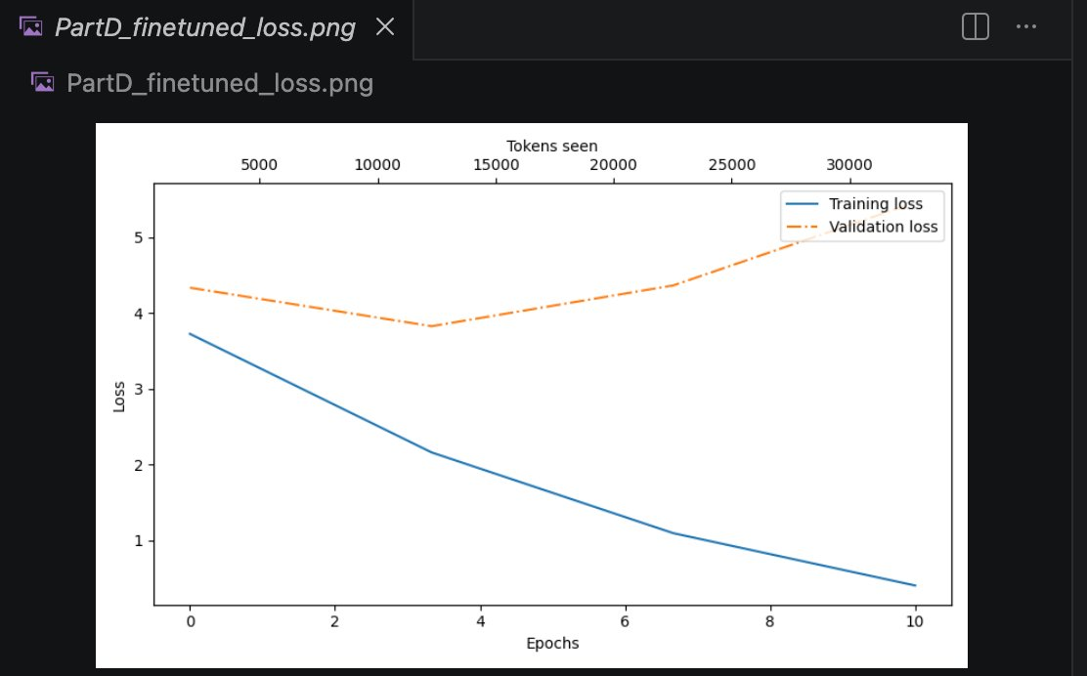

Fine-Tuning Loss Values
Ep 1 (Step 000000): Train loss 3.727, Val loss 4.337
Ep 3 (Step 000005): Train loss 2.161, Val loss 3.829
Ep 6 (Step 000010): Train loss 1.095, Val loss 4.368
Ep 8 (Step 000015): Train loss 0.404, Val loss 5.463

Fine-Tuning Analysis
The pretrained model started with a much lower initial training loss (3.727) compared to the scratch-trained model (9.437), reflecting its existing language knowledge. The validation loss initially decreased but then rose sharply after epoch 4, indicating overfitting. The training loss continued to drop to 0.404, showing that the model was memorizing The Verdict. This pattern is typical when fine-tuning a large pretrained model on a very small dataset.

Generation Experiments After Fine-Tuning

Experiment 1 — max_new_tokens=25, top_k=10, temperature=1.5:
Every effort moves you forward, and all that is left after that, the adulation
gradually died out, and the atmosphere in the dining-room
The output is fluent and thematically connected to the story. The temperature of 1.5 introduces some variety while still producing coherent text.

Experiment 2 — temperature raised to 5:
Every effort moves you thither; yet no less an atom or atom is made of
_thattagre_--nor _that_ its analog
Raising the temperature to 5 makes the output almost incoherent. Very high temperatures cause the model to sample from very low-probability tokens, resulting in nonsensical and broken words like '_thattagre_'. This demonstrates that temperature is a critical parameter — too high produces gibberish.

Experiment 3 — temperature lowered to 0.1:
Every effort moves you forward; but no more harm is done by it!
Destroy it! he said, with a laugh that tried
At temperature 0.1, the model becomes very confident and deterministic, always picking the most likely next token. The output is coherent and reads almost like a direct quote from The Verdict, confirming that low temperature leads to memorized, repetitive output.

Experiment 4 — max_new_tokens=50, temperature=1.5:
Every effort moves you forward; the more you murmur MRS., the murmur under
the hood, the more you understand. The more people you tell me the murmur
an inflexible tinge of Stroud's dingy old pride; and the more you
With 50 tokens generated, the model produces a longer passage that shows thematic elements from the story (mentioning 'Stroud' and 'MRS.'). The repetitive structure ('the more you...') suggests the model is looping on high-probability patterns.

Experiment 5 — max_new_tokens=30, top_k=20:
Every effort moves you in opposite directions--rather an endless stream of
repeating the same thing over and over again, repeating the same idea over
and over again, amplening every
Increasing top_k to 20 gives the model more choices at each step. The output shows a repetitive loop pattern ('repeating the same thing over and over again'), which is a known failure mode when the model gets stuck in a high-probability cycle.

Part E: Fine-Tuning the Pretrained GPT-2 Medium (355M) Model
Part E repeats the experiments from Part D using the larger GPT-2 medium model with 355 million parameters — approximately three times larger than the small model. The larger model has more capacity to learn language patterns.

Generation Before Fine-Tuning (Pretrained Weights Only)
Input: 'Every effort moves you'
Output: Every effort moves you in the best possible way and you have a huge
choice of things to be thinking and having fun.

The medium pretrained model immediately generates more natural and contextually appropriate text than the small model, reflecting its larger training capacity and more parameters.

Fine-Tuning Loss Plot
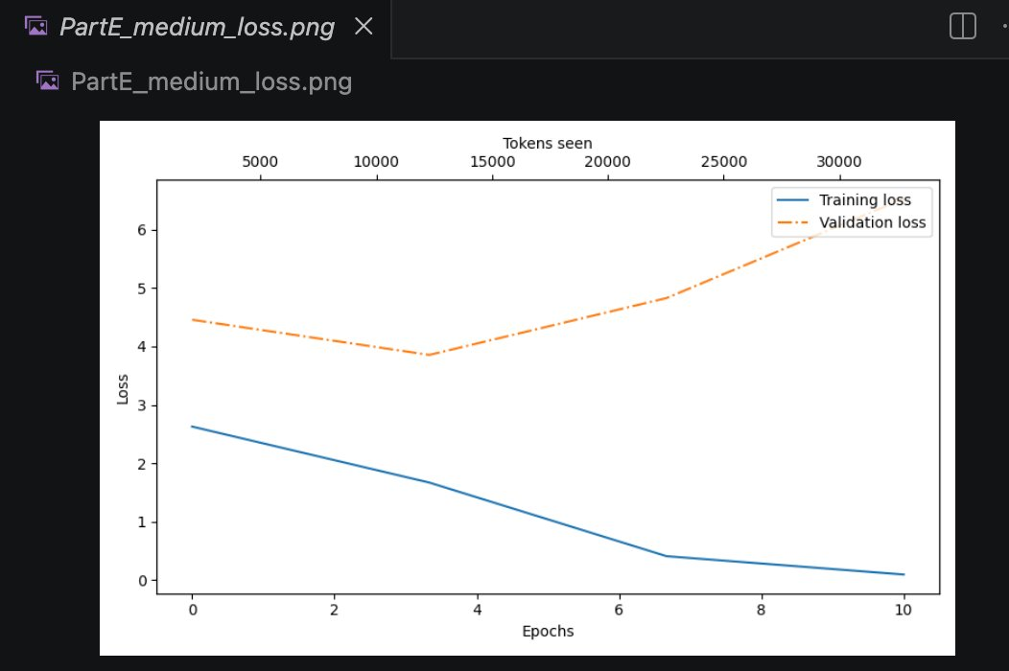

Fine-Tuning Loss Values
Ep 1 (Step 000000): Train loss 2.628, Val loss 4.455
Ep 3 (Step 000005): Train loss 1.670, Val loss 3.854
Ep 6 (Step 000010): Train loss 0.411, Val loss 4.826
Ep 8 (Step 000015): Train loss 0.097, Val loss 6.526

Fine-Tuning Analysis
The medium model started with an even lower initial training loss (2.628) compared to the small pretrained model (3.727), reflecting its greater language capacity. However, overfitting was even more severe — the training loss dropped to an extremely low 0.097 while the validation loss rose sharply to 6.526. This is because the larger model has more parameters and therefore greater capacity to memorize a small dataset. The validation loss curve shows a clear U-shape: it first improved, then degraded significantly after epoch 4 as memorization took over.

Generation Experiments After Fine-Tuning

Experiment 1 — max_new_tokens=25, top_k=10, temperature=1.5:
Every effort moves you toward a better state of mind and body. By Jove,
and he's won that fair fight! Mrs. Gis
The medium model produces more sophisticated and thematically rich output, referencing story characters like Mrs. Gisburn and using more complex sentence structures than the small model.

Experiment 2 — temperature raised to 5:
Every effort moves you along. Only failure,, as such: people do get to see
how foolishly the millionaire-barons, with full
At temperature 5, the medium model also produces incoherent text, though it retains slightly more structure than the small model at the same temperature, demonstrating the benefit of larger model capacity.

Experiment 3 — temperature lowered to 0.1:
Every effort moves you, but the thought of failure is all that counts. And
so it was fitting that, in the height of her glory,
At low temperature, the medium model produces highly coherent text that closely mirrors the source story. The phrase 'but the thought of failure is all that counts' is stylistically consistent with The Verdict's themes.

Experiment 4 — max_new_tokens=50, temperature=1.5:
Every effort moves you toward a better state of mind--and it's the reason
behind the diagnosis of my friend's disease. Mrs. Gisburn, beaming on him,
added for my enlightenment: Jack is so morbidly sensitive to every form
of beauty.
With 50 tokens, the medium model generates a longer passage that sounds remarkably like the original story, referencing Mrs. Gisburn by name and using the character's voice. The quality of generation at this length is noticeably better than the small model.

Experiment 5 — max_new_tokens=30, top_k=20:
Every effort moves you farther toward the goal of being elected the
People's man, while the other's efforts to win over the similar woman's
high ideals--that is
With top_k=20, the medium model generates more diverse and creative text. The output introduces new concepts ('People's man', 'high ideals') that are not direct quotes from the story, showing that the larger model has more capacity for creative generation even after fine-tuning.

Summary and Conclusions

This exercise demonstrated several key concepts in language model training:

1. Training from scratch vs. pretrained weights: The scratch-trained model required many epochs just to produce coherent text fragments, while the pretrained model generated fluent English immediately. This illustrates the enormous value of pretraining on large corpora.

2. Overfitting on small datasets: All models showed signs of overfitting when fine-tuned on The Verdict, which contains only a few thousand tokens. The training loss dropped dramatically while validation loss stagnated or rose, indicating memorization rather than generalization.

3. Temperature effects: High temperature (5.0) produced incoherent, random output. Low temperature (0.1) produced deterministic, memorized text. A moderate temperature (1.5) provided the best balance between coherence and creativity.

4. Model size matters: The medium (355M) model consistently produced higher-quality, more coherent, and more contextually appropriate text than the small (124M) model, demonstrating that larger models have greater language understanding capacity.

5. Top-k sampling: Limiting the sampling pool to the top-k most likely tokens helps prevent the model from selecting very low-probability, nonsensical words, improving overall output quality.

