Found existing split dataset. Loading splits...

Calculating class weights for balanced sampling...

Data loaders are ready.

/tmp/ipykernel_36/1443983444.py:190: FutureWarning: `torch.cuda.amp.GradScaler(args...)` is deprecated. Please use `torch.amp.GradScaler('cuda', args...)` instead.

scaler = torch.cuda.amp.GradScaler(enabled=USE_MIXED_PRECISION)

Epoch 1/10 | Train Loss: 1.0443 Acc: 0.6616 | Val Loss: 0.5143 Acc: 0.8256

Epoch 2/10 | Train Loss: 0.4909 Acc: 0.8352 | Val Loss: 0.3950 Acc: 0.8737

Epoch 3/10 | Train Loss: 0.3504 Acc: 0.8802 | Val Loss: 0.3663 Acc: 0.8719

Epoch 4/10 | Train Loss: 0.2815 Acc: 0.9061 | Val Loss: 0.3405 Acc: 0.8808

Epoch 5/10 | Train Loss: 0.2472 Acc: 0.9184 | Val Loss: 0.3333 Acc: 0.8950

Epoch 6/10 | Train Loss: 0.2212 Acc: 0.9275 | Val Loss: 0.3545 Acc: 0.8843

Epoch 7/10 | Train Loss: 0.1731 Acc: 0.9374 | Val Loss: 0.3013 Acc: 0.9146

Epoch 8/10 | Train Loss: 0.1511 Acc: 0.9531 | Val Loss: 0.3313 Acc: 0.8843

Epoch 9/10 | Train Loss: 0.1217 Acc: 0.9580 | Val Loss: 0.3567 Acc: 0.8986

Epoch 10/10 | Train Loss: 0.0985 Acc: 0.9668 | Val Loss: 0.3161 Acc: 0.9075

Training complete.

Model saved to ../saved_models_and_data/final_hybrid_model.pth

Test set predictions complete. Generating confusion matrix...

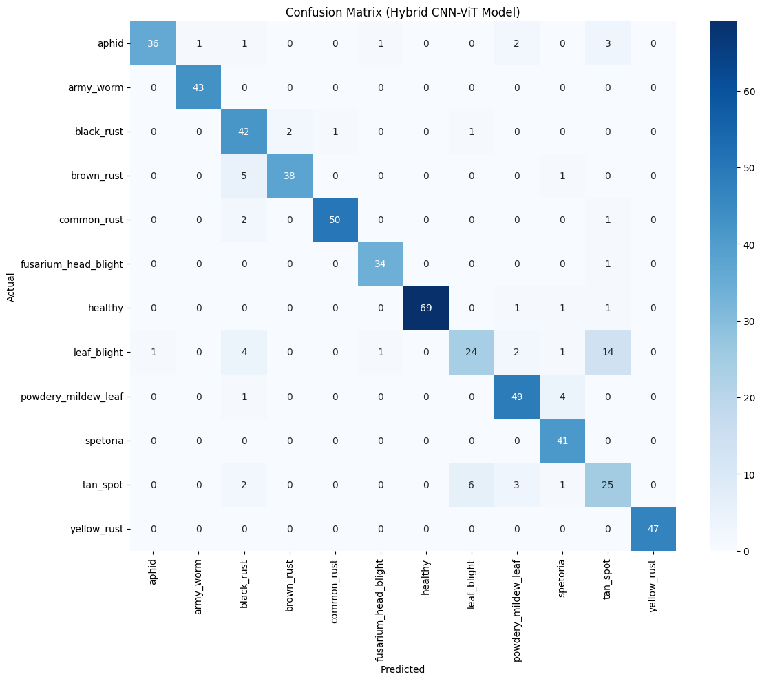

Classification Report:

precision recall f1-score support

aphid 0.9730 0.8182 0.8889 44

army_worm 0.9773 1.0000 0.9885 43

black_rust 0.7368 0.9130 0.8155 46

brown_rust 0.9500 0.8636 0.9048 44

common_rust 0.9804 0.9434 0.9615 53

fusarium_head_blight 0.9444 0.9714 0.9577 35

healthy 1.0000 0.9583 0.9787 72

leaf_blight 0.7742 0.5106 0.6154 47

powdery_mildew_leaf 0.8596 0.9074 0.8829 54

spetoria 0.8367 1.0000 0.9111 41

tan_spot 0.5556 0.6757 0.6098 37

yellow_rust 1.0000 1.0000 1.0000 47

accuracy 0.8845 563

macro avg 0.8823 0.8801 0.8762 563

weighted avg 0.8920 0.8845 0.8835 563

Done. Executed notebook saved as 'train_convnext_executed.ipynb'