SCO 310 / SIT 300 — Component Programming Project Report

QR Component Studio
A QR Code generator built from reusable JavaBeans components
Submission detail | Information
Student name | [STUDENT NAME]
Registration number | [REGISTRATION NUMBER]
Lecturer | Dr. Bernard Ondara, Ph.D.
Institution | Kenyatta University — Department of Computing
Unit | SCO 310 / SIT 300 — Component Programming
Submission date | [DATE]

Table of contents
- The application
- Output formats
- Main program logic
- Components used
- QR Code generation
- Configuration and saved data
- Testing
- Problems fixed
- Conclusion
- References

1. The application
QR Component Studio accepts text, creates a QR Code, displays it and saves the generated file. The same window also shows the selected output format, recent history and details about the generated symbol.
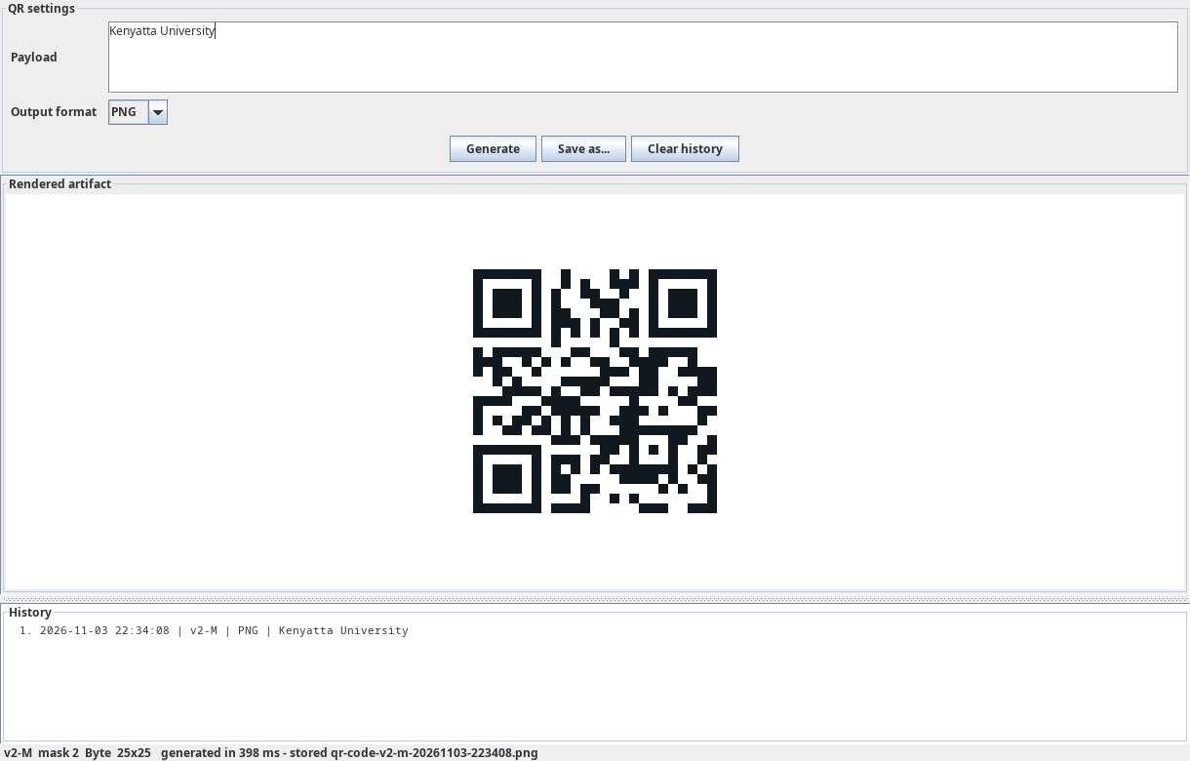

1.1 Entering the text and choosing the format
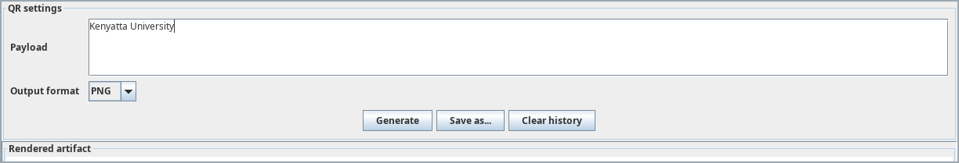
The payload box contains the text to be encoded. The output selector chooses the renderer used for the result. When Generate is clicked, the text is passed to QrStudioFacadeBean, which starts the generation process.

1.2 Result, history and saved file
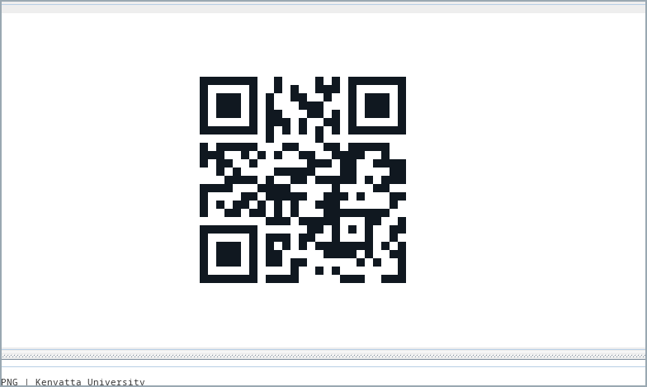
The encoder creates the QR matrix and the selected renderer turns it into the requested output. The result is displayed in the preview area.
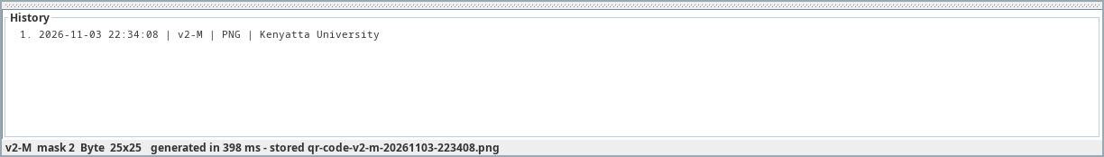
After generation, the history area records the operation. The status line shows the QR version, error-correction level, mask, generation time and saved filename.

2. Output formats
The application uses separate renderer components. Changing the format does not change the encoder, history or file-storage components.

2.1 PNG
The PNG result is shown in Section 1. It is produced by PngRendererBean using the configured module size, quiet zone and colours.

2.2 SVG
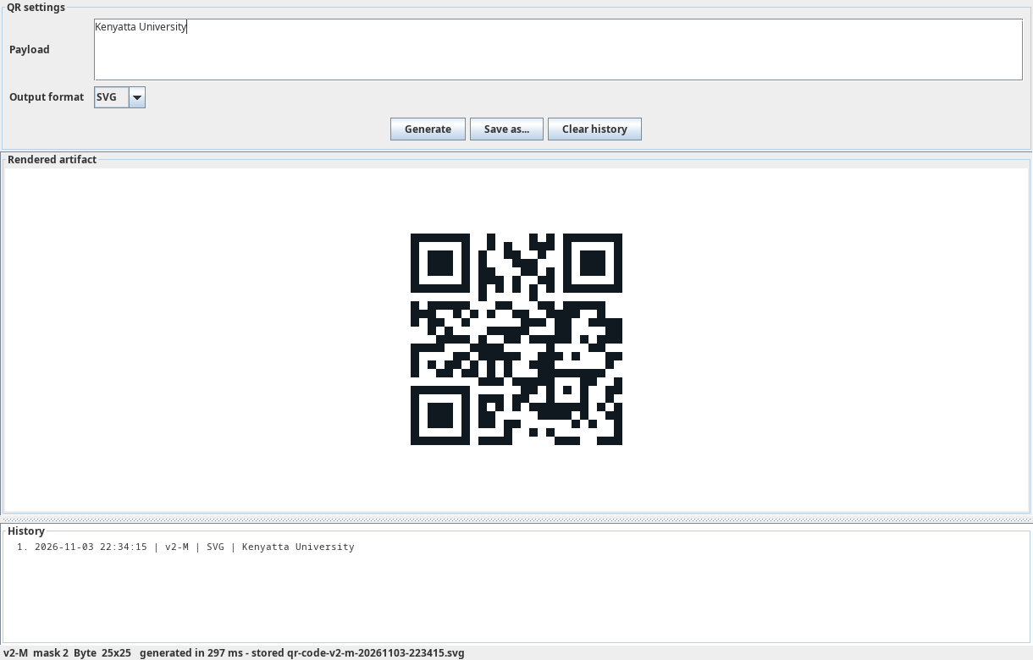
SvgRendererBean creates vector output from the same QR matrix. The image remains clear when it is resized.

2.3 Text
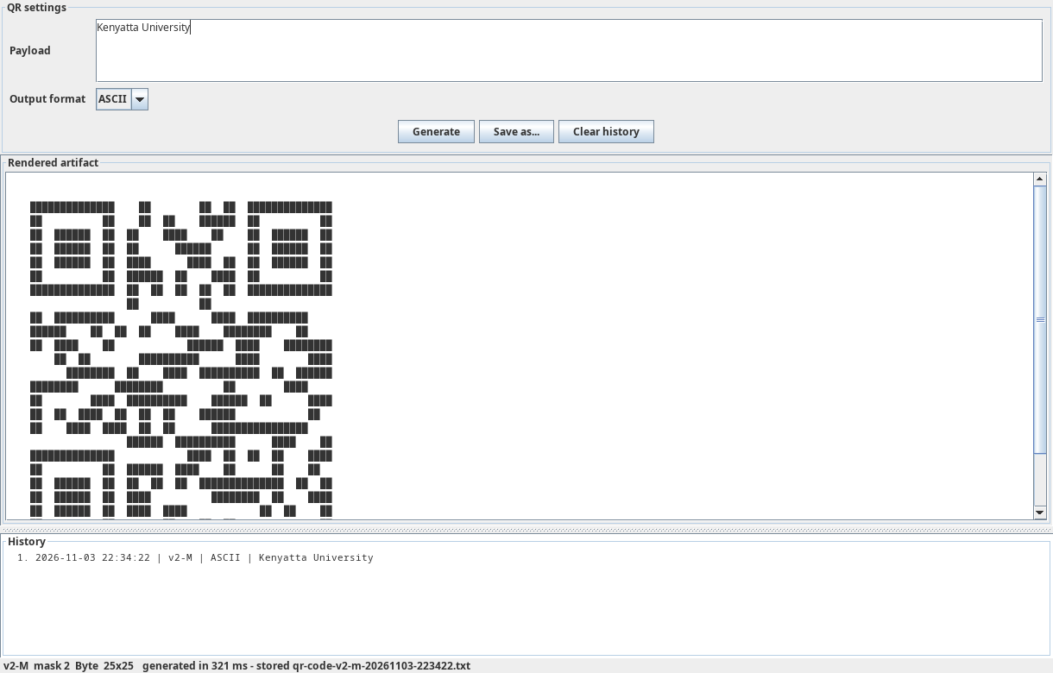
AsciiRendererBean changes the dark and light modules into text characters. The application shows the result in a scrollable text area.

2.4 Other available formats
The project also contains RoundedModuleRendererBean for rounded PNG output and PdfRendererBean for vector PDF output. Both implement the same QrCodeRenderer interface.

3. Main program logic

3.1 Encoder interface
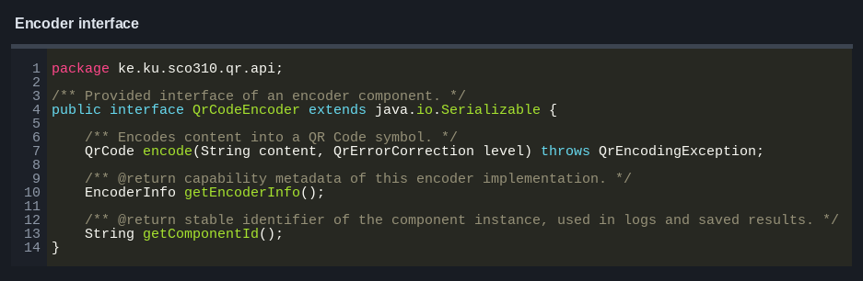
QrCodeEncoder defines the method used to encode text. The built-in encoder and the optional ZXing encoder both implement this interface.

3.2 Encoder component
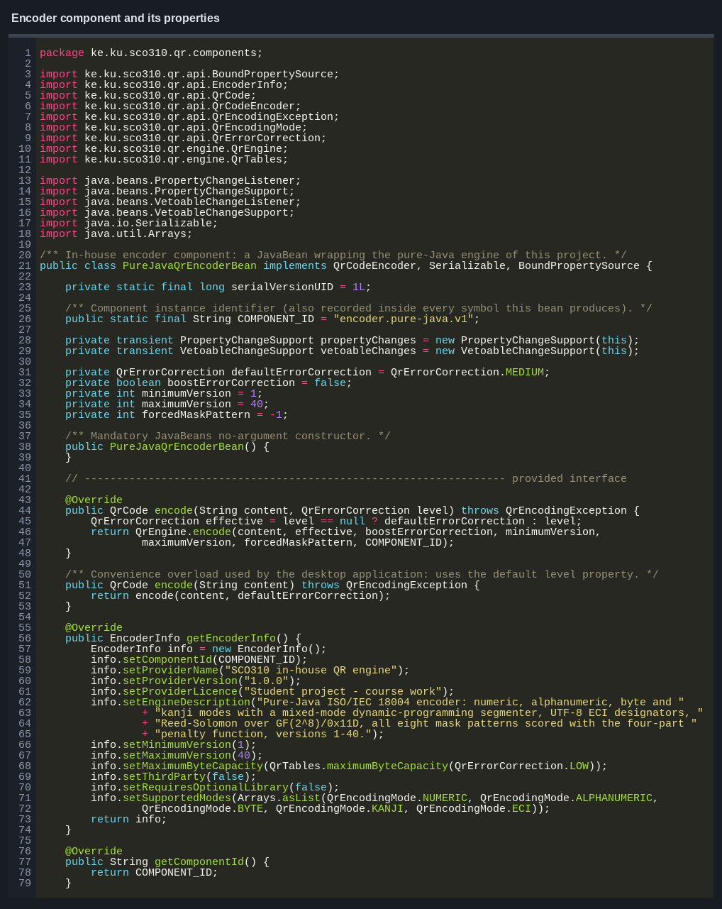
PureJavaQrEncoderBean stores the encoder settings and passes the work to the QR engine. Its main properties include the default error-correction level, minimum version, maximum version and forced mask.

3.3 Error correction
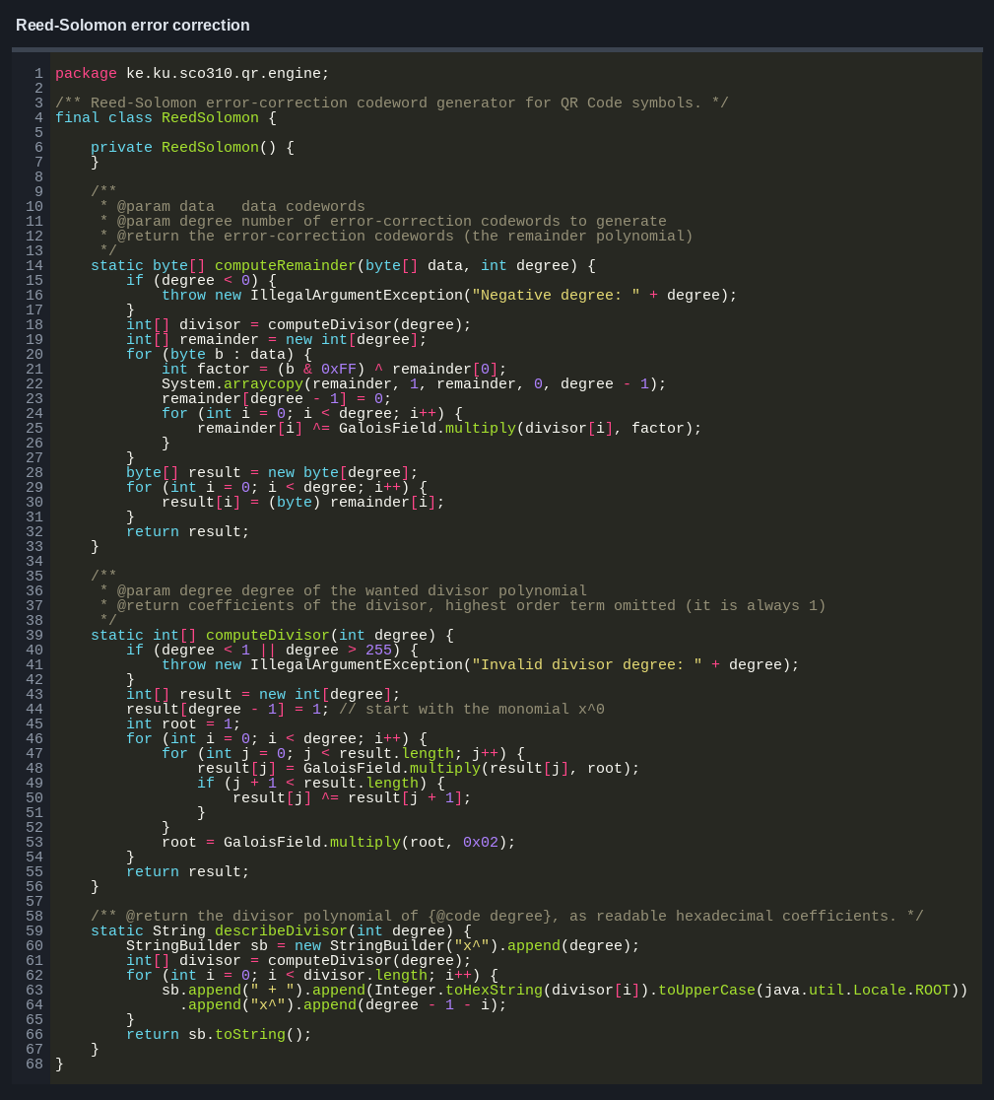
ReedSolomon creates the error-correction codewords. These codewords allow a damaged QR Code to remain readable within the limit of its selected error-correction level.

3.4 PNG creation
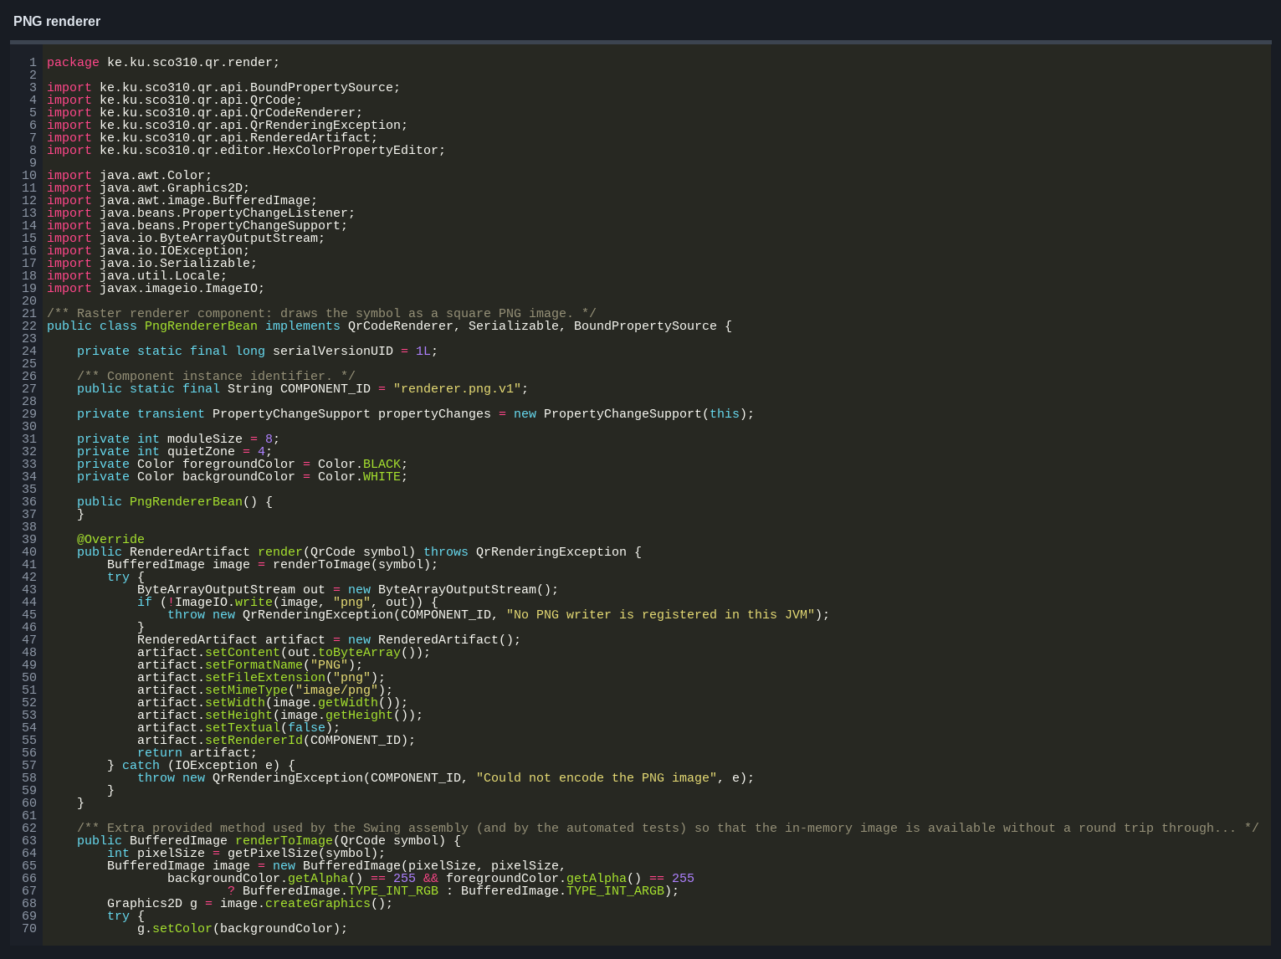
PngRendererBean creates the image, paints the background and draws every dark QR module. The final image is returned as a RenderedArtifact.

3.5 Generation process
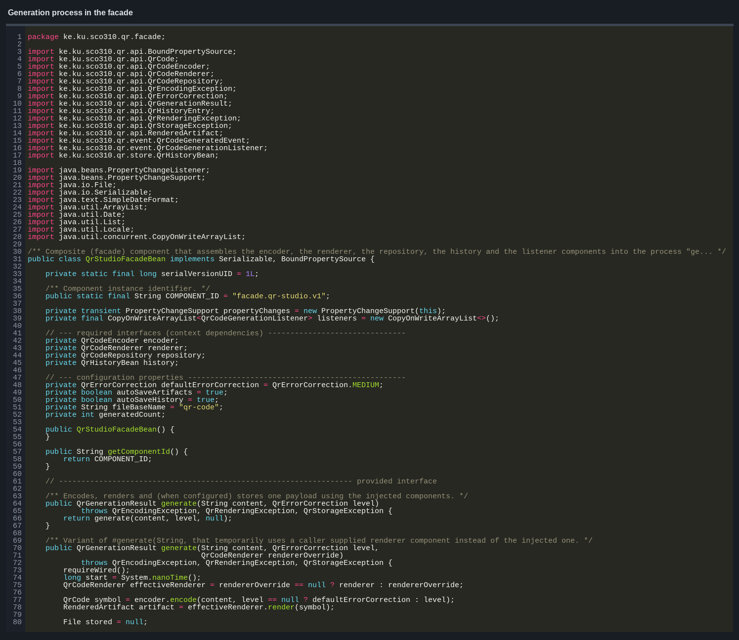
QrStudioFacadeBean controls the main process:
- encode the text;
- render the QR Code;
- save the generated file;
- update the history; and
- notify registered listeners.

3.6 Loading and connecting components
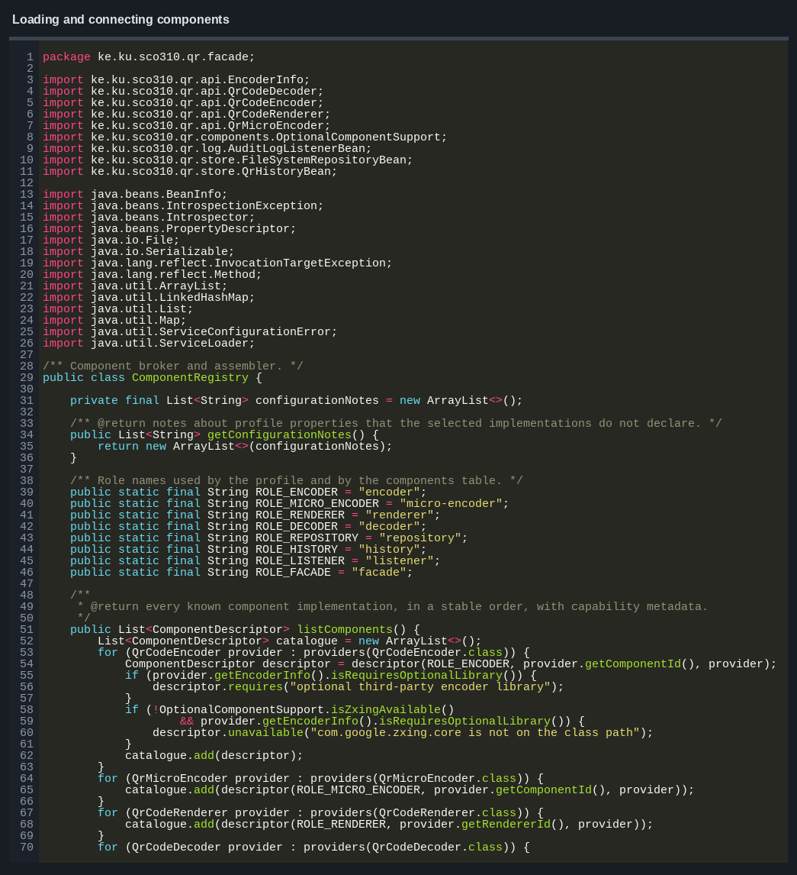
ComponentRegistry loads the selected components, applies their property values and checks that the required connections are available.

3.7 History
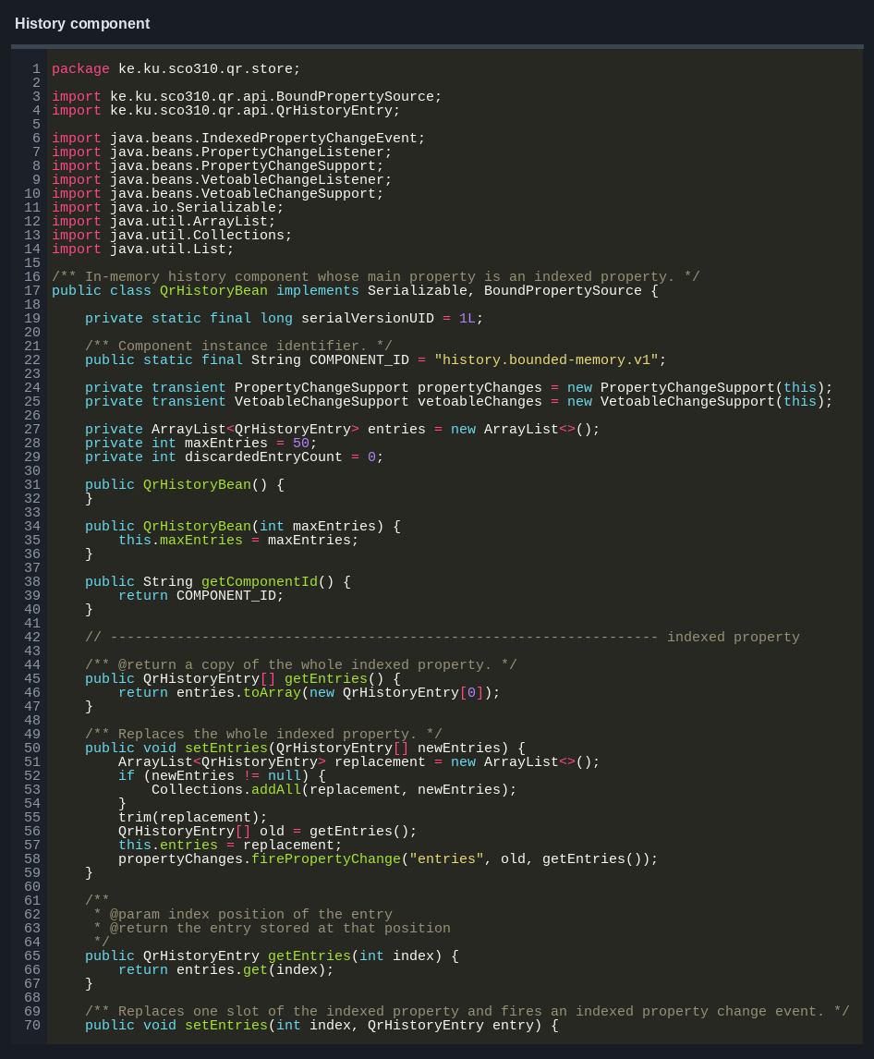
QrHistoryBean stores recent generation records. Its maximum size can be changed, and older entries are removed when the limit is reached.

3.8 Desktop window
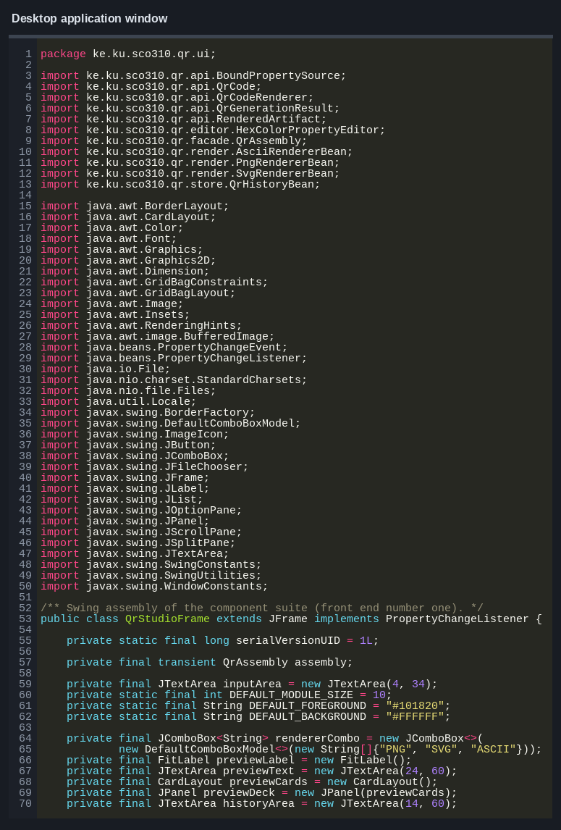
QrStudioFrame reads the user input, calls the facade and displays the returned result. The QR encoding algorithm is kept outside the window class.

3.9 ZXing adapter
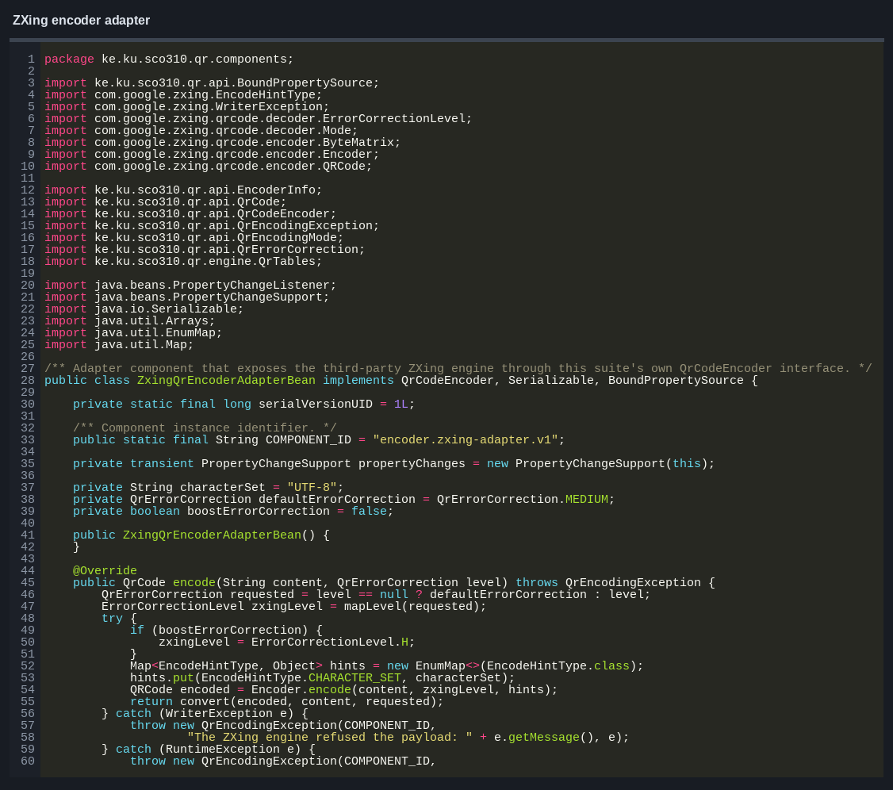
ZxingQrEncoderAdapterBean allows ZXing to be used through the same QrCodeEncoder interface. The rest of the application does not need to know which encoder is connected.

4. Components used
Role | Component | Main work
Encoder | PureJavaQrEncoderBean | creates standard QR Codes
Encoder | ZxingQrEncoderAdapterBean | uses the optional ZXing encoder
Micro QR encoder | MicroQrEncoderBean | creates Micro QR M1–M4 symbols
Decoder | PureJavaQrDecoderBean | reads supported QR matrices and generated files
Decoder | ZxingQrDecoderAdapterBean | uses ZXing for decoding
Renderer | PngRendererBean | creates PNG images
Renderer | SvgRendererBean | creates SVG files
Renderer | AsciiRendererBean | creates text output
Renderer | RoundedModuleRendererBean | creates rounded PNG images
Renderer | PdfRendererBean | creates PDF files
Repository | FileSystemRepositoryBean | saves files and stored history
History | QrHistoryBean | keeps recent generation records
Listener | AuditLogListenerBean | records generation events
Facade | QrStudioFacadeBean | controls the generation process

4.1 JavaBeans features used
The components use public no-argument constructors and getter/setter methods. Bound properties send change events when their values are updated. Constrained properties can reject invalid values. QrHistoryBean also provides indexed access to individual history entries.
PngRendererBeanBeanInfo and QrHistoryBeanBeanInfo provide extra information about the bean properties. HexColorPropertyEditor changes hexadecimal colour text into Java Color objects.

5. QR Code generation
The built-in encoder follows these steps:
- check the text and choose suitable encoding modes;
- choose the smallest version that can hold the data;
- add the mode, character count, data and padding bits;
- create Reed–Solomon error-correction codewords;
- place the finder, timing, alignment and data modules;
- test the eight mask patterns; and
- add the format and version information.
Numeric, alphanumeric, byte, Kanji, UTF-8 ECI and mixed-mode content are supported. Standard QR versions 1–40 and error-correction levels L, M, Q and H are available. Micro QR M1–M4 is handled by a separate encoder component.

6. Configuration and saved data
config/assembly.xml stores the selected components and their property values. AssemblyProfile loads this file, while ComponentRegistry creates and connects the components.
FileSystemRepositoryBean saves generated files in the configured folder. It also stores the history so that previous records can be loaded again. AssemblyGraphBean supports saving and restoring the connected bean objects through XMLEncoder and XMLDecoder.

7. Testing
The project includes checks for encoding, decoding, renderers, component properties, history, configuration and saved files. The tests also use ZXing to decode generated symbols and compare the result with the original text.
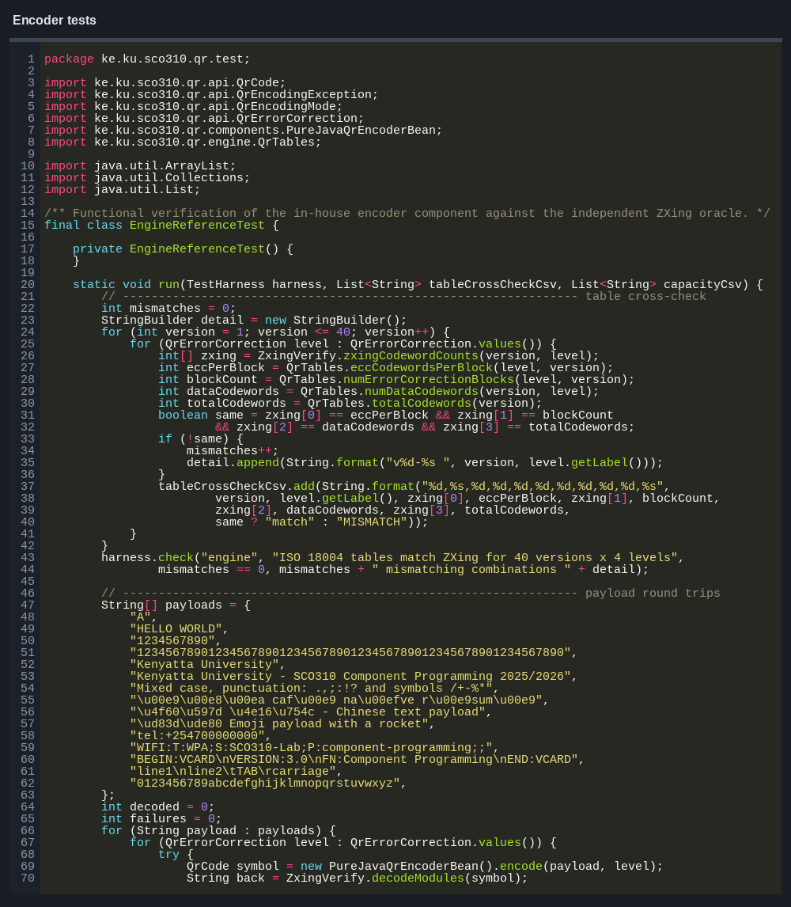
The latest full test run completed successfully. Invalid component names, missing connections and corrupted files are also tested to make sure errors are detected.

8. Problems fixed

8.1 Error-correction blocks
The first multi-block version placed some data and error-correction codewords in the wrong order. The interleaving step was corrected and checked with larger QR versions.

8.2 Large preview images
Large QR Codes could be cut off in the desktop window. The preview layout was changed so the result can fit or scroll correctly.

8.3 History property
The history entries were first shown as a normal property. IndexedPropertyDescriptor was added so individual entries can be discovered and accessed correctly.

8.4 Optional ZXing library
The application now checks whether ZXing is available before selecting its adapter. If it is not available, the built-in encoder remains selected.

9. Conclusion
QR Component Studio generates QR Codes through separate encoder, renderer, storage, history and listener components. These parts are connected through shared interfaces, which allows an encoder or renderer to be changed without changing the rest of the application.
The desktop application generates PNG, SVG and text output, saves the result and records recent operations. The built-in QR engine handles the complete generation process, while the optional ZXing adapter provides another encoder using the same interface.

10. References
- International Organization for Standardization and IEC. *ISO/IEC 18004:2015 — QR Code bar code
symbology specification*.
- Szyperski, C. *Component Software: Beyond Object-Oriented Programming*. Second edition,
Addison-Wesley, 2002.
- Oracle. *JavaBeans Specification* and java.beans API documentation.
- ZXing Project. *ZXing Core 3.5.3*.
- SCO 310 / SIT 300 Component Programming course materials, Kenyatta University.

