产品介绍部分：
- 背景：介绍Labubu产品线。拉布布的创造者是谁？什么促成了这个产品的创造（灵感）？
英文：Labubu began as a character designed by Kasing Lung (1972–[1]), a Hong Kong–born artist raised in the Netherlands. Labubu was part of Lung's story series The Monsters, which was influenced by Nordic folklore[7][8] and mythology that he enjoyed during his childhood.[5]
Labubu was first introduced in 2015[5] with "Monsters" figurines produced by the company How2Work;[1] the toy gained wider recognition in 2019 following a collaboration with Pop Mart.[3][9] This partnership boosted Labubu's popularity among collectors.
中文：拉布布最初是由龙家升（Kasing Lung，1972- [ 1 ] ）设计的一个角色。他是一位出生于香港、在荷兰长大的艺术家。拉布布是龙家升故事系列《怪物》中的一个角色。该系列受到龙家升童年时期喜爱的北欧民间传说[ 7 ] [ 8 ]和神话的影响。 [ 5 ]
Labubu 于 2015 年首次推出[ 5 ]，当时与 How2Work 公司生产的“怪兽”雕像一起推出；[ 1 ]在与Pop Mart合作后，该玩具在 2019 年获得了更广泛的认可。[ 3 ] [ 9 ]此次合作提升了 Labubu 在收藏家中的人气。

英文：Now let's get into the history of these popular Labubu dolls. They first originated in Hong Kong, and unlike its popular predecessors (Hello Kitty and other plush characters), they are described as elvish creatures. They came to fruition in a Nordic-inspired picture book that artist Kasing Lung created. After the initial release of the book, the popular toy company Pop Mart created the first collectible collection for sale in 2019, and since then, sales have been soaring as new collections are released.
The Labubu creatures are a part of a tribe known as "The Monsters," and other members of the group include Zimomo, Mokoko, Tycoco, and more. A few key features that make her so unique are the wide eyes that are almost as big as her "mischievous smile," she has a furry exterior body and nine very visible teeth in her grin. From collection to collection, each can be seen wearing various outfits, different facial features and more fun accessories that make each drop unique. But don't let the mischievous smile make you think Labubus are evil. Lung says they are well-natured little creatures who have nothing but good intentions, that sometimes inevitably end up in a pickle.

中文：现在，让我们来回顾一下这些广受欢迎的拉布布娃娃的历史。它们最初起源于香港，与之前流行的Hello Kitty和其他毛绒玩具不同，它们被描述为精灵生物。它们的雏形出现在艺术家龙嘉星创作的一本北欧风格的图画书中。这本书首次发行后，热门玩具公司泡泡玛特于2019年推出了首个收藏系列，自此之后，随着新系列的推出，销量一路飙升。
拉布布（Labubu）是一个名为“怪兽”的部落的成员，该部落的其他成员包括齐莫莫（Zimomo）、莫可可（Mokoko）、泰可可（Tycoco）等等。拉布布的独特之处在于它那双几乎和她“顽皮的笑容”一样大的圆眼睛，毛茸茸的外表和咧嘴一笑露出的九颗牙齿。从不同的收藏系列中，我们可以看到每个拉布布都穿着不同的服装，拥有不同的面部特征和更多有趣的配饰，使每个系列都独一无二。但不要因为拉布布顽皮的笑容就认为它们是邪恶的。隆说，它们是性情温和的小动物，心地善良，但有时难免会陷入困境。

2、产品特性：描述Labubu的主要特性。是什么让它与众不同于市场上的其他产品？
英文：Their newest collection is the "Big Into Energy" and is described on the site as "a vibrant and emotionally rich series that encapsulates different types of energy experienced in our daily lives." What makes this collection different is the new ombre colorways and the fact that each monster's teeth are painted to coordinate with her fur.
Now, what makes Labubus so popular, besides the obvious cute charm, is that they are collectibles and hard to get, so it adds to the excitement of the hunt. According to Google Trends, searches for "Labubu doll" and "Labubu Keychain" have been at an all-time high in recent weeks and have stayed as a continuous breakout search term. Just in the last month alone, Google searches hit 2.1 million.
When you get a blind box, you have no idea what character you are going to get, so many fans record their first impression of their creature to capture the moment. This excitement transcends age groups and communities, with everyone from pop stars like Lisa of BLACKPINK to middle school students wearing the bag charms. It creates a sense of joy and status that you can say, "Yes, I succeeded and found a Labubu." While they can be resold for hundreds of dollars, they are initially pretty accessible in terms of prices, ranging from under $25 to $100.
中文：他们的最新系列是“Big Into Energy”，网站上将其描述为“一个充满活力且情感丰富的系列，囊括了我们日常生活中体验到的不同类型的能量。” 这个系列的与众不同之处在于新的渐变配色，以及每个怪物的牙齿都与其毛发相协调的涂色。
拉布布娃娃如此受欢迎的原因，除了显而易见的可爱挂饰之外，还在于它们极具收藏价值，而且很难获得，这更增添了寻宝的刺激感。根据谷歌趋势显示，“拉布布娃娃”和“拉布布钥匙扣”的搜索量在最近几周创下历史新高，并持续成为热门搜索词。仅在上个月，谷歌搜索量就达到了210万次。
当你收到盲盒时，你完全不知道会得到什么角色，所以很多粉丝会记录下他们对这个角色的第一印象，以此来捕捉那个瞬间。这种兴奋感跨越了年龄和群体，从像BLACKPINK成员Lisa这样的流行歌手，到初中生，每个人都会佩戴盲盒挂饰。它营造出一种喜悦和地位感，让你可以说：“是的，我成功找到了一个拉布布。”虽然它们可以转售到数百美元，但最初的价格相当亲民，从不到25美元到100美元不等。

3、产品线：列出并描述Labubu产品的不同系列或版本（如马卡龙系列、太空探险系列）。
Labubu products have various Series such as Big Into Energy Series, One Piece Series, COCA-COLA Series Plush Pendant, Classic Series COCA-COLA Series, Playing Games Series.The Labubu Animals Series brings together the mischievous spirit of Labubu with an adorable lineup of animals, capturing each creature’s unique personality in a playful, collectible form. From lively monkeys to cuddly koalas, every character in this series features Labubu’s iconic smile blended with the defining traits of each animal. The series is a tribute to the diversity of wildlife, offering fans a delightful journey through a world where Labubu transforms into some of nature’s most beloved animals.
中文：拉布布动物系列将拉布布顽皮的性格与一系列可爱的动物融为一体，以俏皮有趣且值得收藏的形式捕捉每个生物的独特个性。从活泼的猴子到可爱的考拉，该系列中的每个角色都融合了拉布布标志性的微笑和每种动物的标志性特征。该系列是对野生动物多样性的致敬，为粉丝们带来了一场愉悦的旅程，在拉布布变身为大自然中最受喜爱的动物的世界里，拉布布将化身为各种动物。

大力发展能源系列

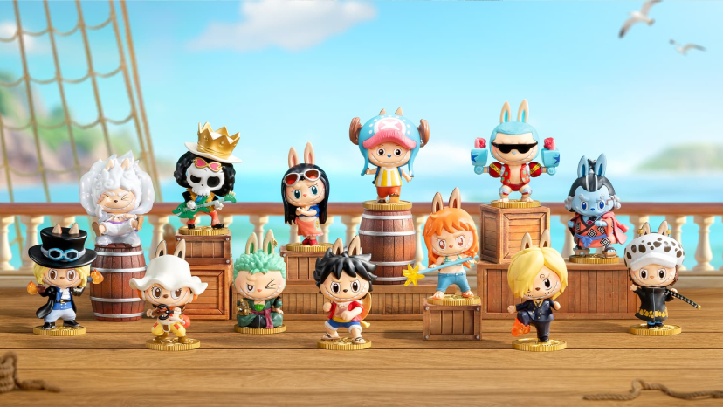

海贼王系列

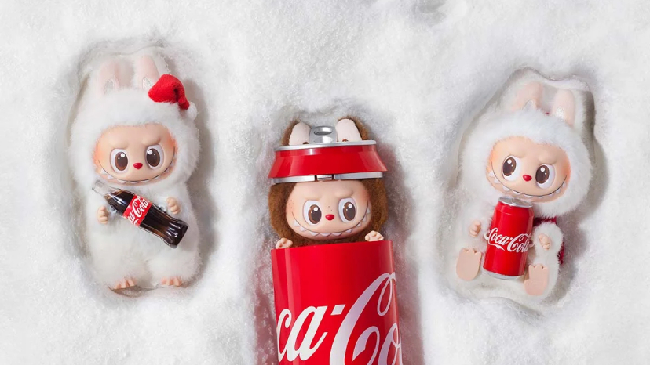

可口可乐系列毛绒挂件

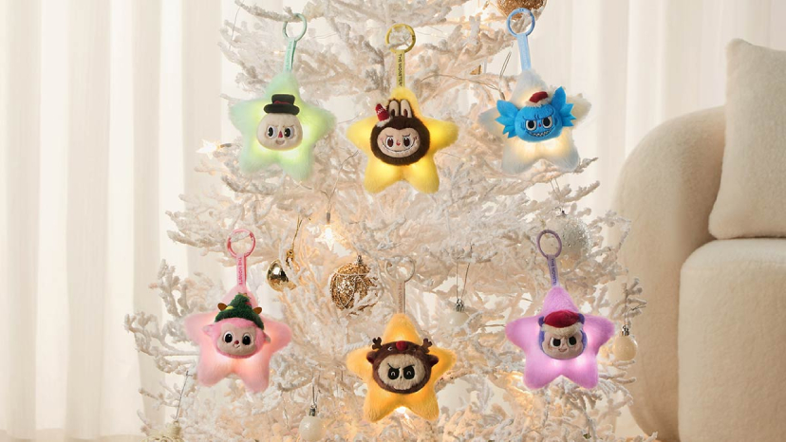

经典系列

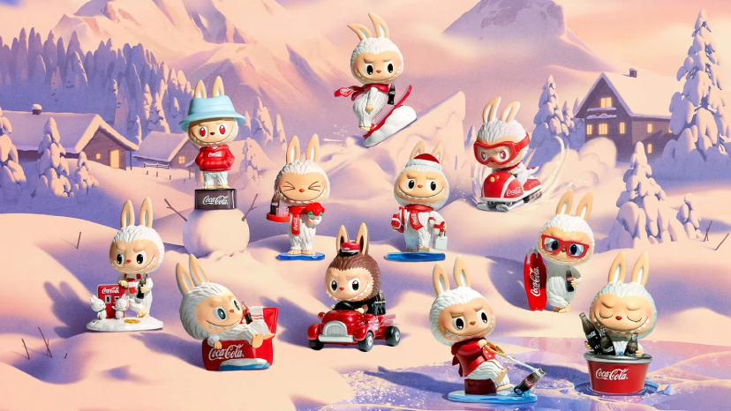

可口可乐系列

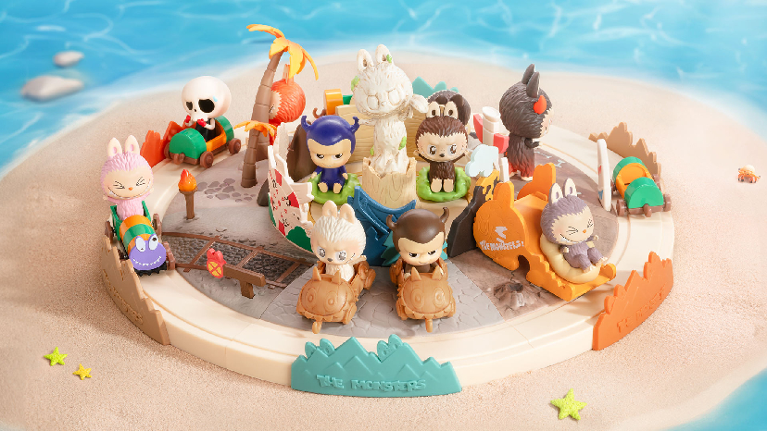

玩游戏系列

