数据库第三次作业——SQL查询
1、--查询每个制造商及其生产的最低价格的笔记本型号
SELECT A.maker,A.model,A.price
FROM(
SELECT p.maker, l.price,p.model
FROM Product p,Laptop l
WHERE p.model = l.model
UNION
SELECT p.maker, pc.price,p.model
FROM Product p,PC pc
WHERE p.model = pc.model
) A
WHERE EXISTS (
SELECT 1
FROM (
SELECT maker, MIN(price) as min_price
FROM (
SELECT p.maker, l.price
FROM Product p, Laptop l
WHERE p.model = l.model
UNION
SELECT p.maker, pc.price
FROM Product p, PC pc
WHERE p.model = pc.model
) B
GROUP BY maker
) C
WHERE C.maker = A.maker AND C.min_price = A.price
)
ORDER BY A.maker;
查询结果为：
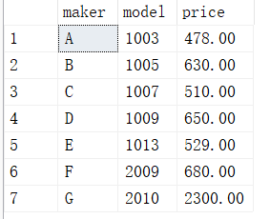
执行SELECT p.maker, l.price,p.model
FROM Product p,Laptop l
WHERE p.model = l.model
UNION
SELECT p.maker, pc.price,p.model
FROM Product p,PC pc
WHERE p.model = pc.model
查看所有生产商，产品，价格元组，对照结果，验证正确
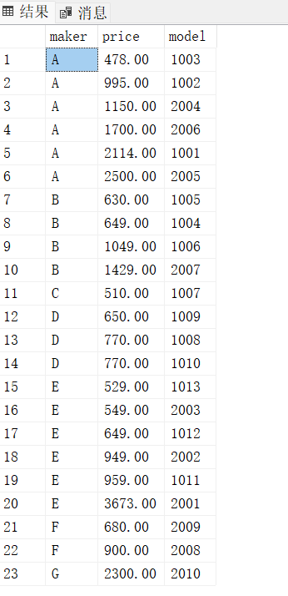
2、--查询生产的笔记本的硬盘容量不小于100GB的制造商
SELECT DISTINCT A.maker
FROM(
SELECT maker,hd
FROM Product,Laptop
WHERE Product.model=Laptop.model
)A
WHERE A.hd>=100;
查询结果为：
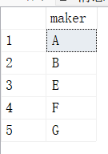
验证：运行
SELECT p.maker, l.hd
FROM Product p, Laptop l
WHERE p.model = l.model
得到所有制造商和hd的元组
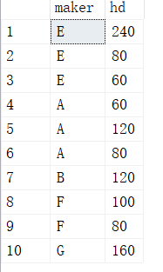
比对结果确认结果中的制造商都有生产hd不小于100GB的产品

3、--查询生产最快速度的计算机的制造商
SELECT DISTINCT A.maker
FROM(
SELECT maker,price
FROM Product,PC
WHERE Product.model=PC.model
)A
WHERE price IN (
SELECT MAX(price)
FROM PC
)
查询结果为：
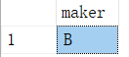
验证：运行
SELECT p.maker, pc.speed
FROM Product p, PC pc
WHERE p.model = pc.model
得到所有制造商和其所生产的计算机的速度的元组
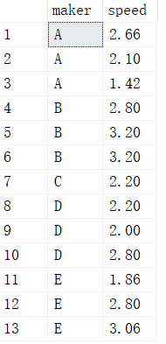
比对确认制造商B生产最快速度的计算机

4--用差集法查询选修了全部课程的学生姓名
SELECT DISTINCT Sname
FROM Student
EXCEPT
SELECT DISTINCT Sname
FROM Student
WHERE EXISTS(
SELECT *
FROM Course
WHERE NOT EXISTS(
SELECT *
FROM SC
WHERE SC.Sno = Student.Sno
AND SC.Cno = Course.Cno
)
)

