Oumou Balde

Bis 23

Final project

PHP Programming

PHP: Hypertext Preprocessor is an open source server-side scripting language for general purpose. PHP is essentially use for web development to make web pages dynamic and attractive. PHP is a programming language that allows web developers to create dynamic content that interacts with databases. PHP is basically used for developing web based software applications.

PHP was created by Ramus Lerdorf in 1994. It was created as a set of Common Gataway Interface (CGI) written in C programming. You can use inside the HTML code or save The PHP as an external file.

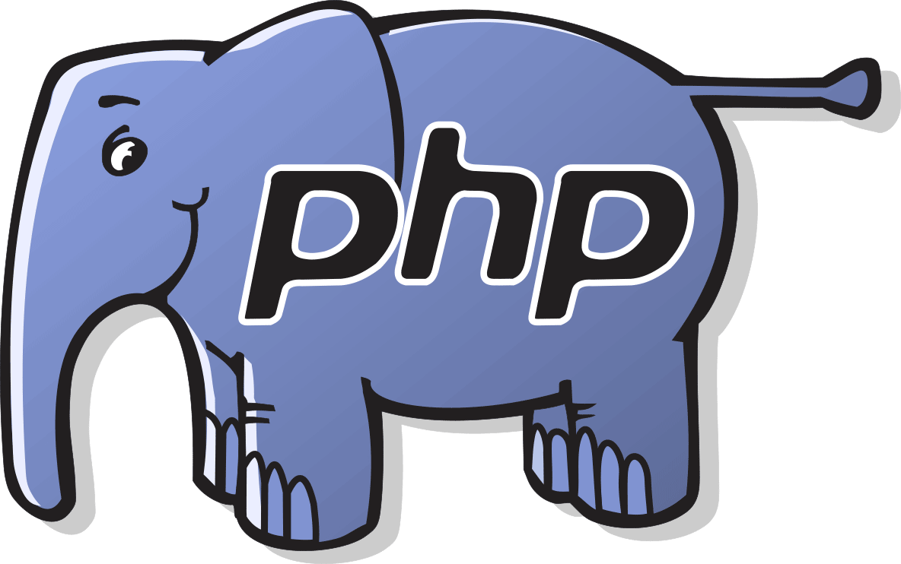

PHP is Easy to learn. Here is a simple PHP code

<!DOCTYPE html>  
<html>  
<body>  
  
<?php  
echo "My first PHP script!";  
?>  
  
</body>  
</html>

The browser will display

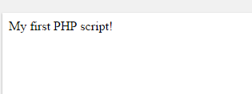

The latest version of PHP is PHP 7.0.17.

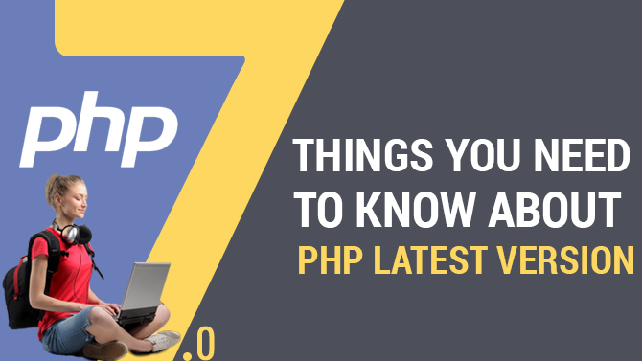

You can also learn Array functions, Calendar Functions Date functions and many functionalities.

PHP is Fast: According to the official website of Zen, PHP & will be twice than the previews ones. Also, PHP can run in a 64-bit windows support system.

You can find free tutorial for PHP on W3schools at their website <https://www.w3schools.com/php/> or on Tutorial Point Simply Easy Learning at their website <https://www.tutorialspoint.com/php/> . It is also free to download at <https://php.en.softonic.com/>. I hope you will found these helpful and easy to understand.