LIEN FIGMA VUE GESTIONNAIRE:https://www.figma.com/design/L3TVvnKEiZ9TPw49YVnHXh/Vue-Gestionnaire?node-id=0-1&t=ffhleegpHyv6TqSI-1
LIEN FIGMA VUE CLIENT:https://www.figma.com/design/0e1FS27RSRHjTk4nVBqFgB/vue-Client?node-id=0-1&t=qr1lCYy9T6lunt9Y-1

USE CASE CLIENT ANALYSE
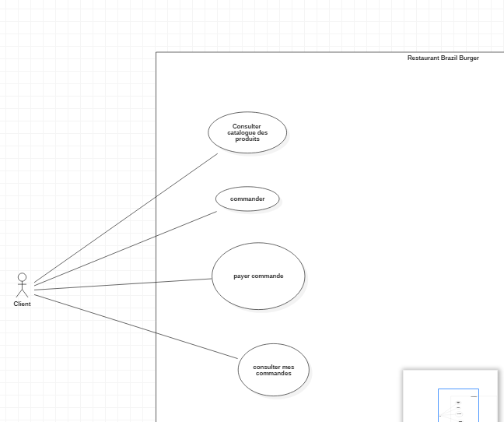

USE CASE CLIENT CONCEPTION
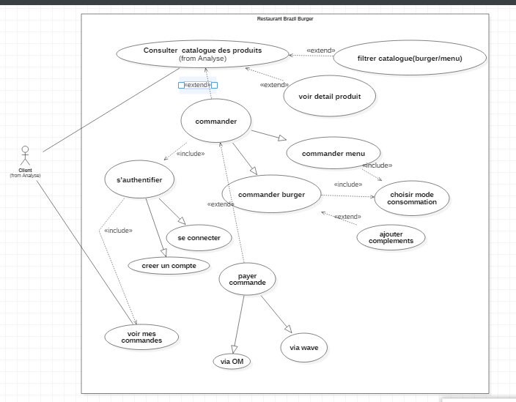

USE CASE GESTIONNAIRE ANALYSE
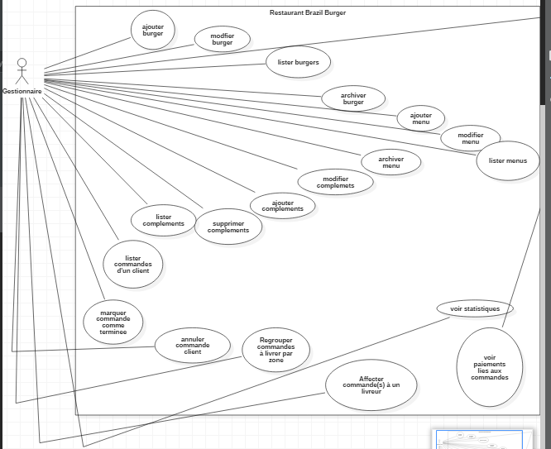

USE CASE GESTIONNAIRE CONCEPTION
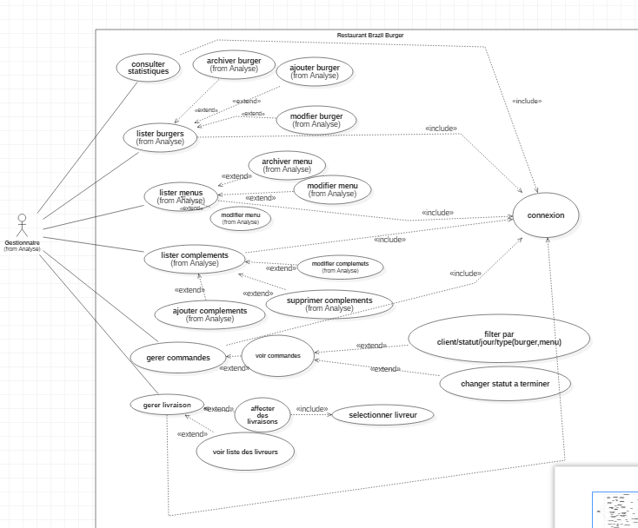

Diagramme de classe
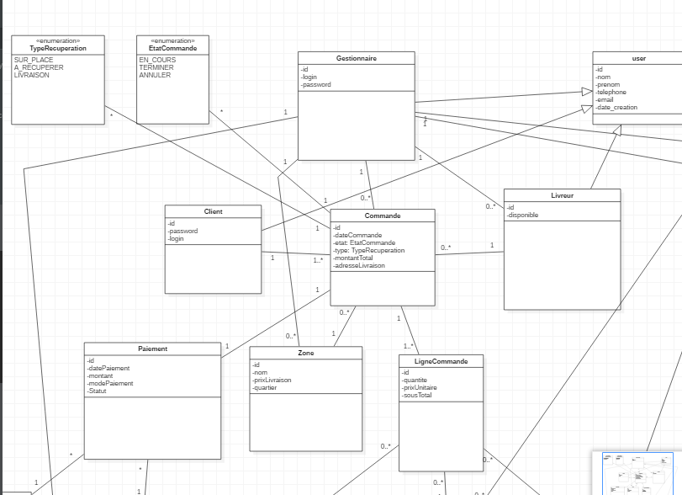
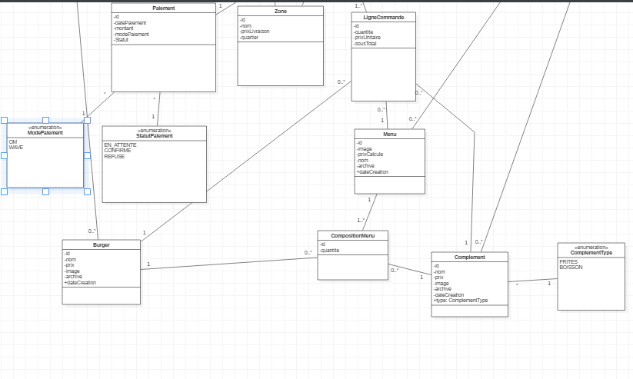
DIAGRAMME DE SEQUENCE
