Software Requirements Specifications

***1. Introduction***

***1.1 Purpose***

The purpose of this document is to present a detailed description of the File Manager Application. File Manager Application is a simple file manager that performs standard operations on file system and allows user to manage them. This document describes the scope, explains the purpose, features and goal of the application. In addition to describing non-functional requirements, this document models the functional requirements with use cases and class diagram. This document is intended to direct the design and implementation of the target application.

***1.2 Project Scope***

The purpose of the File Manager Application is to ease the process of managing the file system for its user. The software will facilitate processing on the contents of different file catalogues. Developed application will provide a user with a list of standard operations, common for file managers, while remaining easy to understand and use.

***1.3 Intended audience***

Regular users who will find easier to manage their file system using File Manager Application.

***1.4 Responsibilities***

The primary responsibilities of the developed application:

* Show an appropriate icon for different file types.
* Show files attributes (file name, extension, file size,  date created etc).
* Ability to show/hide some file attributes.
* Ability to sort files by name, size etc.
* Support file/folders operations: copy, move, rename, delete.
* Show progress bar during the operation.

***1.5 Product perspective***

1.5.1 System interfaces

1.5.1.1 User interfaces

The application GUI should look visually like Total Commander (have two windows), and show a catalogue inside every window. It should have buttons for copy, move, insert, delete operations, also corresponding button for creating mew folder and exit button. Both windows should have columns for file name, size, type and date of its latest changing. Main window should have menu bar, containing drop-down list with specific fields.

1.5.1.2 Hardware interfaces

Personal computers (including laptop/notebook computers) have a connected monitor, keyboardб mouse and CPU.

1.5.1.3 Software interfaces

Linux OS (Ubuntu 18.04) and Windows OS (Windows 10).

***1.6 Overview of Document***

The rest of this document gives the detailed specifications for the File Manager Application. It is organized as follows:

1. Introduction contains general purpose and scope for developed application.

2. Functional requirements section contains a list of requirements that determine the way the application will function. They are separated in two groups by priority.

3. Use case diagram model section contains the diagram itself and description for selected cases.

4. Class diagram section contains Class Diagram that represents general relationships between system modules.

***2. Functional requirements***

***2.1 High Priority***

* Non-blocking UI is a mandatory requirement. UI should not freeze while using the application.
* Application should look visually like Total Commander (have two windows).
* Application should show a catalogue inside every window.
* Application should show an appropriate icon for different file types.
* Application should show files attributes (file name, extension, file size, date created).
* Application should support file/folders operations: copy, move, rename, delete.
* When file/folder is copying, user still can browse the app.

***2.2 Medium Priority***

* Add the ability to show/hide some file attributes.
* Add the ability to sort files by name, size, date.
* Handle copying like in Total Commander (from one window to another).
* Show progress bar during the operation.
* Show dialog windows (like confirm deleting).

***3. The Use Case Model***

***3.1 System Use Case Diagram***

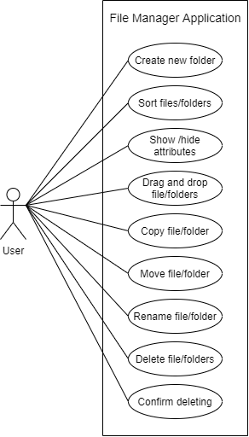

***3.2 Use Case Descriptions (for selected cases)***

Create new folder

|  |  |
| --- | --- |
| Use case name | Create new folder |
| Summary | The process of creating a new folder using the application. |
| Basic flow | 1. User selects appropriate root for new folder.  2. User clicks on New folder button.  3. User enters a name of a new folder.  4. When the full name is typed, user clicks Ok button to confirm. |
| Alternative flow | Step 2: user clicks on menu bar.  3. User clicks on New folder activity.  Step 4: user clicks Cancel button to cancel the creation of new folder. |
| Preconditions | No new folder exists. |
| Postconditions | New folder has been created. |

Move file/folder

|  |  |
| --- | --- |
| Use case name | Move file/folder |
| Summary | The process of moving a file or folder using the application. |
| Basic flow | 1. User chooses a file/folder, which is going to be moved.  2. User clicks on Move button.  3. User selects appropriate destination folder for moving.  4. User clicks Insert button. |
| Alternative flow | Step 2: user drags selected file/folder using his mouse.  3. User drops selected file/folder using his mouse to destination folder. |
| Preconditions | Correctly running File Manager application. |
| Postconditions | Selected file/folder is moved to the new folder. |

Sort files/folders

|  |  |
| --- | --- |
| Use case name | Sort files/folders |
| Summary | The process of sorting files and folders using the application. |
| Basic flow | 1. User chooses sorting criteria (file name, type, size or date).  2. User clicks on chosen attribute.  3. Application sorts files and folders in ascending or descending order. |
| Alternative flow | Does not exist. |
| Preconditions | Default sorting of files and folders. |
| Postconditions | Files and folders are sorted according to criteria, chosen by user. |

***4 Class diagram***

