Self Driving Cars 2023-Fall
Homework 2
312605001 機器人碩士 歐庭維

1. Suppose we live at a place where days are either sunny, cloudy, or rainy. The weather transition function is a Markov chain with the following transition table:

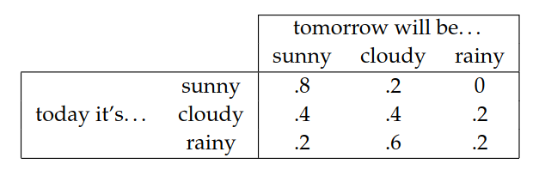

(a) Suppose Day 1 is a sunny day. What is the probability of the following sequence of days: Day2 = cloudy, Day3 = cloudy, Day4 = rainy?

<ANS>

1 (Sunny)* 0.2(sunny->cloudy) * 0.4(cloudy->cloudy) * 0.2 (cloudy->rainy)= 0.016

(b) Write a simulator that can randomly generate sequences of “weathers” from this state transition function.

<ANS>
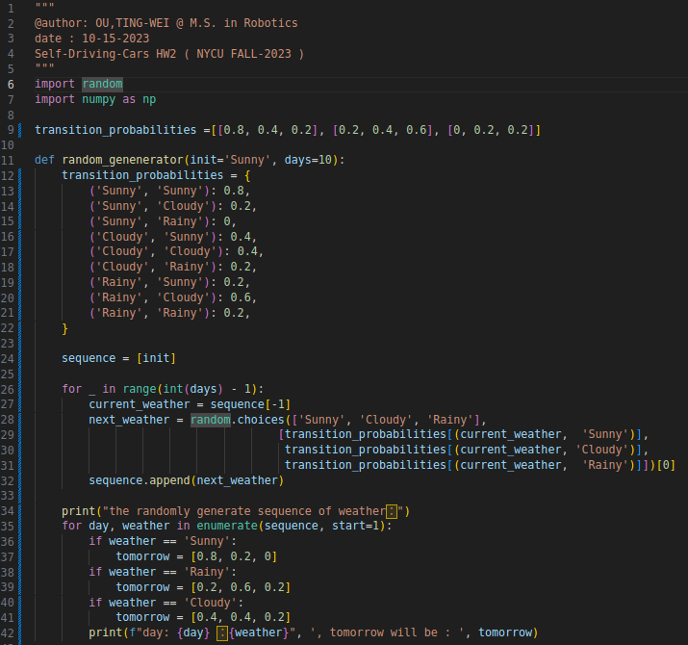
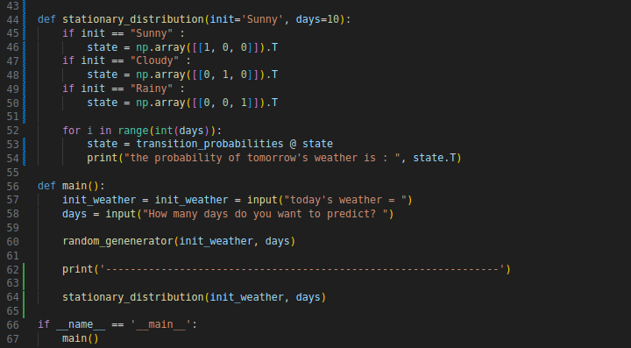
< DEMO > Today is cloudy, days = 10
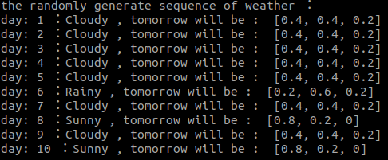

< DEMO > Today is Sunny, days = 10
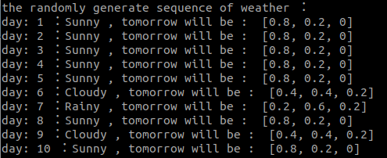

< DEMO > Today is Rainy, days = 10
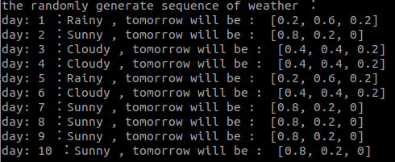

(c) Use your simulator to determine the stationary distribution of this Markov chain. The stationary distribution measures the probability that a random day will be sunny, cloudy, or rainy.

<ANS>

< DEMO > Today is sunny, days = 10
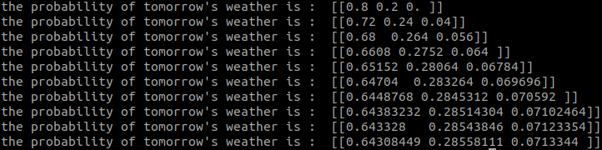
< DEMO > Today is Cloudy, days = 10

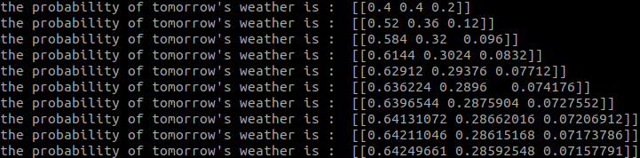
< DEMO > Today is Rainy, days = 10
