Mermaid Showcase
This sample demonstrates how Mermaid code fences can be rendered into the generated Word document as normal images.

Simple Flowchart
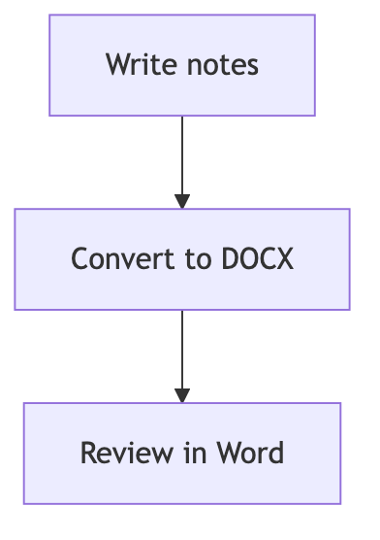
Figure 1. Simple Flowchart

Styled Conversion Flow
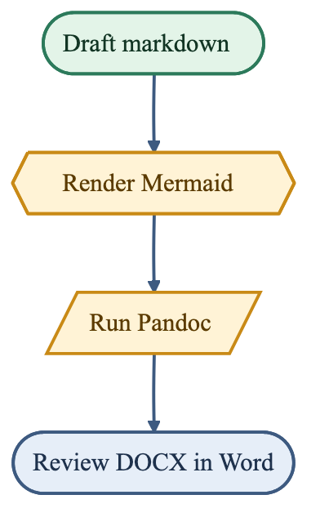
Figure 2. Styled Conversion Flow

Sequence Diagram
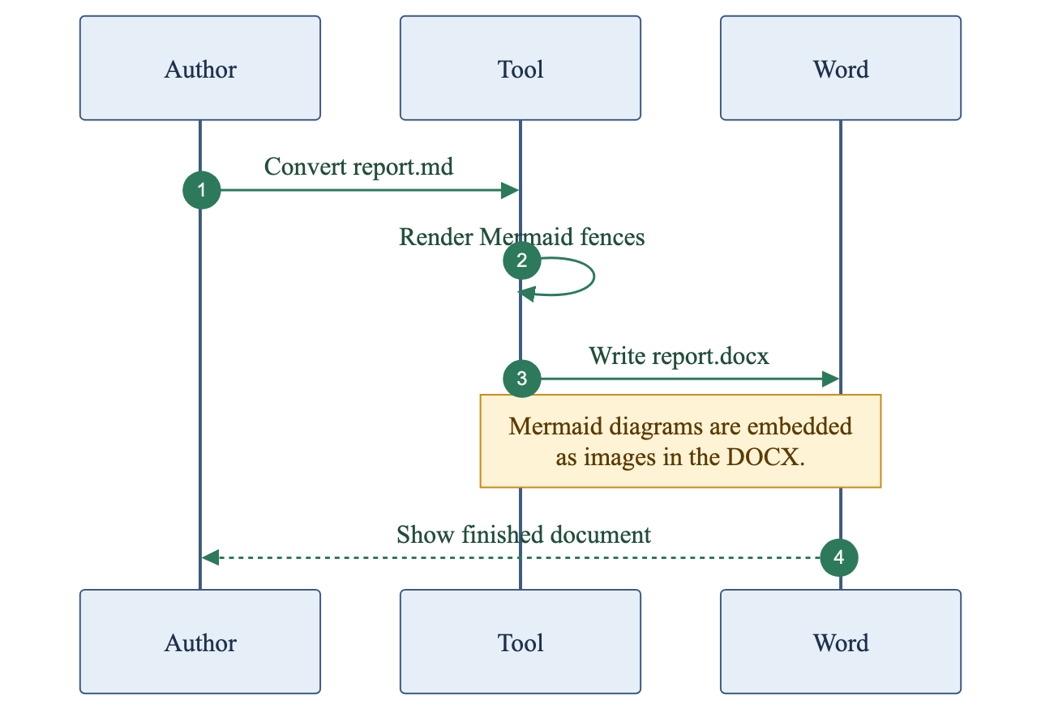
Figure 3. Sequence Diagram

