问题：

1. 下面哪个说法是正确的？

a. 独立屋（SFR）都没有HOA

b. 买房一定要有经纪人

c. 双重代理在所以的州都是不允许的

d. 投资房可以折旧

2. 关于Short Sale 的说法哪个是正确的：

a. 短时间卖房

b. 卖房不收手续费

c. 不用经纪人直接卖

d. 卖价低于所欠贷款

3. 房主不还贷款会怎样？

a. Foreclose

b. Refinance

c. Depreciate

d. Appreciate

4. 下面哪个现金买房的说法是不正确的？

a. 贷款买了十个房子后，就不能贷款买房了

b. 贷款买了十个房子后，可以借商业贷款买房

c. Flip 房子可用Hard Money

d. Flip 房子可用私人贷款

5. 卖房的利润超过以下时间就按Capital Gain 交税？

a. 6 个月

b. 一年

c. 一年半

d. 两年

6. 以下哪条是正确的？

a. HELOC 利率是固定的

b. HELOC 用钱的时候才算利息

c. FHA 贷款要20%以上首期

d. Hard Money 从来不查信用

作业：

用上面列举的4 个网站去做一个自己居住城市的房地产一个小小的市场报告， 人口/工作

的变化等，并判断属于ABCD 区哪一种。

**Livingston, NJ**

Population: 26,590 in 2017, increase 0.75% since 2000

Population distribution: White 80.9%, Asian 14.5%, Hispanic 2.5%, Black 1.2%

Median household income: $13,2936, 34.5% increase since 2000

Median house price: $582.995, 74.1% increase since 2000

Median age: 40.6

% of renters here: 10%, 36% in NJ

Crime rate: 79.4, compared to U.S. average 274

Summary:

Crime rate is very low compared to the U.S. average. Also based on city-data’s income map, the median household income in Livingston, NJ in 2017 was $132,935, which was 39.8% greater than the median annual income of $80,088 across the entire state of New Jersey.

Also, most schools rank at 9/10. Overall, this town is A area.

An example:

14 Lee Rd, Livingston, NJ 07039

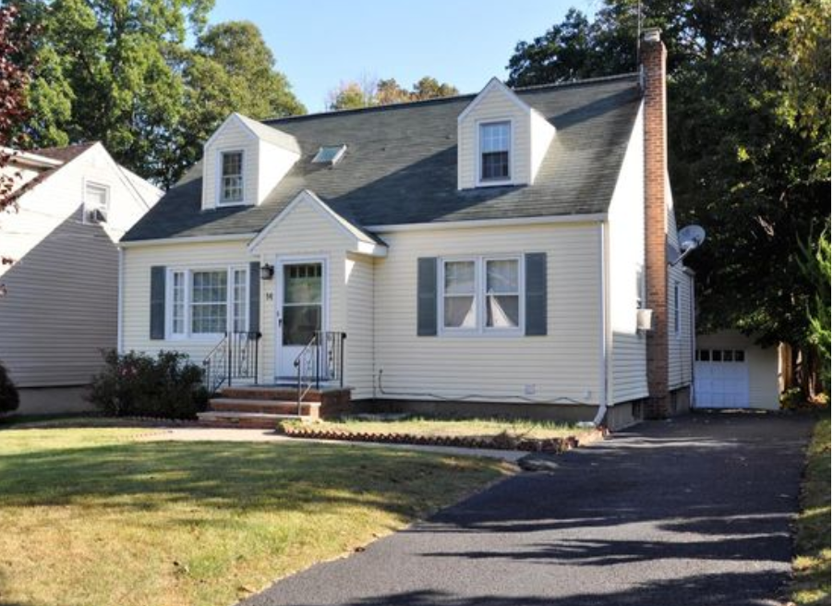

Purchase price: $410,000 cash in 2017

Rent: $2700

Vacancy rate: 8%

Property tax: $11,303/y

Home insurance: $954/y

Maintenance: $100/m

Utility: 0

NOI: $16,351/y

Cap rate: 4%

If 25% down, 4% interest, Principle&Interest = $1,468/m

Cash on cash return: -1.2%

Low cap rate, negative cash on cash return. Not good for cash flow purpose. But could wait for appreciation or do a flip.

|  |  |  |
| --- | --- | --- |
|  |  |  |
|  |  |  |
|  |  |  |
|  |  |  |
|  |  |  |