Note HW3

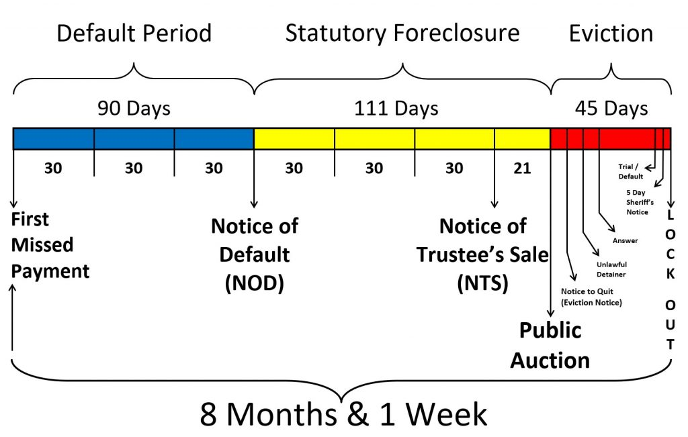

* The California foreclosure process can last up to 200 days or longer. Day 1 is when a payment is missed; your loan is officially in default around day 90. After 180 days, you’ll receive a notice of trustee sale. About 20 days later, your bank can then set the auction.
* Many foreclosures go beyond 200 days. Most in California are nonjudicial, meaning going through the court system is unnecessary.
* You can stop foreclosure in California either by making a big enough payment toward your mortgage, or filing for bankruptcy. Bankruptcy can help debtors keep their homes, either through a liquidation Chapter 7 bankruptcy or repayment plan under Chapter 13. The automatic stay is one of the most beneficial aspects in bankruptcy in that it keeps your house safe from the bank while you go through bankruptcy. Foreclosure must stop