Bankruptcy cannot be filed in state courts.

Six basic types of bankruptcy cases exist under the U.S. Bankruptcy Code:

|  |  |
| --- | --- |
| **CHAPTER 7 Liquidation** | Court-supervised procedure where trustee takes over the debtor's estate assets and reduces them to cash to make distributions to creditors |
| **CHAPTER 9 Municipality** | Much like reorganization under Chapter 11, but for municipalities |
| **CHAPTER 11 Reorganization** | Used by commercial enterprises that desire to continue operating a business and repay creditors concurrently through a court-approved plan of reorganization |
| **CHAPTER 12 Farmer or Fisherman** | Provides debt relief to family farmers and fishermen with regular incomes |
| **CHAPTER 13 Individual** | Designed for individual debtors with regular sources of income |
| **CHAPTER 15 Ancillary & Other Cross-Border Cases** | Deals with cases of cross-border insolvency |

* **Chapter 7** – Liquidation

Reportedly, the most common filing is **Chapter 7**. A **debtor** filing Chapter 7 is essentially scrapping everything and starting over, hoping for a clean financial slate.

* **Chapter 11** - Reorganization
* **Chapter 12** - Adjustment of Debts of a Family Farmer with Regular Annual Income
* **Chapter 13** - Adjustment of Debts of an Individual with Regular Income

You may be wondering why someone would file for Chapter 12 or 13 instead of Chapter 7. There are a couple of reasons for this:

* Under Chapter 12 and 13 filings, debtors do not have to **liquidate** their assets -- they actually get to keep everything, not just the items that meet the legal exemption.
* In most Chapter 12 and 13 cases, the debtor is repaying only a **percentage** of what he or she actually owes -- sometimes as little as 30 cents to 50 cents on the dollar!

**Chapter 11** bankruptcy is very similar to Chapter 13. The main difference is that there is no limit regarding the amount of money owed by the debtor. Originally only intended for large corporations, individuals can now file Chapter 11 as well.

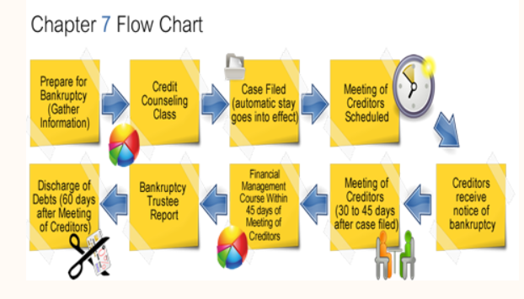

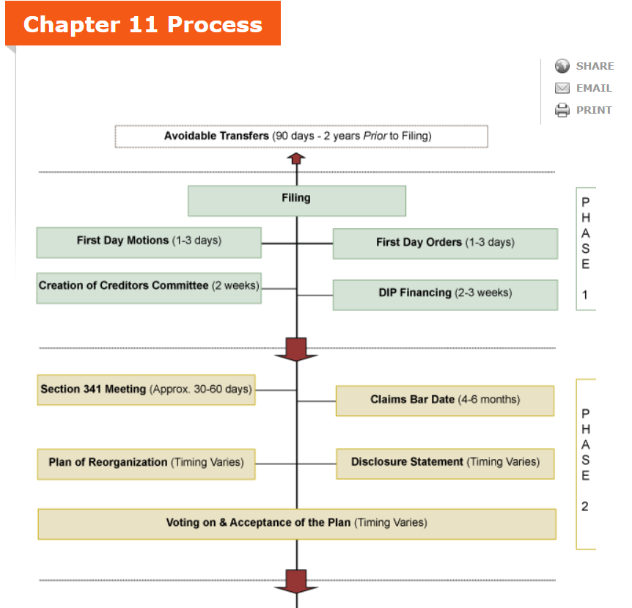

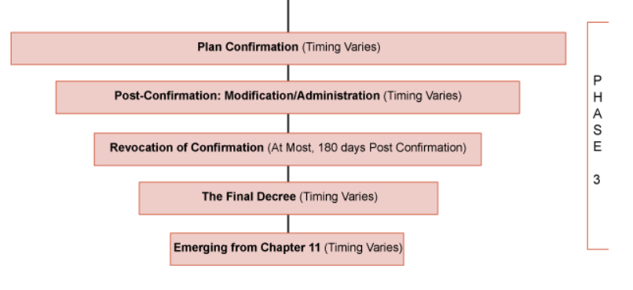

In addition to the federal bankruptcy laws, each state has its own provisions for handling bankruptcies within that state. For the most part, the differences have to do with income and debt limits that debtors must meet to be eligible for filing under each chapter. There are also differences in the time limits given for reorganization plans, income subject to liquidation, exempt assets and other details. In the past, these differences led debtors (particularly corporations) to "shop around" for the state with the best possible terms. The Bankruptcy Abuse Prevention and Consumer Protection Act of 2005 requires anyone filing for bankruptcy in a state to have lived in that state for two years prior to the filing.