投研报告 McKinney, TX

# 当地的经济情况

## 工作机会

McKinney has seen the job market increase by 3.3% over the last year. Future job growth over the next ten years is predicted to be 54.8%, which is higher than the US average of 33.5%.

## 失业率

McKinney has an unemployment rate of 3.5%. The US average is 3.9%.

## 工作分布

|  |  |  |
| --- | --- | --- |
| **Finance and insurance** | **McKinney** | **US** |
| Retail trade | 13.3% | 11.6% |
| Health care and social assistance | 12.9% | 13.8% |
| Manufacturing | 9.7% | 10.4% |
| Educational services | 9.3% | 9.3% |
| Finance and insurance | 9.2% | 4.7% |
| Professional, scientific, technical services | 9.2% | 6.7% |

## 家庭收入数据

The Median household income of a McKinney resident is $82,988 a year. The US average is $53,482 a year.

## 公司的分布情况

The city has attracted companies like Raytheon, Wistron GreenTech, Torchmark, Emerson Process Management, Tong Yang, Simpson Strong-Tie, Tenant Tracker, Manner Plastics and Traxxas. Home-grown companies like Encore Wire, Newtoy (now Zynga), RMCN and Brandon Industries have also thrived here. McKinney has led in sustainable developments and its historic business district is one of the largest and most successful in the state.

# 人口结构

## 人口增长的预期

## Chart

## 

## 

## 

## 

## 

## 

## 出生率、人口年龄结构

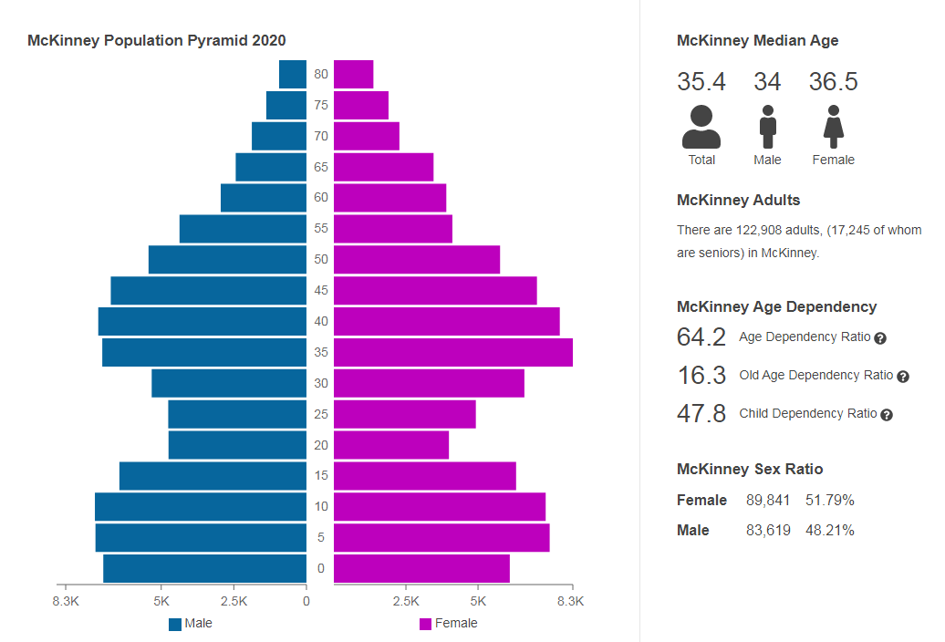

## 种族多源化

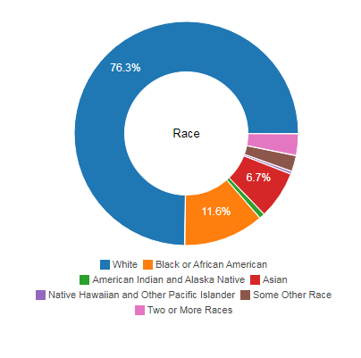

# 周边环境

## 附近的购物中心,医院,学校,餐馆, grocery store,健身房

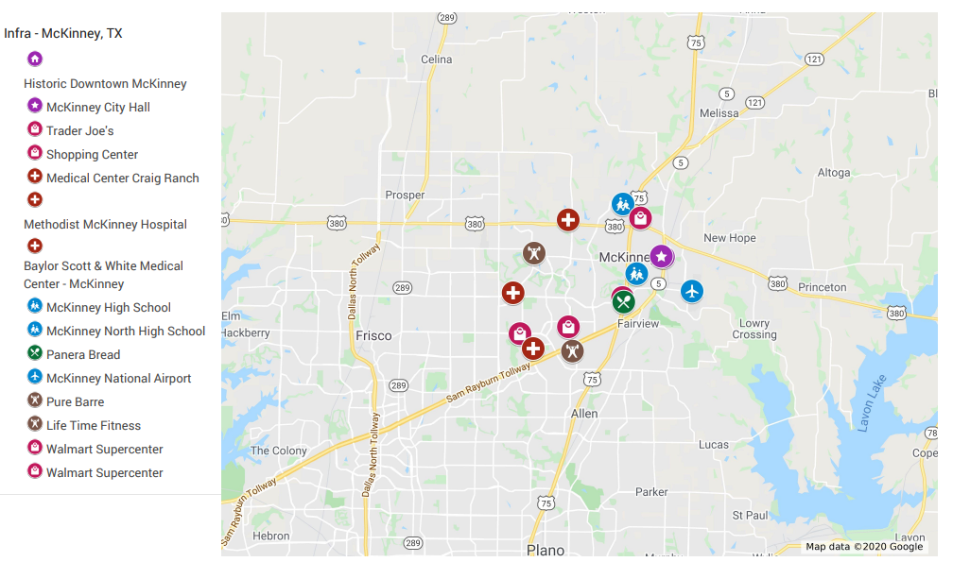

## 城市规划

### building permit

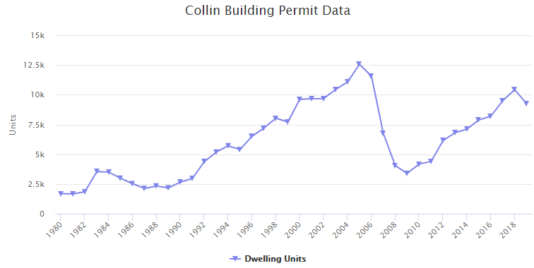

### 犯罪率 & 自住比例

|  |  |
| --- | --- |
| McKinney city | 10.5 |
| US | 26.2 |

Renters make up 29.7% of the McKinney population

### 租售比

|  |  |
| --- | --- |
| **Median Home Value** | $330,593 |
| **Median Household income** | $87,608 |
| **Median Rent price** | $1,895 |

### 空置率

2.2% of houses and apartments in McKinney, are available to rent

## 交通情况

### 机场

McKinney National Airport

### 高速

*MAJOR ROADWAYS SERVING MCKINNEY*

*S.H. 121*

Provides direct link to Dallas / Fort Worth (DFW) International Airport

Intersects North Dallas Tollway to the east

Intersects I.H.-35 to the southeast

*U.S. 75*

Provides direct access to downtown Dallas – 30 miles to the south

Intersects I.H.-635 – 19 miles to the south

Intersects S.H. 190 / Bush Turnpike – 16 miles to the south

*U.S. 380*

Intersects I.H.-35 to the east in Denton

### 车站

## 其它因素

### 地税 (2.26%)

|  |  |
| --- | --- |
| City:  Maintenance & operations  Interest & sinking (debt) | 0.355393  +0.160207  0.515600 |
| McKinney ISD | 1.488350 |
| Collin County | 0.174951 |
| Collin College | +0.081222 |
| Total tax rate  (per $100 assessed value) | **$2.260123** |

### 法律是否对房东友好

landlord friendly

# Real Estate Market

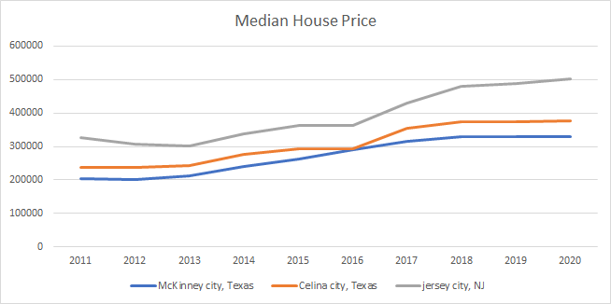

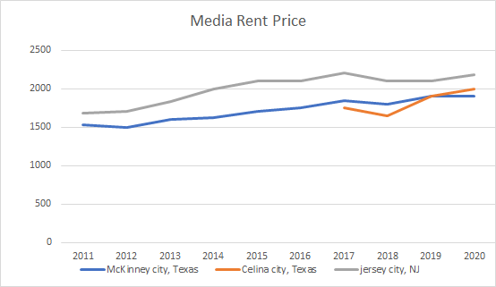

Year 2016-2020

|  |  |  |  |
| --- | --- | --- | --- |
| Location | IRR | Median House Price Change % | Median Rent Price Change % |
| McKinney city, Texas | 8% | 14% | 9% |
| Celina city, Texas | 8% | 29% | 14% |
| Garland, TX | 12% | 39% | 19% |
| Jersey city, NJ | 9% | 38% | 4% |

*Table 1, 2,3,4,5

*IRR calculated based on house sold on 2020

|  |  |  |  |  |  |  |
| --- | --- | --- | --- | --- | --- | --- |
| **Table 1: Median House Price** |  |  |  |  |  |  |
|  | 2016 | 2017 | 2018 | 2019 | 2020 | Change % |
| McKinney city, Texas | 290000 | 314000 | 329000 | 330000 | 330000 | 14 |
| Celina city, Texas | 294000 | 355000 | 374000 | 374000 | 378000 | 29% |
| jersey city, NJ | 364000 | 430000 | 479000 | 488000 | 502000 | 38% |

|  |  |  |  |  |  |  |
| --- | --- | --- | --- | --- | --- | --- |
| **Table 2: Median Rent Price** |  |  |  |  |  |  |
|  | 2016 | 2017 | 2018 | 2019 | 2020 | Change % |
| McKinney city, Texas | 1750 | 1850 | 1800 | 1900 | 1900 | 9% |
| Celina city, Texas |  | 1750 | 1650 | 1900 | 2000 | 14% |
| jersey city, NJ | 2100 | 2200 | 2100 | 2100 | 2180 | 4% |

|  |  |  |  |  |  |
| --- | --- | --- | --- | --- | --- |
| **Table 3: McKinney** |  |  |  |  |  |
|  | 2016 | 2017 | 2018 | 2019 | 2020 |
| Rent | 21000 | 22200 | 21600 | 22800 | 22800 |
| Vacancy | -462 | -488 | -475 | -502 | -502 |
| **Effective Gross Income** | 20538 | 21712 | 21125 | 22298 | 22298 |
| property tax | 6554 | 7096 | 7435 | 7458 | 7458 |
| insurance | 1000 | 1000 | 1000 | 1000 | 1000 |
| water | 1000 | 1000 | 1000 | 1000 | 1000 |
| repair/maintenance | 1027 | 1086 | 1056 | 1115 | 1115 |
| management fee | 1680 | 1776 | 1728 | 1824 | 1824 |
| **Total Expense** | 11261 | 11958 | 12220 | 12397 | 12397 |
| **NOI** | 9277 | 9754 | 8905 | 9901 | 9901 |

|  |  |  |  |  |  |
| --- | --- | --- | --- | --- | --- |
| **Table4 : Jersey City** |  |  |  |  |  |
|  | 2016 | 2017 | 2018 | 2019 | 2020 |
| Rent | 25200 | 26400 | 25200 | 25200 | 26160 |
| Vacancy | -554 | -581 | -554 | -554 | -576 |
| **Effective Gross Income** | 24646 | 25819 | 24646 | 24646 | 25584 |
| property tax | 7280 | 8600 | 9580 | 9760 | 10040 |
| insurance | 1000 | 1000 | 1000 | 1000 | 1000 |
| water | 1000 | 1000 | 1000 | 1000 | 1000 |
| repair/maintenance | 1232 | 1291 | 1232 | 1232 | 1279 |
| management fee | 2016 | 2112 | 2016 | 2016 | 2093 |
| **Total Expense** | 12528 | 14003 | 14828 | 15008 | 15412 |
| **NOI** | 12117 | 11816 | 9817 | 9637 | 10172 |

|  |  |  |  |  |  |
| --- | --- | --- | --- | --- | --- |
| **Table 5:Celina City** |  |  |  |  |  |
|  | 2016 | 2017 | 2018 | 2019 | 2020 |
| Rent | 21000 | 22200 | 21600 | 22800 | 22800 |
| Vacancy | -462 | -488 | -475 | -502 | -502 |
| **Effective Gross Income** | 20538 | 21712 | 21125 | 22298 | 22298 |
| property tax | 6644 | 8023 | 8452 | 8452 | 8543 |
| insurance | 1000 | 1000 | 1000 | 1000 | 1000 |
| water | 1000 | 1000 | 1000 | 1000 | 1000 |
| repair/maintenance | 1027 | 1086 | 1056 | 1115 | 1115 |
| management fee | 1680 | 1776 | 1728 | 1824 | 1824 |
| **Total Expense** | 11351 | 12885 | 13237 | 13391 | 13482 |
| **NOI** | 9187 | 8827 | 7888 | 8907 | 8817 |

# 推荐理由

**•10年人口增长是全国均值2倍以上 (4.9% vs 0.6%)**

**• 工作机会多年增长,产业多元化**

**• 刚需产业+增长型产业**

|  |  |  |
| --- | --- | --- |
| **Finance and insurance** | **McKinney** | **US** |
| Retail trade | 13.3% | 11.6% |
| Health care and social assistance | 12.9% | 13.8% |
| Manufacturing | 9.7% | 10.4% |
| Educational services | 9.3% | 9.3% |
| Finance and insurance | 9.2% | 4.7% |
| Professional, scientific, technical services | 9.2% | 6.7% |

## 

**• 家庭收入略高于州内均值 ($82,988 vs $60,629)**

• 地区平均年龄小于35岁 (35.4)

**• 地区工资收入是租金的3倍 ($87,608 vs $22,740)**

• 房产税低,1.0%左右 (2.26%)

• 租房比例在40%左右 (29.7%)

**• 房价接近county均价 ($330,593 vs $343,083)**

**• 月租金在1000到2000之间 ($1,895)**

**• 交通方便,离高速近 (三条环镇高速，机场）**