**ndeCasa Grande, Arizona**

Population in 2017: 55,477 (97% urban, 3% rural). Population change since 2000: +119.9%

 The population of the city is 58,632 as of 2019

Median resident age: 37.3 years Arizona median age: 37.7 years

Zip codes: 85122, 85131, 85172, 85194  
  
Estimated median household income in 2017: $53,312 (it was $36,212 in 2000) Casa Grande: $53,312 AZ: $56,581  
  
Estimated median house or condo value in 2017: $188,388 (it was $79,900 in 2000) Casa Grande: $188,388 AZ: $223,400 Mean prices in 2017: all housing units: $161,160; detached houses: $174,693; townhouses or other attached units: $292,835; mobile homes: $53,090; occupied boats, rvs, vans, etc.: $14,477

Median gross rent in 2017: $905.  
  
Percentage of residents living in poverty in 2017: 18.5% (12.8% for White Non-Hispanic residents, 24.0% for Black residents, 24.2% for Hispanic or Latino residents, 30.4% for American Indian residents, 100.0% for Native Hawaiian and other Pacific Islander residents, 23.2% for other race residents, 23.9% for two or more races residents)  
  
Most common industries in Casa Grande, AZ (%)

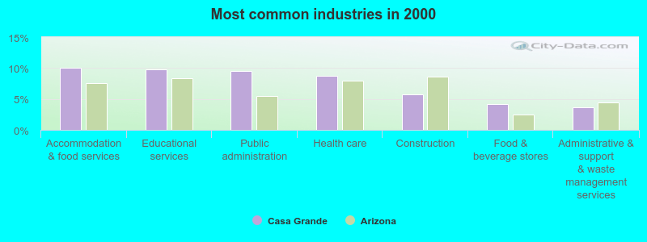  
  
Accommodation & food services (10.1%)

Educational services (9.7%)

Public administration (9.5%)

Health care (8.7%)

Construction (5.8%)

Food & beverage stores (4.2%)

Administrative & support & waste management services (3.6%)

College/University in Casa Grande:

Turning Point Beauty College (Full-time enrollment: 41; Location: 580 n camino mercado; Private, for-profit; Website: turningpointbeauty.com)

<http://www.city-data.com/city/Casa-Grande-Arizona.html>

Casa Grande is an emerging area in Arizona. The cap rate is around 6.9% to 7%. The average housing price is around $220,000 to $250,000.