**Deal4期 第一次作业**

我们小组根据大家的location分成了三个分组，第一小分队是波士顿，第二小分队是大纽约+华府地区，第三小分队是加州

第一小分队

Target area: Lowell, MA

[**ZIP code**](https://www.google.com/search?rlz=1C1GCEB_enUS891US891&sxsrf=ALeKk01DGlkPluaWH4dhDyPW5-JIhykNMQ:1597845790704&q=lowell,+massachusetts+zip+code&sa=X&ved=2ahUKEwjPyYq2t6frAhVhm-AKHUBGASMQ6BMoADAnegQIDhAC)**:** 01850, 01851, 01852, 01853, 01854

House type: Multi family

Bedroom: 3+

Bathroom: 2+

Price range: < 800k

We have set up this search and get the house alert instantly.

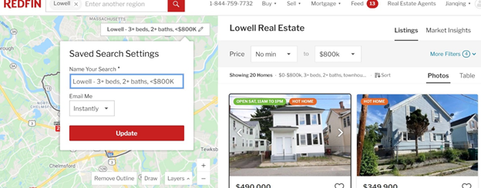

第二小分队

· 费城:

1. 确定选房标准，如邮码，城市，几室，几卫，面积，楼龄，等等。。。

Philadelphia, PA: 费城东北区，邮编是19149，at least 3 bed room 1.5 bathroom, at least 1200 sqft, single family house or multi-family or townhouse. 楼龄是1940年以后，价位在13万左右或以下，状态不要太差，可以适当修理，不要有大的问题（比如foundation），至少有一个车库

The reason to choose 19149:

1. 费城经过这几年的轮涨，南费城和东北费城其他几个好区价格已经偏高了, 19149现金流还不错，在东北区各方面属于中等，准备长期持有

2.According to Zillow, median rent for 3 bedrooms in 19149 is $1100-1350. 基本符合1% rule

3. According to CityData, 19149 41% residents are renters, property tax is lower than median PA. Median property tax in 19149 is around $1600.

4.数据显示是年轻蓝领社区,基本属于C区.

5. Based on zillow, home values in this area have risen about 5% over the past 12 months, and expect to rise about 4 - 14% depending on exact location in the next year.

2. 在Redfin根据Search Criteria设置自动Email。或请中介在MLS上根据Search Criteria设置自动Email。

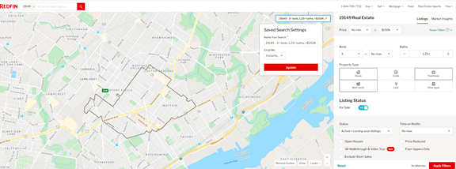

· 北卡：

**选房标准**

· City: Raleigh, NC

· Zip code: 27617

· Maximum price: 300,000

· >3 bedrooms

· >2 bathrooms

· Area size: >1,500 sq. ft.

· Year built: later than 1990s

· Garage: 2

**Search Criteria Setup**

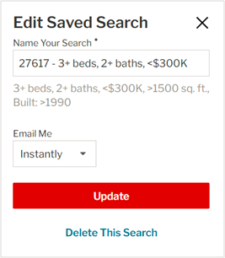

第三小分队 加州CA小组

1. 确定选房标准，如邮码，城市，几室，几卫，面积，楼龄，等等。。。

* North San jose and South San jose
* Price <=$1M
* 95133, 95112, 95116, 95123, 95136
* >= 3 bedrooms >= 2 bedrooms
* Lot size >= 4500
* Property type: house, multi-family

1. 在Redfin根据Search Criteria设置自动Email。或请中介在MLS上根据Search Criteria设置自动Email。

