Our team researched 4 Property Management software including TenantCloud, Cozy, Buildium, AppFolio. TenantCloud and Cozy are free with basic features but a monthly fee for premium features. Buildium and Appfolio don’t have a free version but both of their paid versions have much more advanced features than the free tools we researched. Each software has pros and cons. One team member has experience for all the four software. Below is a summary of the comparison between them.

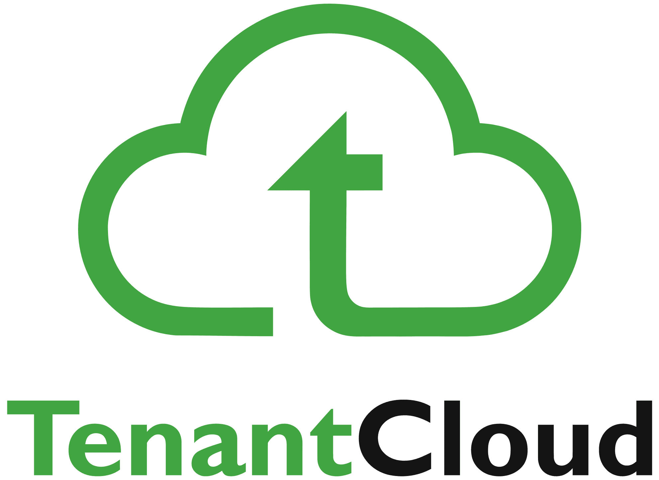**TenantCloud VS Cozy**

TenantCloud is a free-to-use property management software for landlords and tenants that aims to bridge the gap between them by offering an all-in-one solution. It allows landlords to receive payments online, screen the applicants, invoice and charge late fees, while a free listing site is also part of the package. Tenants can also make online payments, submit rental applications, submit requests for maintenance and securely store their rental and payment history.

Cozy is a costless dynamic property management software. Other than the fact that it is free, it is also cost-efficient when it comes to applicant screening. That is because prospective tenants are required to shoulder the fees for credit and background checks. This way, you can rest assured that you are transacting with reliable individuals. While all other tools included in Cozy come at no cost, rent estimates and property analyses are for a fee.

|  |  |
| --- | --- |
| **TenantCloud** | **Cozy** |
| * Free for basic use * Android and iOS apps * Online payments * Applicant screening * Automatic invoicing * Free listing website * Online rental applications * Rental and payment history * Online maintenance requests * Maintenance request bidding * Landlord Pro Services * Basic accounting * Analysis reports * Visual maintenance requests * Payment tracking * Property management * ILS Syndication * E-sign rental agreements * Marketplace * On-demand reports * Equipment tracking * Service reminders * Tenant match * Trusted listings * Home search for tenants * Customer reviews * Order management | * Rent Collection * Multiple Deposit Accounts * Payment Requests * Rental Applications * Applicant Screening * Tenant Credit Reports * Tenant Background Checks * Maintenance Requests Tracking * Tenant Communications * Property Expenses Tracking * Property Marketing * Rent Estimate * Property Analysis * Insurance * Transaction History & Export |

Tenantcloud has abundant reports analysis even in free version while Cozy can only export the data to .csv file.

**TenantCloud:**

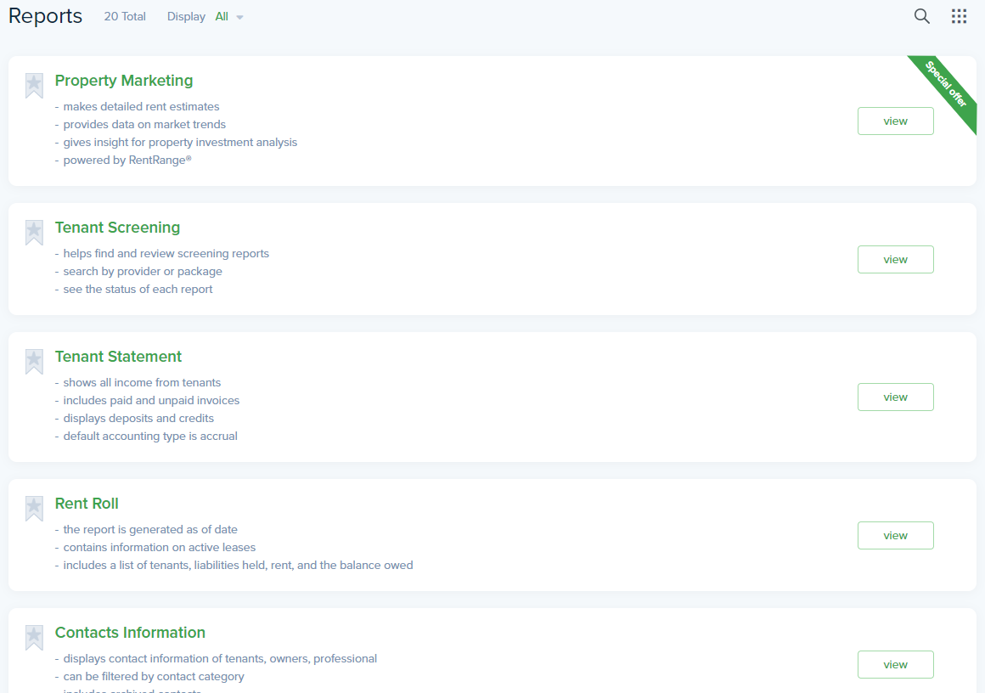

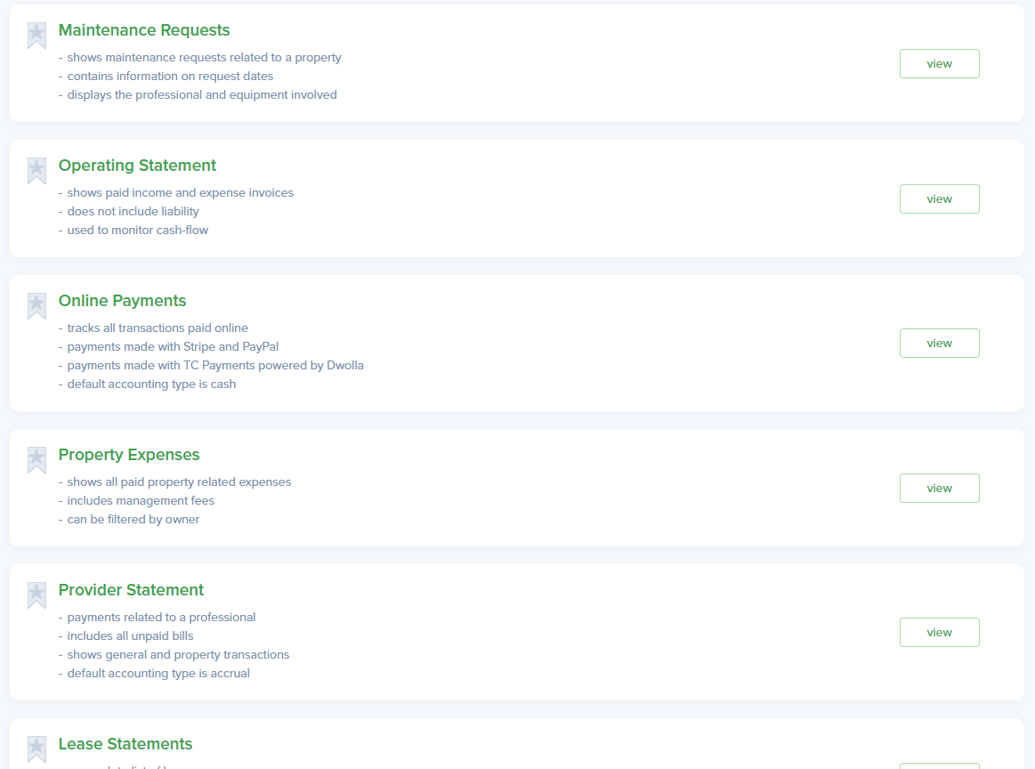

**Cozy.co:**

**Buildium VS AppFolio**

Cloud-deployed property management platform Buildium is designed to give property manager absolute control over their businesses and operations. Association and residential managers can use the software to improve vacancy, rental and maintenance cycles. Also, the solution makes it easier to receive rents and automatically notifies when payments are due or late.

Being a cloud-based system, it does not require any additional hardware or software installation and can easily be accessed from anywhere using a browser. Property managers often find themselves overwhelmed with the workload as their job isn’t just about collecting rents. The software takes cares of the hard work and allows managers to focus more on new business opportunities instead of spending all their time on routine operational work.

AppFolio is a web-based property management application that is loaded with accounting and management tools and features. The system delivers a robust solution designed for a plethora of user types, enabling them to centralize all their property management processes such as accounting, marketing, applicant screening, online rent payments, online lease agreements and more.

With a clean and intuitive user interface, AppFolio streamlines all property management-related workflows. The software is also designed to work well various types of properties (HOA, residential, commercial, and student housing). With AppFolio, property owners can easily manage their properties, marketers can boost their property listings and online visibility, residents and landlords have a clear communication channel, and more.

|  |  |
| --- | --- |
| **Buildium** | **Appfolio** |
| * Marketing website * Online rental applications * Tenant and credit screening * Electronic payments * Rental listing syndication * Reporting tools * Lease tracking * Online maintenance requests and tracking * Automatic reminders * Mailings and forms * Full general ledger accounting * Online rent collection * Tenant portal * 1099 e-filing * **Core**: Starts from $45/month for 1 Unit * **Pro**: Up to $4,560/month for 4500 units * **Extras** (*Special discount for Pro subscribers) * **Online payments for residents:** $.50 * **Electronic leases:** $5 * **Property Inspections:** $40 * **Basic tenant screening:** $15 | * Online Owner Portal * Owner & Vendor eCheck * Owner Contributions * Texting to Owners * Online Maintenance Requests * Maintenance Contact Center * Work Orders * Mobile Inspections * Training & Support * Data Migration * Professional Websites * Rent Comparison Tool * Revenue Management * Marketing Campaigns * Vacancy Dashboard * Vacancy Posting * Premium Leads * Guest Card Tracking * Mobile App * Rental Applications * Tenant Screening * Online Leases * Online Renter Portal * Texting & Email * Tenant Liability Insurance * Task Management * Schedule Rent Increases * Rent By-the-Bed * Universal Search * Accounting * Real-time Flexible Reporting * Online Rent Payments * RUBS * Bulk Tenant Charges * CAM Tracking & Reconciliation * Holding Deposits * Automated Late Fees * AP Approval Process * Security * **HOA** – $0.80/unit/month * **Student Housing** – $1.25/unit/month * **Commercial** – $1.50/unit/month * **Residential** – $1.25/unit/month   Discount offered with annual billing. $250 minimum monthly fee.  Onboarding fee based on portfolio size. $400 minimum. |

**Buildium:**

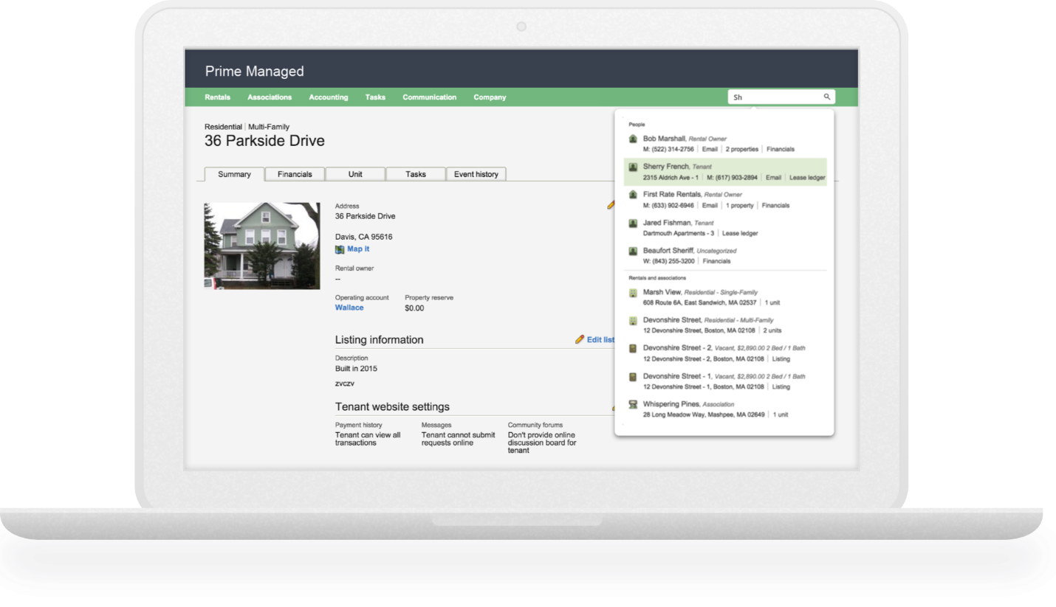 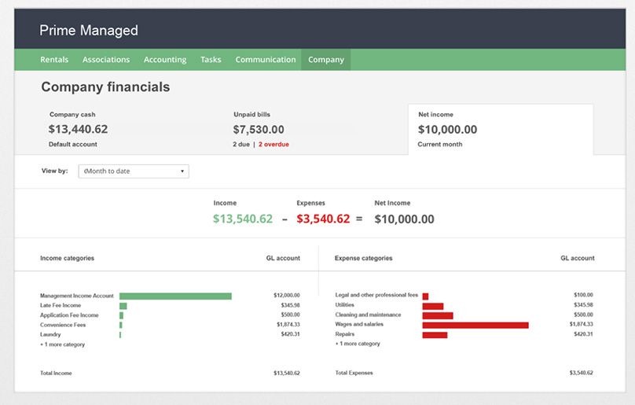

**Appfolio:**

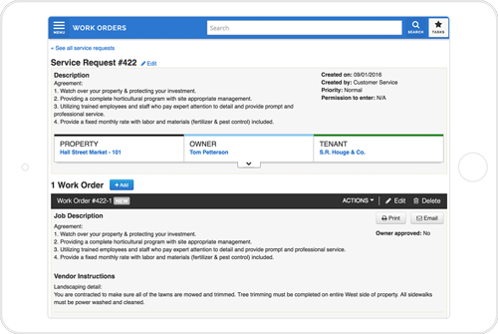

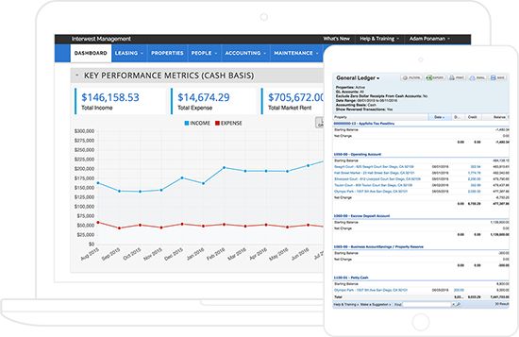

**Ref:**

* 1. <https://reviews.financesonline.com/>
  2. <https://www.softwareadvice.com/property/>