SUNNYDAY 多单元公寓初级 作业 CASE STUDY



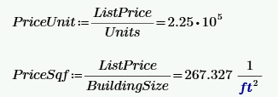





















|  |  |  |  |  |  |
| --- | --- | --- | --- | --- | --- |
| case study question 7 |  | Actual | | Market | |
|  |  | Owner | PM | Owner | PM |
|  | NOI | 59040 | 53290 | 78460 | 71480 |
| 7a.CapRate 4.1% | ListPrice | 1440000 | 1300000 | 1914000 | 1743000 |
|  | NOI-Trail | 64540 | 63920 | 66620 | 65870 |
|  |  |  |  |  |  |
| 7a. SCENARIO 2 | NOI | 59040 | 53290 | 78460 | 71480 |
| DSCR 1.25 | DebtAnnSer | 47230 | 42640 | 62770 | 57180 |
| LTV 80% | ListPrice | 1100000 | 1000000 | 1450000 | 1330000 |
|  | DP | 220000 | 200000 | 290000 | 266000 |
| 7b. CoC 2.2% | Cash Flow | 4840 | 4400 | 6380 | 5852 |
|  | DebtAnnSer-年付 | 54200 | 48890 | 72080 | 65628 |
|  | Loan Amount-可借 | 1000000 | 904000 | 1340000 | 1220000 |