3018 44th st, Sacramento CA 95817

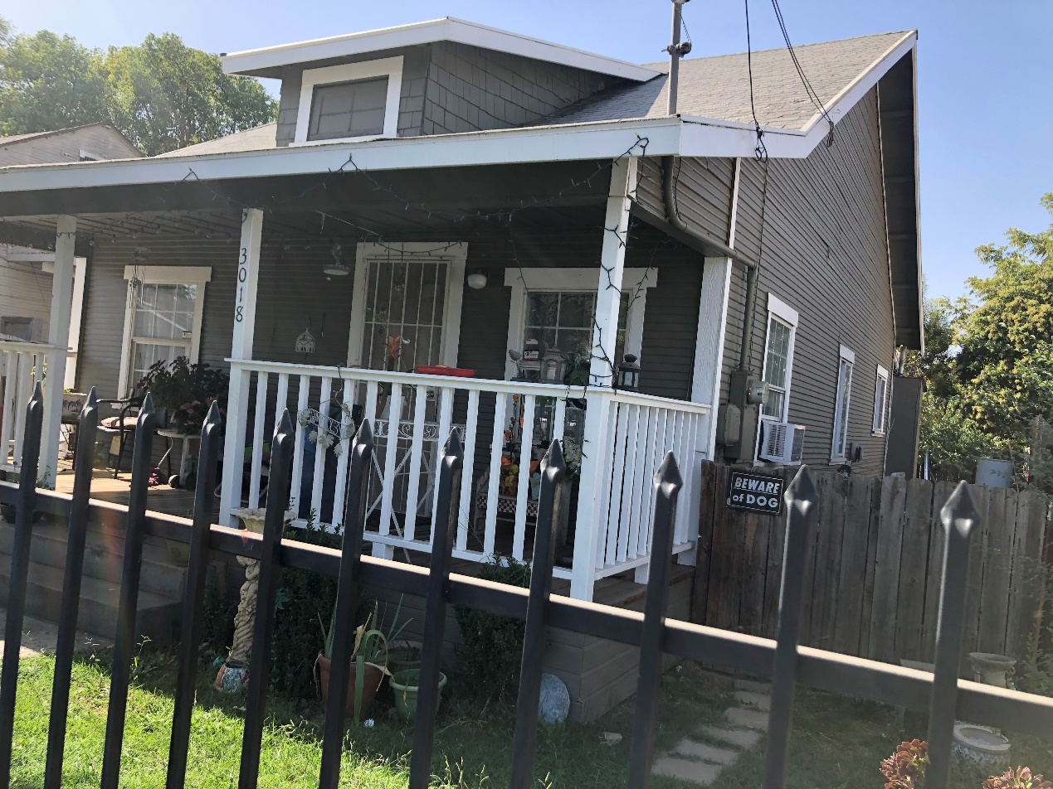

Purchase price: $235k

Rehab: $6000-8000

Closing cost: $20k

Estimate sale price: $290k

Net: $27k

BRRRR Refi

Cash out LTV 80% $232K

Rent: $1700/month

Monthly mortgage + property tax + insurance: $1,290/month

Monthly positive cashflow: $410.

Cap: 6.4%