Bank Owned

211 Brookside Dr

Smithfield, North Carolina 27577

3 Beds2 Baths1,772 Sq. Ft.

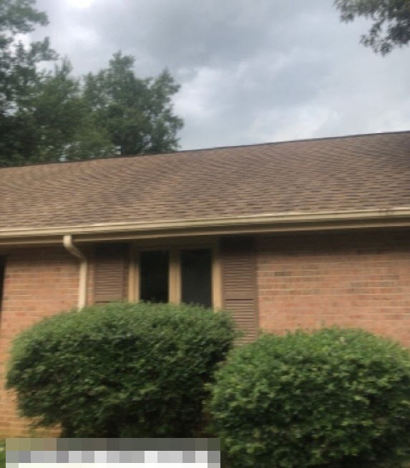

https://www.auction.com/details/211-brookside-dr-smithfield-nc-27577-2951927-o_1318

## Property Details

|  |  |  |  |
| --- | --- | --- | --- |
| Beds | **3** | Baths | **2** |
| Square Footage | **1,772** | Lot Size (Acres) | **-** |
| Property Type | **Single Family** | Year Built | **1971** |

Purchase price : 30000

Repair cost: 120000

ARV:210000

Finance including repair cost, down payment 20%: 30000

Interest rate:8%

BRRRR: 210000*75%=157500

Buyer closing cost and holding cost for 6 months:7824

Refinance closing cost:5962.5

After cash out, cash invest: 6286.5+ buyer premium2500=8786.5

Monthly cash flow: 263.47 factored in 5% vacancy and 10% repair and maintenance cost

Monthly rent:1400

70% rule : 210000*70%-120000=270000 not match