**Federal Law of Bankruptcy Procedure**

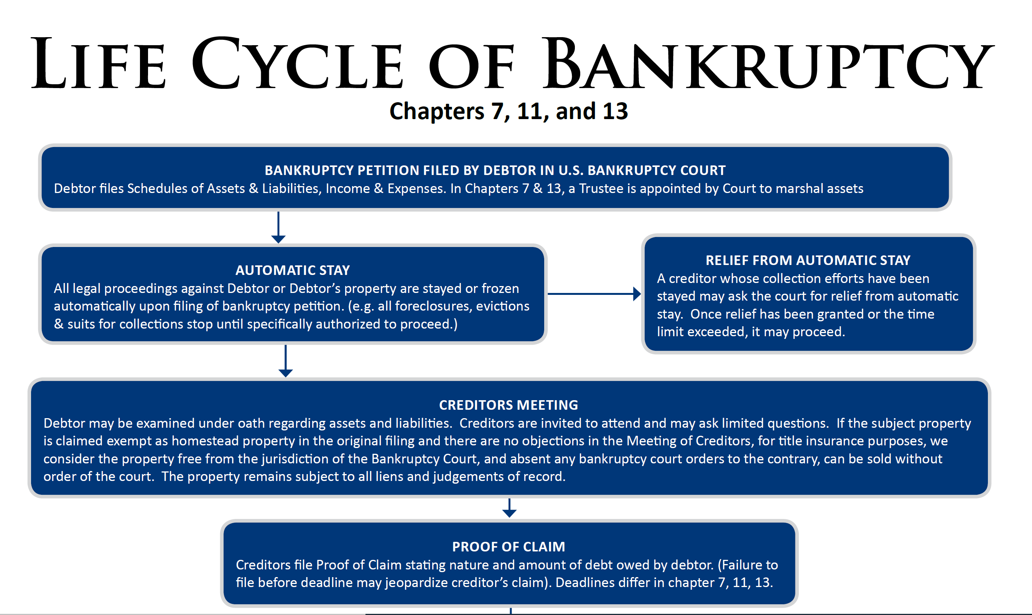

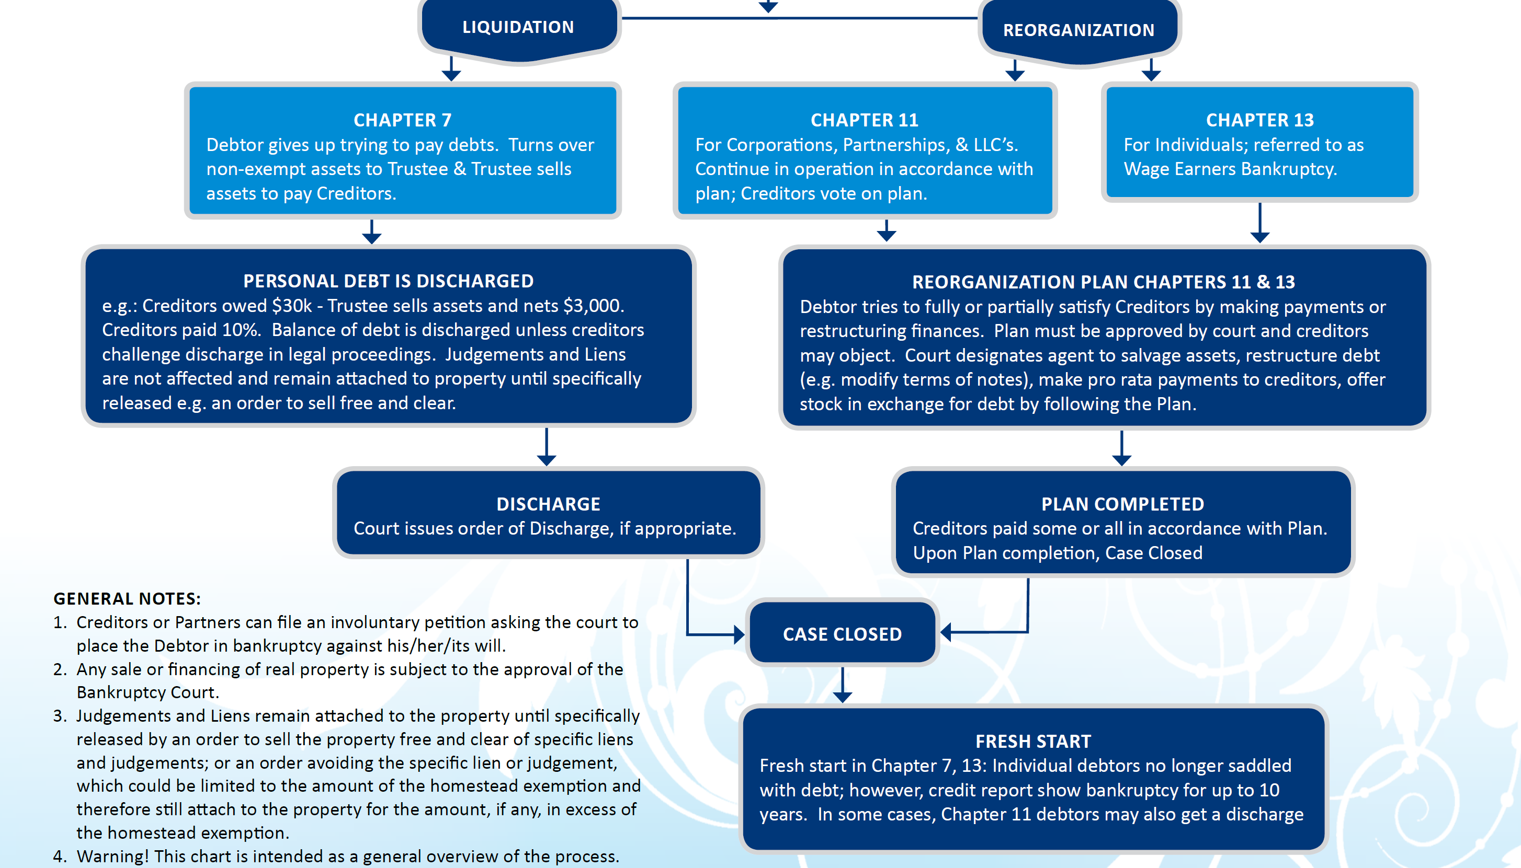

Data Source: Ticor Title

**Bankruptcy in California gets its distinct color from three things:**

* State law on foreclosure including anti deficiency statutes

(1). The lender gets only the collateral, nothing more.

(2). In a non judicial foreclosure, lender gives up the right to collect anything further on its debt.

(3). Once a standard foreclosure is complete, the borrower has no further liability to the creditor who foreclosed.

* Exemption law
* Community property

------------------------------ Detail For California Bankruptcy Laws -----------------------------------------

Foreclosure

California is a non judicial foreclosure state.

That means that there is no court proceeding before a foreclosure sale can be held.  The widely touted “show me the note” foreclosure defense is not available here.  In a non judicial foreclosure, there is no court involved, and therefore, no one to show the note to.

[California foreclosure timeline](https://www.bankruptcyinbrief.com/bankruptcy-timeline/)

State law provides that loans used to purchase a home are “non recourse”.  Non-recourse means that a lender making a loan to fund a home purchase cannot get a money judgment against the borrower, even in a judicial foreclosure.  The lender gets only the collateral, nothing more.

Further, when a lender uses the power of sale in a deed of trust to conduct a non judicial foreclosure, it gives up the right to collect anything further on its debt.  It doesn’t matter if the loan was purchase money or a refinance.

So once a standard foreclosure is complete, the borrower has no further liability *to the creditor who foreclosed.*  Any junior lien holders may have rights against the borrower, depending on whether the loan was recourse or non recourse.

Exemptions

California gives debtors a choice between the state law exemptions found in [Code of Civil Procedure §704](http://www.leginfo.ca.gov/cgi-bin/displaycode?section=ccp&group=00001-01000&file=704.010-704.210)and a set of bankruptcy-only exemptions in [CCP §703.140](http://law.onecle.com/california/civil-procedure/703.140.html)that mirror the bankruptcy code exemptions in the federal law when the California law was adopted.

Usually, homeowners chose the  704 state law exemptions with a generous homestead exemption when they have equity in a primary residence.

Renters or those with no equity in their homes choose the  CCP 703 exemptions, with its “wild-card” or “grub stake” exemption for equity in any kind of property.  The [dollar amounts for California exemptions](http://www.courts.ca.gov/documents/ej156.pdf) are updated every three years.

New law, effective January 1, 2020, increases the state law homestead exemption to a number between $300,000 and $600,000, depending on the median home price in that county. More on [California homestead.](https://www.bankruptcysoapbox.com/new-california-homestead/)

Community Property

California is a community property state where property acquired by a married couple during marriage  belongs equally to both spouses, unless they agree otherwise.

The community  property (though not necessarily the other spouse personally) is liable for the debts incurred by either spouse during the marriage and before the marriage.

♦  [7 principles of community property](http://www.bankruptcysoapbox.com/principles-of-california-community-property/" \o "on the Bankruptcy Soapbox" \t "_blank)

Even if only one spouse files bankruptcy, *all* of the community property becomes[property of the estate](https://www.bankruptcyinbrief.com/property/).   Property of the estate, if not exempt, is available to pay the community debts of both spouses through the bankruptcy. Can I f[ile bankruptcy by myself?](https://www.bankruptcyinbrief.com/alone/)

Community Property Discharge

There is a trade off for debtors in community property states like California for the inclusion of  both halves of the community property in the bankruptcy estate when only one spouse files bankruptcy.

When the filing spouse gets a [discharge](https://www.bankruptcyinbrief.com/discharged-in-bankruptcy-whats-it-mean/),  all community property of the marriage acquired **after** the bankruptcy is protected by the discharge, even if only one spouse filed.

The property exempted or abandoned to the debtor at the closing of the case is also immune to the claims discharged in the case.

That means that the community property a couple acquires after the bankruptcy filing is not liable for the debts of the non filing spouse that existed when the bankruptcy was filed.  11 U.S.C. 524(a)(3).

♦ [The community property discharge in action](http://www.bankruptcysoapbox.com/cp-discharge/)

The non filing spouse’s separate property (if any) may be liable for his or her debts, however.

This provides lots of opportunities for planning in cases where there are reasons why both spouses can’t file or where debt and/or property holdings are lop sided.

# California Homestead Exemption Increased For Bankruptcy Cases – AB 1885

**What Is A Homestead Exemption?**

A huge concern for those who need to file bankruptcy is whether they will lose their home.

[See More On Exemptions In Bankruptcy](https://www.bklaw.com/bankruptcy-exemptions/)

Every state has “exemptions” which protect the homestead (where one resides) up to a certain value.

Until now, California’s homestead exemptions were relatively low compared to other states.

People filing bankruptcy often could not do a [Chapter 7 case](https://www.bklaw.com/chapter-7/) because they could not protect enough equity in their home.

And the bankruptcy Trustee would sell the home to pay creditors.

The alternative would be to file a [Chapter 13 case](https://www.bklaw.com/chapter-13/) and pay out over time the non-exempt equity in their home over 60 months.

But given how low the homestead exemption was, this resulted in a required payment too high for many.

**New California Homestead Exemption Amounts – As Of January 1, 2021**

After decades of below-average exemptions, on September 18, 2020 Governor Newsom signed into law Assembly Bill AB 1885.

The new law, which becomes effective on January 1, 2021, increases the homestead exemption in California to between $300,000 to $600,000, depending on the median house sales prices in the county.

Specifically:

(a) The amount of the homestead exemption is the greater of the following:

(1) The countywide median sale price for a single-family home in the calendar year prior to the calendar year in which the judgment debtor claims the exemption, not to exceed six hundred thousand dollars ($600,000).

(2) Three hundred thousand dollars ($300,000).

(b) The amounts specified in this section shall adjust annually for inflation, beginning on January 1, 2022, based on the change in the annual California Consumer Price Index for All Urban Consumers for the prior fiscal year, published by the Department of Industrial Relations.

These amounts apply to anyone, whether you are married, single, disabled, elderly or low income.

**Limitations Under Bankruptcy Law**

If your interest in your home was acquired within the past 40 months (1215 days), the Bankruptcy Code limits the amount of the homestead exemption to approximately $170,000.

That amount is still much higher than the previous California homestead exemption for single and married persons.

But it may be necessary to wait to file bankruptcy until you are more than 1215 days past the acquisition date of your property.

The exemption amount may also be reduced by any amounts used to pay towards the property if done with intent to hinder, delay or defraud creditors.  For example, if you pay down your existing mortgage in order to protect money that would otherwise NOT be protected in a bankruptcy case, then the exemption would be reduced by that amount.

**Bankruptcy Will Now Be Possible For Many Who Previously Could Not File**

The result of the new law is that far more equity in residential real estate can be protected than before.

If one is otherwise eligible for a Chapter 7 case (by meeting the income/means test and other requirements), they can now take advantage of that relief without losing their homes.

And if they do have more equity than the exemption amount, they may still be able to file a Chapter 13 case and pay far less than they previously would have under the prior laws.