1. 人口。目前人口数，过去十年的人口年增长率。

In 2018, Philadelphia, PA had a population of 1.58M people with a median age of 34.5 and a median household income of $46,116. Between 2017 and 2018 the population of Philadelphia, PA grew from 1.58M to 1.58M, a 0.207% increase and its median household income grew from $39,759 to $46,116, a 16% increase.

The Philadelphia metropolitan area, which includes parts of Delaware and Maryland, grew in population by only 2.1 percent from 2010 to 2018, ranking 40th out of the 53 metro areas with 1 million or more residents.

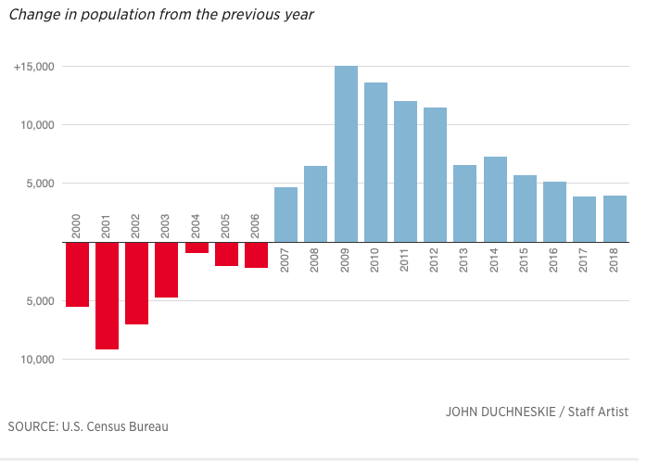

2. 工作。失业率，去年工作机会增长率，主要支柱产业，家庭平均收入。大的

employer有哪些?列出主要的机场、大学、医院、购物中心等大型服务性机构。

Households in Philadelphia, PA have a median annual income of $46,116, which is less than the median annual income of $61,937 across the entire United States. This is in comparison to a median income of $39,759 in 2017, which represents a 16% annual growth.

The economy of Philadelphia, PA employs 714k people. The largest industries in Philadelphia, PA are Health Care & Social Assistance (150,971 people), Educational Services (73,641 people), and Retail Trade (65,473 people), and the highest paying industries are Management of Companies & Enterprises ($61,434), Professional, Scientific, & Technical Services ($61,145), and Utilities ($56,772)

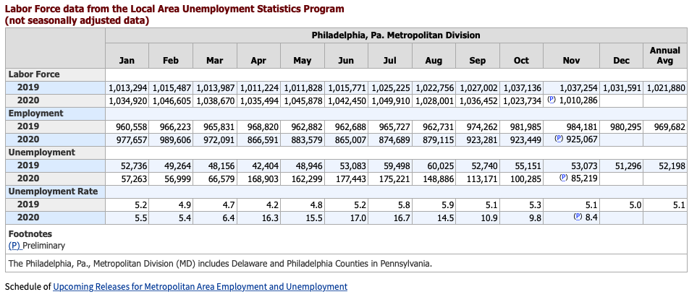

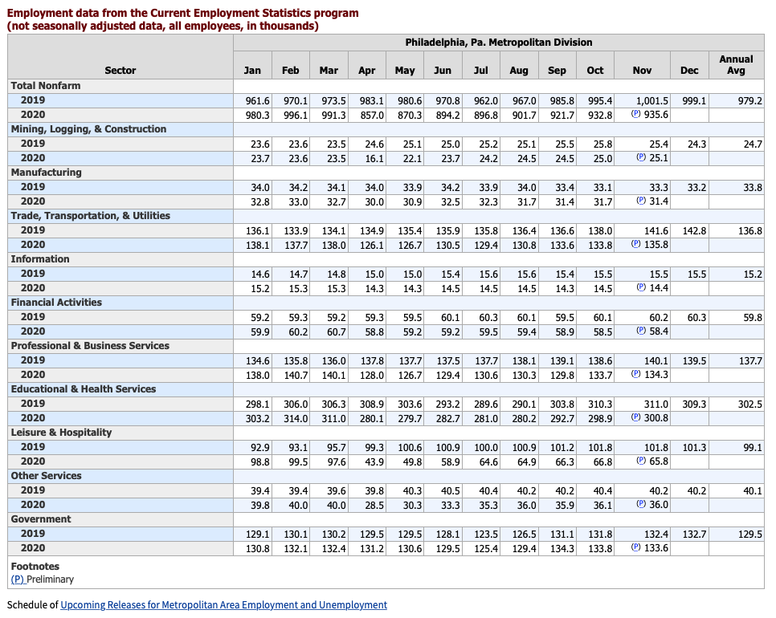

Universities:

