**Here’s a brief summary of the foreclosure process in North Carolina:**

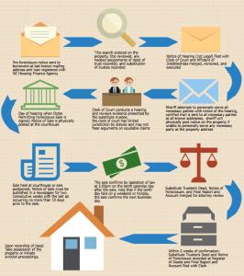

click to see better image.

<https://www.m1propertygroup.com/how-does-the-foreclosure-process-work-in-north-carolina/>

1. Pre-foreclosure notice sent to borrowers at last known mailing address and loan registered with NC Housing Finance Agency.
2. Title search ordered on the property, title reviewed, any needed assignments of deed of trust recorded, and substitution of trustee recorded.
3. Notice of Hearing (1st Legal) filed with Clerk of Court and Affidavit of Indebtedness merged, reviewed, and executed.
4. Day of hearing when Order Permitting Foreclosure Sale is signed, Notice of Sale is physically posted at the Courthouse.
5. Clerk of Court conducts a hearing and reviews evidence presented by the substitute trustee; the clerk of court has limited jurisdiction by statute and may not hear arguments on equitable claims.
6. Sheriff attempts to personally serve all necessary parties with notice of the hearing, certified mail is sent to all necessary parties at all known addresses, sheriff will physically post notice on the property if unable to personally serve any necessary party at the property address.
7. Sale held at courthouse or sale postponed; Notice of Sale must be published in a newspaper for two consecutive weeks with the last ad occurring no more than 10 days prior to the sale.
8. The sale confirms by operation of law at 5:00PM on the tenth calendar day after the sale; note that if the tenth day falls on a weekend or holiday, the sale confirms the next business day.
9. Substitute Trustee’s Deed, Notice of Foreclosure, and Final Report and Account merged for attorney review.
10. Within 2 weeks of confirmation: Substitute Trustee’s Deed and Notice of Foreclosure recorded at Register of Deeds and Final Report and Account filed with Clerk.
11. Upon recording of deed: Take possession of the property or initiate eviction proceedings.