**Tax Sale第一周作业：**

作业上交截止时间：**1/16/2021 西部时间晚上11:59PM**

1.给自己的小组起一个响亮的名称。

近税楼台

2.每个小组成员选1-2个想要重点研究和投资的市场。

大家讨论了新泽西，宾州，马里兰州

3.小组讨论，最后决定1-2个想要在后期进行重点研究和投资的市场

大家决定小组作业重点研究马里兰州

4.对于所选择的每一个市场，回答以下至少14个问题：

我们组目前仅确定了目标州，会随着学习深入进一步决定县。下面问题中如需要具体到县的，暂时以**巴尔的摩市**为例回答。我们调整了问题顺序，确定答案的列在前面，不确定答案的列在后面

**I.答案确定的题目：**

1. 小组名称？比如1-梦想成真队

8-近税楼台队

1. 小组成员都有谁？组长是谁？小组成员是如何分工完成作业的？

小组成员10人，组长Dennis，12个待查问题分工给参与讨论的8人

1. 该市场销售的是税留置权 （Tax Liens）还是税地契 (Tax Deeds), Redemption Dees?

Tax Lien

1. 税务留置权售出方式是什么，是线上拍卖， 还是现场拍卖？

巴尔的摩市为线上拍卖[www.bidbaltimore.com](http://www.bidbaltimore.com)

* 提前7天注册
* $100 non-refundable注册费
* 需交W-9
* 注册费和购买tax certificate用同一账户

1. When are the taxes assessed and when do they become delinquent? 房地产的税务评估何时进行的？税款拖欠起始日期？

巴尔的摩市税务评估分3个区域每隔3年进行一次，最近一次税务评估区域地图及时间：

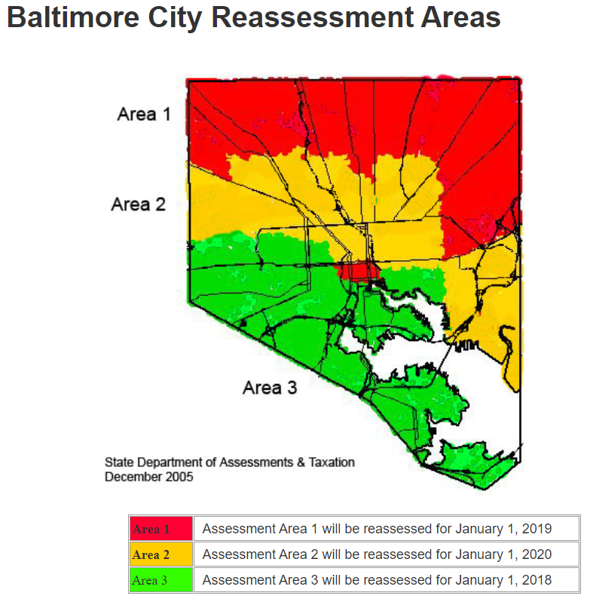

每年7月1日寄出当年房产税，税款拖欠费用从10月1日起缴，每月利息，罚金各1%

1. How does the bidding work (do you did down the interest rate, pay a premium, or bid down ownership interest)?拍卖方式（是否由高向低拍利率，支付溢价，或由高向低拍房地产所有权利息）？

以竞价拍卖(Premium Bidding System)的方式出售，口头竞标(Oral Bid)，价高者得。

溢价仅当投资者申请法拍(files for foreclosure) 时才需交付。如果屋主提前赎回房产(property is redeemed)，投资者就不用交付溢价部分了

1. What are the sale procedures and does the local government have a brochure or printed materials that outline the process?税务销售流程？政府是否提供小册子或印刷材料概述过程？

马里兰州销售流程概况：

州法律规定，各县在进行税务销售(Tax Sale)前需要在连续四周内每周都在当地报纸上发布一次税务销售通知(Tax Sale Notice)。  
与其他州相比，马里兰州法律给予各县更多的自主决定权:

* 各县可以自由决定竞标方法(Bidding Methods)，利率和拍卖日期
* 大多数县允许投资者在税务销售(Tax Sale)当天登记参与竞拍，但公司实体投资者(Corporate Entities)或需要在拍卖前数日就登记。也有部分县要求提前邮件登记(pre-registration by mail)
* 部分县可能要求投资者在参与竞拍前预付押金。具体支付方法一般为填写W-9表，支付1000美元认证押金(certified funds)。如竞拍者未中标，押金可退回。  
  起始竞标价(minimum bid)包括任何逾期应缴税款(past due taxes), 利息和其他费用。未售出的留置权(Unsold Lien)由税务总署(Tax Collector)收作库存留予日后处理。

巴尔的摩市销售流程概况：

巴尔的摩市Tax sale网站有该市流程介绍，包括每年3-5月详细时间表和赎回过程介绍，但未找到额外小册子：[Ref](https://taxsale.baltimorecity.gov/tax-sale-process)

**Tax Sale Timetable**

* March: The complete list of properties still eligible for tax sale is published twice in two newspapers of general circulation during the month of March.
* Early April: The City mails a second tax sale notice to the same property address during the first week of April. The amounts included in the second notice are due and valid until the last day of April, the last day to pay all of the outstanding taxes and charges owed the City to avoid tax sale.
* Mid-May: The annual tax sale is normally held during the third week in May.
* Late May: Redemption can begin. Redemption involves the owner, or an interested party such as a mortgage holder, reimbursing the bidder an amount of interest and other fees and costs. If a property is not redeemed by July 1, then the new fiscal year’s real property taxes also must be paid to redeem the property.

**Redemption Process**

Once a successful bidder has paid to the City all of the taxes and charges listed in the tax sale for a property, the property owner may only redeem their property by reimbursing the bidder. The sooner a property is redeemed, the lower the additional charges imposed by the bidder will be.

* Four months after the tax sale, other fees and costs may be added to the redemption amount.
* Six months after the sale, the successful bidder may file a lawsuit to foreclose the right of redemption on non-owner occupied residential properties.
* More fees and costs may be added seven months after the tax sale on owner occupied properties.

1. What is the interest rates or penalties to be earned?应赚取的利率或罚款是多少？

从网上资料搜到的信息为：

The interest rate in Maryland actually varies and it’s usually between 6% and 24%, each county and/or municipality handles sales differently. For example, 24% in Baltimore City, 20% in Garrett County, 20% in Montgomery County, and 24% in Prince George’s County.

然而组员实际电话询问结果为：

Called Baltimore City tax sales customer service, 被告知non-principal resident的redemption interest rate 是18%， residents interest rate is 12%.No penalties to redeem property.

1. If redemption occurs mid-month do you get the entire month’s interest?如果月中赎回，你会得到整月的利息吗？

是的， 会得到整月的利息。Even if you are only one day late with your tax payment, the property owner will have to pay the balance due plus a penalty of interest per month.

1. What is the redemption period and can property owners be contacted during the redemption period? 赎回期限多久？赎回期间可以联系原业主吗？

赎回期对于非自住业主（non-owner occupied) 6个月,巴尔的摩市自住业主（owner-occupied) **9个月**，可否联系业原主 [ref](https://taxsale.baltimorecity.gov/tax-sale-process)

“Six months after the sale, the successful bidder may file a lawsuit to foreclose the right of redemption on non-owner occupied residential properties”

“The successful bidder may file a lawsuit to foreclose the right of redemption nine months after the tax sale on owner occupied properties”

税务销售(tax sale)之后直至第七个月，业主直接市政府处付讫欠税并赎回

税务销售(tax sale)之后第8，9个月，房主需要主动联系购买人，赔付相关费用（例如title search和attorney fee）后才能与在市政府处付讫欠税并赎回

税务销售(tax sale)之后第9个月后，房主需要主动联系购买人，赔付更多相关费用(如告示费，提讼费等）后才能与在市政府处付讫欠税并赎回 [ref2](http://www.taxsalehelpbaltimore.org/b2_18)

1. What are the redemption rights of the property owner?产权人的赎回权有哪些？

屋主有6个月零一天(巴尔的摩市较特殊，owner-occupied屋主为 9个月零一天)时间来赎回房产。在此之后，投资者可随时采取必要步骤进行法拍获得房产地契

1. What is the life of lien? When does it expire? 留置权的有效期是多久？什么时候到期？

2年，2年内不法拍即作废

1. 止赎程序 （Foreclosure）如何？

止赎程序非自动执行(non self-executing), 需要投资者主动采取行动执行法拍。  
屋主有六个月零一天时间来赎回房产。在此之后，投资者可随时采取必要步骤进行法拍获得房产地契(obtain the deed to the property)。在启动法拍前，投资者需从先法院获得“取消赎回权令”( Order to Foreclose the Right of Redemption)

1. How does the holder of the tax lien take ownership if redemption does not occur?如果未有赎回，税留置权持有者如何取得物业所有权？

持有者需发起法拍。法拍非自动执行(non self-executing), 需要投资者主动采取行动执行法拍。  
屋主有六个月零一天时间来赎回房产。在此之后，投资者可随时采取必要步骤进行法拍获得房产地契(obtain the deed to the property)。在启动法拍前，投资者需从先法院获得“取消赎回权令”( Order to Foreclose the Right of Redemption)

1. Are there special noticing requirements in existence that could impact the status or priority of the tax lien?是否存在可能影响税收留置权的地位或优先级的特殊通知要求？

No - I called Baltimore Tax Sale customer care rep

1. Are subsequent taxes available for purchase? If yes, what rate?可以购买后续税吗？ 如果是，利率是多少？

组员电话确认subsequent taxes available，未查到具体rate可能默认和初次买相同, 如需要可花$10(money order)买一本去年tax sale剩下的list.但我们认it doesn’t make sense to do it in the financial perspective. The property can be foreclosed after 18 months. No need to buy the subsequent taxes in the 2nd year

1. 为了完成该份作业，你们参考了哪些网站，比如County网站，Tax Sale拍卖网站，这些网站对你们有什么帮助。

我们查询了如下网站/资料，很多组员还专门电话联系了Baltimore Tax Sale customer care rep，极大帮助我们详细了解了马里兰/巴尔的摩市的Tax Sale从头到尾的过程，为我们接下来的实操提供了方法和资源

* Tax Lien and Deed Investing Quick Start Guide By Dustin Hahn
* State Guide to Tax Lien And Tax Deed Investing By Joanne M. Musa
* 州法律和法典：马里兰州注释法，税务财产条款，第14章，副标题8，第三部分。“税务销售”
* <https://en.wikipedia.org/wiki/Maryland>
* <https://www.data-z.org/state_data_and_comparisons/detail/maryland>
* 马里兰州tax sale信息：

<https://dat.maryland.gov/Pages/Tax-Sale-Information.aspx>

* 巴尔的摩市税务评估信息：

<https://dat.maryland.gov/realproperty/Pages/HomeOwners-Guide.aspx#:~:text=Properties%20are%20reassessed%20once%20every,their%20assessment%20in%20late%20December>.

* 巴尔的摩市税务账单信息：

<https://taxsale.baltimorecity.gov/real-property-tax-bills>

* 巴尔的摩市tax sale流程信息：

<https://taxsale.baltimorecity.gov/tax-sale-process>

* 我打电话给Tax Sale customer care rep at 410-396-3987, 若再有详细问题可以写邮件给他们, 他们还提供了另一个号码可以咨询410-396-4170

**II.答案不确定的题目：**

1. Are physical certificates printed and what is the timing of their receipt? 是否有打印的实物证书？多久提供收据？

拍卖完成后会收到地契（deed）以及相应的置留权（liens）

“The balance of the purchase price is to be paid upon delivery of the deed, as well as, subsequent liens that have accrued on the property since the sale date”[ref](https://thedailyrecord.com/downloads/files/2020/05/TDR-Tax-Sale2020.pdf)

我们未找到是否是实物证书及多久提供收据，但认为本身也不是很重要

1. Is a quiet title suit required? 是否要求产权清晰诉讼？

查询了官网和马里兰当地律所的blog，没有查到相关要求，应该没有。官网：<https://dat.maryland.gov/Pages/Tax-Sale-Information.aspx> 没有quiet title相关字眼。

但我们找到了提到处理tax sale止赎 quiet title业务的律所，例如：

<http://www.ardenlawfirm.com/real-estate/real-estate-litigation/>

所以虽然不确定州法律是否要求必须做，但至少是common practice。

1. What is the expected period before clear title can be obtained?多久可以获得清晰产权？

Tax lien投资人必须通过法院程序才能拿到物业的地契/产权 （Baltimore County）。一般通过法院判决的应该是清晰产权。具体时间case by case,因为需要走法庭程序，所以至少需要几个月

1. What other items or situations impact the priority status of the lien?还有哪些事项或情形可以影响留置权的优先级？

这个问题我们不是很确定，但列下了一些可能原因，请老师点评：

* + IRS lien (取决于IRS是否在property上attach lien,什么时候attach lien,且可能半年左右会expire)
  + Tax lien from previous years
  + Sewer lien (当属于township本身的情况下)
  + 水电公司,mechanical/utility lien
  + Easement地域权

1. Are there any put-back provisions that would allow the purchaser to put back the lien to the municipality (bankruptcy, incorrect advertisement, etc.)?是否有任何退回条款允许购买者将留置权退还给市政当局（破产，不正确的广告等）？

向rep电话查询收到详细解答。如下两种情况可以退回：

* 1. 购买者Bankruptcy
  2. The owner changed the address and noticed the municipality in a time manner, which cause mailed wrong address to the investor
  3. 然而Incorrect advertisement 不可以作为退回理由。

除上述情况外应该还有其他情况，可以进一步打电话给rep查询