**投资County**:

[Prince George’s County, Maryland](https://taxsale.princegeorgescountymd.gov/)

County简况：紧邻DC以东，为DC都会区一部分。是马里兰州人口第二多County。为全国最富裕的非裔人口占多数的County。近年绅士化进程较快，犯罪率显著下降。[Wiki链接](https://en.wikipedia.org/wiki/Prince_George%27s_County,_Maryland)

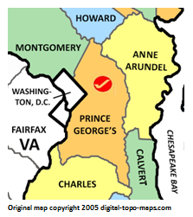

**选择原因**：

1. County为线上拍卖的Tax Lien, 符合投资目标 - 寻求低风险，低时间/精力投入的被动收入
2. 根据[马里兰州Tax assessment网站信息](https://dat.maryland.gov/Documents/2020-Annual-Maryland-Tax-Sale-Report.pdf)，Prince George’s County redemption interest annual rate为20%，目前为马里兰州最高之一

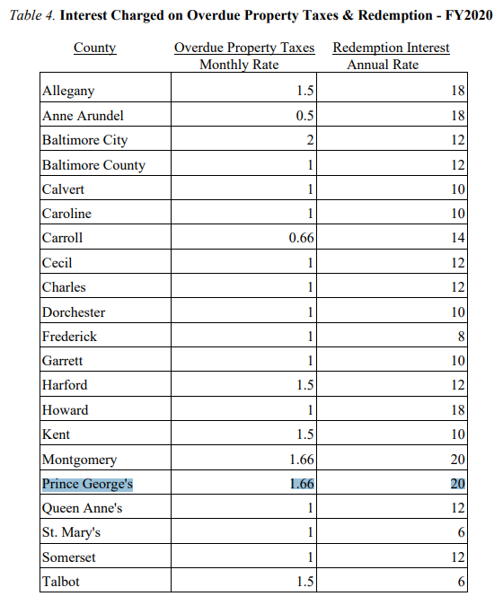

1. County提供PDF/Spreadsheet包含现有和最近两年所有标的的详细信息，可选择标的数量大，且同时有Online Sale和OTC标的可选择。非常适合研究筛选：

[2020 Tax Sale Result](https://taxsale.princegeorgescountymd.gov/2020Taxsaleresults.pdf)

[2020 OTC Tax Sale List (Pdf)](https://taxsale.princegeorgescountymd.gov/FY2020AssigmentList.pdf)

[2020 OTC Tax Sale List (Spreadsheet)](https://taxsale.princegeorgescountymd.gov/GenerateMacroExcelASale.aspx)

**拍卖规则**：

County网站总结得非常清楚：

<https://taxsale.princegeorgescountymd.gov/BiddingRules.aspx>

整体规则和马里兰州通行规则类似，我们已在Homework 1里详细回答，但Highlight如下几个值得一提的细节或特殊规则：

1. 网站信息还是2020年的，尚未更新至2021，按去年schedule大约在春季3-4月份会更新2021细则。下面细则暂时按2020 schedule阐述：
2. 需于5月30-6月12日期间在County Tax Sale网站注册：[https://taxsale.princegeorgescountymd.gov](https://taxsale.princegeorgescountymd.gov/)
3. 注册时需提供W9, 并交付$150注册费(non-refundable and will not be applied to the amount owed for certificates)和$1,000押金(refundable, applied to certificates)
4. Bid于6月15-19日期间Online进行，结果19日7pm公布，winning bidder需在次日5pm前付款，6月22日Certificate签发
5. Bid可为dollar amount或基于property full cash value的一个比值（比如0.4）
6. 溢价部分的交付规则比较特殊需要额外注意：winning bidder需交超过property assessed value 40%部分的20%。这部分溢价在老屋主赎回时可以退回给投资人，但无利息。但如果老屋主过了赎回期未赎回，且持有者未在止赎期发起法拍/或法拍被驳回，则溢价不会退还。

“This high bid premium is 20% of the amount by which the bid exceeds 40% of the property’s assessed value. The high bid premium is due and payable at the time the successful bidder pays the tax lien amount.

The County will refund the high bid premium, without interest, to the holder of the tax sale certificate upon redemption of the property or to the plaintiff in an action to foreclose the right of redemption upon delivery of a tax sale deed for the property for which the high bid premium was paid. The high bid premium is not refundable after the time required (under Section 14-833 of the Tax-Property Article) for the filing of action to foreclose the right of redemption, if there has been no redemption and if an action to foreclose the right of redemption has not been filed within that time. In addition, the high bid premium will not be refunded in the event a tax sale foreclosure suit is dismissed and there has been no redemption.”

下面是一个具体的溢价计算的例子：屋主欠税1千，投资人一口气bid到了5万(50% of property value)。但按照County算法，投资人起始时需要交的只有：

1,000 +（50,000 - 100,000 * 40%）*20% = 1,000 + 2,000 = 3,000

如果老屋主赎回。溢价2,000还会还给投资人，但是没有利息。Implication就是当投资人有信心老屋主会赎回的时候，可以overbid很多，甚至到Property value的40%以上。但实际上的成本只有底价左右。风险在于老屋主不赎回的情况，这时overbid的数额就要交了，投资人要保证当初overbid的数额如果需要法拍拿到房子的情况下是划算的。

