Alhambra Mobile Home Park

The park was put for sale on 06/26/2015 for parcel number 20527084B/20527085B， cannot find the listing price.

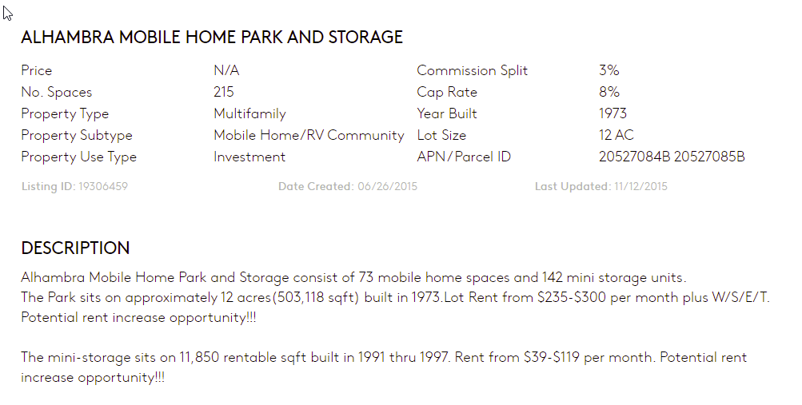

Parcel# 0527085B should be the storge area which is not included in the current sale.

Current sale: **Multifamily Sales price: 2,500,000**

Alhambra Mobile Home Park is an All Age Community located in Globe, Arizona.​ The Park is comprised of 68 Mobile Home Spaces.​ The Park was originally built in 1973.​ Alhambra sits on approximately 10.13 acres.​ Electric is provided by APS and is Direct Billed to Tenants.​ The Park is on City Water with submeters installed for a bill back program.​ Alhambra has an onsite septic system with three leach fields.​ Sewer (service/maintenance fee) and Trash are billed through a flat monthly fee to tenants ($60).​ There are 28 Park Owned Homes (one Unit is used for Park storage).​ There are 9 Homes under Contract for Sale.​ Alhambra currently has 2 vacant lots and 3 vacant homes.​ Four new Champion Homes have recently been set in place, each unit is 16x56 (3Bed/2Bath).​ Since 2017, over $100,000 in capital improvements have been completed.​ Items include new pavement of the roads, several homes updated with new HVAC’s, Furnace, Paint, Flooring and several new Appliances.​ The Park offers large lots with off street parking.​ The Community has an Onsite Manager (pays own rent/utilities) that is willing to continue with new ownership.​ Alhambra offers a convenient In Town location。

* **Multifamily Sales price: 2,500,000**
* Subtype **Mobile Home Park**
* Cap Rate **9.34%**
* NOI b **$233,612**
* Units **68**
* Year Built**1973**
* Zoning: **MHL**
* Lot Size (acres):**10.13**
* APN: **205-27-084B, 205-27-088K**
* Price/Unit: **$36,764.71**
* Ownership: **Free Simple**
* All Age Community
* ​28 Park Owned Homes
* ​$100K IN Capital Expenses
* ​Rent Increase Effective August 1, 2021

The surrounding of the park -Globel Arizona – The Globel AZ, the income, Mediam house price are ok, but the population reduce 2.9% since 2010 and unemployment is 6.3% which is high

* The park is next to US 70 w highway
* The park is 2 miles away from Gila County Board-Supervisors – government office.
* Media Monthly Rent is ok but the vacant is 15.1% ， it is high then 12%
* The Metro Area vacant house# is very high: 35.1%

Globe's economy remains heavily dependent on the service industry, and the mining industry, and as of 2008 the city was home to one of the few operating copper [smelters](https://en.wikipedia.org/wiki/Smelter) in the United States.[[18]](https://en.wikipedia.org/wiki/Globe,_Arizona)  
Major employers in Globe include Gila County, [Arizona State Prison Complex – Florence](https://en.wikipedia.org/wiki/Arizona_State_Prison_Complex_%E2%80%93_Florence), [Heritage Health Care Center](https://en.wikipedia.org/wiki/Life_Care_Centers_of_America), [Globe Unified School District](https://en.wikipedia.org/wiki/Globe_Unified_School_District), and [Gila Community College](https://en.wikipedia.org/wiki/Gila_Community_College).

* Goble economy depending on MINING heavily which is too solo. With the Silver Mine finish, the population will continue decline which is a threaten to MHP