**第二周作业：**

详细阐述该市场的拍卖规则， 并说明做出选择该市场的原因。

#### For beginner, we choose St. Joseph County Indiana Tax Lien Sale

(Bid Up / Proxy Bidding / No Deposit / Approval Required)  
Items: 2273  
Bidders: 78  
[download list](https://www.zeusauction.com/methods/exportsale.php?idAuctionSale=797) [Terms and Conditions.pdf](https://www.zeusauction.com/auctionsalefiles/1627412582Terms%20and%20Conditions.pdf) [Tax Sale Buyer Handout.pdf](https://www.zeusauction.com/auctionsalefiles/1627412592Tax%20Sale%20Buyer%20Handout.pdf) [2021 Payment Terms.pdf](https://www.zeusauction.com/auctionsalefiles/16274125982021%20Payment%20Terms.pdf) [2020 2022 Blanket Consent Form.pdf](https://www.zeusauction.com/auctionsalefiles/16274126072020%202022%20Blanket%20Consent%20Form.pdf) [Dynamic Ending Close.pdf](https://www.zeusauction.com/auctionsalefiles/1627413646Dynamic%20Ending%20Close.pdf) [Payment Terms.pdf](https://www.zeusauction.com/methods/paymentterms.php?idSale=797)

**Starting:**9/7/2021 2:00 PM EDT  
**Ending:**9/10/2021 5:00 PM EDT

**Registration open until:**  
9/7/2021 12:00 PM EDT  
[Click To Register](https://www.zeusauction.com/managebidder.php?idRegister=797)

#### First, Indiana hold both tax lien and tax deed, it’s good for beginners. Second, as the 38th largest city with growing opportunity, the price is affordable.

对于所选择的每一个市场，选择至少8个相关问题，进行回答：

1. How does the bidding work (do you did down the interest rate, pay a premium, or bid down ownership interest)?拍卖方式是什么？是利率向下拍卖，竞价拍卖，或所有权向下拍卖）？

Bid up

1. What are the sale procedures and does the local government have a brochure or printed materials that outline the process?税务销售流程是什么样的？政府是否提供小册子或印刷材料概述过程？

* Review and complete the Bidder Registration Card and sign. Return the card to auction staff.
* Complete W-9 IRS form to complete. With the payment of winning bid.
* After registration card has been processed, bidder’s name will be called and bidder number page will be given to you prior the start of the auction.
* Raise your bidder number page to signal your bid.
* After the bid is accepted as the winning bid, a Bid verification and receipt form will be printed by auction staff. Your name will be called and you will be given this form for signature and verification.
* Payment.

The certificate include those info:

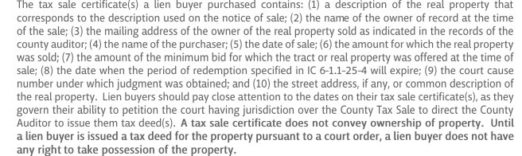

1. What is the interest rates or penalties to be earned?如果是Tax Lien, 投资者能赚取的最高利率或罚款是多少？

If the property is redeemed during redemption period, the lien buyer may be reimbursed for its attorney’s fees and costs of giving notice under IC 6-1.1-25-4.5 as well as the cost of a title search. The cost is subject to a maximum amount established by the court having jurisdiction over the sale. The form 137B is required before the property is redeemed.

During the redemption period, lien buyers have to pay all subsequent taxes and special assessments on the properties. The lien buyer will be reimbursed for all such taxes and special assessments plus interest at the rate of 5% per annum, upon redemption.

But if the property is not redeemed during redemption period, the lien buyer will not be reimbursed for any subsequent taxes and special assessments. Lien buyer has to file form 137 B otherwise, the lien buyer won’t be reimbursed.

1. If redemption occurs mid-month do you get the entire month’s interest?如果月中老屋主赎回房产，投资者是否得到整月的利息？
2. Are physical certificates printed and what is the timing of their receipt? 政府是否提供打印的实物tax lien certificate？多久能收到tax lien certificate？
3. What is the redemption period and can property owners be contacted during the redemption period? 有赎回期限多久？赎回期间，投资者可以联系原业主吗？

One year for redemption, yes, bidder can contact owner.

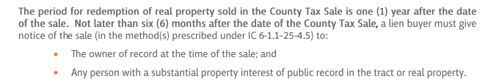

1. 如果老屋主赎回， 投资者的收益是什么？

The property can be redeemed at any time within one year after the date of the sale.

Lien buyer will receive a refund 100% of the minimum bid for which the tract or real property was offered at the time of sale, if the property is redeemed not more than 6 months after the date of sale; 115% of the minimum bid at the time of sale, if more than 6 months less than 1 year. In addition, lien buyer will receive a refund of the amount by which the purchase price exceeds the minimum bid plus 5% per annum on that amount, plus all prior and properly filed 137 B cost, which include attorney’s fee and cost of giving notice , the cost of title search and all taxes and special assessment paid after the sale (plus 5% annum on the subsequent taxes and special assessment paid).

1. How does the holder of the tax lien take ownership if redemption does not occur? 如果房产税留置权没有赎回，房产税留置权持有者如何取得物业所有权？

After 1 year, not later than 3 months, if redemption doesn’t occur, the lien buyer may file a verified petition with the court for tax deed.

The court will assess those conditions before issue the tax deed:

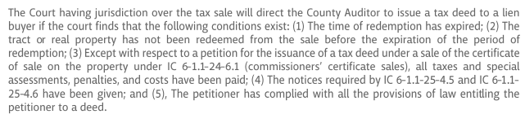

1. What is the expected period before clear title can be obtained? 多久可以获得清晰产权？

A reasonable time according to the country’s document.

1. What other items or situations impact the priority status of the lien?还有哪些事项或情形可以影响留置权的优先级？

Don’t know, can’t find the info.

1. Are there special noticing requirements in existence that could impact the status or priority of the tax lien?是否存在可能影响税收留置权的地位或优先级的特殊通知要求？

Don’t know, can’t find the info.

1. Are there any put-back provisions that would allow the purchaser to put back the lien to the municipality (bankruptcy, incorrect advertisement, etc.)?是否有任何退回条款允许购买者将留置权退还给市政当局（破产，不正确的广告等）？

Don’t know, can’t find the info.

1. Are subsequent taxes available for purchase? If yes, what rate?可以购买后续税吗？ 如果是，利率是多少？
2. 为了完成该份作业，你们参考了哪些网站，比如郡 （County）或者城市 （City）网站，Tax Sale拍卖网站，这些网站对你们有什么帮助？

Sriservices.com