作业2

筛选合适的投资项目

1 下载所有LISTING,

<https://sriservices.com/>,找到St Joseph,

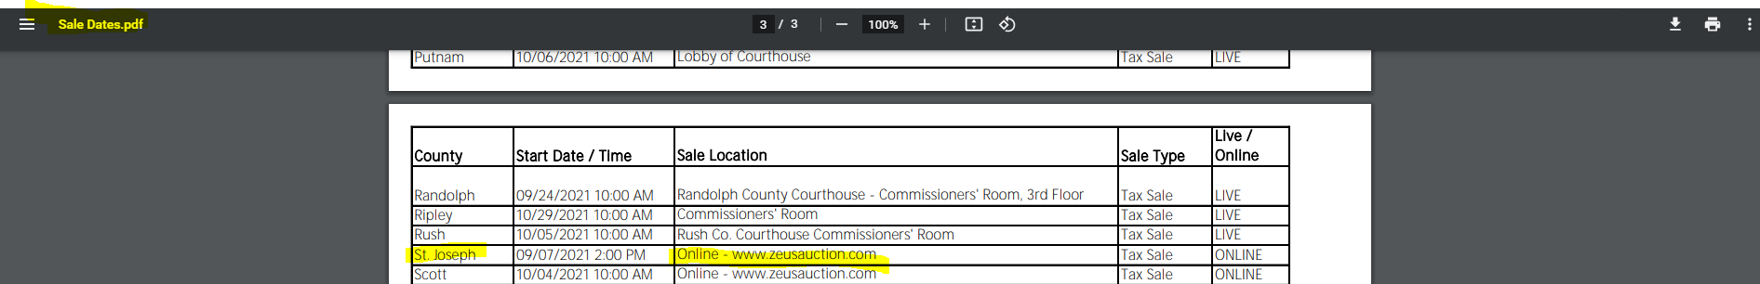

<https://www.zeusauction.com/>, 注册然后登录：

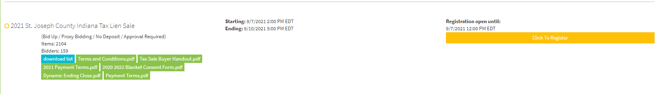

下载, download list.

2 筛选，价位1000-2000，房主名称含“LLC”， 选中：

7995458 712101570 Batch 2 018-4048-1784 South Bend – Portage Captial Housing LLC Lot 1469 Summit Place 5th 610 S Dundee St $1,673.10

3 调查网站：

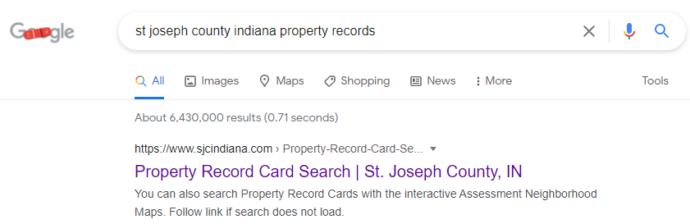

1. [Home](http://in-stjosephcounty.civicplus.com/)
2. [Departments](http://in-stjosephcounty.civicplus.com/101/Departments)
3. [Assessor](http://in-stjosephcounty.civicplus.com/173/Assessor)
4. Assessment Neighborhood Map, 找到
5. 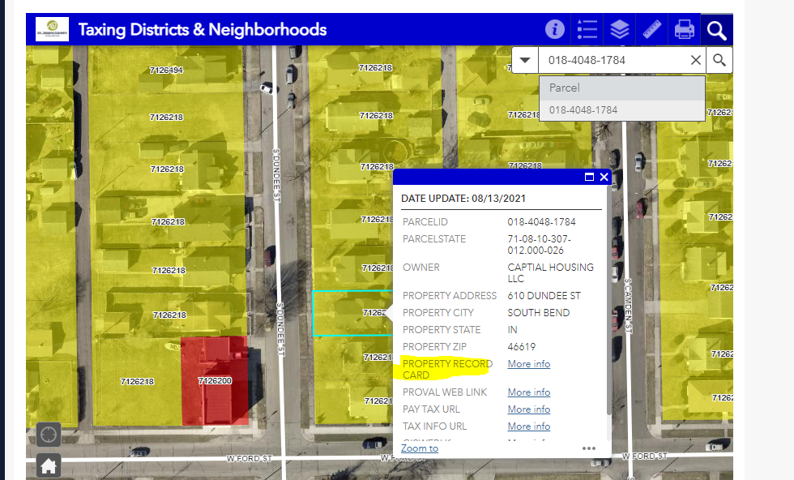
6. 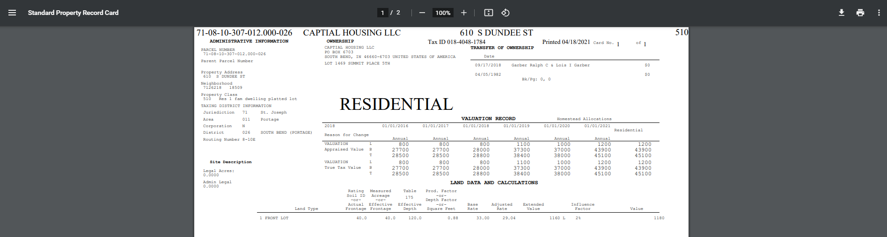

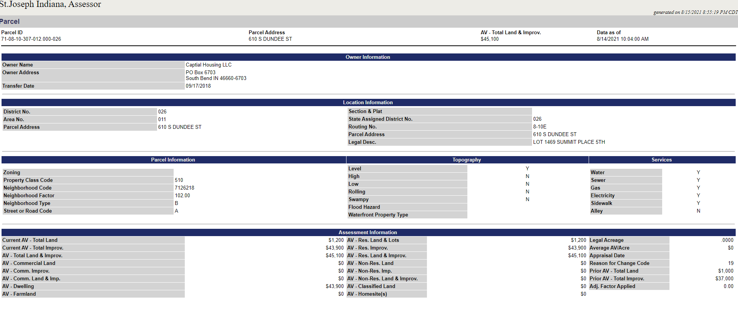

**Tax Bill Detail**

**Property Information**  
(If information appears incorrect or inaccurate, please contact the county auditor.  
Data appears as reported from the county.)

|  |  |
| --- | --- |
| **Tax Bill ID** | 152670396 |
| **Assessment Year** | 2020 |
| **County** | St. Joseph |
| **Parcel Number** | 710810307012000026 |
| **Tax Payer Name** | Captial Housing LLC |
| **Tax Payer Street Address** | PO Box 6703 |
| **Tax Payer City** | South Bend |
| **Tax Payer State** | IN |
| **Tax Payer Zip** | 46660-6703 |
| **Tax District** | 18 |

**Total AV**  
(If information appears incorrect or inaccurate, please contact the county auditor.  
Data appears as reported from the county.)

|  |  |
| --- | --- |
| **Total AV** | $38,000.00 |

**Deductions**  
(If information appears incorrect or inaccurate, please contact the county auditor.  
Data appears as reported from the county.)

|  |
| --- |
| No Deductions |

**Exemptions**  
(If information appears incorrect or inaccurate, please contact the county auditor.  
Data appears as reported from the county.)

|  |
| --- |
| No Exemptions |

**Net AV**  
(If information appears incorrect or inaccurate, please contact the county auditor.  
Data appears as reported from the county.)

|  |  |  |  |
| --- | --- | --- | --- |
| **Net AV** | |  |  | | --- | --- | |  | $38000 | |

**Tax**  
(If information appears incorrect or inaccurate, please contact the county auditor.  
Data appears as reported from the county.)

|  |  |
| --- | --- |
| **Total Gross Rate** | 596.13 % |
| **Gross Tax** | $2,265.28 |

**Credits**  
(If information appears incorrect or inaccurate, please contact the county auditor.  
Data appears as reported from the county.)

|  |
| --- |
| No Credits |

**Net Tax**  
(If information appears incorrect or inaccurate, please contact the county auditor.  
Data appears as reported from the county.)

|  |  |  |  |
| --- | --- | --- | --- |
| **Net Tax** | |  |  | | --- | --- | |  | $911.88 | |

**Penalties**  
(If information appears incorrect or inaccurate, please contact the county auditor.  
Data appears as reported from the county.)

|  |  |
| --- | --- |
| **Personal Property Late Penalty** |  |
| **Personal Property Underpayment Penalty** |  |
| **Prior Year Delinquent Payment** | $384.00 |
| **Prior Year Delinquent Penalty** | $110.23 |

**Total Tax Due**   
(If information appears incorrect or inaccurate, please contact the county auditor.  
Data appears as reported from the county.)

|  |  |
| --- | --- |
| **Total Tax Due** | $1,406.11 |

但是没有找到免费的 Title Search