**Tax Lien Tax Deed作业**

**第三周作业：**

在要投资的市场, 拿到一个List， 然后缩短List到50个标的以内。 详细阐述小组成员是如何拿到这个List的， 原来List有多长，是如何缩短。

作业截止时间：下一次上课之前，请组长把作业上传到网站上

**作业答辩：**

**1.** 根据小组成员的时间，精力，以及资金，小组投票确定1个要投资的市场。

详细阐述该市场的拍卖规则， 并说明做出选择该市场的原因。

2. 在要投资的市场, 拿到一个List后，缩短List到50个标的以内。 详细阐述小组成员是如何拿到这个List的， 原来List有多长，是如何缩短。

3. 做完一个房产的调研过程， 详细阐述小组成员是如何做调研的，设定最高出价，说明设定价格原则。如果拿到标的，计划如何退出。

答辩时间： 8/25/2021-8/26/2021

1. I download the list from, pick the one coming in early Sept 2021.

<https://www.zeusauction.com/dash.php>

1. Sort by the price from 5000-10,000, and include the owner’s name by LLC or Inc, which shorten the list from over 2000 to around 66.
2. Found this list inside my budget, it’s a lot owned by a company.



1. Search St. Joseph + property search by Google. Find that this is vacant lot for many years and the estimated value by government is lower than the listed value. And the value has been stayed the same for over 6 years.

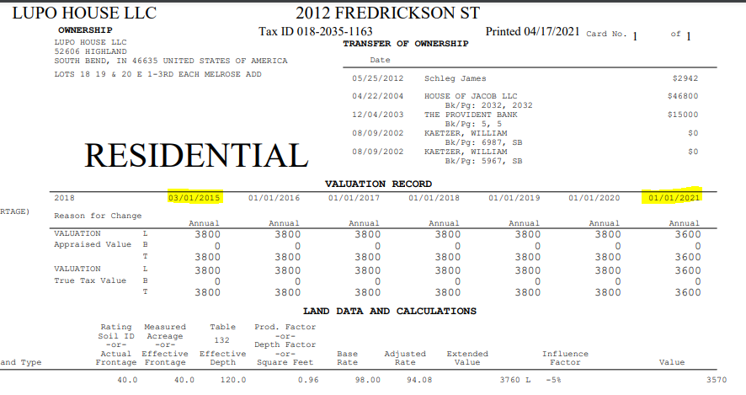

1. Result: Not choose this one due to the overstated value.

Check another property value:



1. This is the gas station as the main street intersection. This value has been transferred once only in 1996.

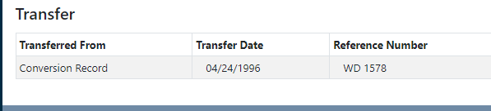

1. The appraised value is increasing every year.

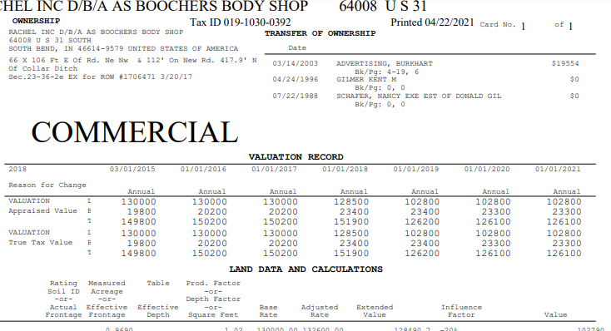

1. Check map. Google. There is no water pipe or flood area.
2. Result: a potential bid.