The Hakai Institute, as seen by OpenAlex
  - The case study of a research funder, told through OpenAlex funder data and some of my own history
Kyle Demes
2026-06-13
TL;DR. As part of a Wellcome-funded effort to build open funding metadata into OpenAlex, I assembled research outputs I could tie to the Tula Foundation and its Hakai Institute, the Canadian funder where I got my start in research management and strategy. The result is 1,496 research works (overwhelmingly coastal and environmental science), cited 58,000+ times by research from 199 countries and every field of science, with more than 6% in the world’s top 1% most-cited papers. The work runs from a 13,000-year-old discovery on a BC beach to the pathogen behind a continent-wide ecological collapse; it’s co-acknowledged alongside 500+ other funders; and it shows BC universities working across institutional silos. This is a story about a remarkable funder and a demonstration of what is now possible with open research funding data integrated into OpenAlex.

Measuring what funders make possible
For the past year at OpenAlex, I’ve been leading a Wellcome-funded project to build out open funding metadata and to connect the world’s research to the funders who made it possible, as open data anyone can use. We’ve now made enough progress that I wanted to put it through the test of a real case study. I chose one close to home: the Tula Foundation and its Hakai Institute, the British Columbia funder that launched my career in research management and strategy.
The Tula Foundation was founded in 2001 by Eric Peterson and Christina Munck, after Eric sold his medical-imaging company. With those resources, they did something ambitious: they built two world-class marine research stations: one on Calvert Island, on the wild Pacific edge of the Great Bear Rainforest, and one on Quadra Island in the Salish Sea. Rather than issue smaller grants to researchers at universities, they aspired to bring scientists together across university and sectoral silos to focus on place-based research on British Columbia’s Central Coast, in collaboration with the First Nations whose territories span the region. The Calvert lodge was acquired in 2009 and opened the following spring; the Hakai Institute (for a time the “Hakai Beach Institute,” and earlier administered as the “Hakai Network”) grew from there.
Tula’s work reaches well beyond the coast, including other important initiatives like TulaSalud, a maternal- and child-health program in Guatemala. But the coastal science is the part I know best, because I lived a chapter of it, and so I focus on that aspect of their work here.

My chapter
After finishing my PhD at UBC, I was hired as a postdoc in Anne Salomon’s lab at Simon Fraser University, funded through the Hakai Network. My job was to design a kelp-forest monitoring protocol for the Central Coast (the first long-term baseline of its kind there) built to be interoperable with monitoring initiatives elsewhere in BC (like Haida Gwaii) but also aimed squarely at a question that was rewriting the coast in real time: what happens as sea otters return after decades of local extinction? I ran a dive team out of the Calvert Island station for two field seasons, and supported the work of trainees like Jenn Burt and Christine Stevenson, who have since launched successful careers in the field.
As my postdoc wound down, I was interviewing for faculty jobs and was conflicted about my future, not wanting to leave BC, which had become my home. Around the same time, Eric was rethinking how to best mobilize Tula’s resources to move coastal research forward. Because I already knew researchers across the BC universities and was familiar with his vision, he offered me a full-time role building Hakai’s in-house research administration: designing better ways to partner with universities, and exploring collaborative models with government, industry, other funders, and NGOs.
I was in that job less than a year. But the entrepreneurial spirit of the organization and the founders’ ambition and mission-focus gave me a unique crash course in research management, specifically: how to align the incentives of researchers and institutions with a mission (which are often orthogonal) to produce real impact. These experiences became the foundation of everything I’ve done since and motivate my work at OpenAlex today, supporting research globally with an open index of the world’s research ecosystem.
You can probably read from my tone that I am not a neutral observer in this story, but I see that as an excellent opportunity to test the state of OpenAlex’s funding data.

Finding the corpus: casting a wide net
Here’s the first hard problem, and it’s a general one for funder analyses: you cannot just look up a funder and expect the list to be completely accurate and comprehensive.
Tula and Hakai aren’t always acknowledged the way a federal funding agency is in publications. Conventions changed over two decades; some researchers name “Hakai Institute” as an affiliation rather than in an acknowledgements section; closed-access papers may carry no machine-readable funding; Hakai publishes open datasets, not only papers; and as I mentioned above Tula supports great initiatives outside of the mission of the Hakai Institute. A single funder lookup would miss some outputs and include others that don’t fit the scope of the analysis.
So I cast a deliberately wide net using nine complementary search strategies in OpenAlex:
Strategy | What it catches
Funder = Hakai Institute / Tula Foundation | Explicit funder acknowledgements and linkages asserted in Crossref
Affiliation = Hakai Institute / Tula Foundation | Authors who list Hakai/Tula as one of their institutions
Raw affiliation string “Hakai” | Affiliations OpenAlex hasn’t yet linked to an institution
Full-text “Hakai Institute” / “Hakai Network” / “Tula Foundation” | Mentions in the open full text
Full-text “Calvert Island” | Work done at the field station, however acknowledged
Datasets | Hakai-published open data
That produced 1,684 candidate works but casting a wide net means catching some fish you didn’t want, which is exactly why the next step matters. [To those who are annoyed by unnecessary marine puns: sorry, I just couldn’t help myself]

Verifying every candidate
I ran an LLM over all 1,684 candidates (title, abstract, venue, affiliations, provenance) to judge whether each was genuinely Tula/Hakai work, then hand-checked every exclusion. 170 were false positives. A few illustrate why the step is essential: a protein called Hakai (CBLL1, named for the Japanese word for “destruction”) that full-text matching brought in; the Russian city of Tula and its universities; and one was a 1985 oceanography paper tagged to a funding organization that wouldn’t exist for another sixteen years.
That left 1,514 genuine Tula/Hakai works. The analysis below covers 1,496 of them that are overwhelmingly coastal and environmental science, plus Tula’s marine-microbial, earth-science, and related research. Setting aside only the clinical and behavioural papers (Medicine, Psychology, Neuroscience) relating to TulaSalud as off-topic for this analysis.
The real point here. Open funder metadata is now good enough to find a funder’s footprint across journals, repositories, and full text. Broad open metadata plus a verification pass is what makes a study like this possible. A few years ago, it wasn’t. And later this year, users will be able to submit the types of curations I made during this analysis directly to OpenAlex!
A note on precision and recall. For those who are interested, I estimated precision and recall of two search strategies: one with just the OpenAlex funder filter and one with all 9 queries combined (full search). Precision was calculated as the number of publications in the final set divided by the total candidates in each strategy, and recall against Hakai’s public list of publications (https://hakai.org/publications). The funder filter alone is slightly more precise (95% vs 90%) but finds less than half of Hakai’s known publications (49% recall); the full search trades a little precision for far better completeness (90% precision, 89% recall). The ~11% the full search still misses are works with no funder acknowledgement, no Hakai affiliation, and no searchable full text — the frontier that direct, funder-asserted linkages are built to close.
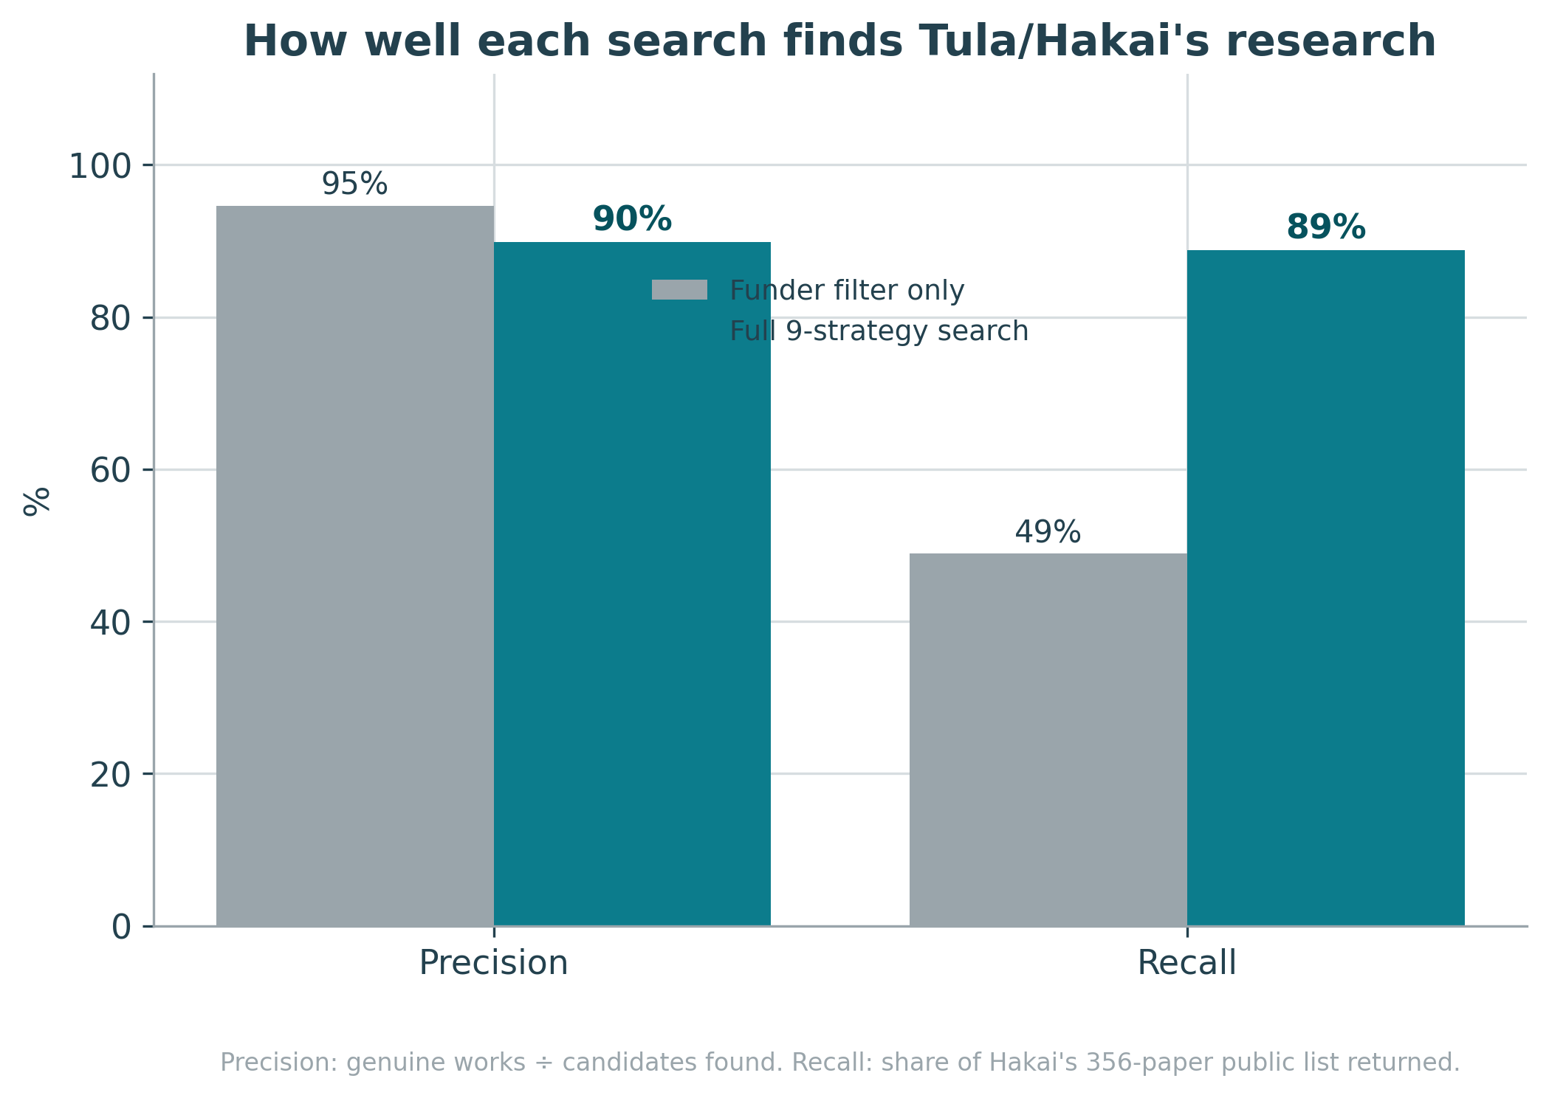
Precision and recall of the funder filter vs. the full search

What the funding produced
1,496 verified Tula/Hakai research works, spanning effectively 2007 to today, from 4,742 authors at 1,200+ institutions in 85 countries. ~80% are open access. Over 100 are open datasets.
That ~80% open-access share is well above the global average (about 47% of research published 2015–2024). That isn’t an accident. In 2015, Hakai adopted an open-science policy (one I helped implement) requiring open data and publications. Funders are one of the most powerful levers for open science: when the Gates Foundation made immediate open access a condition of its grants, compliance followed across the fields it funds and other funders were empowered to make similar policies. Hakai’s policy is a small, early example of the same dynamic, and it shows up directly in how discoverable and reusable this body of work is today.
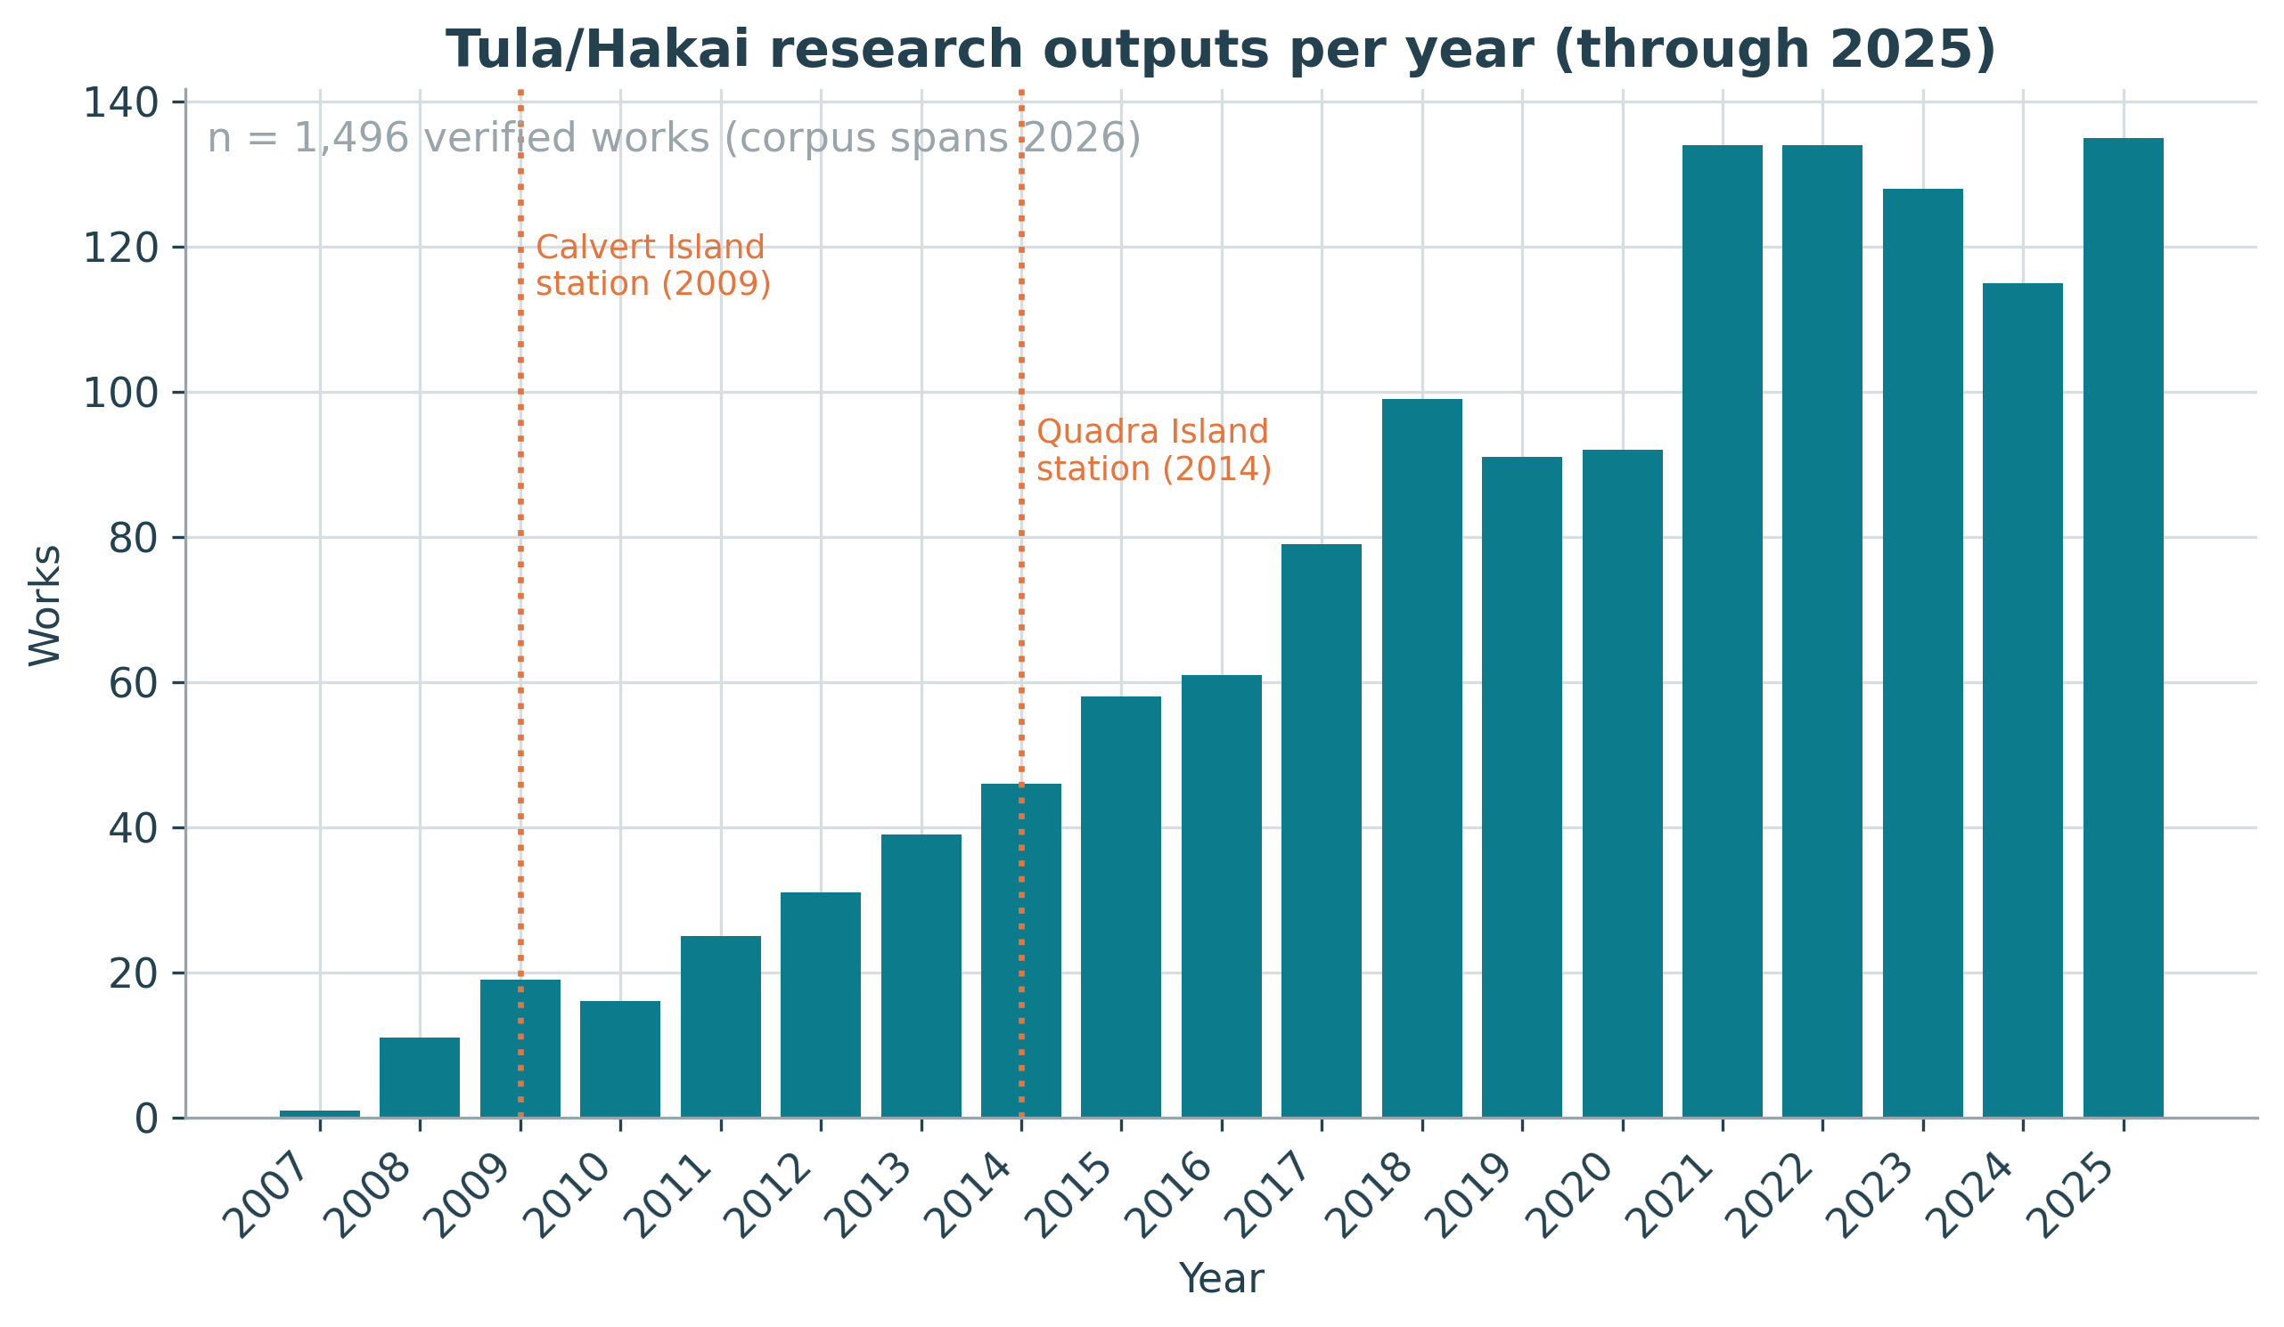 Annual outputs climb from a handful before the field stations to well over 100 a year; the dotted lines mark the Calvert (2009) and Quadra (2014) field stations.
The work is overwhelmingly environmental and marine science and the single most common topic is marine and coastal plant biology (read: related to seaweeds, seagrasses, and their ecosystems). Works are published in venues like Frontiers in Marine Science, Marine Ecology Progress Series, The ISME Journal, Proceedings of the Royal Society B, and PNAS.
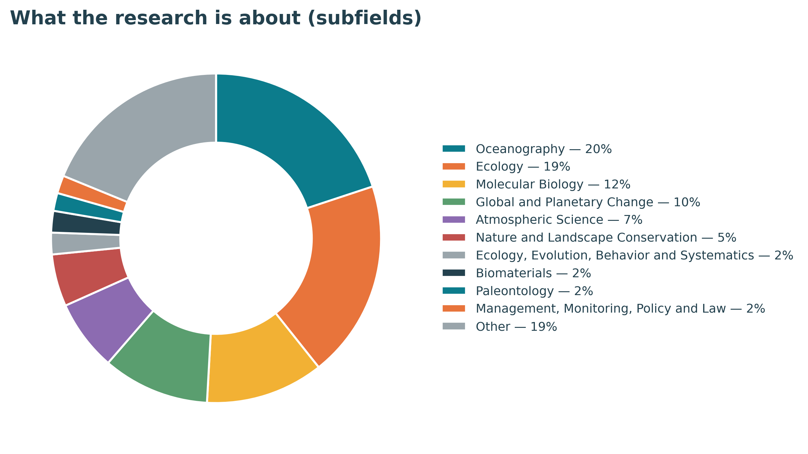 Subfields of the corpus (top 10; the long tail is grouped as “Other”).

Citations: punching above weight
Counting papers is the easy part. The more interesting question is whether anyone built on the knowledge produced and shared through those outputs. They did, of course: the corpus has been cited 58,579 times.
The standard field-normalized measure is Field-Weighted Citation Impact (FWCI), where 1.0 is the world average for a paper of the same age, field, and type. People like FWCI because it allows comparisons across very different outputs and that’s why FWCI underpins university rankings and many institutional research intelligence use cases. But averaged FWCI is notorious for being heavily right-skewed: a handful of very highly cited papers can pull the mean far above the typical paper. Here the mean FWCI is 6.94 but that is inflated by a few giant consortia papers. Data from the Central Coast of BC are only able to be included in mega-authored global syntheses because of the Hakai Institute, and so it’s important to still value Hakai’s contributions to those highly cited initiatives, but the median and the percentile shares are more robust here:
- Median FWCI: 1.69 — the typical Hakai/Tula paper is cited ~69% more than its global peers.
- 62.5% of works are above the world average.
- 92 works (6.1%) sit in the world’s top 1% most-cited — 6.1× the expected rate.
- 526 works (35.2%) are in the top 10% — 3.5× the expected rate.
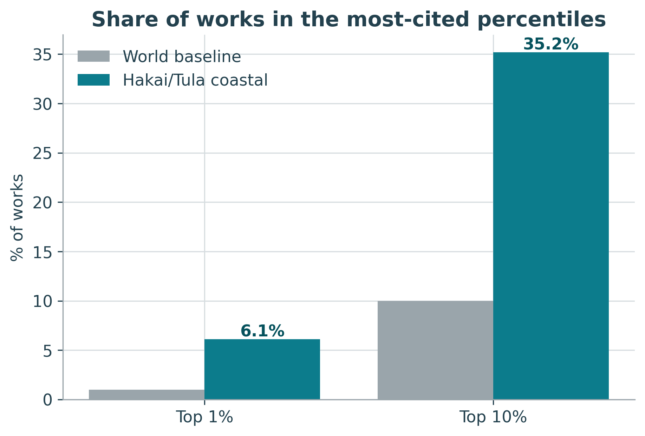 The corpus is ~6× over-represented in the world’s top 1%, and ~3.5× in the top 10%.

What was the science?
Citation metrics tell you that people built on the work; they don’t tell you what the work was. So I pulled the 50 highest-FWCI works to understand the work and its impact better. It was surreal to read about some of the incredible discoveries that came from the Calvert Island field station while reflecting on the memories I built there with other researchers:
- The sea stars, the mystery, and the answer. Starting in 2013, sea stars from Alaska to Mexico melted away in the largest marine wildlife die-off ever recorded. A Hakai-linked team documented the continent-scale collapse of the sunflower sea star (Pycnopodia), tied to a marine heat wave (2019). The loss rippled straight into my world: fewer sea stars and otters means more urchins, and more urchins meant less kelp. Then, after a decade-long hunt by scientists globally, a 2025 paper in the corpus named the culprit, the bacterium Vibrio pectenicida, finally giving the disease a cause.
- A 13,000-year-old morning on Calvert Island. Among the highest-impact papers (FWCI 93) is the discovery of terminal-Pleistocene human footprints pressed into the shoreline of Calvert Island, representing direct evidence for the peopling of the Americas along a coastal route. The field station didn’t only host marine biology; it helped rewrite an understanding of human history.
- Kelp forests, globally. The corpus includes the definitive syntheses of global kelp-forest change over the past half-century and the economic value of the world’s kelp forests. This is the big-picture context for exactly the monitoring I was sent to Calvert to build.
- The invisible ocean. Tula’s marine-microbial program produced landmark work on microbial and viral “dark matter” and the evolutionary origin of plastids, the hidden machinery of ocean ecosystems.
- Filling a blank spot in the global picture. Some of the highest-FWCI works are large climate syntheses (e.g., the Global Carbon Budget series, a multi-decade ocean-CO₂ record) where Hakai is one of many contributors. That’s not a footnote to discount. Coastal British Columbia was historically underrepresented in global ocean and carbon models; Hakai’s sustained observations are the only reason that this region appears in those worldwide analyses at all. Putting a blank spot on the map is its own kind of impact.
- Science with, not about, communities. Several top papers are Indigenous-led, Haida and Haíɫzaqv ethics and oral history guiding ecological restoration, reflecting how the work is done on this coast.
The point: the impact numbers aren’t abstract. They’re footprints, sea stars, and kelp.

How far does the work travel?
This is my favourite analysis, and it’s only possible because OpenAlex maps the full citation graph. I took every paper that cites the corpus and asked where, and in what fields, those citing papers come from.
The answer: research from 199 countries and all 26 fields of science has cited this coastal work. A program run from two islands on the BC coast is being built upon on every continent.
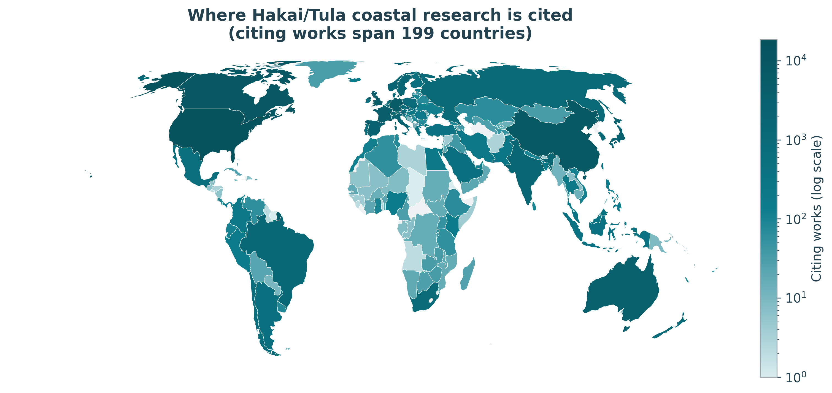 Every shaded country has published research citing this corpus; colour is on a log scale.
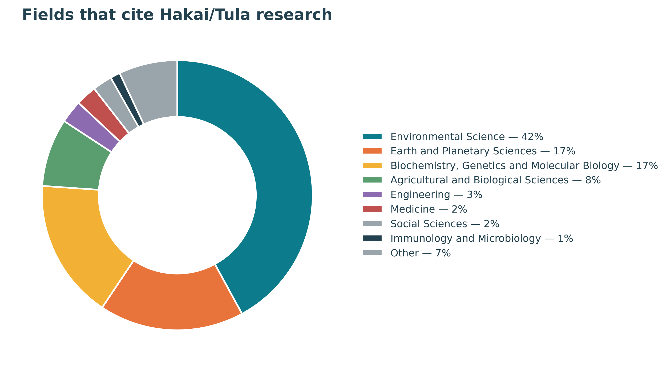
Fields that cite the work

Breaking the silos
Tula’s bet wasn’t only on papers; it was on a place where people from different organizations would work side by side. Does the data show it?
I looked at co-authorship among five BC universities (UBC, SFU, UVic, UNBC, and VIU) restricted to Hakai’s focus coastal topics (kelp and coastal plant biology, fisheries, coastal ecosystems, fish ecology, ocean acidification, marine biology, and environmental DNA). Comparing two equal 15-year windows around the field station’s 2009 opening, cross-university co-authorship links in these topics grew from 76 before (1994–2008) to 462 after (2010–2024), roughly a sixfold rise. UBC–SFU joint coastal papers alone went from 27 to 196. A rich body of research exists showing the benefits of collaboration across institutions, but institutional incentives restrict this type of collaboration. Without organizations like Tula/Hakai creating incentives for collaboration, they tend not to happen, despite the increased impact such collaborations can produce.
Crucially, that’s not just more papers. Total BC output in these topics grew ~2.7× over the same period, but collaboration links grew ~6× — so collaboration intensity (links per BC coastal paper) more than doubled, from 0.06 to 0.13. The universities didn’t only publish more; they published together more.
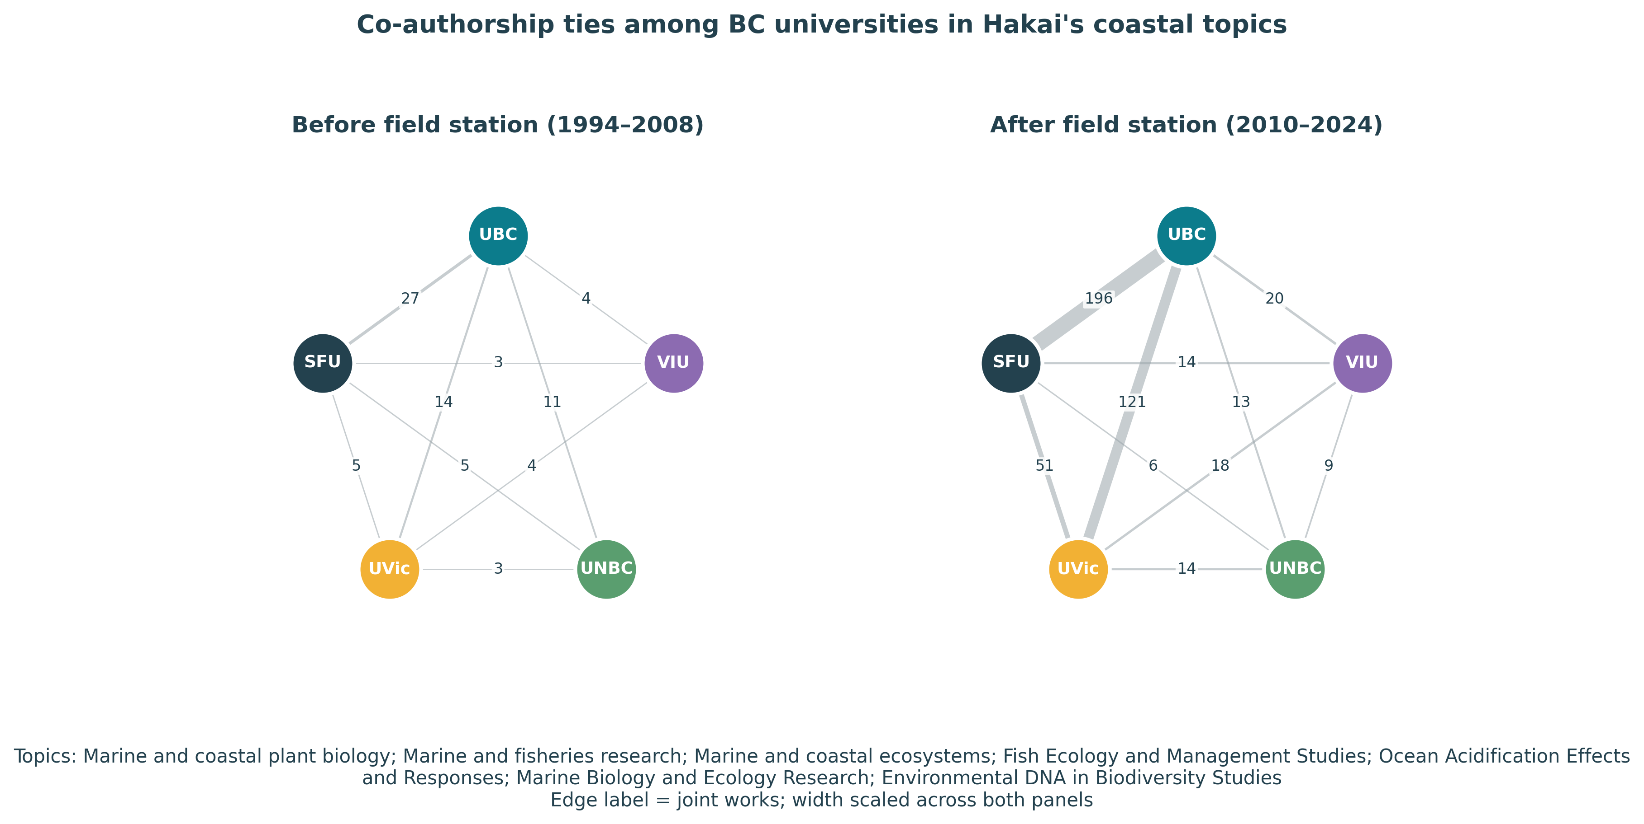 Co-authorship ties among the five BC universities in Hakai’s coastal topics (listed beneath the figure). Before the field stations (left) the universities barely co-published in this space; afterward (right) the ties thicken dramatically.

Amplifying other funders’ investments
Research rarely has a single funder. When I grouped the corpus by every funder acknowledged on each paper, I found 537 distinct co-funders beyond Tula/Hakai (excluding universities’ own internal grants):
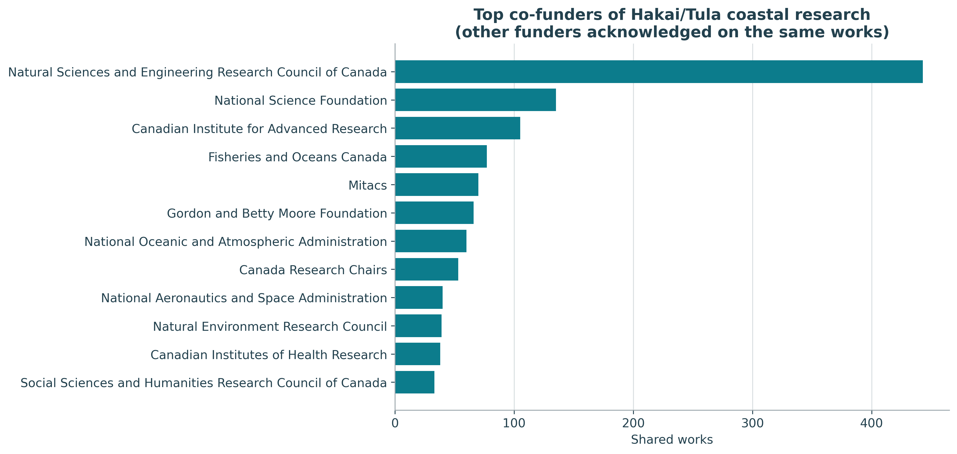
Top co-funders
Canada’s NSERC appears on 388 of these works; the US National Science Foundation on 127; CIFAR, Fisheries and Oceans Canada, and Mitacs on ~70–80 each; and a long international tail including NOAA, NASA, the UK’s NERC, the Gordon and Betty Moore Foundation, and the Pacific Salmon Foundation. (NASA is there because Hakai’s satellite-based kelp mapping leverages Landsat imagery to map coastal resources.)
These mostly aren’t formal partnerships between Tula/Hakai and, say, NSERC. They’re something quietly valuable: Tula-supported researchers, field stations, and long-term datasets enabling work that other funders also backed so that a single project advances several funders’ missions at once. A trained scientist or a decade-long dataset makes the public dollars flowing through NSERC, NSF, DFO, or NOAA reach further than they could alone. Open funding metadata lets any funder see, and show, that amplifying effect directly.

What bibliometrics can and can’t tell you
It’s tempting to look for a clean before-and-after spike when the field stations opened in 2009 and call it “Tula’s effect.” Analysis won’t support that and the reason is instructive about the method itself. BC was already a global leader in marine science (that’s what drew me here originally), and also because Tula’s impact in this space began earlier than the Hakai Institute, in the 2000s. A place-based funder embedded in an already-strong region simply cannot be cleanly isolated with this approach.
What the data can show robustly, is specialization. BC produces about 1.2% of the world’s output in Hakai’s focus topics but only ~0.3% of science overall, meaning BC is 4× more present in exactly the topics Hakai funds than in research at large, and has been since the early-grant era. BC’s annual output in these topics grew from 61 papers in 2000 to ~272 a year recently.
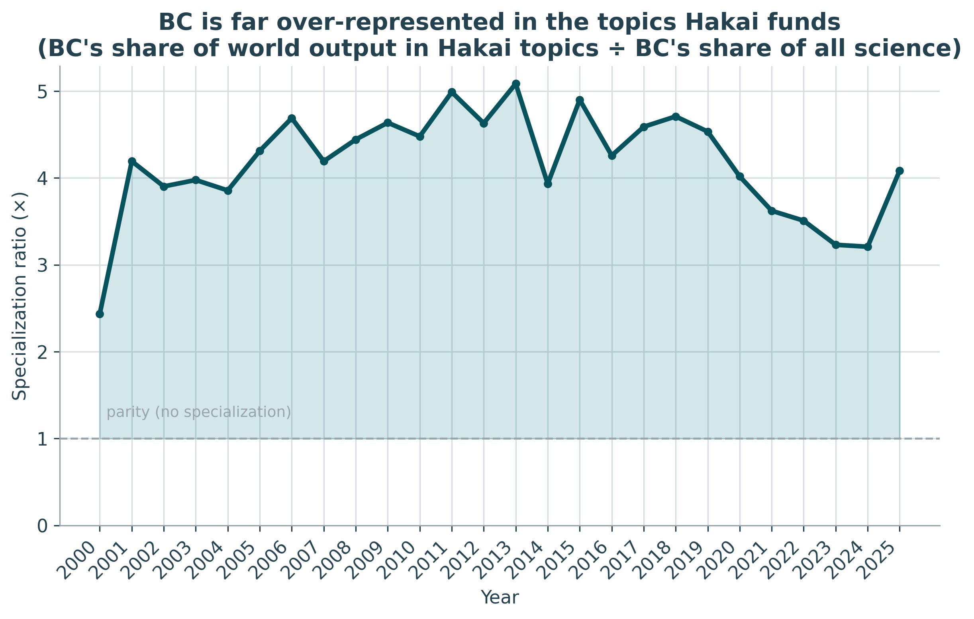 BC is consistently 4–5× over-represented in the topics Hakai funds, relative to its overall share of science.
That’s the right altitude for this kind of analysis. Bibliometrics can map a footprint and its concentration with confidence; it cannot, on its own, prove what caused it. Being clear about that line is part of using funder data well.
And these analyses are useful well beyond telling one funder’s story. The same open data lets a funder run a landscape analysis of its own portfolio; it helps funders read the broader landscape to find others with overlapping missions for large-scale collaboration; and it supports gap analyses that reveal promising areas with little funding. Open funder metadata turns work that used to be a bespoke consulting engagement or a subscription to a proprietary database into something any funder can do.

The part the bibliometrics miss
I want to be clear about the limits of everything above. The true impact of Tula’s funding is much larger than papers. The field stations supported local and First Nations economies, created jobs on the BC coast, trained leaders in coastal ecology, and underpinned Indigenous-led monitoring and stewardship. Tula also funded important work outside the scope of this analysis (like TulaSalud’s community health program in Guatemala) which were omitted here and whose true impact barely appears in the citation record at all, because that kind of impact mostly doesn’t get published in indexed journals. Bibliometrics are a shadow of the whole. I’m showing you the shadow because it’s what the data in OpenAlex and other bibliometric databases can describe, not because it’s the whole figure.

Careers, including mine
Here’s something no citation count fully captures. The Calvert Island station didn’t only produce papers, it produced people. Over the years it trained and launched a generation of coastal scientists: graduate students, postdocs, dive technicians, data managers, etc., many of whom now lead research and conservation at universities, government agencies, NGOs, and the Institute itself. Properly tracing all of those careers would be a study in its own right. Here, I’ll just say the pattern is unmistakable to anyone who knows the people. [Maybe next year, I’ll try to get a list of all the trainees and track their careers as another case study.]
The sea-otter-and-kelp question that brought me to Calvert is one small example of the through-line: it seeded a whole research lineage with 86 kelp papers (2,500+ citations) and 24 sea-otter papers in this corpus alone.
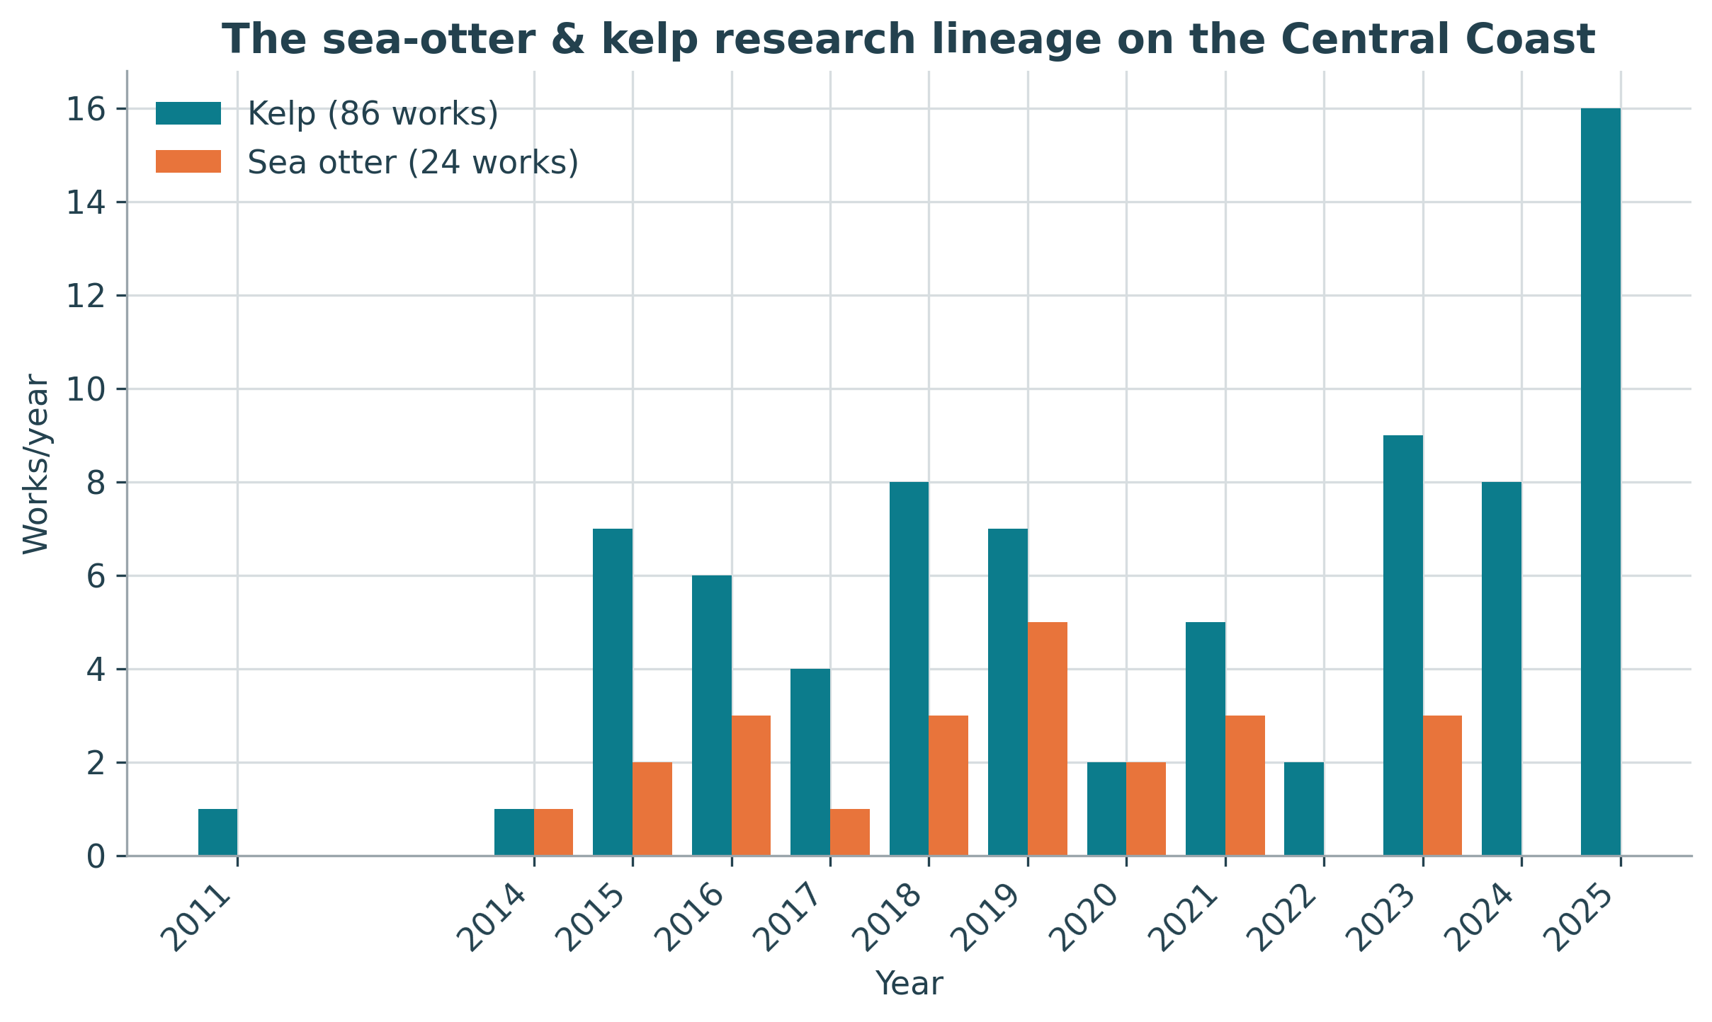
The sea-otter and kelp research lineage
And me? The crash course Eric and Christina gave me in how research actually gets supported, and how collaborations are built around missions, is the reason I’m writing this from OpenAlex instead of a faculty office. A funder’s impact includes the careers it shapes, including my own.

Why I could do this now — and an invitation
A few years ago, this study would have been a months-long manual slog of reading acknowledgements sections. Today, open funding data in OpenAlex (funder IDs, linked affiliations, full-text search, the complete citation graph, datasets, FWCI and percentiles, etc.) let me assemble, verify, and analyze a funder’s entire research footprint in a single day, with every step reproducible and every work’s provenance recorded. The scripts and data behind every number here are open.
It also showed me where the work still is: entity resolution strategies that conflate a foundation with a gene, institutions that over-match a common place name, conventions that vary across decades. That’s exactly the kind of curation this Wellcome-funded project is built to improve and where funders themselves can help, by connecting their own data.
If you’re a research funder (agency or foundation, large or small) and you’d like to understand your research footprint with open, transparent metadata, I’d love to talk. This is what open funder data makes possible, and we’re just getting started.

Methods & reproducibility
Corpus built from OpenAlex (June 2026) via nine search strategies (funder, affiliation, raw affiliation, full-text, datasets); 1,684 candidates de-duplicated and verified with an LLM plus manual review of all exclusions (170 removed), with a second pass to bring Tula’s marine microbial/protist research into the marine frame. Analysis corpus: 1,496 works — all genuine Tula/Hakai research output except clinical/behavioural papers (Medicine, Psychology, Neuroscience, Health Professions) and a couple of off-topic items, which were set aside. Trend charts run through 2025, the last reliably-indexed year; OpenAlex’s 2026 publication-year counts are still inflated by indexing lag, though the corpus totals span 2026. Citation metrics use OpenAlex FWCI and citation-normalized percentiles. Precision is the share of candidates that were genuine; recall is measured against Hakai’s public publication list (356 valid DOIs). Collaboration analysis compares two equal 15-year windows (1994–2008 vs 2010–2024) for five BC universities within Hakai’s coastal topics; co-funding groups the corpus by acknowledged funders; downstream reach aggregates citing works by country and field. The field-influence analysis is associational, not causal. All code, data, and figures are in the project repository.
Funder background drawn from the Tula Foundation and Hakai Institute, with reporting by The Globe and Mail and The Narwhal.

