Azure Solutions Document-Corti
1. Low-Level Design 1
2. Required components: 2
3. Security 3
4. Pipeline Considerations: 4
5. Backup: 5

1. Low-Level Design
- Detailed Component Design:
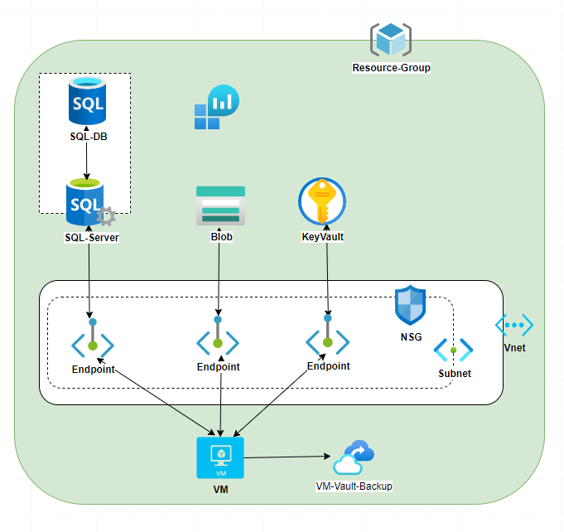

2. Required components:

Resource Type | Tier | Quantities
VM |  | 1
Blob | Standard-LRS | 1
Vnet |  | 1
Subnet |  | 1
KeyVault |  | 1
Storage Account | Standard-LRS | 1
Log Analytics workspace |  | 1
NSG |  | 1
Backup Vault | Locally redundant | 1

Vnet prefix | Vnet name | Subnet name | Subnet Prefix
10.133.100.0/24 | Vnet-dss-corti-test | snet-dss-corti-vm-test | 10.142.100.0/25
 |  | snet-dss-corti-endpoints-test | 10.142.100.128/25

ReosurcGroups: rg-dss-corti-test

3. Security
- One Vnet with two subnets for all Azure resources
- Private endpoint for each resource using Subnet (“snet-dss-corti-endpoint-test”)
- Firewall rules on the Azure SQL Server
- Allow the whole Virtual network (with two subnets) to access each Azure resource
- Save all the important information in the KeyVault (VM and SQL credentials)

Resources
- VM:
- VM communicates with SQL server using the following:
- Managed identity
- Firewall rule on the SQL server
- Network security group (inbound and outbound rules) on the subnet level
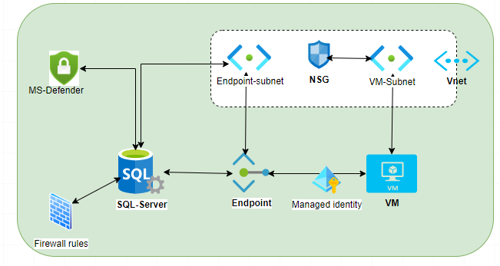

- Azure SQL database
- Private endpoint
- Firewall rules on the SQL Server level to restrict access for public IPs.
- Virtual Networks Rule to assign the Vnet/subnets that can reach to the Azure Databases
- Enable Auditing on Azure SQL Server
- Enable Microsoft Defender for SQL Server

- Storage Account
- Private Endpoint
- Firewall rules to restrict access to public IPs. and allow traffic from specified Vnet/Subnets

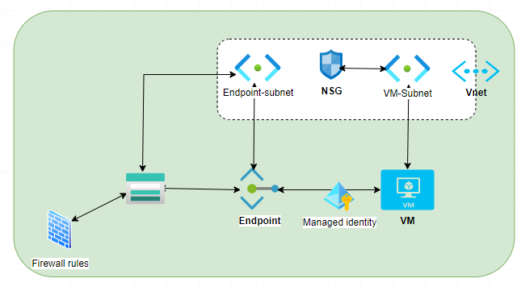
- Managed identity- System Assigned
- All communication between the resources is designed by using MI-System Assigned

- Vnet and Subnet:
One Vnet and two subnets for all resources
- Subnet for the VM
- Subnet-Endpoint for the other (SQl server, Event_Hub, Service_bus)

4. Pipeline Considerations:
- Project Name : Cori > https://dev.azure.com/dssdk/Corti
- Bicep repository: https://dev.azure.com/dssdk/Corti/_git/corti.infrastracture.bicep”
- Pipelines for Bicep deployments of all resources.
- Bicep modules for each resource, with exceptions for cases with multiple related resources (e.g., VM Storage Accounts, Azure SQL Server with databases)

5. Backup:
- Azure SQL is considered PaaS, which means backups are taken automatically.
- A VM is IaaS, so you use a Recovery Services vault to take backups based on a backup policy

