Azure Infrastructure- CprService
Project: CprService
Date: 2026-01-06

1. Low-Level Design:
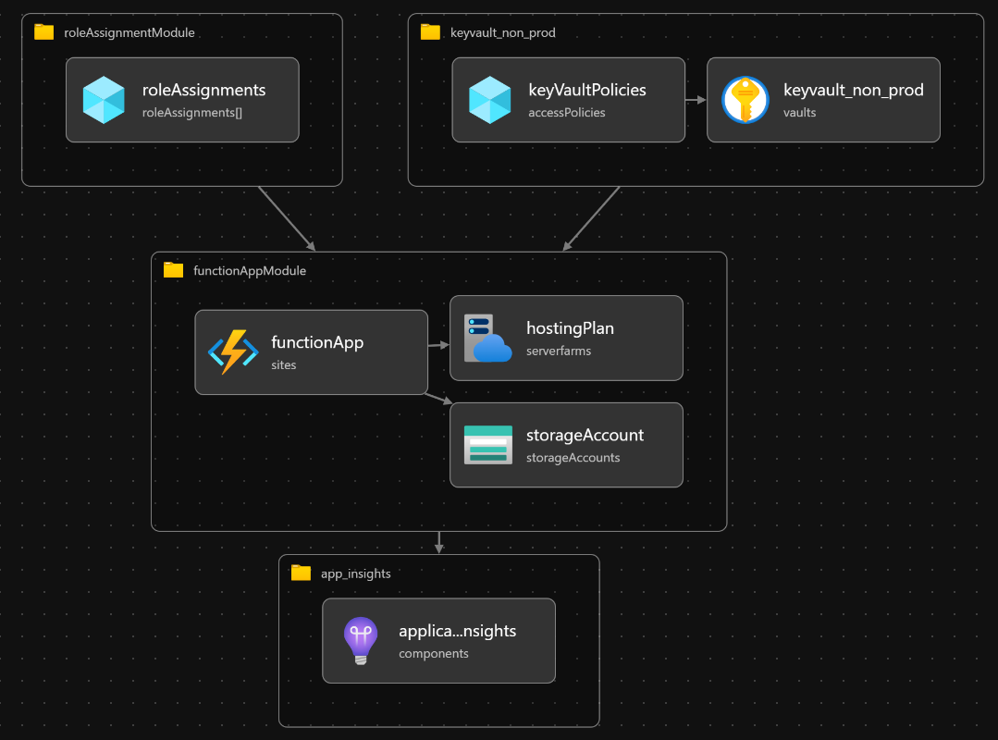

https://dev.azure.com/dssdk/Operation_Team_Bicp/_wiki/wikis/Operation_Team_Bicp.wiki/6657/CPR-Services
2. Azure Resources Inventory
2.1- Environment:
- Dev, UAT, Prod, Test

2.2- Resources:
 | Resource Type |  | Quantity | Resource Name |  |  | Resource Group
 | App Service Plan |  | 1 | asp-dss-cpr-prod |  | rg-dss-cpr-prod-001
 | Azure Function |  | 1 | func-dss-cpr-prod
 | KeyVault |  | 1 | kv-dss-cpr-prod
 | Application insights |  | 1 | ai-dss-cpr-prod
 | Storage Account |  | 1 | j2r3eq3ircdr6azfunctions
 | Log-Analytics |  | 1 | law-dss-kas-prod
 | Resource Type |  | Quantity | Resource Name |  | Resource Group
 | App Service Plan |  | 1 | asp-dss-cpr-dev |  | rg-dss-ods-dev
 | Azure Function |  | 1 | func-dss-cpr-dev
 | KeyVault |  | 1 | kv-dss-cpr-dev
 | Application insights |  | 1 | ai-dss-cpr-dev
 | Storage Account |  | 1 | hu4q6ftpeivj4azfunctions
Resource Type |  | Quantity |  |  | Resource Name | Resource Group
 | App Service Plan |  | 1 | asp-dss-cpr-uat |  | rg-dss-ods-uat
 | Azure Function |  | 1 | func-dss-cpr-uar
 | KeyVault |  | 1 | kv-dss-cpr- uat
 | Application insights |  | 1 | ai-dss-cpr- uat
 | Storage Account |  | 1 | hn3qnx2xmaz4kazfunctions
 | Log-Analytics |  | 1 | law-dss-kas-nonprod
 | Resource Type |  | Quantity | Resource Name |  | Resource Group
 | App Service Plan |  | 1 | asp-dss-cpr-test |  | rg-dss-ods-test
 | Azure Function |  | 1 | func-dss-cpr-test
 | Application insights |  | 1 | ai-dss-cpr-test
 | Storage Account |  | 1 | j2r3eq3ircdr6azfunctions
 | Log-Analytics |  | 1 | law-dss-kas-nonprod

3. Security

4. Monitoring:
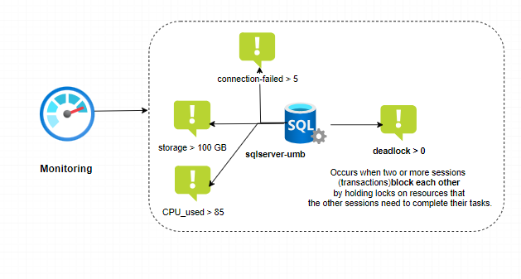
Resource Name | Alert name | Threshold
SQL Server | cpu_used | > 85
 | storage | >107374182400
 | deadlock | > 0
 | connection_failed | > 1

5. Resources Deployment/Provisioning
- Azure DevOps (Pipelines, Bicep)
- Repository-Name: ODS_Infra_Bicep
- Repo-URL: https://dev.azure.com/dssdk/ODS/_git/ODS_Infra_Bicep
6. External Developer Contact Information
- Name: Jeanette Hansen
- Role: External consultant
- Email: jeanette.hansen@ds-sundhed.dk
- Phone/Teams: +45 22177020
7. Internal Contact Information
- Name: Ousama Alnemer
- Role: Azure infrastructure specialist
- Email: Ousama.alnemer@ds-sundhed.dk
- Phone/Teams: +45 21 16 37 39

