Arab Academy for Science, Technology and Maritime Transport
CAI4702 — IoT & AI Integration
Industrial IoT Predictive Maintenance
Machine Fault Detection using Random Forest
Dataset: AI4I 2020 — 10,000 IoT Sensor Readings | Model: Random Forest + SMOTE
Accuracy: 95.86% | Fault Recall: 89% | Missed Faults: 6 / 53

1. Project Overview
This project applies machine learning to Industrial Internet of Things (IoT) data in order to predict machine failures before they occur. Using continuous sensor readings — air and process temperature, rotational speed, torque, and tool wear — a Random Forest classifier is trained to flag machines that are at risk of failure, enabling predictive rather than reactive maintenance.
The model is built on the AI4I 2020 Predictive Maintenance dataset from the UCI Machine Learning Repository, which contains 10,000 real IoT sensor readings across seven usable features. Because actual machine faults are rare (only 3.4% of records), the project also addresses the resulting class-imbalance problem using SMOTE (Synthetic Minority Over-sampling Technique).
The final model achieves 95.86% accuracy and 89% fault recall on unseen test data, missing only 6 of 53 real faults — demonstrating strong potential for real-world factory deployment.

2. Dataset — AI4I 2020 Predictive Maintenance
The dataset was sourced from the UCI Machine Learning Repository and consists of 10,000 sensor readings with 7 features used for modeling. Machine Failure is the binary target variable, present in only 3.4% of records.

Sensor Features
Feature | Unit | Role
Air Temperature | K | Sensor input
Process Temperature | K | Sensor input
Rotational Speed | RPM | Sensor input
Torque | Nm | Sensor input
Tool Wear | min | Sensor input
Machine Failure | 0 / 1 | TARGET — value to predict
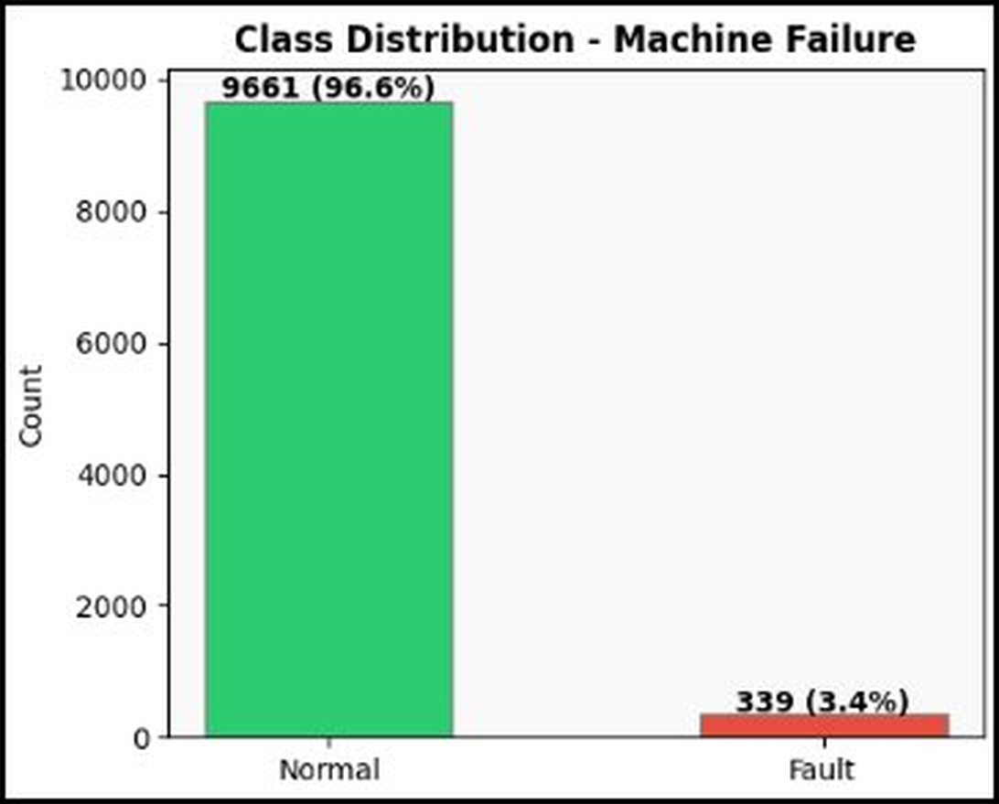
Figure 1 — Class balance of the target variable (Machine Failure)

3. Data Analysis — Outlier Detection & Distributions
Boxplots were used to inspect each sensor feature for outliers prior to modeling. Using the IQR (Interquartile Range) method, 465 outlier rows were identified and removed, leaving a clean dataset of 9,535 rows for feature engineering and model training.
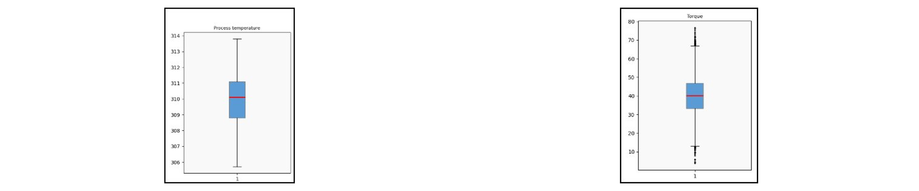
Figure 2 — Boxplots of sensor features before outlier removal
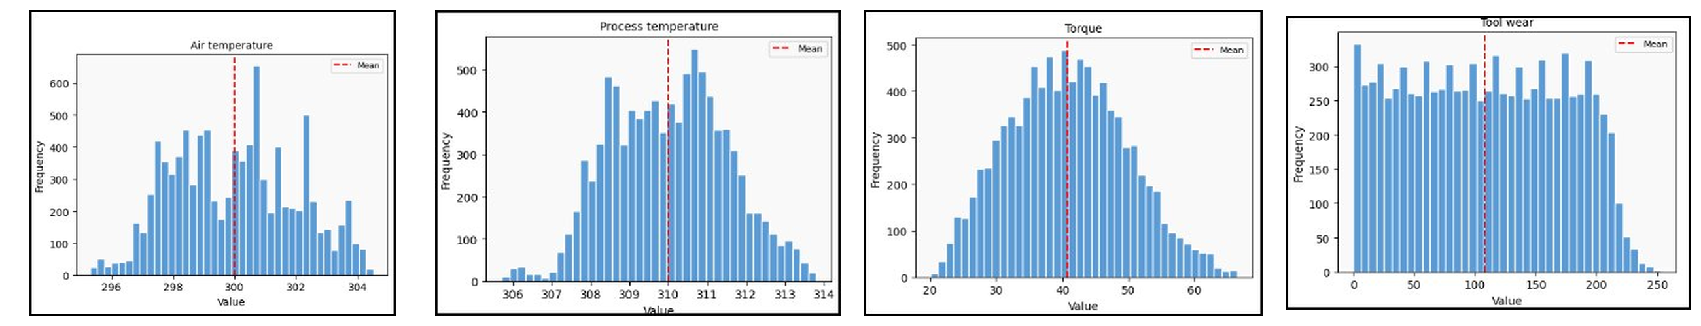
Figure 3 — Feature distributions after outlier removal (9,535 rows)

4. Correlation Heatmap — Sensor Relationships
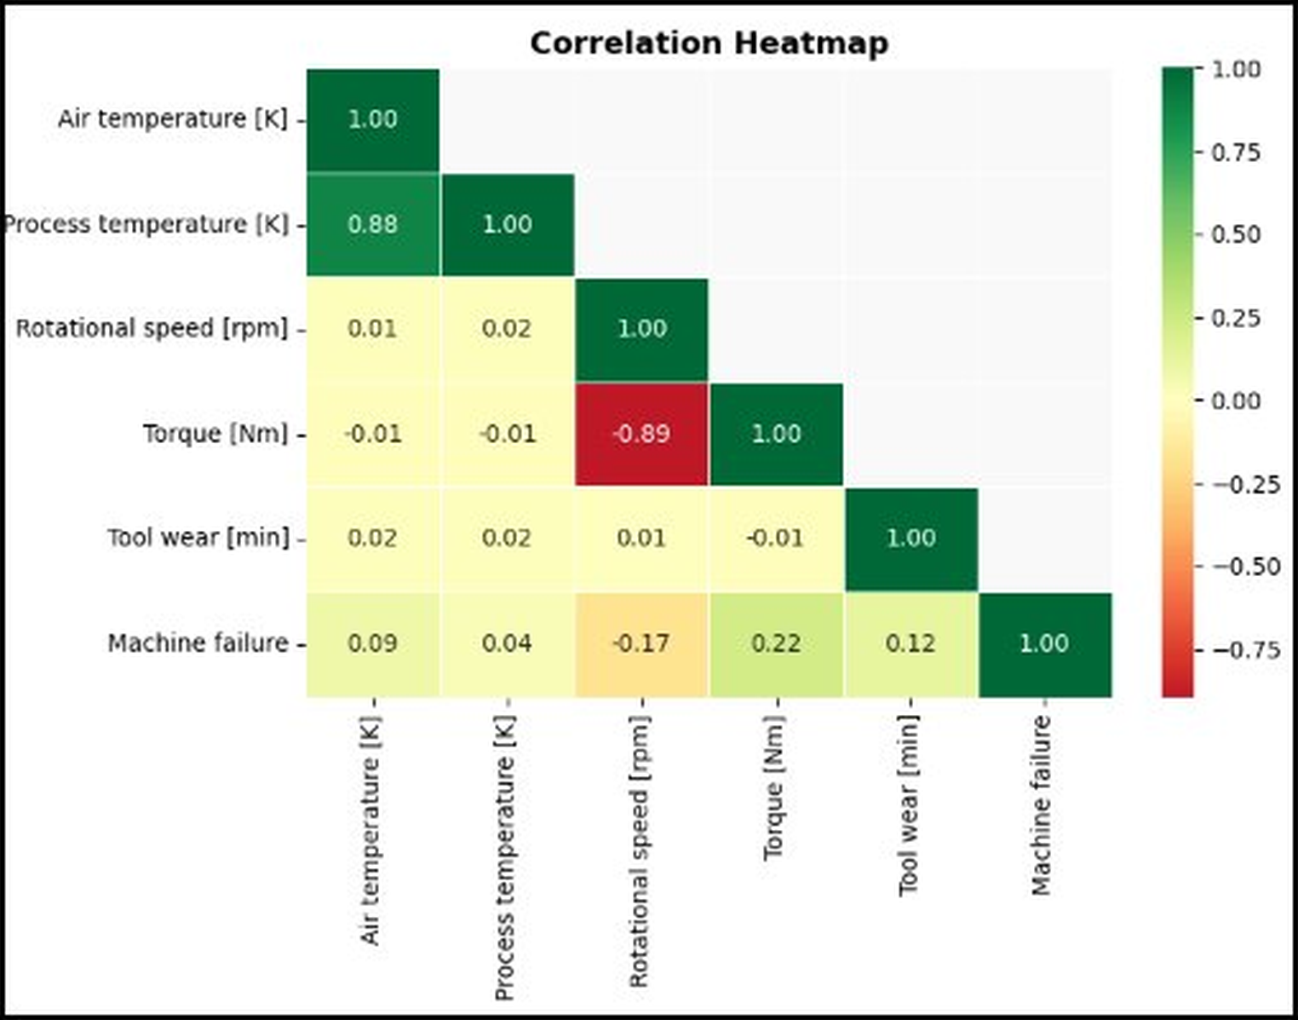
Figure 4 — Correlation heatmap of sensor features

Key Observations
- Air Temperature and Process Temperature are highly correlated (0.88).
- Torque and Rotational Speed are strongly negatively correlated (−0.89).
- Torque has the highest correlation with machine failure (+0.22).
- Rotational speed shows a negative link with failure (−0.17).
- Tool wear is also related to failure (+0.12).

5. Feature Engineering

5.1 Encode the Type Column
The categorical Type column (L / M / H, representing product quality variants) was label-encoded to numeric values 0 / 1 / 2, since machine learning models require numerical input.

5.2 Create a Power Feature
A new engineered feature, Power = Torque × RPM, was created to combine two sensor readings into a single, more meaningful signal describing mechanical load.

5.3 Feature Scaling
All features were scaled using StandardScaler so that no single feature with large numeric values would dominate the model's learning process.

5.4 Train / Test Split
The cleaned data was split into 80% training (7,628 rows) and 20% testing (1,907 rows), using stratified sampling to preserve the same fault ratio in both sets.

6. Feature Correlation with Machine Failure
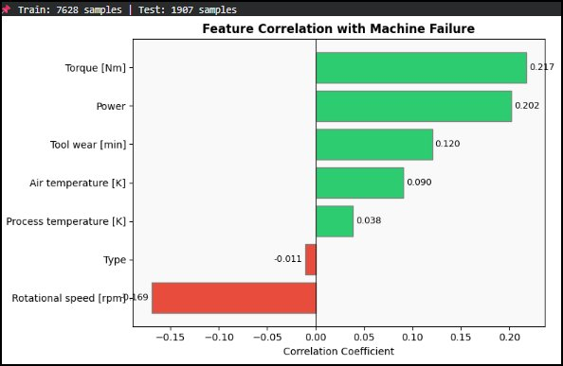
Figure 5 — Correlation of individual features with machine failure

Interpretation
- Torque (0.217) — the strongest positive signal for failure.
- Power (0.202) — the engineered feature proved highly effective.
- Tool Wear (0.120) — longer wear time increases failure likelihood.
- Air Temperature (0.090) — a moderate positive link.
- Rotational Speed (−0.169) — an inverse relationship with failure.

7. AI Model — Random Forest + SMOTE

The Class Imbalance Problem
Before balancing, the training data contained 7,418 normal readings versus only 210 fault readings — a severe imbalance that would cause a naive model to largely ignore faults. SMOTE was applied to synthetically balance the classes to 7,418 normal and 7,418 fault samples, bringing the total training set (after SMOTE) to 14,836 rows.

Why Random Forest?
- Uses 100 decision trees (n_estimators = 100).
- Maximum depth of 10 to prevent overfitting.
- Performs well on imbalanced classification tasks.
- Provides interpretable feature-importance scores.

Pipeline
Raw Data → Data Cleaning → SMOTE Balancing → Train Random Forest → Predict → Evaluate
Stage | Row Count
Total rows (after cleaning) | 9,535
Training set (80%) | 7,628
Testing set (20%) | 1,907
Training set after SMOTE | 14,836

8. Model Evaluation Results
Metric | Value
Accuracy | 95.86%
Fault Recall | 89%
Missed Faults | 6
Caught Faults | 47
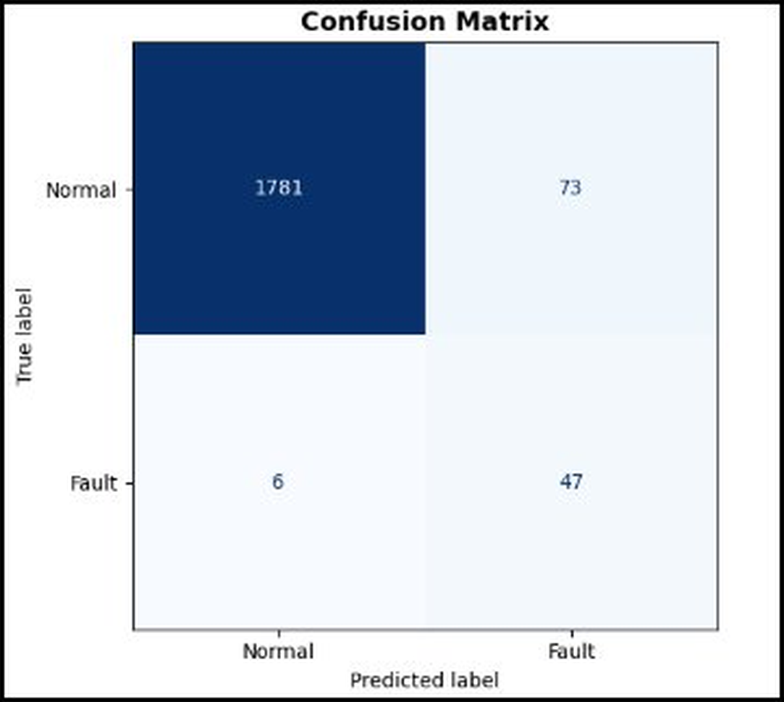
Figure 6 — Confusion matrix on the test set
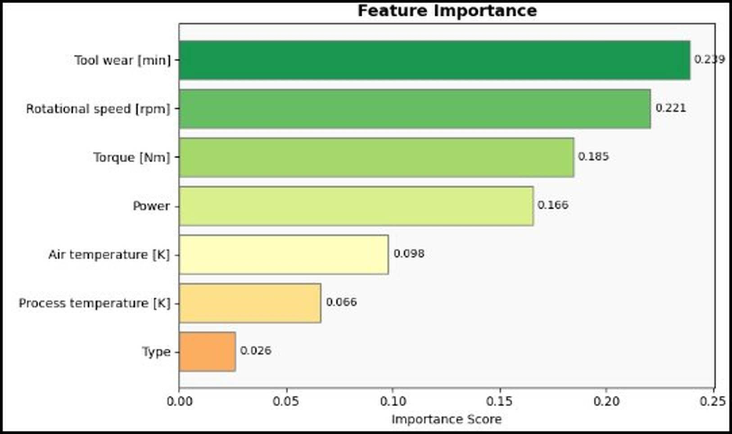
Figure 7 — Feature importance ranking from the Random Forest model

9. Key Insights

Tool Wear — #1 Predictor (0.239)
The longer a tool runs without replacement, the higher the failure risk. Factories should schedule maintenance based on tool wear time.

Rotational Speed — #2 Predictor (0.221)
Abnormal RPM is a strong fault signal; a negative correlation means unusual speed drops are dangerous.

Torque & Power (0.185 / 0.166)
High torque combined with low speed indicates machine overload. The engineered Power feature proved very useful for prediction.

Class Imbalance Challenge
Only 3.4% of the data represented faults. Without SMOTE, the model would have largely ignored faults; SMOTE balanced the classes to 50/50, allowing the model to learn fault patterns effectively.

10. Real-World Application in Factories

1. Continuous Monitoring
IoT sensors collect temperature, torque, RPM, and tool wear data every second from machines on the factory floor.

2. Early Warning System
When the model predicts a fault, an alert is sent immediately to the maintenance team before the machine breaks down.

3. Cost Savings
Unplanned downtime can cost thousands of dollars per hour. Predictive maintenance can reduce downtime by up to 50%.

4. Smart Scheduling
Rather than following fixed maintenance schedules, machines are serviced only when sensor data indicates it is actually needed.
Result: 95.86% Accuracy | 89% Fault Recall | Only 6 faults missed out of 53

11. Project Summary
- Loaded and explored 10,000 real IoT sensor readings from the UCI repository.
- Cleaned the data by removing 465 outliers using the IQR method.
- Created a Power feature (Torque × RPM) that improved model performance.
- Handled class imbalance with SMOTE, balancing 210 faults up to 7,418.
- Trained a Random Forest model achieving 95.86% accuracy on unseen test data.
- Achieved 89% fault recall — the model catches most real faults early.
- Identified Tool Wear as the #1 predictor — a key signal for maintenance scheduling.

