AI FOR INDUSTRY 4.0
Predictive Maintenance
for the Smart Factory
Technical and business report: inputs, method, how to run, outputs, results, analysis, deployment, strengths and limitations.

Item | Detail
Prepared by | Yousef Abdallah Khamis, AI and Machine Learning Engineer
Dataset | AI4I 2020 Predictive Maintenance (UCI), 10,000 records
Best model | XGBoost: F1 0.725, Recall 0.794, ROC-AUC 0.981
Business impact | 75.8% lower maintenance cost (about 31.4M EGP per year under stated assumptions)
Date | October 2026

Table of Contents

1. Executive Summary
Unplanned machine failures stop production lines and are expensive. This project builds a machine-learning system that reads sensor values from a machine (temperatures, rotational speed, torque and tool wear) and outputs a failure risk score so that maintenance can be done before the machine breaks.
Three models were trained on 10,000 records of which only 3.39% are failures. After correcting the class imbalance with SMOTE and adding five physics-based features, XGBoost gave the best balance between catching failures and avoiding false alarms.
Key number | Value | What it means
Records analysed | 10,000 | 14 raw columns, no missing values, no duplicates
Failure rate | 3.39% (339) | Highly imbalanced: about 28 healthy records per failure
Accuracy (XGBoost) | 97.95% | Share of all test machines classified correctly
Recall (XGBoost) | 79.4% | 54 of 68 real failures were caught
Precision (XGBoost) | 66.7% | Two of every three alerts are real failures
F1-score | 0.725 | Harmonic mean of precision and recall; used to pick the best model
ROC-AUC | 0.981 | Excellent separation between failing and healthy machines
Cost reduction | 75.8% | 3.40M EGP down to 0.82M EGP on the test set (assumed unit costs)

Bottom line
The system is accurate enough to justify a pilot on a real production line. Its main limits are that the data is a public synthetic dataset and the cost figures are assumptions, so both must be confirmed with plant data before any financial commitment.

2. Problem and Objectives

2.1 The problem
Reactive maintenance (repair after failure) causes sudden stoppages. Calendar-based maintenance wastes effort on healthy machines. Predictive maintenance uses data to service only machines that are likely to fail soon.

2.2 Objectives
- Predict whether a machine will fail (binary classification: Machine failure = 0 or 1).
- Handle the severe class imbalance correctly (3.39% failures).
- Explain which factors drive failures so engineers can trust and act on the output.
- Detect unusual behaviour that supervised models may miss (anomaly detection).
- Translate model quality into money (cost-benefit analysis in Egyptian pounds).
- Package the model and supporting files so it can be reused and deployed.

2.3 Success criteria
Because failures are rare, accuracy alone is misleading: a model that always predicts "no failure" would already be 96.6% accurate. The project therefore uses Recall (how many failures are caught), F1-score (balance with precision) and ROC-AUC (ranking quality) as primary measures.

3. Inputs

3.1 Data source
The AI4I 2020 Predictive Maintenance dataset from the UCI Machine Learning Repository. It is stored as archive.zip containing a single 0.50 MB file, ai4i2020.csv, with 10,000 rows and 14 columns. Quality checks in the notebook found 0 missing values and 0 duplicate rows.

3.2 Column dictionary
Column | Role | Description
UDI | Identifier | Row index 1 to 10,000. Dropped before modelling.
Product ID | Identifier | Product code (letter plus number). Dropped.
Type | Input | Quality variant: L (6,000), M (2,997), H (1,003). Encoded as H=0, L=1, M=2.
Air temperature [K] | Input | Ambient air temperature in kelvin (around 298 K).
Process temperature [K] | Input | Temperature of the process in kelvin (around 308 K).
Rotational speed [rpm] | Input | Spindle speed in revolutions per minute.
Torque [Nm] | Input | Torque applied, in newton-metres.
Tool wear [min] | Input | Minutes of use accumulated by the cutting tool.
Machine failure | Target | 1 if the machine failed, else 0. The value the model predicts.
TWF | Label detail | Tool Wear Failure: 46 cases (0.46%).
HDF | Label detail | Heat Dissipation Failure: 115 cases (1.15%).
PWF | Label detail | Power Failure: 95 cases (0.95%).
OSF | Label detail | Overstrain Failure: 98 cases (0.98%).
RNF | Label detail | Random Failure: 19 cases (0.19%).

Why TWF, HDF, PWF, OSF and RNF are not used as inputs
They describe how a failure happened, so using them to predict failure would leak the answer into the model. The notebook correctly excludes them from the 11 model features. The five mode counts add up to 373, more than the 339 failures, which means some failures have more than one cause.

3.3 Target distribution
Of 10,000 machines, 9,661 (96.61%) are healthy and 339 (3.39%) failed. This imbalance is the central technical challenge of the project.
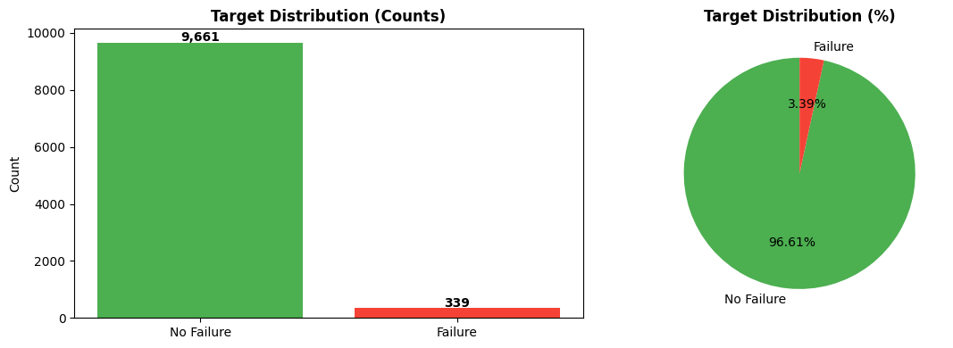
Figure 1. Target distribution: counts and percentages
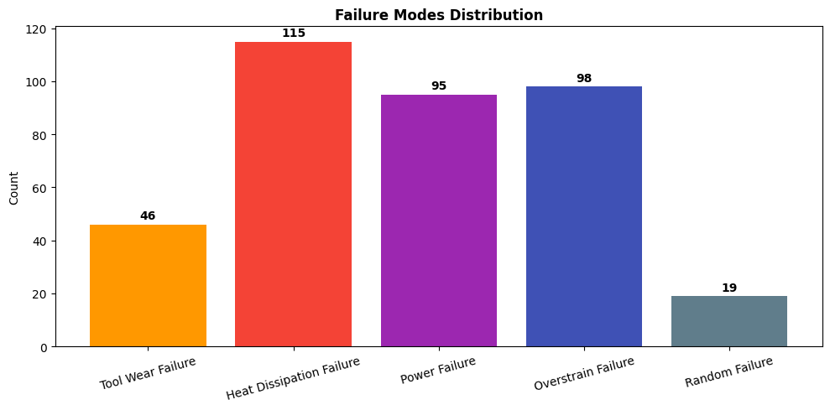
Figure 2. Failure modes distribution

3.4 Failure rate by product type
Type | Records | Failures | Failure rate
L (low quality) | 6,000 | 235 | 3.92%
M (medium) | 2,997 | 83 | 2.77%
H (high) | 1,003 | 21 | 2.09%
Lower-quality products fail more often, but the Type column on its own has almost no linear relation with failure (correlation -0.005 after encoding).

3.5 Correlation analysis
Raw feature | Correlation with failure | Reading
Torque [Nm] | +0.191 | Strongest raw signal; higher torque, more failures
Tool wear [min] | +0.105 | More wear, more failures
Air temperature [K] | +0.083 | Weak
Rotational speed [rpm] | -0.044 | Weak; lower speed slightly riskier
Process temperature [K] | +0.036 | Very weak
All raw correlations are below 0.20. Failures therefore come from combinations of variables (for example high torque together with high wear), which a simple linear model cannot capture. This motivates both feature engineering and tree-based models.
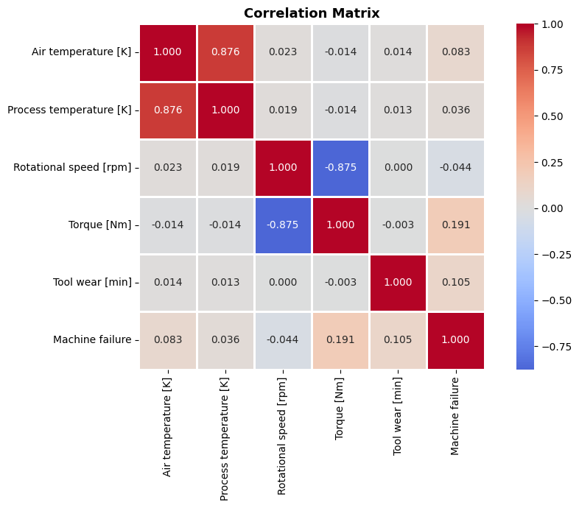
Figure 3. Correlation matrix of the numeric variables

4. Methodology

4.1 Notebook structure, cell by cell
Cell | Purpose | What it does
1 | Mount Drive and search | Connects Google Drive and looks for CSV/Excel files; finds none because the data is zipped.
2 | Unzip data | Lists archive.zip, extracts ai4i2020.csv to /content/dataset.
3 | Load and inspect | Loads the CSV, prints shape, types, missing values, duplicates and first rows.
4 | Target analysis | Class balance, failure modes, product-type distribution, with charts.
5 | Correlation and EDA | Correlation matrix, histograms and box plots by class, failure rate by type.
6 | Feature engineering | Creates 5 physics features and encodes Type; compares correlations.
7 | Prepare, SMOTE, train | Stratified split, scaling, SMOTE, trains 3 models, compares metrics and ROC curves.
8 | Deep evaluation | Confusion matrices, classification report, feature importance, SHAP explanations.
9 | Anomaly detection and business impact | Isolation Forest, cost-benefit analysis, annual projection, real-time warning demo.
10 | Save outputs | Saves model, scaler, JSON files, README and a downloadable zip.

4.2 Feature engineering
Five features were derived from basic physics so that the model can see relationships that the raw columns hide. A sixth change encodes the product type as a number.
Feature | Formula | Why it matters
Temp_Difference | Process temp - Air temp | Proxy for cooling efficiency; a small gap means heat is not leaving the process
Power_W | Torque x RPM x 2pi / 60 | Mechanical power in watts; very low or very high power stresses the machine
Tool_Stress | Tool wear x Torque | A worn tool under heavy torque is at risk of overstrain
Wear_per_RPM | Tool wear / (RPM + 1) | Wear relative to speed; the +1 avoids division by zero
Thermal_Load | Temp_Difference x Power_W | Combines heat build-up with the power being delivered
Type_Encoded | H=0, L=1, M=2 | Makes the product type numeric for the models

Observation
Individually the new features do not beat the best raw correlation (Tool_Stress 0.190 against Torque 0.191), yet three of them rank in the SHAP top five. Their value is in interaction, not in single-variable correlation. These formulas also resemble the physical failure conditions described in the UCI dataset documentation (heat dissipation, power range and overstrain), which is a plausible reason they help; this is an interpretation, not something the notebook tested.
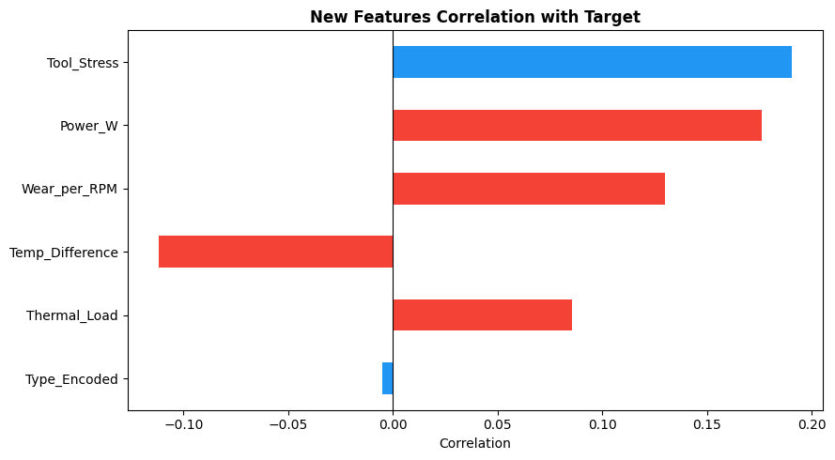
Figure 4. Correlation of the new features with failure

4.3 Splitting, scaling and SMOTE
- Split: 80% train (8,000 rows, 271 failures) and 20% test (2,000 rows, 68 failures), stratified so both keep the same failure rate; random_state 42.
- Scaling: StandardScaler fitted on the training set only, then applied to the test set, which avoids information leaking from test to train.
- SMOTE: creates synthetic failure examples by interpolating between real neighbours. Applied only to the training set, growing it from 8,000 to 15,458 rows with 7,729 failures per balanced class. The test set stays untouched and realistic.

4.4 Models trained
Model | Settings | Role
Logistic Regression | max_iter 2000 | Simple linear baseline
Random Forest | 200 trees, max_depth 15, n_jobs -1 | Strong non-linear ensemble of decision trees
XGBoost | 200 trees, max_depth 6, learning_rate 0.1, logloss | Gradient boosting; fast and accurate on tabular data
Isolation Forest | 100 trees, contamination 0.05, trained on healthy rows only | Unsupervised anomaly detector

4.5 Evaluation metrics explained
Metric | Meaning | Why it matters here
Accuracy | Correct predictions / all predictions | Misleading when 96.6% of cases are healthy
Precision | Real failures / all alerts raised | Low precision means many false alarms and wasted inspections
Recall | Real failures caught / all real failures | Low recall means missed failures, the most expensive error
F1-score | Harmonic mean of precision and recall | Single number used to choose the best model
ROC-AUC | Probability that a random failure is ranked above a random healthy case | Threshold-independent quality of the risk score

4.6 Explainability with SHAP
SHAP assigns every feature a contribution to each prediction. Averaging the absolute contributions gives a global ranking of drivers, and the beeswarm plot shows whether high or low values push the risk up or down. This lets engineers verify that the model relies on sensible variables.

4.7 Cost-benefit model
Unit costs are assumptions that the company should replace with its own figures:
Item | Assumed cost | Applied to
Unplanned failure (line stoppage) | 50,000 EGP | Every real failure without AI; every missed failure with AI (FN)
Preventive maintenance | 2,000 EGP | Every correctly predicted failure (TP)
False alarm inspection | 500 EGP | Every false positive (FP)
Without AI cost = (TP + FN) x 50,000. With AI cost = TP x 2,000 + FN x 50,000 + FP x 500. The annual figure multiplies the test-set result by 365 / 30, which assumes the 2,000-row test set represents one month of operation.

5. How to Run

5.1 Prerequisites
- A Google account with Google Drive and access to Google Colab (CPU runtime is enough).
- The file archive.zip containing ai4i2020.csv, placed directly in My Drive.
- Python libraries: pandas, numpy, matplotlib, seaborn, scikit-learn, imbalanced-learn, xgboost, shap, joblib (fastapi and uvicorn are listed for later deployment).

5.2 Step-by-step
- Upload archive.zip to the root of Google Drive (MyDrive).
- Open the notebook in Google Colab.
- Run cell 1 and approve the Drive permission prompt.
- Run cell 2 to unzip; confirm that /content/dataset/ai4i2020.csv is listed.
- Run cells 3 to 6 for inspection, exploration and feature engineering.
- Run cell 7 to split, apply SMOTE and train the three models (about 8 seconds in total).
- Run cells 8 and 9 for evaluation, SHAP, anomaly detection and business analysis.
- Run cell 10 to save everything and download predictive_maintenance_project.zip.

5.3 Observed run time
Model | Training time
Logistic Regression | 0.18 s
Random Forest | 7.69 s
XGBoost | 0.55 s

5.4 Troubleshooting
Problem | Fix
Cell 1 finds no CSV or Excel file | Expected: the data is inside archive.zip. Continue to cell 2.
FileNotFoundError for archive.zip | Check that the zip is in MyDrive root, or edit zip_path in cell 2.
ImportError for xgboost or shap | The notebook installs them automatically; otherwise run pip install xgboost shap.
Results differ slightly | Library versions can change results; random_state 42 is set for repeatability. The warning-system demo uses unseeded random samples, so its rows change on each run.
Drive mount fails | Re-run with drive.mount("/content/drive", force_remount=True).

6. Outputs

6.1 Files produced by cell 10
File | Size | Content and use
xgboost_model.pkl | 439.5 KB | The trained XGBoost classifier; load with joblib for scoring.
scaler.pkl | 1.3 KB | The fitted StandardScaler; must be applied to new data before the model.
features.json | 0.2 KB | The ordered list of the 11 input features.
results.json | 0.6 KB | Metrics of all three models.
summary.json | 0.7 KB | Best model, F1, recall, ROC-AUC, savings percent, annual savings, top features, timestamp.
requirements.txt | 0.1 KB | Python dependencies.
README.md | 2.7 KB | Ready-to-publish project description.
predictive_maintenance_project.zip | - | All files above in one download.

6.2 Analytical outputs
- Dataset diagnostics: shape, types, missing values and duplicates.
- Charts: target distribution, failure modes, correlation, feature distributions, box plots, ROC curves, confusion matrices, feature importance, SHAP plots, cost comparison.
- Model comparison table with Accuracy, Precision, Recall, F1, ROC-AUC and training time.
- Business results: cost with and without AI, savings percent, annual projection.
- A per-sample risk score between 0 and 1.

6.3 Real-time warning logic
For each machine reading the model returns a failure probability. If the probability is above 0.5 the status is ALERT, otherwise OK. In the notebook demo, ten random test samples were all healthy and all received risk scores between 0.000 and 0.012, correctly marked OK.
Sample | Actual | Risk score | Status
354 | OK | 0.006 | OK
663 | OK | 0.000 | OK
569 | OK | 0.012 | OK
1903 | OK | 0.006 | OK
The demo happened to contain no real failures, so it shows correct behaviour on healthy machines only; the failure-detection ability is measured by the test-set results in section 7.

7. Results

7.1 Model comparison (test set, 2,000 rows)
Model | Accuracy | Precision | Recall | F1 | ROC-AUC
Logistic Regression | 0.8645 | 0.1838 | 0.8676 | 0.3033 | 0.9360
Random Forest | 0.9745 | 0.5859 | 0.8529 | 0.6946 | 0.9855
XGBoost (selected) | 0.9795 | 0.6667 | 0.7941 | 0.7248 | 0.9809
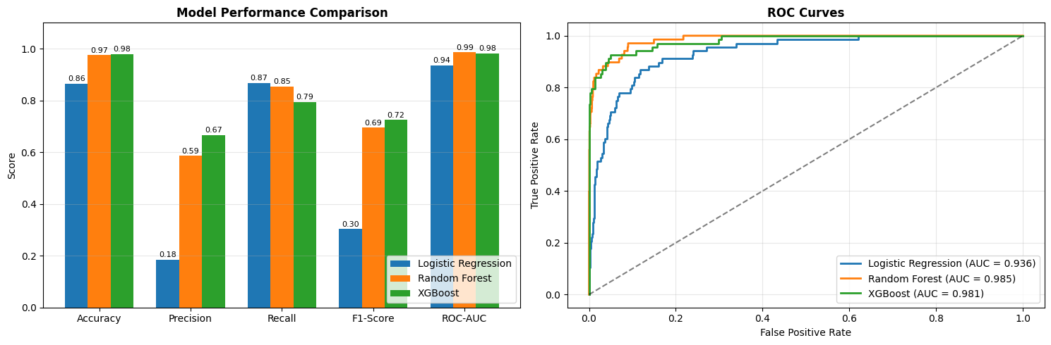
Figure 5. Metric comparison and ROC curves

7.2 Confusion matrix of the selected model
 | Predicted healthy | Predicted failure
Actually healthy (1,932) | 1,905 (TN) | 27 (FP)
Actually failed (68) | 14 (FN) | 54 (TP)
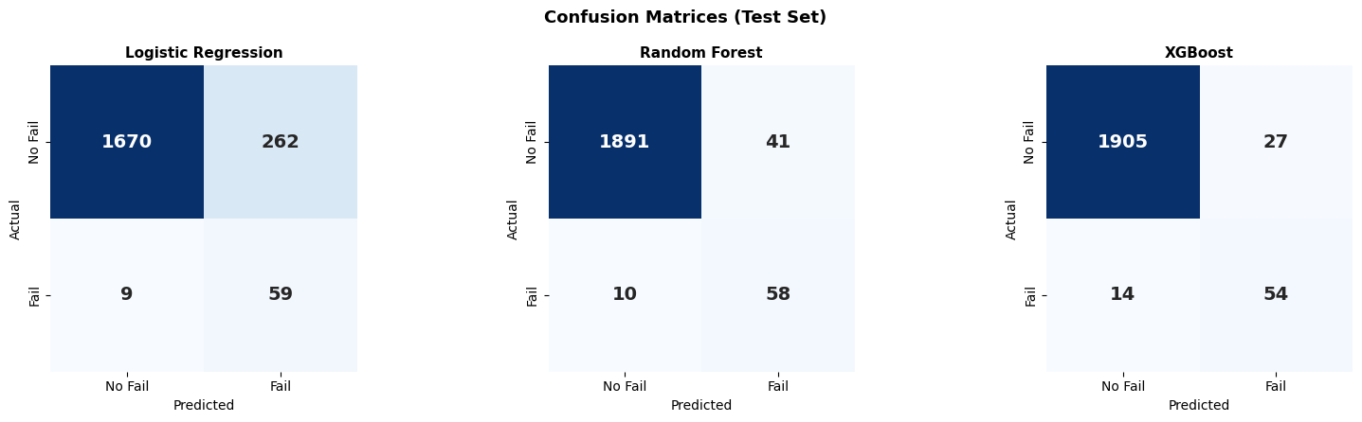
Figure 6. Confusion matrices of the three models

7.3 Classification report (XGBoost)
Class | Precision | Recall | F1 | Support
No failure | 0.99 | 0.99 | 0.99 | 1,932
Failure | 0.67 | 0.79 | 0.72 | 68
Accuracy |  |  | 0.98 | 2,000
Macro average | 0.83 | 0.89 | 0.86 | 2,000

7.4 Feature importance and SHAP
Rank | Feature | Mean |SHAP|
1 | Tool wear [min] | 1.5546
2 | Rotational speed [rpm] | 1.3240
3 | Power_W (engineered) | 1.0915
4 | Temp_Difference (engineered) | 0.8898
5 | Tool_Stress (engineered) | 0.6527
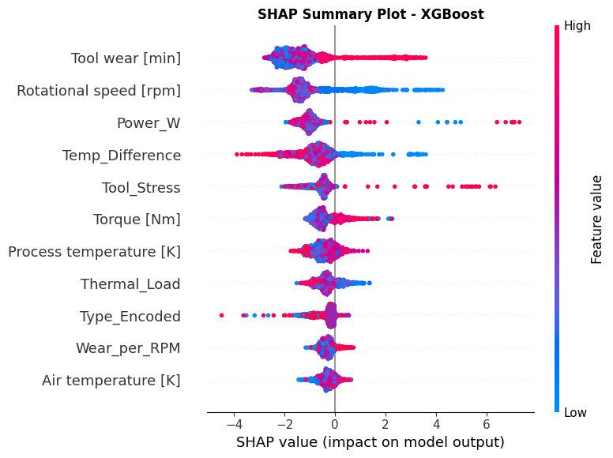
Figure 7. SHAP summary plot (XGBoost)
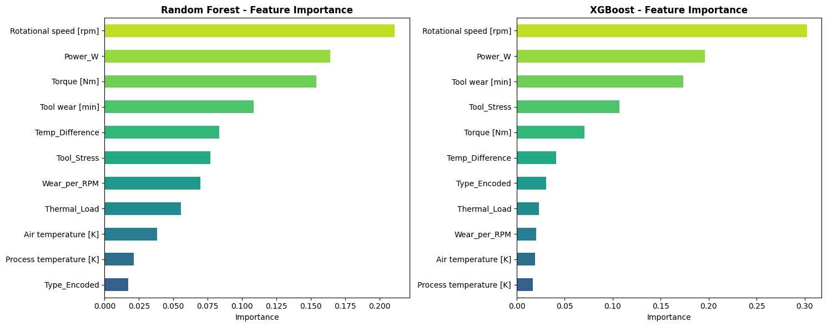
Figure 8. Feature importance: Random Forest and XGBoost

7.5 Anomaly detection (Isolation Forest)
 | Actual healthy | Actual failure
Predicted normal | 1,846 | 34
Predicted anomaly | 86 | 34
It flagged 120 of 2,000 samples (6.0%) and caught 34 of the 68 real failures (50%), with 86 false alarms.

7.6 Business results
Scenario | Test set (2,000) | Projected per year
Without AI (reactive) | 3,400,000 EGP | 41,366,666 EGP
With AI (predictive) | 821,500 EGP | 9,994,916 EGP
Savings | 2,578,500 EGP (75.8%) | 31,371,750 EGP
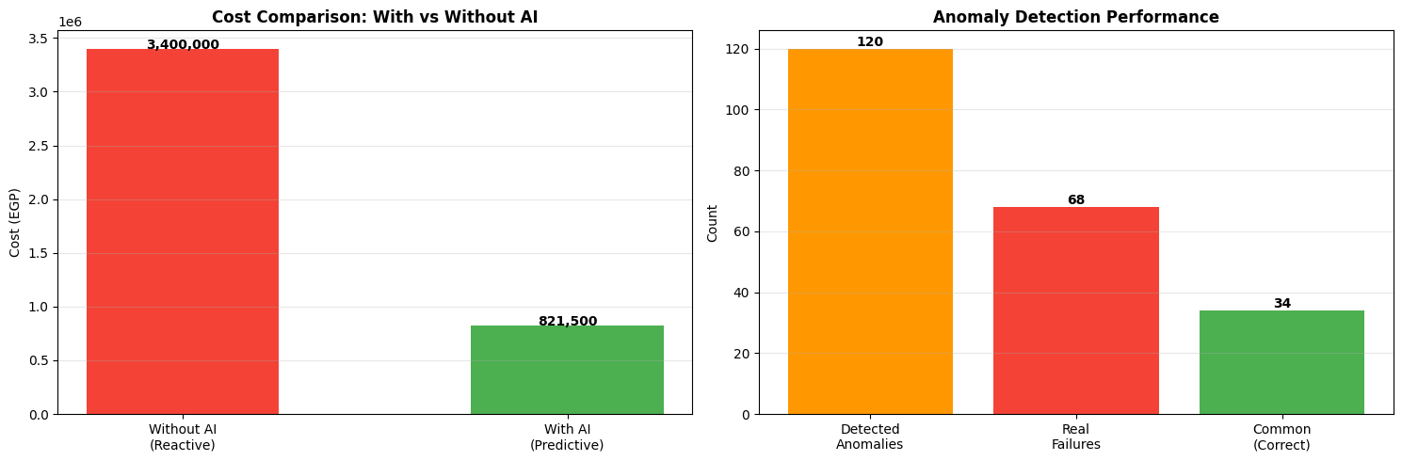
Figure 9. Cost comparison and anomaly-detection performance

8. Analysis of the Results

8.1 Why XGBoost was selected
Logistic Regression has high recall (0.87) but terrible precision (0.18): it raises more than four false alarms for every real failure, so its F1 is only 0.30. Random Forest and XGBoost are much better. Random Forest has the higher recall (0.853 against 0.794) and the higher ROC-AUC (0.9855 against 0.9809), while XGBoost has higher precision (0.667 against 0.586), higher accuracy and the best F1 (0.725). XGBoost was chosen by F1, and it also trains about 14 times faster (0.55 s against 7.69 s).
Trade-off to decide with the plant
If a missed failure is far more costly than a false alarm, Random Forest, or XGBoost with a decision threshold below 0.5, may give a better financial result even with a lower F1. The cost model in section 4.7 can be used to choose the threshold that minimises total cost. This was not done in the notebook and is the most valuable next experiment.

8.2 Error analysis
- Missed failures (14 of 68): the costly error. The cost model charges 50,000 EGP for each, a total of 700,000 EGP, which is 85% of the remaining 821,500 EGP cost with AI.
- False alarms (27 of 1,932 healthy machines, 1.4%): cheap individually (500 EGP each, 13,500 EGP in total) and acceptable for the safety they provide.
- Random failures (RNF, 19 cases) are by definition unpredictable from sensor data, which places a natural ceiling on recall.
- Roughly one alert in three is false (precision 0.67). Maintenance teams need to accept this or the threshold must be raised.

8.3 What drives failures
Tool wear is the dominant driver, followed by rotational speed. Three of the top five features are engineered ones (Power_W, Temp_Difference, Tool_Stress), confirming that interaction features add information even though their single-variable correlations were not higher than Torque. In practice this means maintenance planning should focus on tool life, operating speed and power, and the cooling margin (temperature difference).

8.4 Role of anomaly detection
Isolation Forest, trained only on healthy behaviour, found half of the failures without ever seeing a failure label. It is much weaker than XGBoost (50% recall, 28% precision: 34 of 120 flags) but may be valuable for new failure types that the labelled data does not contain. It is best used as a secondary signal, not as the main alarm.

8.5 Business interpretation
The 75.8% saving is driven mainly by avoided unplanned stoppages: 54 failures were converted from 50,000 EGP events into 2,000 EGP preventive actions. The result is sensitive to the assumed unit costs and to the one-month assumption behind the annual figure, so it should be read as an order-of-magnitude estimate until validated with real plant costs.

9. How the Solution Can Be Employed

9.1 Use cases
Use case | How the model is used
Continuous machine monitoring | Feed live sensor readings to the model every cycle; raise an ALERT when the risk score passes the threshold.
Condition-based maintenance planning | Rank machines by risk and schedule service for the highest-risk ones during planned downtime.
Tool replacement | Use the tool-wear and Tool_Stress signals to replace tools just before the risky zone.
Spare-parts planning | Forecast which parts will be needed from the number of machines at risk.
Process tuning | Use SHAP findings (speed, power, cooling margin) to adjust operating settings.
Reporting | Use summary.json and the cost model for management dashboards.

9.2 Reference architecture
- Sensors and PLC/SCADA collect the five inputs and the product type.
- A data feed (for example MQTT or OPC-UA, to be chosen by the plant) delivers readings to a scoring service.
- The scoring service (FastAPI, already listed in requirements.txt) loads scaler.pkl and xgboost_model.pkl, builds the 11 features in the order of features.json and returns a risk score.
- A dashboard and alert channel (SMS, email or the MES) show ALERT machines to maintenance staff.
- A feedback loop records what technicians found, creating new labelled data for retraining.

9.3 Illustrative scoring sketch
The following is an outline of how the saved files would be used; it is not part of the notebook and has not been run.
model = joblib.load("xgboost_model.pkl"); scaler = joblib.load("scaler.pkl")
features = json.load(open("features.json"))
X = build_features(reading)[features] # create the 5 engineered features, encode Type
risk = model.predict_proba(scaler.transform(X))[0, 1]
status = "ALERT" if risk > 0.5 else "OK"

9.4 Rollout roadmap
Phase | Activities | Exit criterion
1. Pilot | Pick one production line; score historical data offline; replace assumed costs with real ones; tune the threshold. | Recall and cost saving confirmed on real data
2. Integrate | Deploy scoring service; connect SCADA/MES; build the dashboard and alert routing. | Live alerts reach technicians reliably
3. Scale | Roll out to other lines; retrain with plant data; monitor drift and performance. | Stable KPIs across lines

9.5 KPIs to track
- Recall and precision of live alerts; number of missed failures per month.
- Unplanned downtime hours and maintenance cost versus baseline.
- Time between alert and technician action.
- Data drift: shift in the distribution of the sensor inputs.

10. Advantages and Disadvantages

10.1 Advantages
Advantage | Evidence
Early warning | Catches 54 of 68 failures (79.4% recall) on unseen data
High overall quality | Accuracy 97.95%, ROC-AUC 0.981
Handles imbalance properly | SMOTE only on training data; test set unchanged; F1 and recall used for selection
Explainable | SHAP ranks drivers and shows direction of effect
Domain-aware features | Physics-based features; three are in the top five
Fast and light | XGBoost trains in 0.55 s; model file is 440 KB
Clear business value | Cost model shows 75.8% saving under stated assumptions
Reusable package | Model, scaler, features, results, README and requirements are saved

10.2 Disadvantages and limitations
Limitation | Impact and mitigation
Public, synthetic dataset | Real machines may behave differently. Validate and retrain with plant data before relying on the numbers.
Cost figures are assumptions | Savings may be higher or lower. Replace with actual costs and re-run cell 9.
Annual projection assumes test set = 1 month | The annual figure is an extrapolation; use real throughput.
Precision 0.67 | About one in three alerts is false. Tune the threshold or add a confirmation step.
14 missed failures | Lower the threshold or use an ensemble; evaluate with the cost model.
Single train/test split, default-like hyperparameters | Estimates have uncertainty. Add cross-validation, hyperparameter search and confidence intervals.
Only 68 failures in the test set | Metrics move noticeably with a few cases; treat small differences between models with caution.
SMOTE creates synthetic samples | Can overfit to synthetic patterns; confirm with real held-out data.
Isolation Forest is weak | Use only as a secondary signal.
Static snapshot readings, no time series | Trends over time (rising temperature, wear rate) are not used and could improve prediction.

10.3 Risks and mitigations
Risk | Mitigation
Model drift as tools, products or conditions change | Monitor inputs and alerts; retrain on a schedule
Alert fatigue from false alarms | Tune threshold; prioritise by risk score
Mismatch between sensor data at training and in production | Use identical feature building and the saved scaler

11. Recommendations and Next Steps
- Run a pilot on one line using real sensor history and real maintenance costs.
- Choose the alert threshold by minimising total cost with the cost model instead of using 0.5.
- Add cross-validation, hyperparameter tuning and probability calibration.
- Evaluate additional features that use time windows (trend and rate of change).
- Wrap the model in a FastAPI service and connect it to the plant data feed.
- Define KPIs and a retraining schedule before go-live.
- Keep Isolation Forest as a secondary monitor for unseen failure types.

Appendix A. Glossary
Term | Definition
Predictive maintenance | Servicing equipment when data indicates failure is likely, rather than after failure or on a fixed calendar.
SMOTE | Synthetic Minority Over-sampling Technique: creates artificial examples of the rare class.
Class imbalance | One class is much rarer than the other (3.39% failures here).
XGBoost | Gradient-boosted decision trees; builds trees sequentially, each correcting the previous errors.
Random Forest | Many decision trees trained on random subsets; predictions are averaged.
SHAP | Method that assigns each feature a fair contribution to a prediction.
Isolation Forest | Anomaly detector that isolates unusual points with random splits.
ROC-AUC | Area under the ROC curve; 1.0 is perfect, 0.5 is random.
TP / FP / TN / FN | True/false positives and negatives of the confusion matrix.
EGP | Egyptian pound, the currency of the cost model.

Appendix B. Failure Modes
Counts come from the notebook. The short descriptions are the general meaning of each code; the exact generating rules are in the UCI dataset documentation, which should be consulted for details.
Code | Meaning | Count | Share
TWF | Tool Wear Failure | 46 | 0.46%
HDF | Heat Dissipation Failure | 115 | 1.15%
PWF | Power Failure | 95 | 0.95%
OSF | Overstrain Failure | 98 | 0.98%
RNF | Random Failure | 19 | 0.19%

