a)

In the equilibrium point,

So, z = 0 and = 0

So,

So,

b)

based on a), in the equilibrium point, , and is a positive constant,

so x = 0,

so = 0

so,

so,

so, for egio value on

so,

so,

i)

so, so it is stable

ii)

so, then it is stable

or , because

so,

so it is stable

so no matter what, it is stable.

c)

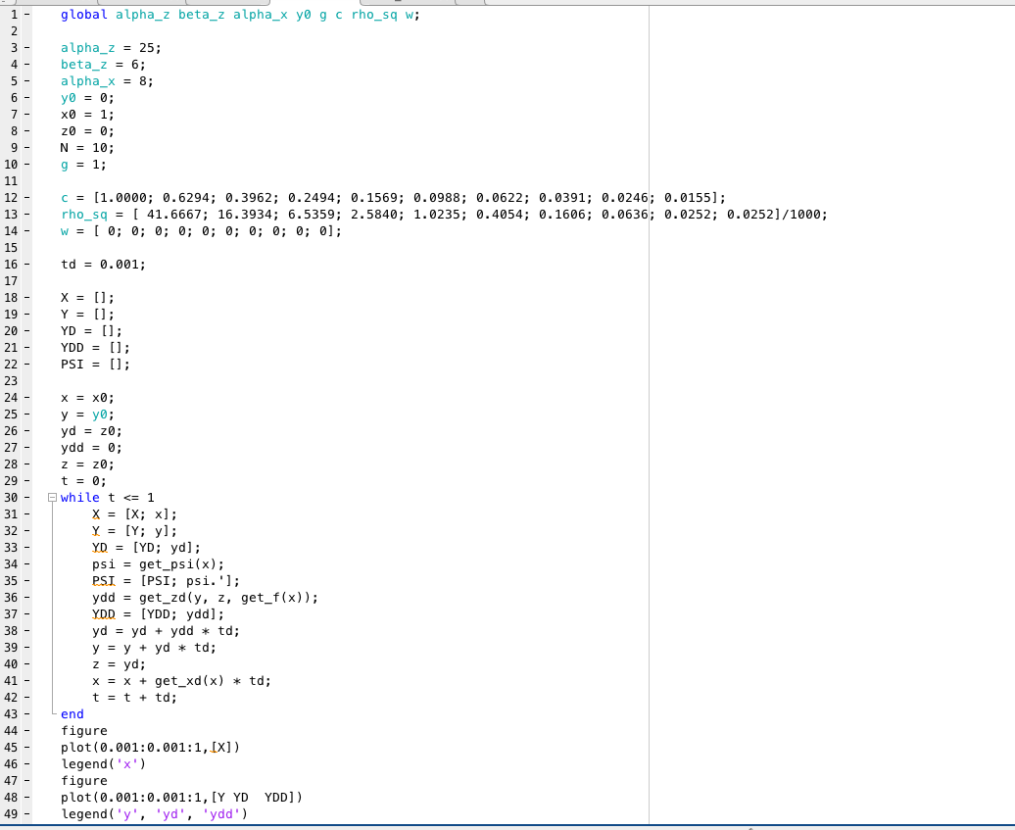

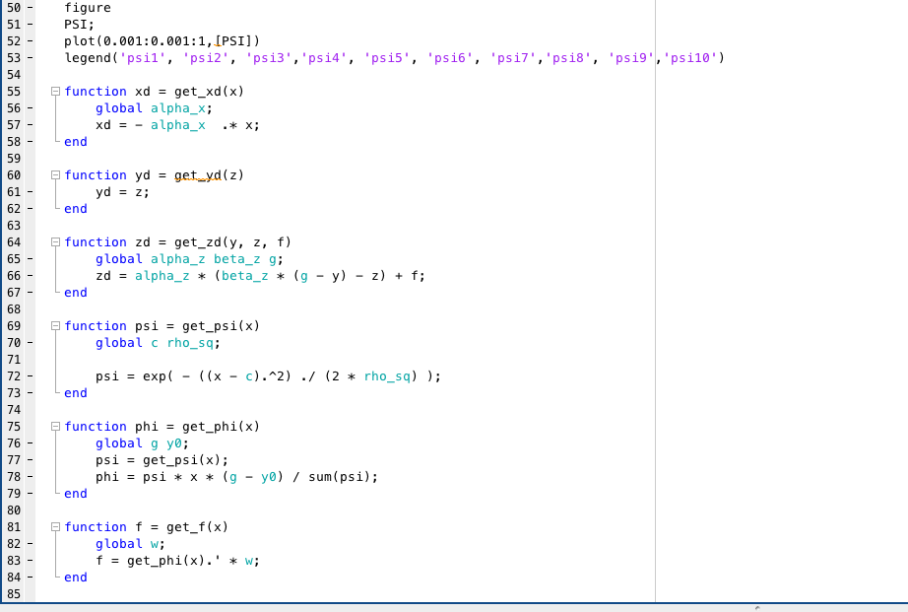

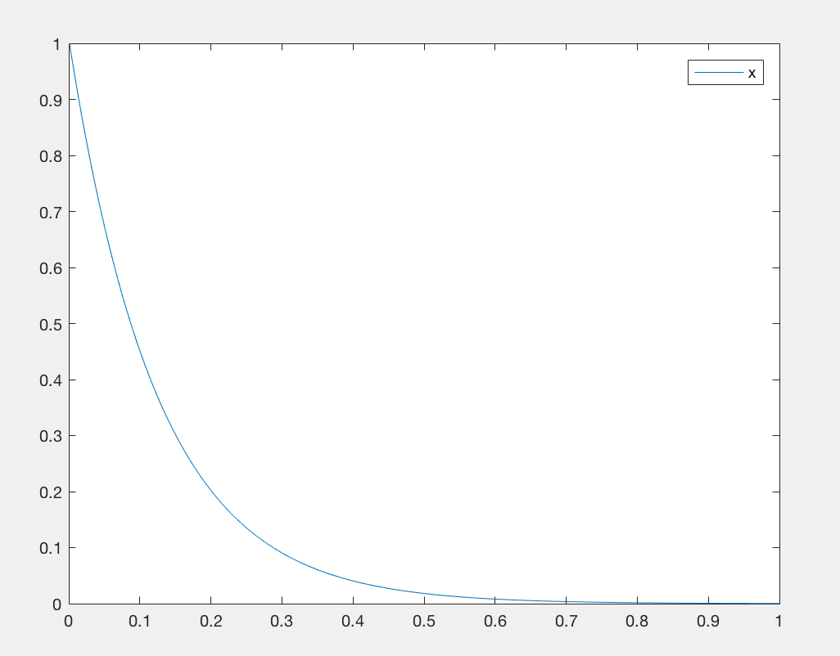

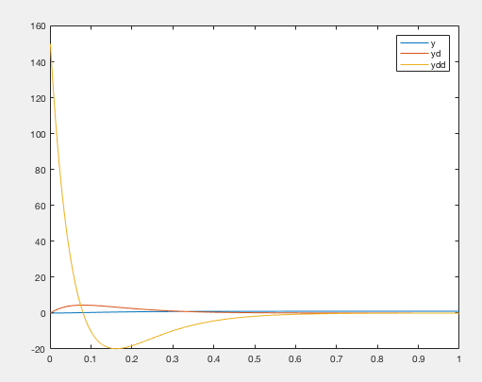

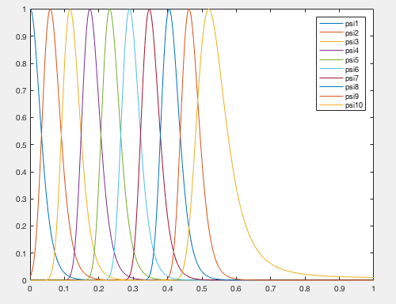

d)

w = [ 1; 200; 3; 4000; 5; 6; 70000; 8; 9; 1000];

the plot will become like this

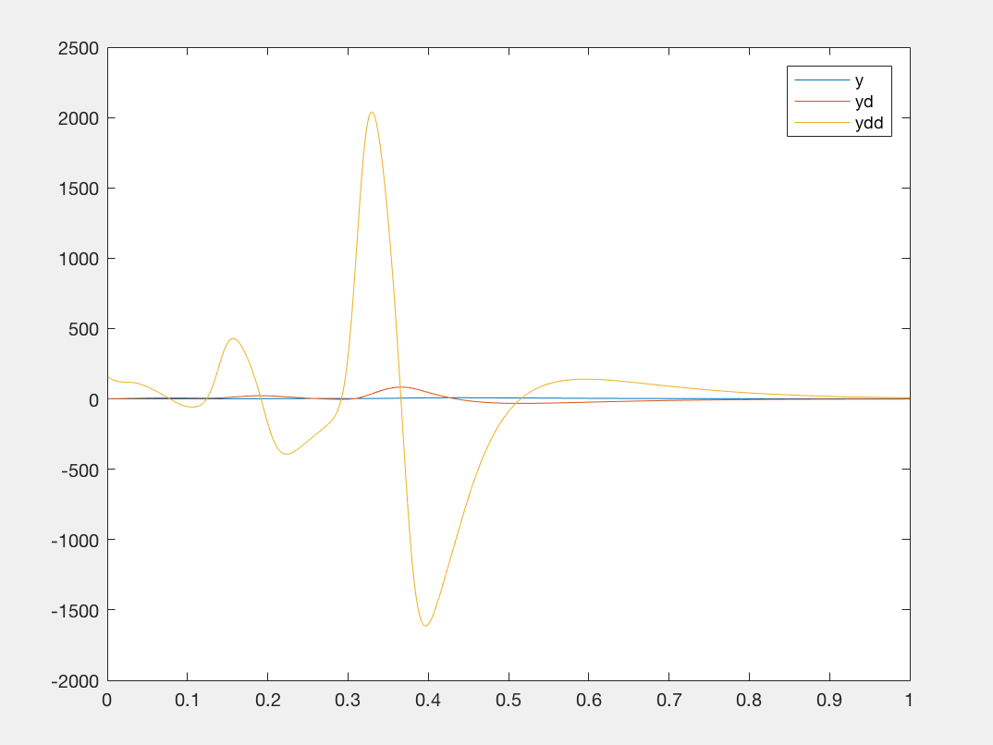

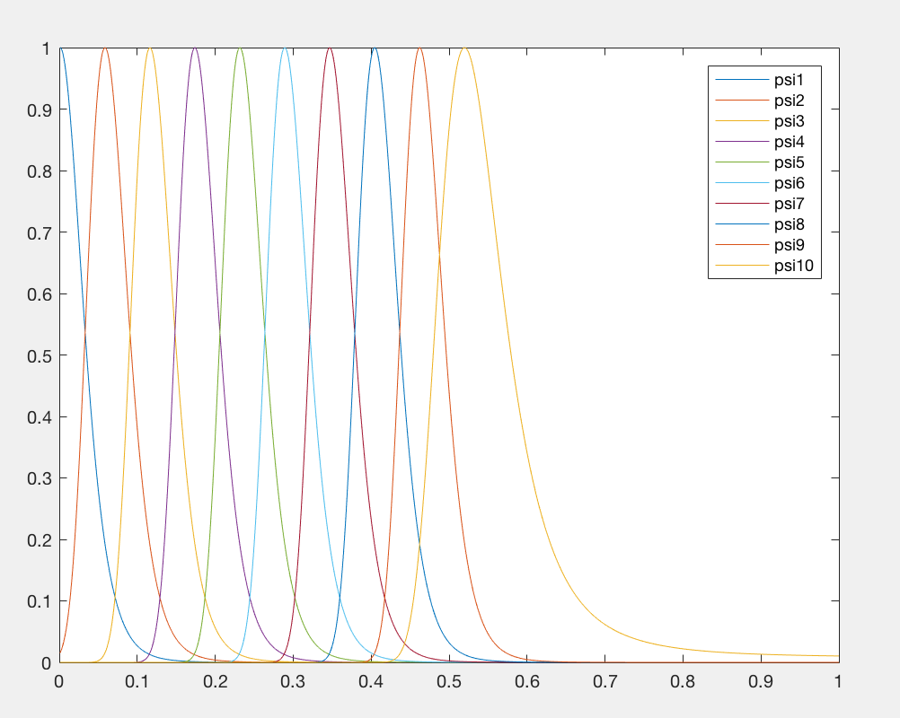

e)

Because

So,

So,

So,

So,

On the other side,

From the equition (1) ,

So, based on the imitation.data file, we can calculate the , then we can get the w.

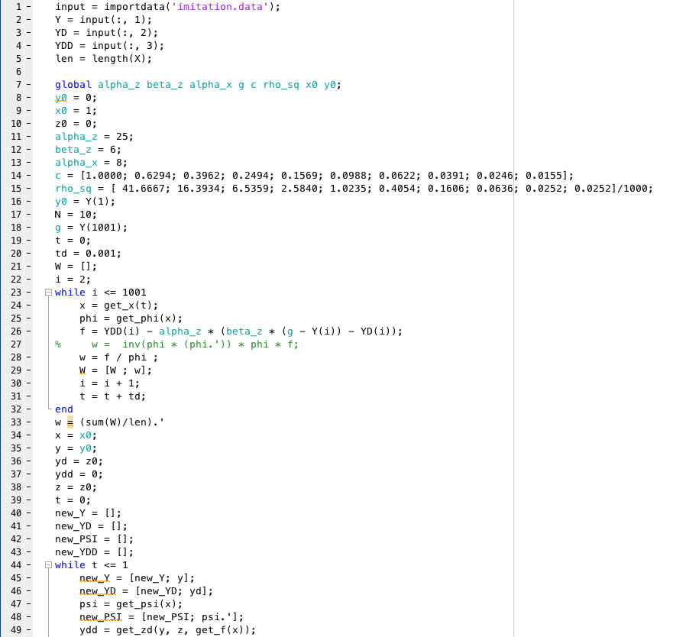

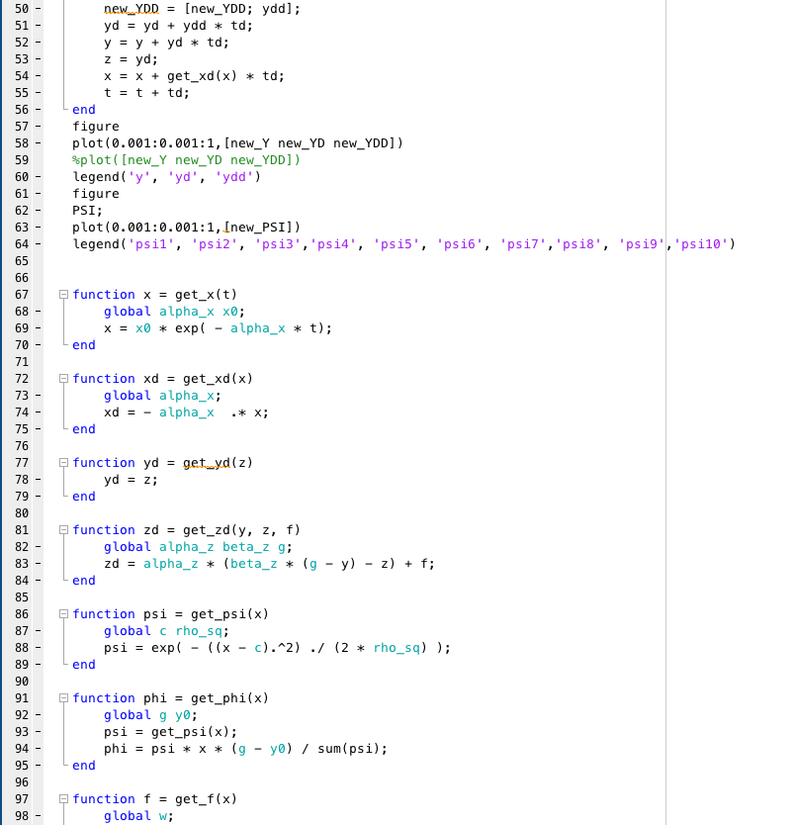



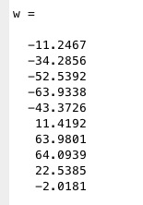

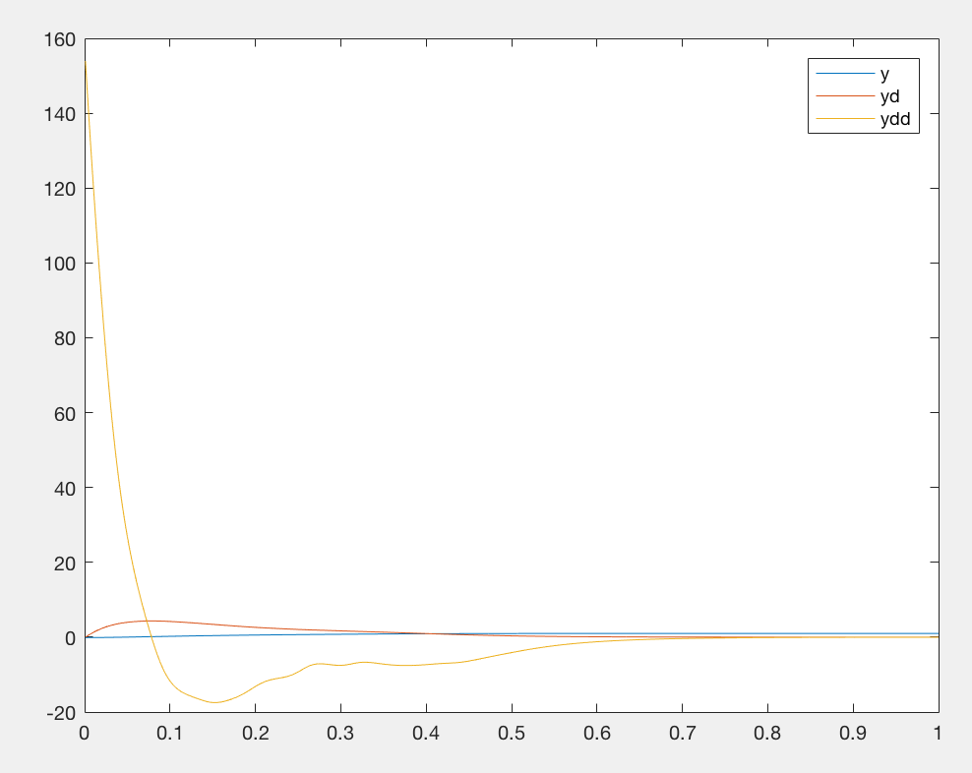

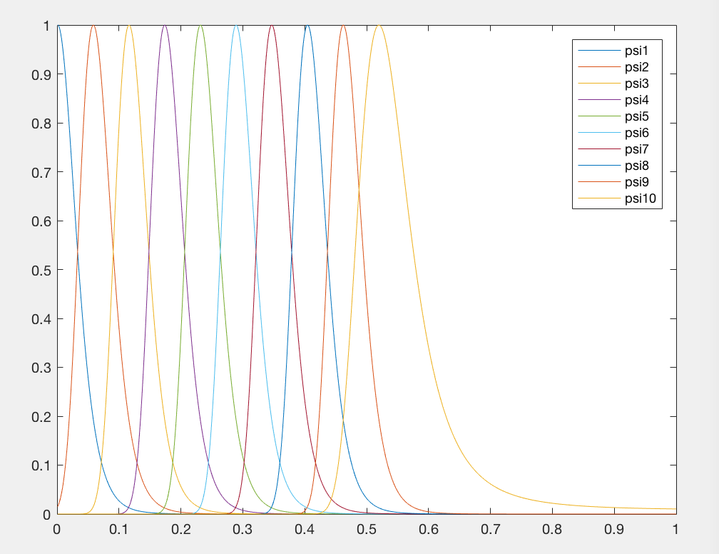

the y and yd are almost like a line, it works pretty good, and much better than before.