(a)

Use Laplace Transfer:

$$\dot{x}= \frac{α}{τ} (x_{f}-x)$$

$$s*x\left(s\right)= \frac{α}{τ}{*x}_{f}\left(s\right)- \frac{α}{τ}*x(s)$$

$$x\left(s\right)= \frac{\frac{α}{τ}}{s+ \frac{α}{τ}}*x_{f}(s)$$

$$x\left(s\right)= \frac{α}{τ*s+ α}{ * x}_{f}(s)$$

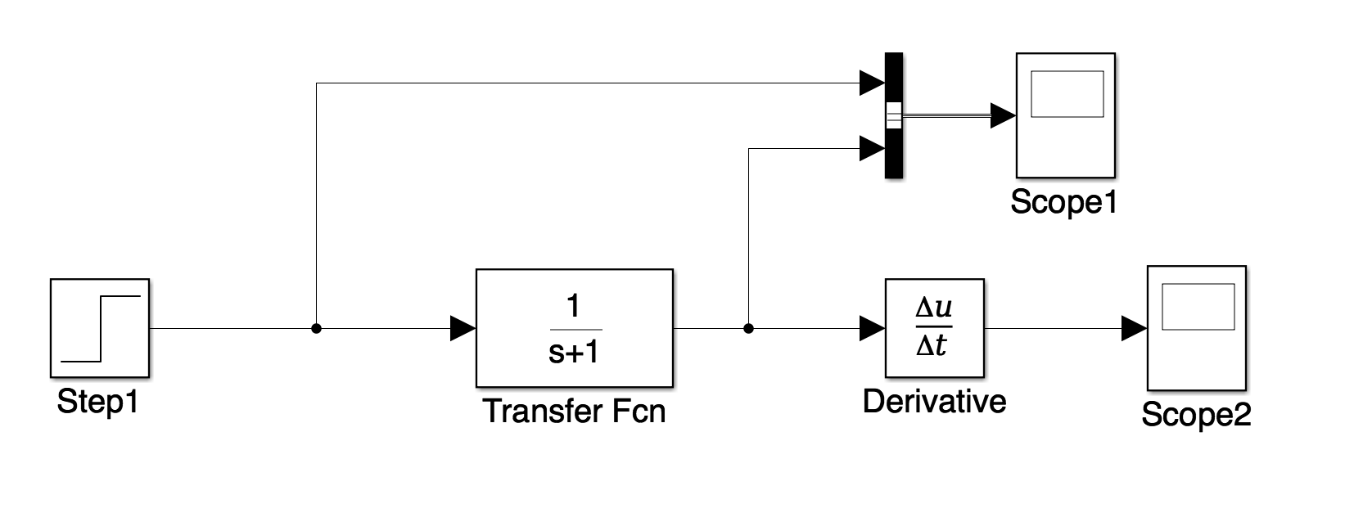

The lines from scope1:

The yellow line represents input. The blue line represents position.

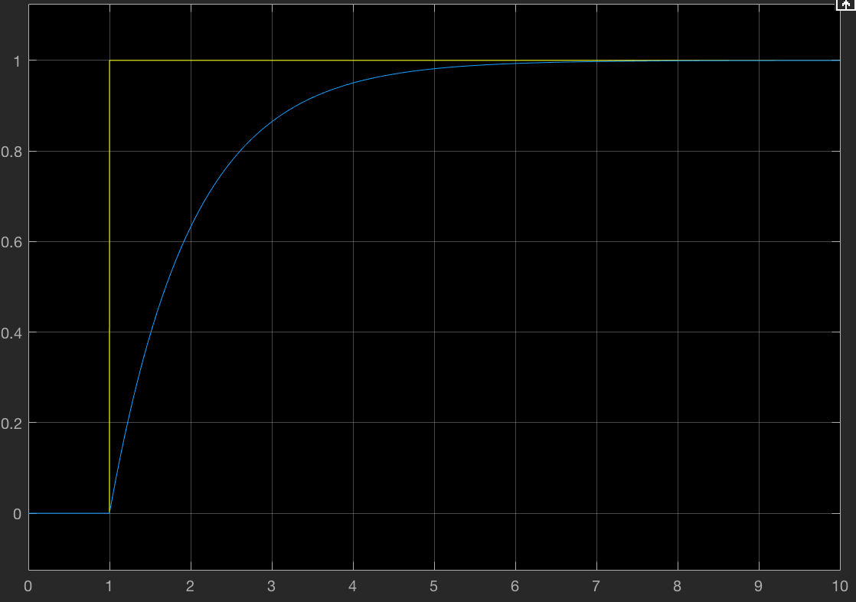

The lines from scope2:

The yellow line represents velocity.

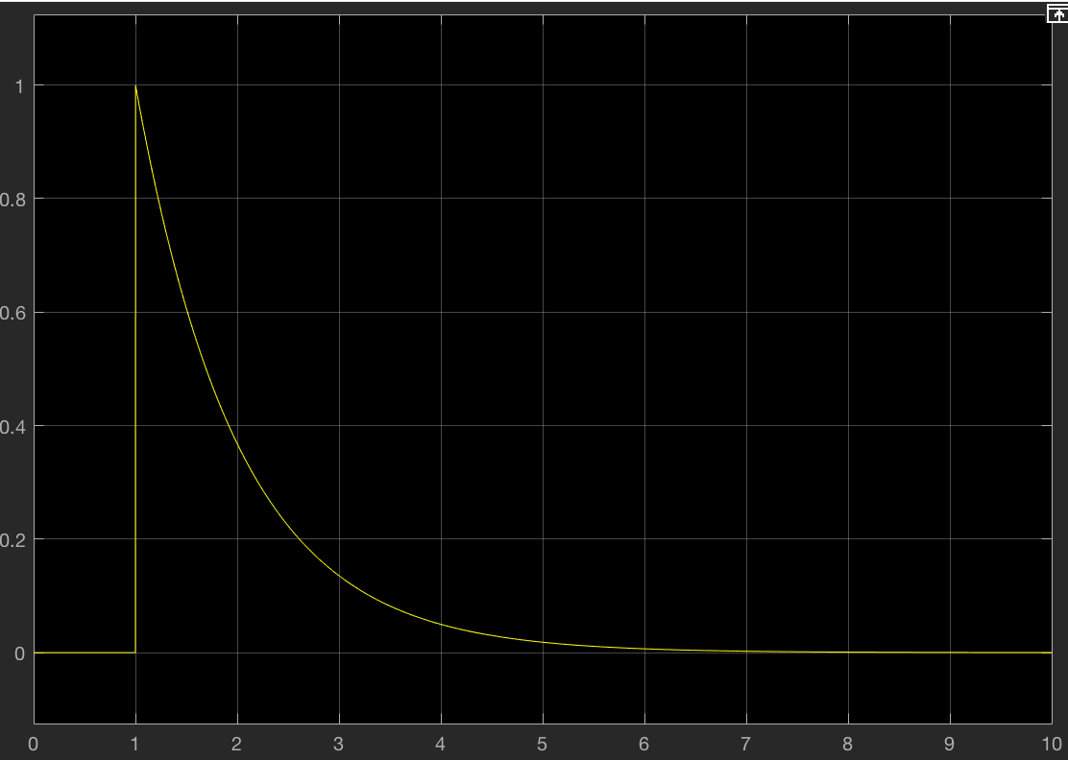

(b)

let $α=10, τ=1$

The lines from scope1:

The yellow line represents input. The blue line represents position.

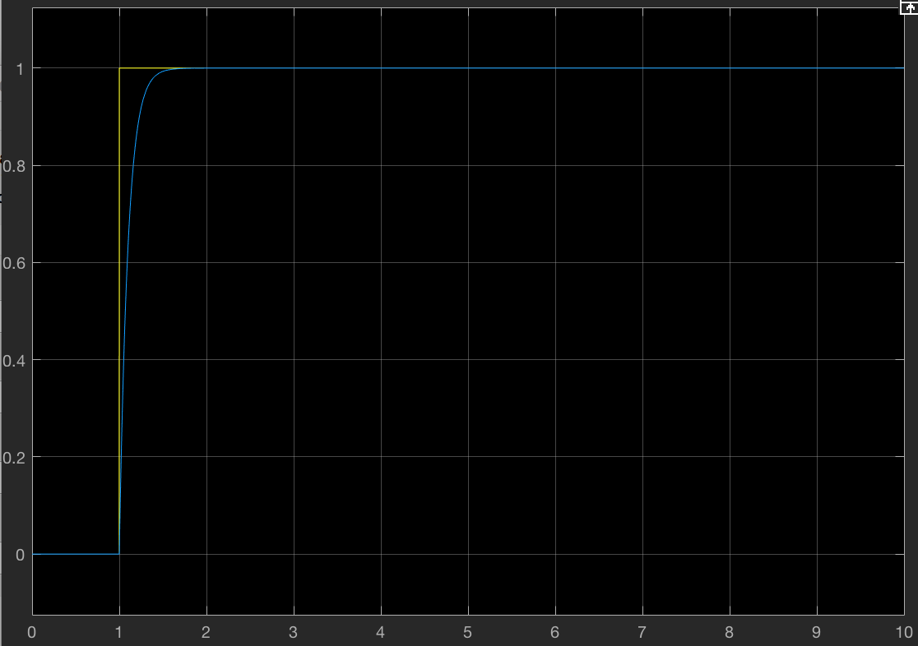

The lines from scope2:

The yellow line represents velocity.

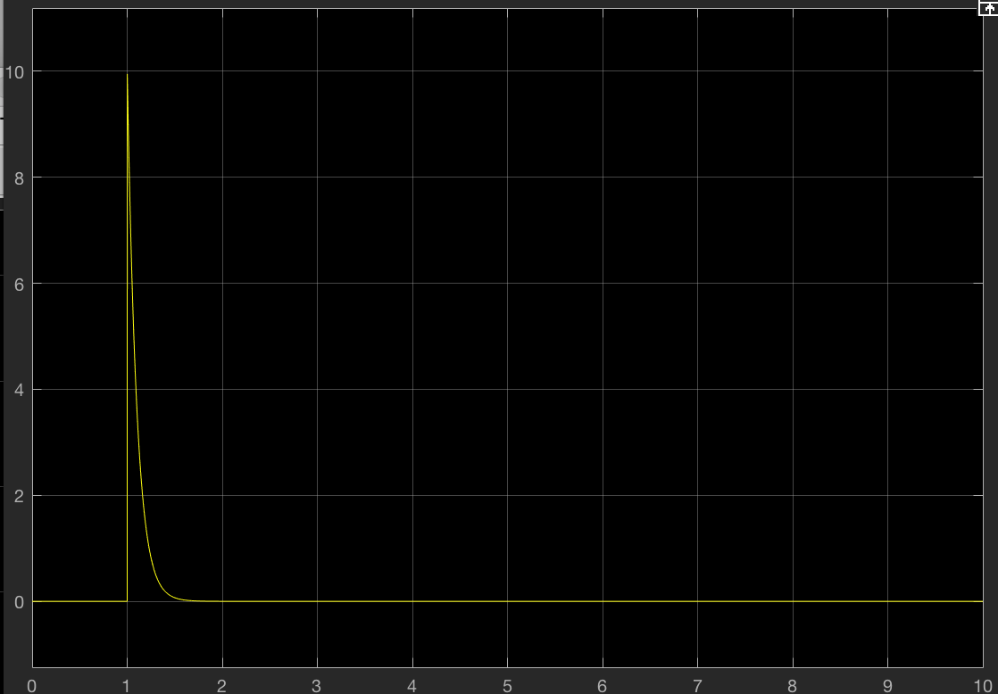

when :

The lines from scope1:

The yellow line represents input. The blue line represents position.

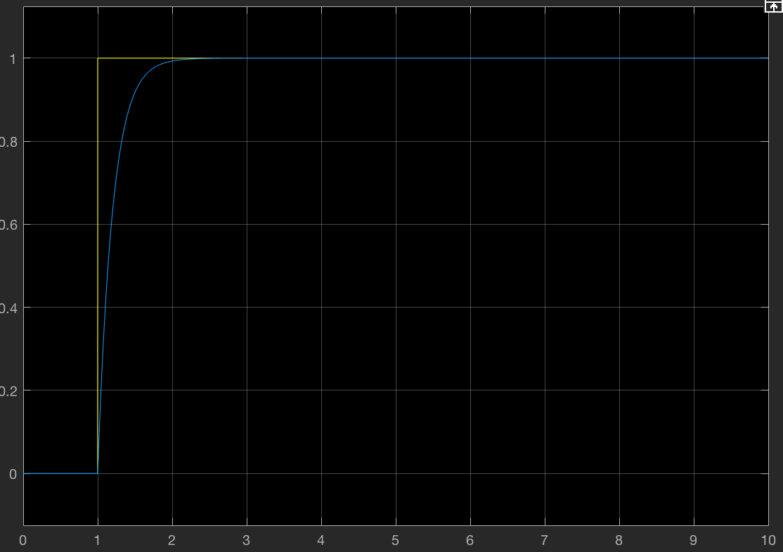

The lines from scope2:

The yellow line represents velocity.

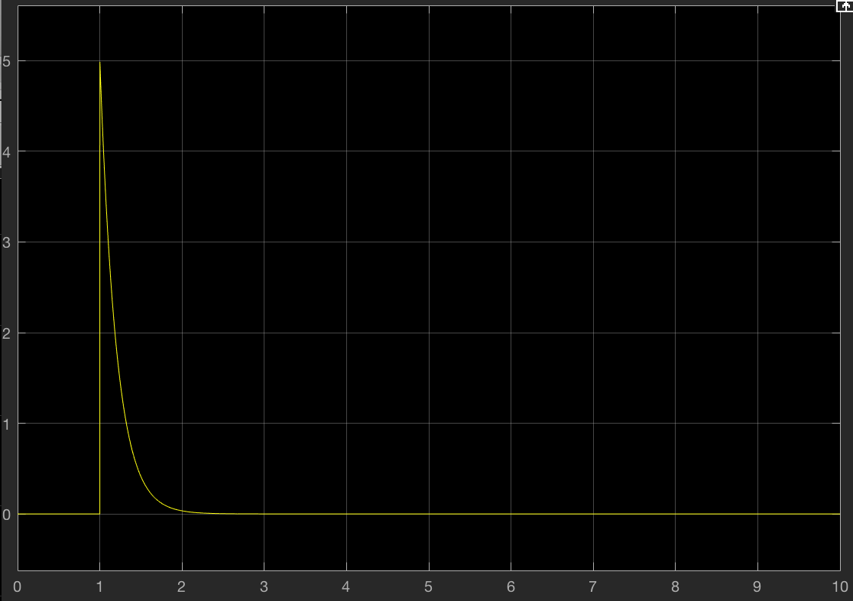

when ,

The lines from scope1:

The yellow line represents input. The blue line represents position.

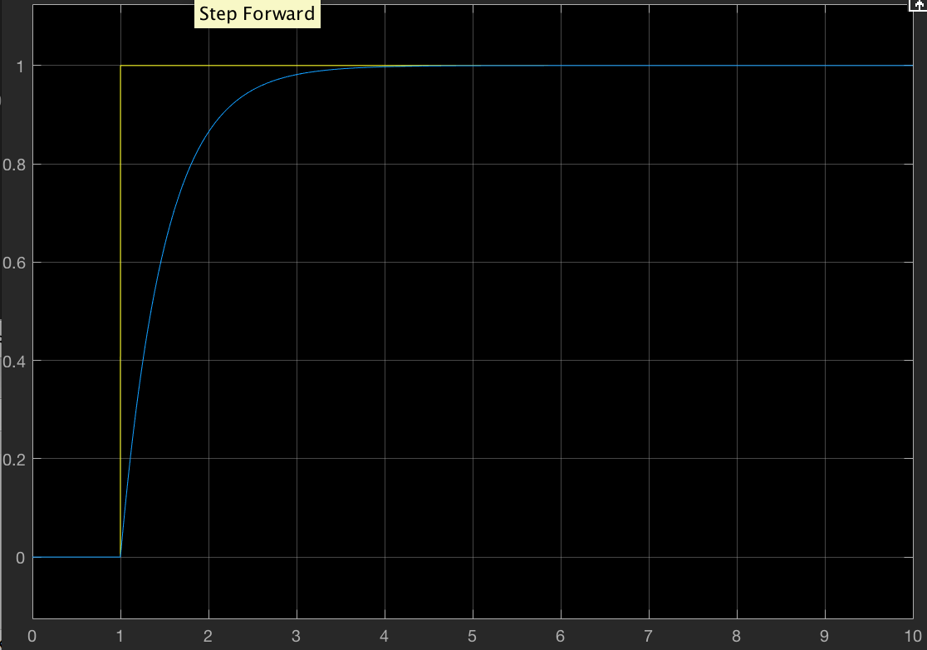

The lines from scope2:

The yellow line represents velocity.

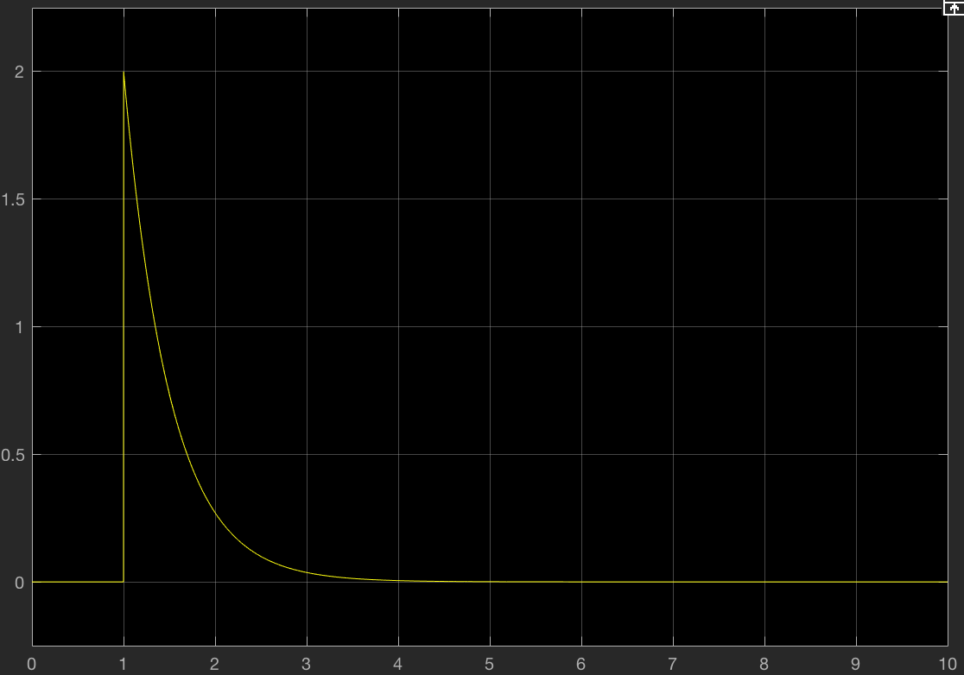

when $α=10, τ=10$:

The lines from scope1:

The yellow line represents input. The blue line represents position.

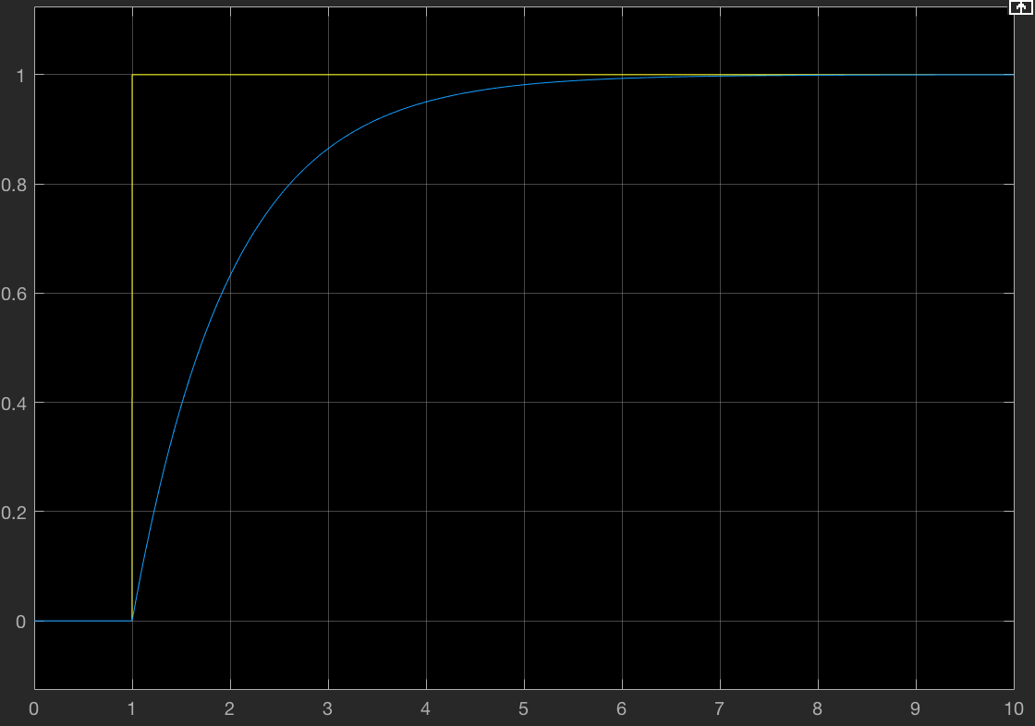

The yellow line represents velocity.

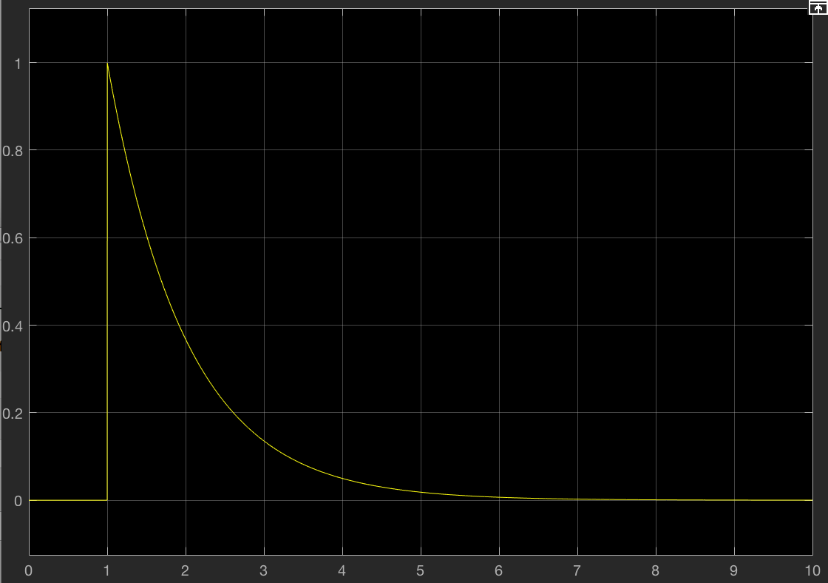

(c)

pros:

1. Easy to understand and implement
2. Easy to adjust the system through changing the parameters

cons:

1. System need to get a high speed immediately at beginning, which means the acceleration is extremely large at the beginning, so it is a little impractical.
2. Only approximately approach to the goal, cannot 100% approach to the goal, even though it is really closed to the goal at last.

(d)

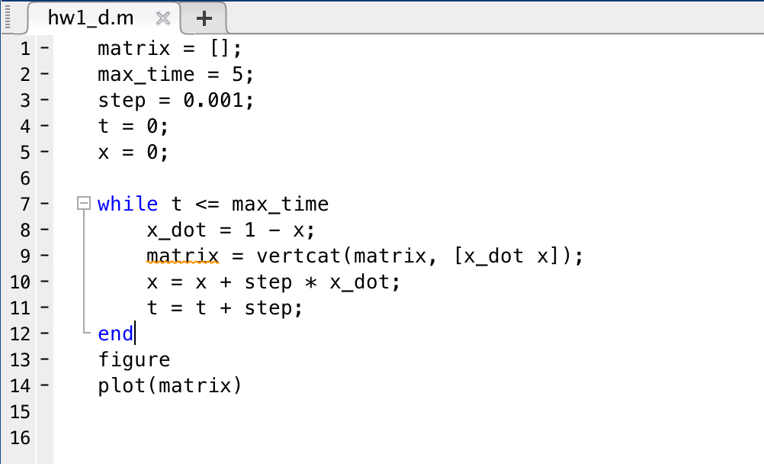

Plot:

The red line represents the position. The blue line represents the velocity.

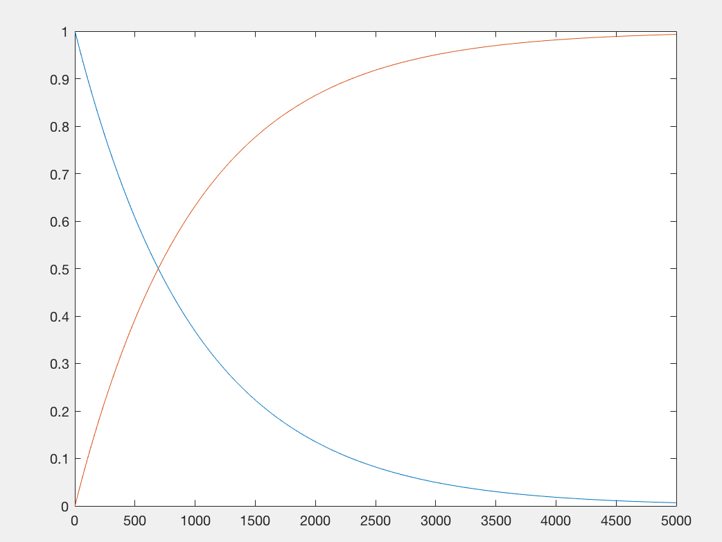

Difference:

For the position, it will move faster when using Euler method than 1a)

For the velocity, it will slow down faster when using Euler method than 1a)

(e)

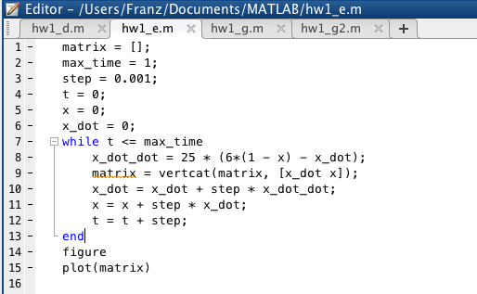

Plot:

The red line represents the position. The blue line represents the velocity.

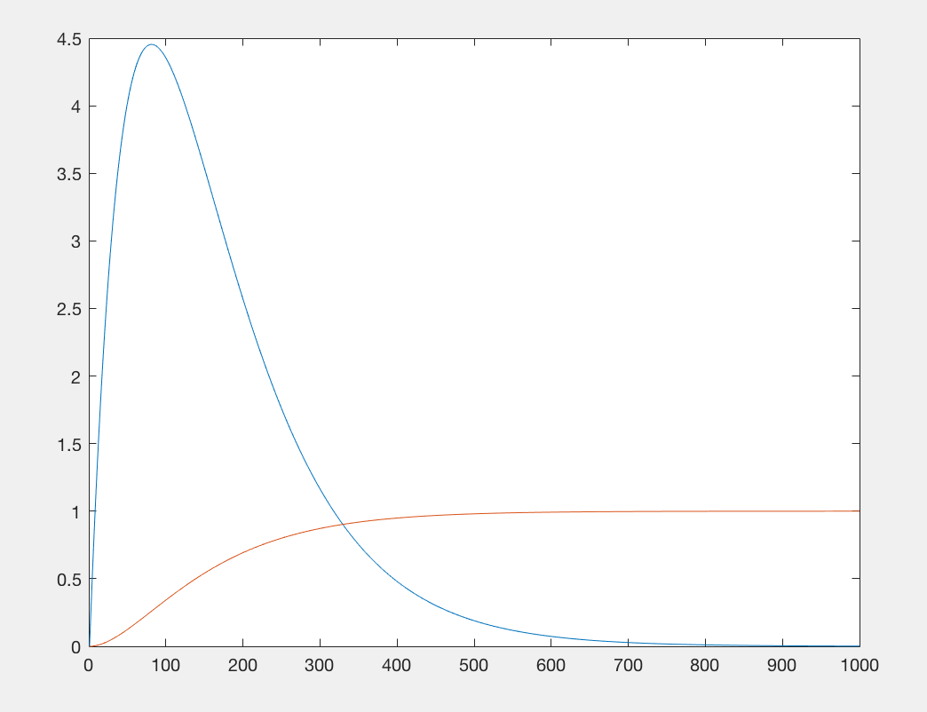

difference:

1. The speed is not from 1 and then decrease, but from 0 and then increase and then decrease
2. It takes less time to make speed approach close to 0 than before
3. The position approach to destination faster than before

Pros:

1. The speed is not from 1, so it is more practical in real life
2. It is faster to approach equilibrium state

Cons:

1. It will reach a larger maximum value of speed
2. The acceleration at the beginning is still very large

(f)

$x\left(t\right)=c_{0} + c_{1}t+ c_{2}t^{2}+ c_{3}t^{3}+ c_{4}t^{4}+ c_{5}t^{5}$

$$\dot{x\left(t\right)}=c_{1}+ 2c_{2}t+ 3c_{3}t^{2}+ 4c_{4}t^{3}+ 5c_{5}t^{4}$$

$$\ddot{x\left(t\right)}=2c_{2}+ 6c_{3}t+ 12c_{4}t^{2}+ 20c_{5}t^{3}$$

$$\left[ \begin{aligned}1 \\ 0 \\ 0 \\ 1 \\ 0 \\ 0\end{aligned} \begin{aligned}0 \\ 1 \\ 0 \\ τ \\ 1 \\ 0\end{aligned} \begin{aligned}0 \\ 0 \\ 2 \\ τ^{2} \\ 2τ \\ 2\end{aligned} \begin{aligned}0 \\ 0 \\ 0 \\ τ^{3} \\ {3τ}^{2} \\ 6τ\end{aligned} \begin{aligned}0 \\ 0 \\ 0 \\ τ^{4} \\ 4τ^{3} \\ 12τ^{2}\end{aligned} \begin{aligned}0 \\ 0 \\ 0 \\ τ^{5} \\ 5τ^{4} \\ 20τ^{3}\end{aligned} \right] \left[\begin{aligned}c_{0} \\ c_{1} \\ c_{2} \\ c_{3} \\ c_{4} \\ c_{5}\end{aligned}\right]= \left[\begin{aligned}x_{0} \\ \dot{x_{0}} \\ \ddot{x_{0}} \\ x_{f} \\ \dot{x_{f}} \\ \ddot{x_{f}}\end{aligned}\right]$$

$$c_{0}= x_{0}$$

$$c_{1}= \dot{x_{0}}$$

$$c_{2}= \frac{\ddot{x_{0}}}{2}$$

$$c_{3}=\frac{ 20x-8y+z}{2}$$

$$c_{4}= \frac{-15a+7y-z}{τ}$$

$$c_{5}= \frac{12a-6b+z}{2τ^{2}}$$

$$x = \frac{{-2x}_{0}-2τ \dot{x_{0}}- τ^{2}\ddot{x_{0}}+2{ x}_{f} }{2τ^{3}}$$

$$y= \frac{-\dot{x_{0}}- τ \ddot{x_{0}}+ \dot{x_{f}} }{τ^{2}}$$

$$z= \frac{- \ddot{x_{0}}+ \ddot{x_{f}} }{τ}$$

(g)

global xf xf_dot xf_dot_dot

xf = 1;

xf_dot = 0;

xf_dot_dot = 0;

matrix = [];

max_time = 1;

step = 0.001;

t_togo = max_time;

x = 0;

x_dot = 0;

x_dot_dot = 0;

matrix = vertcat(matrix, [x_dot x]);

while t_togo >= 0

    x = x + step * x_dot;

    x_dot = x_dot + step * x_dot_dot;

    x_dot_dot_dot = getX_dot_dot_dot(x, x_dot, x_dot_dot, t_togo)

    x_dot_dot = x_dot_dot + step * x_dot_dot_dot;

    matrix = vertcat(matrix, [x_dot x]);

    t_togo = t_togo - step;

end

figure

plot(matrix)

function res = getC0(x)

res = x;

end

function res = getC1(x_dot)

res = x_dot;

end

function res = getC2(x_dot_dot)

res = x_dot_dot / 2.0;

end

function res = getC3(x, x_dot, x_dot_dot, t)

res1 = 20*getX(x, x_dot, x_dot_dot, t) - 8*getY(x, x_dot, x_dot_dot, t) + getZ(x, x_dot, x_dot_dot, t);

res = res1 / 2.0;

end

function res = getC4(x, x_dot, x_dot_dot, t)

res1 = -15*getX(x, x_dot, x_dot_dot, t) + 7*getY(x, x_dot, x_dot_dot, t) - getZ(x, x_dot, x_dot_dot, t);

res = res1 / t;

end

function res = getC5(x, x_dot, x_dot_dot, t)

res1 = 12*getX(x, x_dot, x_dot_dot, t) - 6*getY(x, x_dot, x_dot_dot, t) + getZ(x, x_dot, x_dot_dot, t);

res2 = 2*t*t;

res = res1 / res2;

end

function res = getX(x, x_dot, x_dot_dot, t)

global xf

res1 = 2*xf - 2*x - 2*t*x_dot - x_dot_dot*t*t;

res2 = 2.0 * t*t*t;

res = res1 / res2;

end

function res = getY(x, x_dot, x_dot_dot, t)

global xf_dot

res1 = xf_dot - x_dot - t*x_dot_dot;

res2 = t*t;

res = res1 / res2;

end

function res = getZ(x, x_dot, x_dot_dot, t)

global xf_dot_dot

res1 = xf_dot_dot - x_dot_dot;

res2 = t;

res = res1 / res2;

end

function res = getX_dot_dot_dot(x, x_dot, x_dot_dot, t)

res = 6*getC3(x, x_dot, x_dot_dot, t) ;

end

Plot:

The red line represents the position. The blue line represents the velocity.

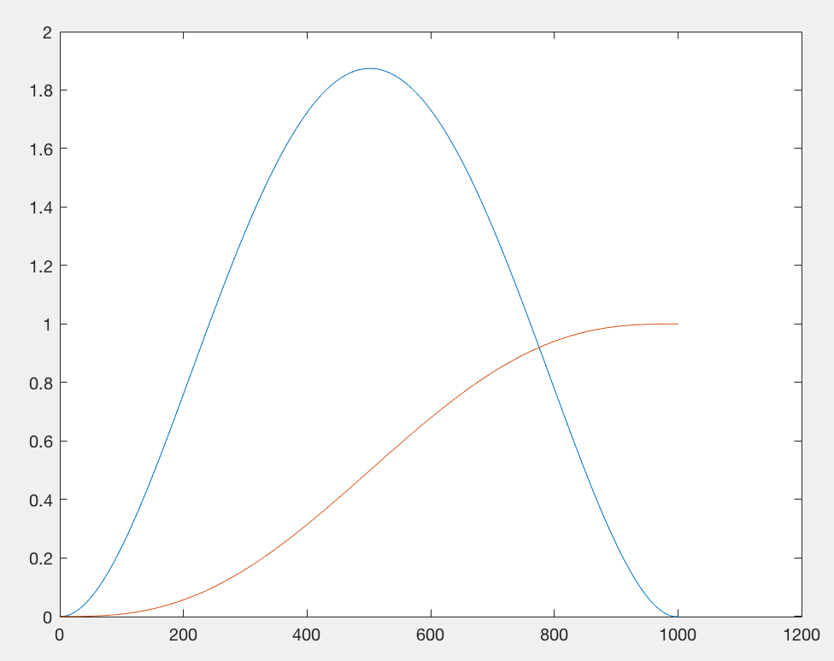

Comparison about results:

1. For position, min-jerk algorithm will arrive destination at 1s, as fast as the method in (e)
2. For velocity, the maximum speed of min-jerk algorithm is smaller than method in (e)
3. In min-jerk, the velocity reaches 0 at 1s, as fast as the method in (e)

Similarity:

1. The lines of speed in both graphs are increase from 0 and then decrease to 0 smoothly
2. The lines of position in both graphs are increase smoothly and reach 1 at 1s.

Differences:

1. In this question, speed increase slower
2. In this question, the maximum number of speed is smaller
3. In this question, the line of speed is about symmetric
4. In this question, the position increase slower

(h)

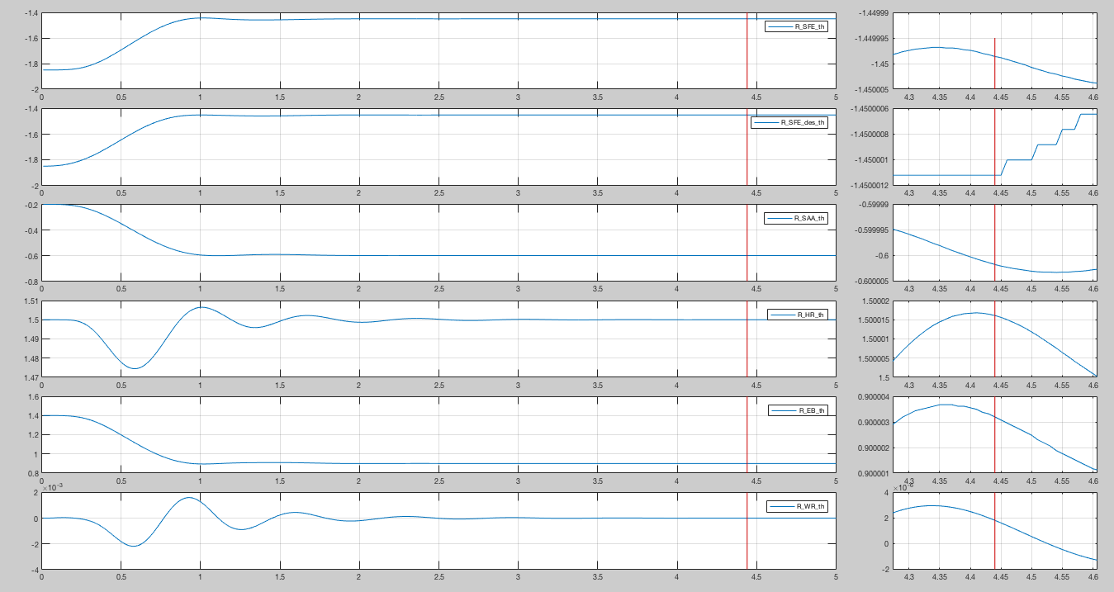

The quality of position of R_SFE, R_SFE_des, R_SAA, R_EB are really good. They move pretty smooth and arrive right position really quick

The quality of position of R_HR, R_WR are not so good. They moves backwards and then forwards before 1s. But they doesn’t arrive the equilibrium at 1s. So after 1s, they are a little shaking around the equilibrium position. And finally arrive right position.

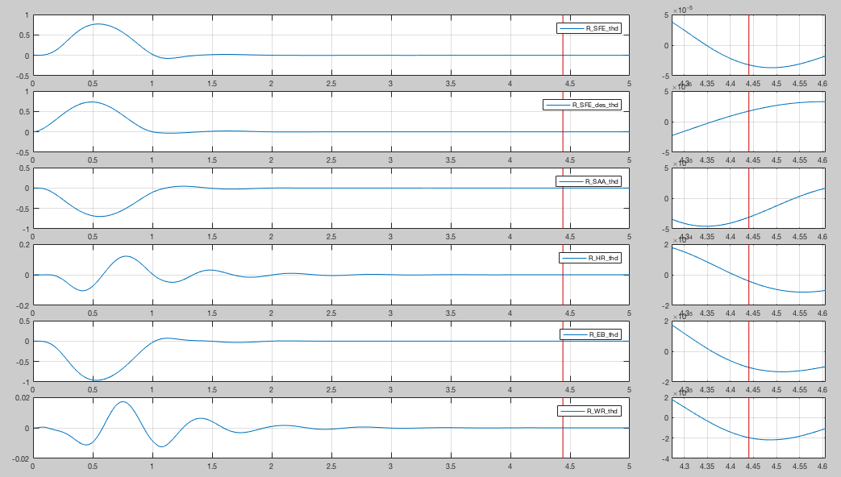

The quality of speed of R_SFE, R_SFE_des, R_SAA, R_EB are really good. They speed up gradually at beginning and slow down at the end, and reach 0 a little after 1s.

The quality of speed of R_HR, R_WR are not so good. The speed of them is floating a lot when moving, and reaches 0 at around 2s.

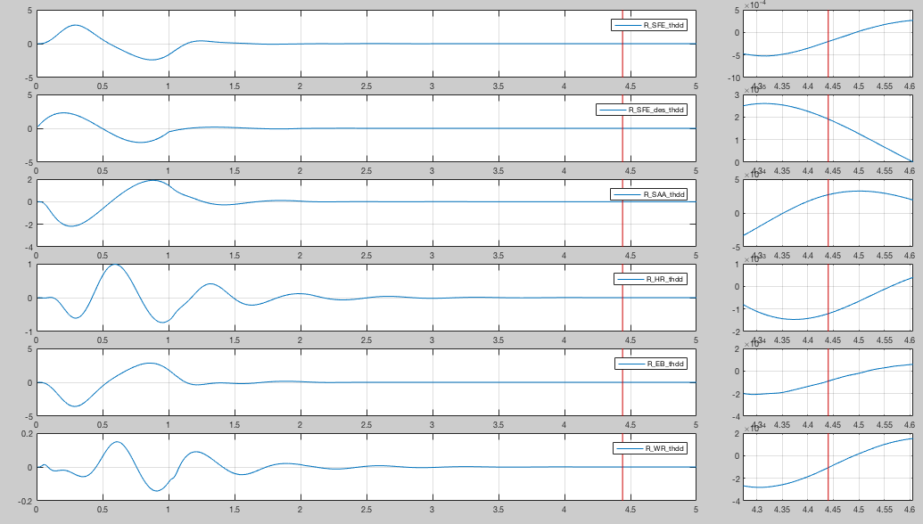

The quality of acceleration of R_SFE, R_SFE_des, R_SAA, R_EB are really good. The acceleration float around 0 twice and then reach 0 a little after 1s.

The quality of acceleration of R_HR, R_WR are not so good. The acceleration float around 0 many times before reaching 0 at around 2s.

(i)

The plot of x-y:

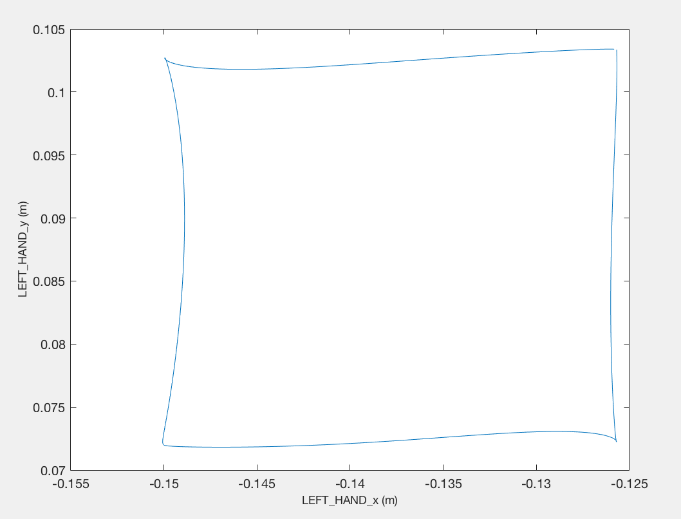

The plot of x-z:

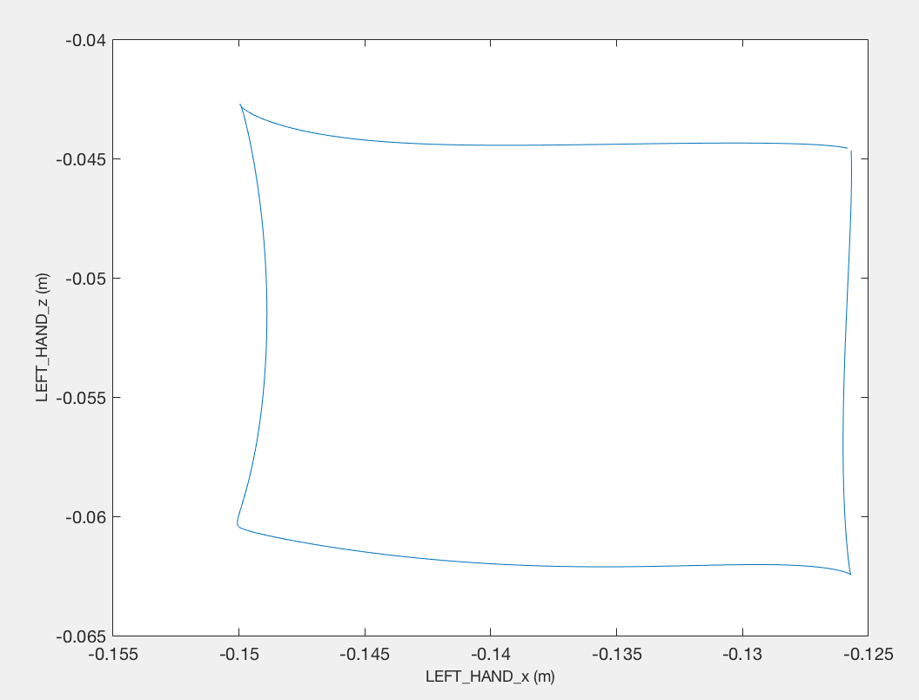

The quality of square in x-y and x-z is pretty good.

In plot of x-y:

1. The top-line is almost straight and horizon.
2. The left line is basically vertical, but a little curve.
3. The bottom-line is almost straight and horizon
4. The right line is almost straight and vertical.

In plot of x-z:

1. The top-line is almost horizon and basically straight.
2. The left line is basically vertical, but a little curve.
3. The bottom-line is almost straight and horizon
4. The right line is almost vertical and straight.

(j)

The plot of x-y:

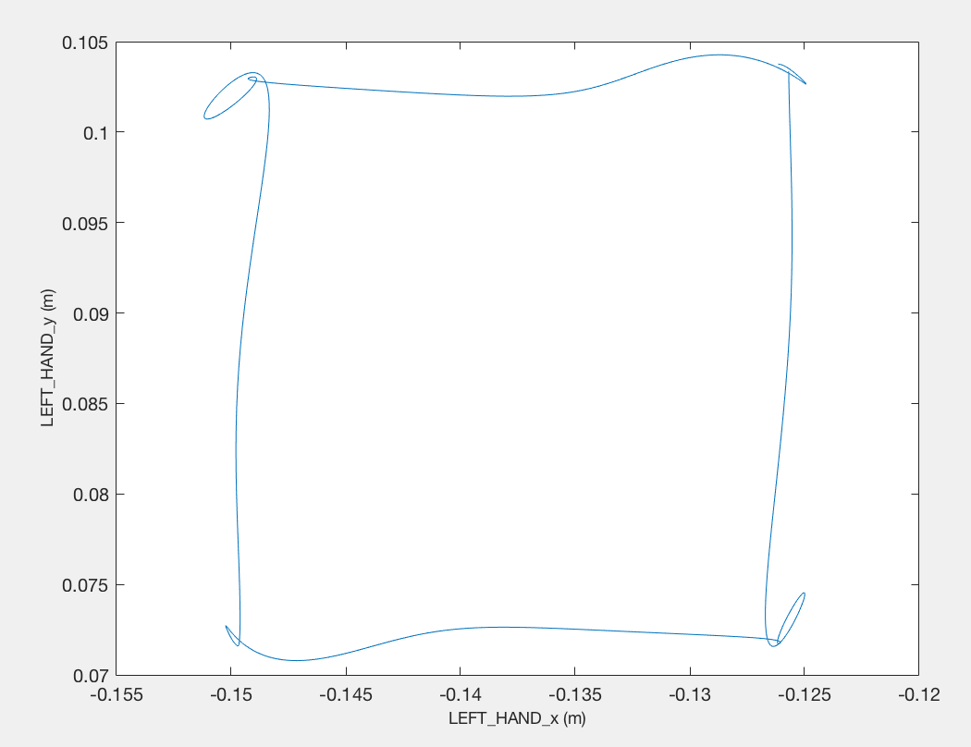

The plot of x-z:

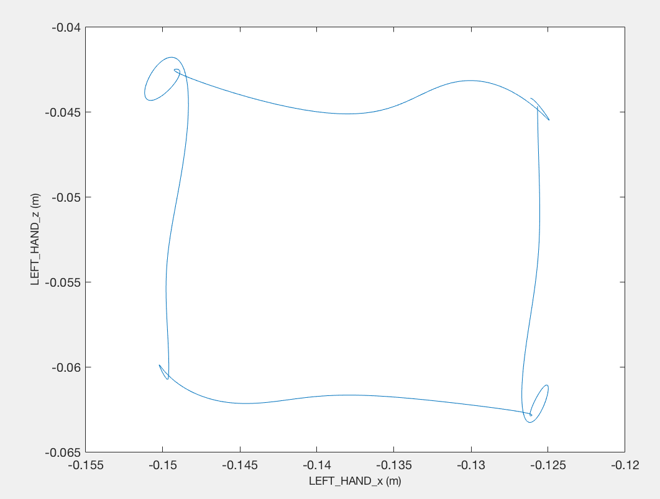

Technical view:

In method in (e), when the hand reaches the corner, the former joint is slowing down, but the next joint is speeding up dramatically. So the movement of two joint influent each other, and cause both joints adjust to the correct positions. So they draw some circles at the corners.

In method in (i), at the corner the speed of both joints are really slow, so the influence between the former joint and the next joint is almost trivial.

Movement view:

In method in (e), L_SFE speeds up dramatically and then gradually slows down. At 1s, L_SFE is almost reach the equilibrium position, but not 100%, so it still has speed. And the L_SAA, L_EB start to move and speed up dramatically. So these two joints will influence the L_SFE, so all of these three adjust positions and draw several circles at the corner. Then at 2s, L_SAA and L_EB slow almost reach the equilibrium position but not 100%, and still have speed and acceleration. And L_SFE start to move again and speed up dramatically, so influence the L_SAA and L_EB, so these three joints adjust again and draw several circles again. And so do them at 3s. At 4s, L_SAA and L_EB almost reach the equilibrium position, but this time no other joint will start to move, so no influence this time. So only except corner of beginning(end), the other three corners have several circles.

In method in (i), L_SFE speeds up gently and then gradually slows down. At 1s, L_SFE is almost reach the equilibrium position, but not 100%, so it still has speed. And the L_SAA, L_EB start to move and speed up gently. So these two joints will influence the L_SFE as much, so L_SFE will soon reach the equilibrium position and L_SAA and L_EB keep moving. And for the 3 corners left, the influence between joints is also trivial. So no circle at the corner.