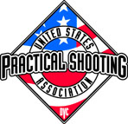 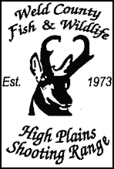

Hosts

11th Annual

“Rocky Mountain 300”

MAY 29th – MAY 31st, 2015

Weld County Fish and Wildlife

8 Miles East/1 Mile South of Ault, CO

**A USPSA Level 1 Pistol Match**

5 Stages + Chrono- 300+ Rounds

Cash Awards-Trophies-Random Prizes

Cash Payback to class and division winners

Match Fee- $85.00 Juniors- $40.00

Match Fee after APRIL 25th- $100.00 Juniors- $65.00

Lunch included in match fee

Camping Available at Range

Make Checks payable to: Weld County Fish & Wildlife

2-day shooting format (pick one)

FRIDAY 8:00am limited to 60 competitors

Saturday 8:00am LIMITED to 80 competitors

Shoot-offs Sunday 8:00am- 100% Cash Payback

Shoot-offs will be handicapped according to class

Entry Fee- $10.00

Match Director / RANGE MASTER: Jerry Westcott

[Westcottjk@msn.com](mailto:Westcottjk@msn,com)

(970) 532-2146