Project Information

Project Name: GroupUp - Student Study Group Platform

Student: Oussama Nasr Eddine Bendjelloul (Leader team ) 59652
Khaled Bouaoukel 55391
Ali Merabet 55392

Course: Team Project IT

Semester: Semester 5

GroupUp Project Overview
What is GroupUp?
GroupUp is a web application that helps students connect and collaborate with peers studying the same courses or subjects. Users can search for, join, or create study groups, coordinate study sessions, and communicate with group members. The platform aims to promote collaborative learning, improve academic performance, and make studying more organized and social.

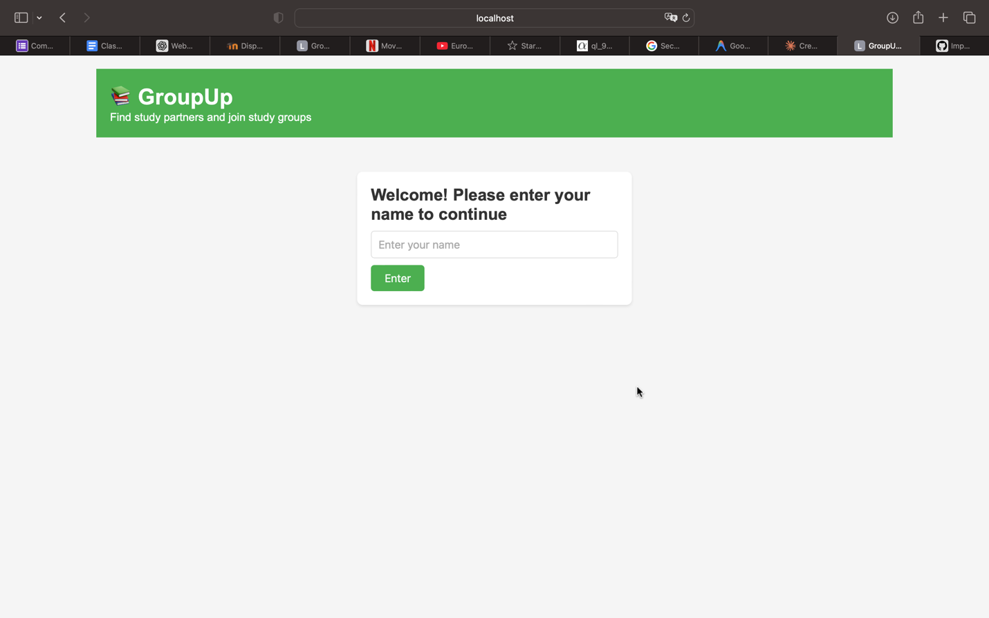

The Problem It Solves

Current Issues with Study Group Formation:
Students struggle to find peers studying the same subjects or courses
Study sessions are poorly organized across multiple messaging apps
Hard to coordinate schedules and meeting times with multiple people
No centralized platform to track study materials and resources
Difficulty finding study partners with compatible learning styles
Lack of accountability in informal study arrangements

GroupUp Solutions:
Centralized platform to discover and join study groups by course or subject
Integrated scheduling system for coordinating study sessions
Built-in messaging and communication tools for group members
Shared resource library for notes, documents, and study materials
User profiles showing courses, study preferences, and availability
Group moderation tools to maintain productive study environments

How GroupUp Helps Students

Time Saving: Find compatible study partners in minutes instead of spending hours messaging classmates
Better Learning: Collaborate with peers who share your academic goals and learning style
Organized Sessions: Schedule and manage study sessions with integrated calendar and reminders
Resource Sharing: Access shared study materials, notes, and resources from group members
Social Learning: Build study relationships and academic support networks
Accountability: Stay motivated with committed study partners and regular sessions

Current Stage of Development :

Fully Working Features:

User authentication and profile creation
Study group creation and discovery by course/subject
Join requests and group membership management
Real-time messaging within study groups
Session scheduling and calendar integration
Resource sharing and file uploads
User profiles with course information and preferences
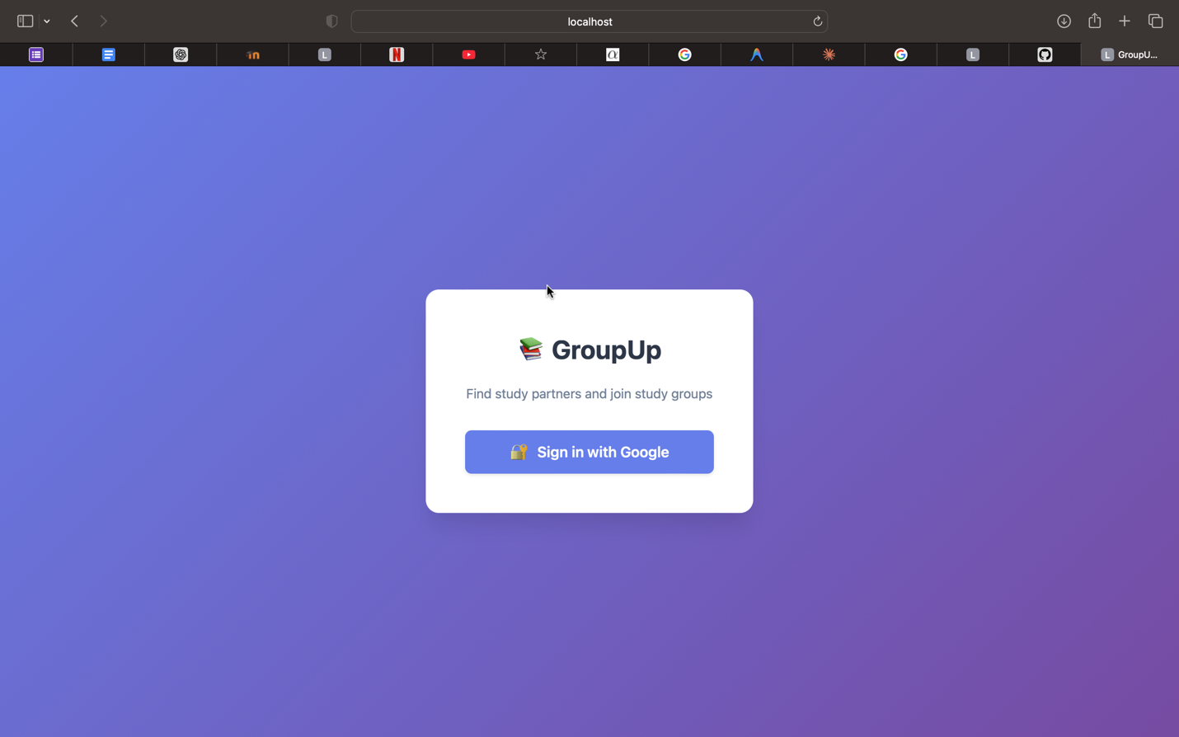

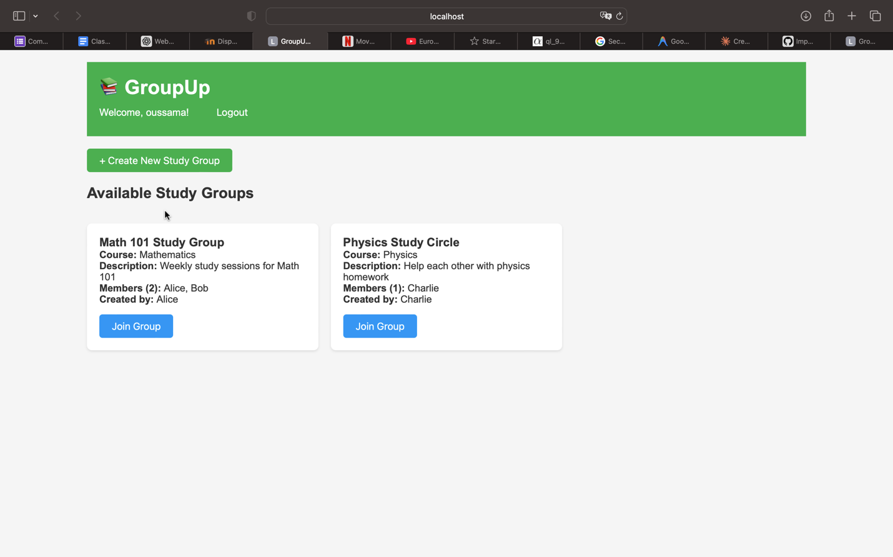

Responsive design for mobile and desktop devices

Technical Status:
Application runs smoothly on local and cloud servers
Database efficiently handles user data and real-time updates
Clean, intuitive user interface with modern design
Secure authentication and data protection implemented

Technologies Used

Frontend:
React 18 with TypeScript
Next.js 14 App Router
Tailwind CSS for styling
shadcn/ui component library

Backend:
Node.js with Express
PostgreSQL database
Prisma ORM for database management
Socket.io for real-time messaging

Authentication & Storage:
NextAuth.js for authentication
AWS S3 for file storage
JWT for session management

Why These Technologies:

Industry-standard tools used by major tech companies
Scalable architecture that can handle thousands of concurrent users
Strong security features to protect student data
Real-time capabilities for instant messaging and updates
Excellent developer experience with TypeScript type safety
Great performance for fast, responsive user experience

Benefits for Students

For Study Group Creators:
Create groups for any course or subject
Set group size limits and study preferences
Review and approve join requests
Moderate discussions and manage group settings
Schedule and organize study sessions

For Students Looking for Groups:

Browse all available study groups by course or subject
See group details, size, and member profiles before joining
Request to join groups that match your schedule and goals
Communicate with potential study partners before committing
Access shared resources and study materials

Future Possibilities

Potential Improvements:
AI-powered study partner matching based on learning styles
Integration with university course management systems (Canvas, Blackboard)
Video conferencing integration for remote study sessions
Study progress tracking and analytics
Gamification features to encourage consistent participation
Mobile app for iOS and Android
Study session recording and note-taking features
Integration with flashcard apps like Quizlet or Anki

Scalability: The platform is built with scalability in mind and can easily expand to serve entire universities or multiple institutions. The chosen technology stack supports horizontal scaling to accommodate growth from hundreds to millions of users.

